**WEEK-6**

**React**

**1. ReactJS-HOL**

**App.js**

import logo from './logo.svg';

import './App.css';

function App() {

  return (

    <h1>Welcome the first session of React</h1>

  );

}

export default App;

**Output:**

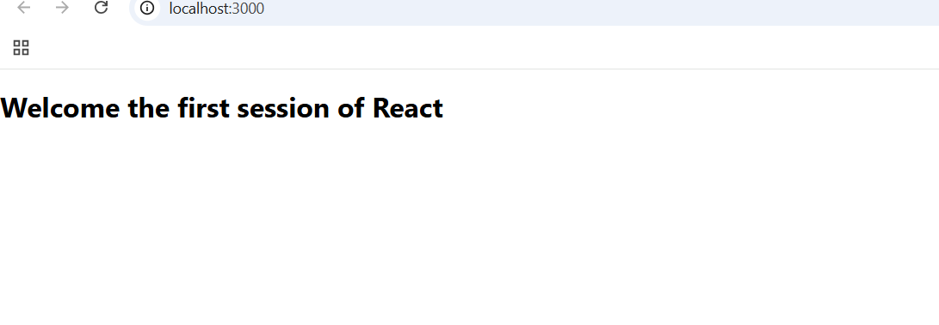

**2. ReactJS-HOL**

**App.js**

import logo from './logo.svg';

import './App.css';

import Home from './components/Home';

import About from './components/About';

import Contact from './components/Contact';

function App() {

  return (

    <div className="App">

      <Home/>

      <About/>

      <Contact/>

    </div>

  );

}

export default App;

**Home.js**

import React, { Component } from 'react';

class Home extends Component {

  render() {

    return (

      <div>

        <h3>Welcome to the About Page of Student Management Portal</h3>

      </div>

    );

  }

}

export default Home;

**About.js**

import React, { Component } from 'react';

class About extends Component {

  render() {

    return (

      <div>

        <h3>Welcome to the About Page of Student Management Portal</h3>

      </div>

    );

  }

}

export default About;

**Contact.js**

import React, { Component } from 'react';

class Contact extends Component {

  render() {

    return (

      <div>

        <h3>Welcome to the About Page of Student Management Portal</h3>

      </div>

    );

  }

}

export default Contact;

**Output:**

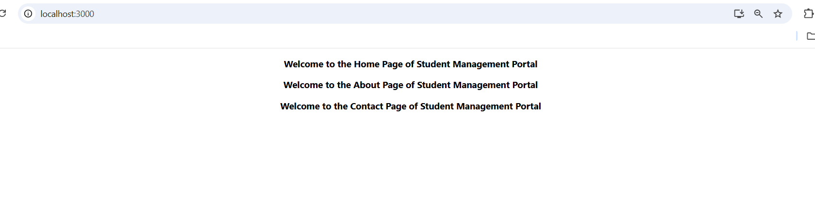

**3. ReactJS-HOL**

**App.js**

import logo from './logo.svg';

import './App.css';

import { CalculateScore } from '../src/Components/CalculateScore';

function App() {

  return (

    <div className="App">

      <CalculateScore Name={"Ashritha"}

      School={"Public School"}

      total={300}

      goal={5}

      />

    </div>

  );

}

export default App;

**CalculateScore.js**

import '../Stylesheets/mystyle.css'

const percentToDecimal=(decimal)=>{

    return (decimal.toFixed(2)+'%')

}

const calcScore=(total,goal)=>{

    return percentToDecimal(total/goal)

}

export const CalculateScore=({Name,School,total,goal})=>{

    return(

        <div className='formatstyle'>

     <h1><font color="Brown">Student Details:</font></h1>

     <div className='Name'>

      <b><span>Name:</span></b>

      <span>{Name}</span>

     </div>

     <div className='School'>

      <b><span>School:</span></b>

      <span>{School}</span>

     </div>

     <div className='Total'>

      <b><span>Total:</span></b>

      <span>{total}</span>

      <span>Marks</span>

     </div>

     <div className='Score'>

      <b>Score:</b>

      <span>

        {calcScore(

            total,

            goal

        )}

      </span>

     </div>

    </div>

    )

}

**mystyle.css**

.Name{

    font-weight:300;

    color:blue;

}

.School{

    color:crimson;

}

.Total{

    color:darkmagenta;

}

.formatstyle{

    text-align:center;

    font-size:large;

}

.Score{

    color:forestgreen;

}

**Output:**

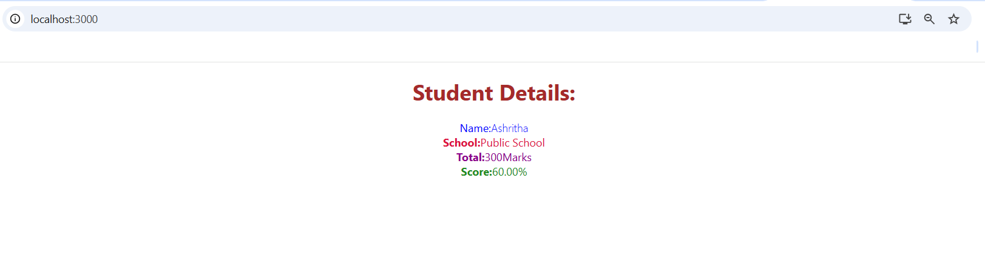

**4. ReactJS-HOL**

**App.js**

import React from 'react';

import './App.css';

import Posts from './Posts';

function App() {

  return (

    <div className="App">

      <Posts />

    </div>

  );

}

export default App;

**Post.js**

class Post {

    constructor(id, title, body) {

        this.id = id;

        this.title = title;

        this.body = body;

    }

}

export default Post;

**Posts.js**

import React from 'react';

import Post from './Post';

class Posts extends React.Component {

    constructor(props) {

        super(props);

        this.state = {

            posts: []

        };

    }

    loadPosts() {

        const samplePosts = [

            new Post(1, "Post 1", "This is the body of the first post."),

            new Post(2, "Post 2", "This is the body of the second post.")

        ];

        this.setState({ posts: samplePosts });

    }

    componentDidMount() {

        this.loadPosts();

    }

    render() {

        return (

            <div>

                <h1>Posts</h1>

                {this.state.posts.map(post => (

                    <div key={post.id}>

                        <h2>{post.title}</h2>

                        <p>{post.body}</p>

                    </div>

                ))}

            </div>

        );

    }

    componentDidCatch(error, info) {

        console.error("Error caught in component:", error, info);

    }

}

export default Posts;

**Output:**

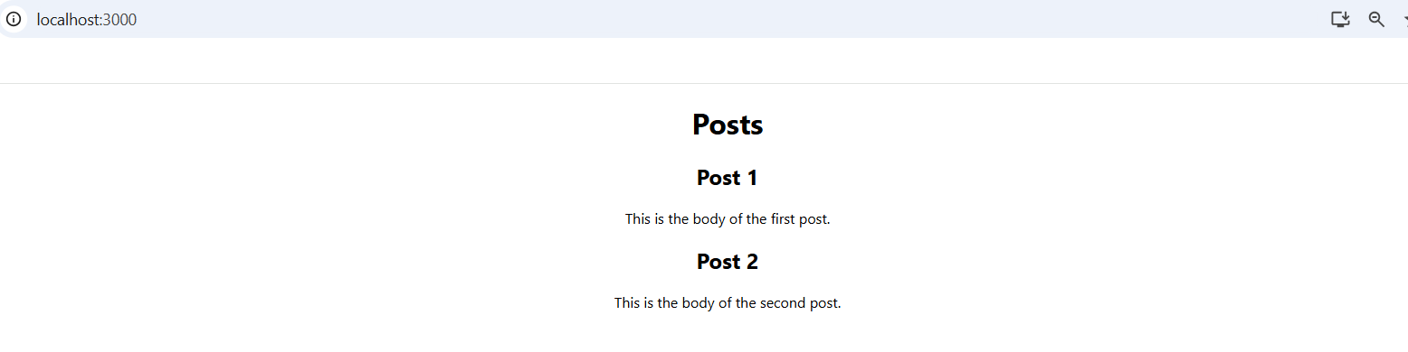

**5. ReactJS-HOL**

**CohortDetails.js**

import React from 'react';

import styles from './CohortDetails.module.css';

function CohortDetails(props) {

    const { cohort } = props;

    const statusClass = cohort.currentStatus.toLowerCase() === 'ongoing' ? styles.ongoing : styles.completed;

    return (

        <div className={styles.box}>

            <h3 className={statusClass}>

                {cohort.cohortCode} -

                <span> {cohort.technology}</span>

            </h3>

            <dl>

                <dt>Started On</dt>

                <dd>{cohort.startDate}</dd>

                <dt>Current Status</dt>

                <dd>{cohort.currentStatus}</dd>

                <dt>Coach</dt>

                <dd>{cohort.coachName}</dd>

                <dt>Trainer</dt>

                <dd>{cohort.trainerName}</dd>

            </dl>

        </div>

    );

}

export default CohortDetails;

**CohortDetails.module.css**

.box {

  width: 300px;

  display: inline-block;

  margin: 10px;

  padding: 10px 20px;

  border: 1px solid black;

  border-radius: 10px;

}

dt {

  font-weight: 500;

}

.ongoing {

  color: green;

}

.completed {

  color: blue;

}

**Output:**

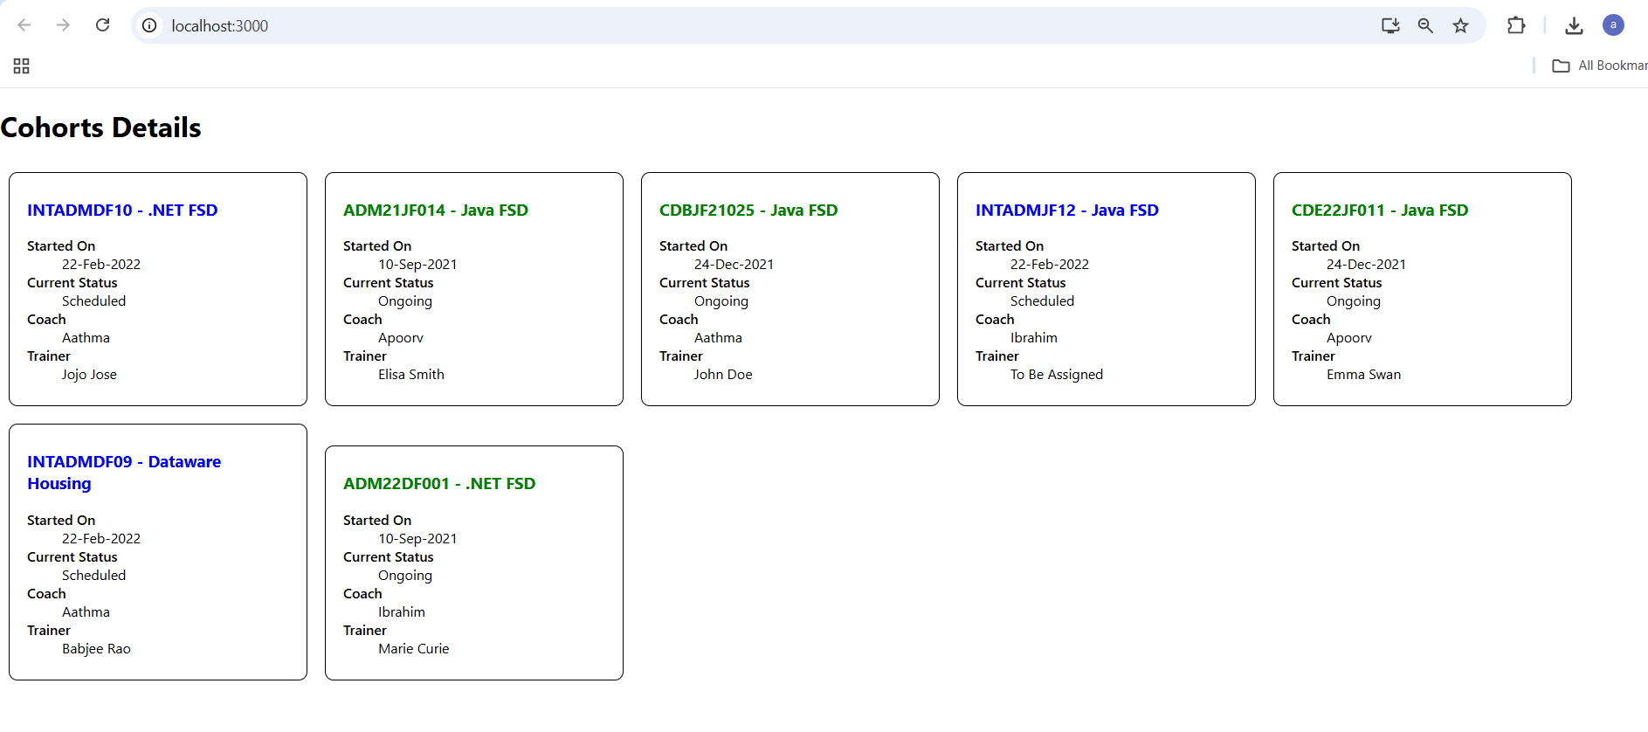

**6. ReactJS-HOL**

**App.js**

import React from 'react';

import { BrowserRouter, Routes, Route, Link } from 'react-router-dom';

import Home from './Home';

import TrainersList from './TrainersList';

import TrainerDetails from './TrainerDetails';

import TrainersMock from './TrainersMock';

function App() {

  return (

    <BrowserRouter>

    <h1>My Academy Trainers App</h1>

      <div>

        <nav style={{ marginBottom: '20px' }}>

          <Link to="/" style={{ marginRight: '10px' }}>Home</Link>

          <Link to="/trainers">Trainers</Link>

        </nav>

        <Routes>

          <Route path="/" element={<Home />} />

          <Route path="/trainers" element={<TrainersList trainers={TrainersMock} />} />

          <Route path="/trainer/:id" element={<TrainerDetails />} />

        </Routes>

      </div>

    </BrowserRouter>

  );

}

export default App;

**Trainer.js**

class Trainer {

  constructor(trainerId, name, email, phone, technology, skills) {

    this.trainerId = trainerId;

    this.name = name;

    this.email = email;

    this.phone = phone;

    this.technology = technology;

    this.skills = skills;

  }

}

export default Trainer;

**TrainersMock.js**

import Trainer from './Trainer';

const TrainersMock = [

  new Trainer('t-syed8', 'Syed Khaleelullah', 'Khaleelullah@cognizant.com', '97676516962','.NET', ['C#','SQL Server','React','.NET Core']),

  new Trainer('t-jojo', 'Jojo Jose','jojo@cognizant.com', '9897199231', 'Java', ['Java','JSP','Angular','Spring']),

  new Trainer('t-elisa', 'Elisa Jones', 'elisa@cognizant.com', '9871212235','Python', ['Python','Django','Angular'])

];

export default TrainersMock;

**TrainersList.js**

import React from 'react';

import { Link } from 'react-router-dom';

function TrainersList(props) {

  return (

    <div>

      <h2>Trainers List</h2>

      <ul>

        {props.trainers.map(trainer => (

          <li key={trainer.trainerId}>

            <Link to={`/trainer/${trainer.trainerId}`}>{trainer.name}</Link>

          </li>

        ))}

      </ul>

    </div>

  );

}

export default TrainersList;

**TrainerDetails.js**

import React from 'react';

import { useParams } from 'react-router-dom';

import TrainersMock from './TrainersMock';

function TrainerDetails() {

  const { id } = useParams();

  const trainer = TrainersMock.find(t => t.trainerId === id);

  if (!trainer) {

    return <p>Trainer not found</p>;

  }

  return (

    <div>

      <h2>Trainer Details</h2>

      <p><strong>ID:</strong> {trainer.trainerId}</p>

      <p><strong>Name:</strong> {trainer.name}</p>

      <p><strong>Email:</strong> {trainer.email}</p>

      <p><strong>Phone:</strong> {trainer.phone}</p>

      <p><strong>Technology:</strong> {trainer.technology}</p>

      <p><strong>Skills:</strong> {trainer.skills}</p>

    </div>

  );

}

export default TrainerDetails;

**Home.js**

import React from 'react';

function Home() {

  return (

    <div>

      <h2>Welcome to My Academy trainers page</h2>

    </div>

  );

}

export default Home;

**Output:**

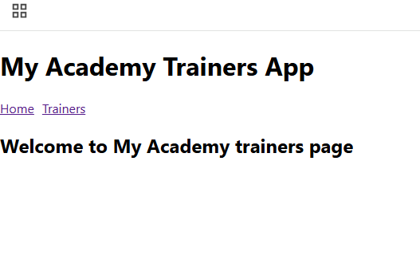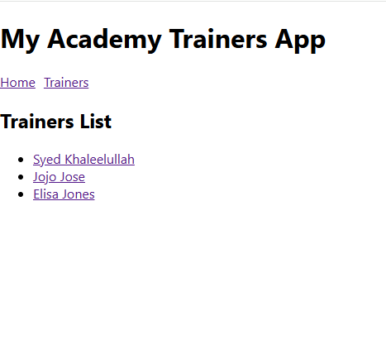

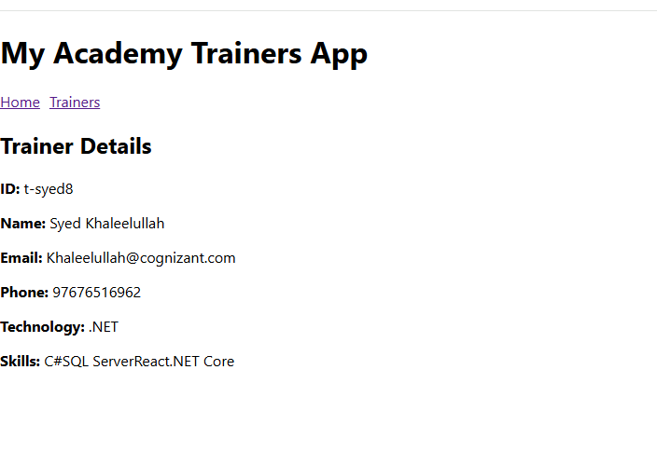

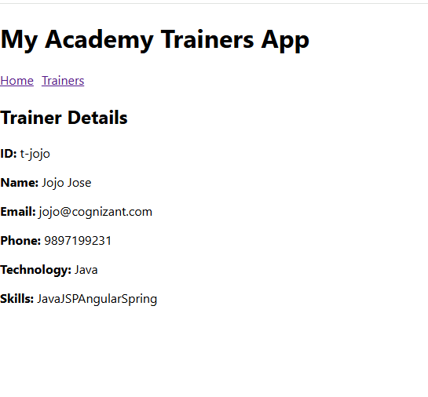

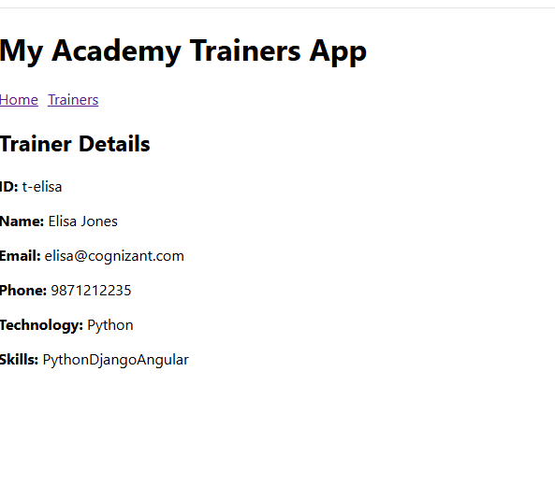  
**7. ReactJS-HOL**

**Cart.js**

import React from 'react';

class Cart extends React.Component {

  render() {

    const { itemname, price } = this.props;

    return (

      <tr>

        <td>{itemname}</td>

        <td>{price}</td>

      </tr>

    );

  }

}

export default Cart;

**OnlineShopping.js**

import React from 'react';

import Cart from './Cart';

import './OnlineShopping.css';

class OnlineShopping extends React.Component {

  constructor(props) {

    super(props);

    this.items = [

      { itemname: 'Laptop', price: 80000 },

      { itemname: 'TV', price: 120000 },

      { itemname: 'Washing Machine', price: 50000 },

      { itemname: 'Mobile', price: 30000 },

      { itemname: 'Fridge', price: 70000 }

    ];

  }

  render() {

    return (

      <div className="container">

        <h2 className="heading">Items Ordered :</h2>

        <table className="items-table">

          <thead>

            <tr>

              <th>Name</th>

              <th>Price</th>

            </tr>

          </thead>

          <tbody>

            {this.items.map((item, idx) => (

              <Cart key={idx} itemname={item.itemname} price={item.price} />

            ))}

          </tbody>

        </table>

      </div>

    );

  }

}

export default OnlineShopping;

**OnlineShopping.css**

.container {

  text-align: center;

  margin-top: 60px;

  font-family: Arial, sans-serif;

}

.heading {

  color: green;

  font-size: 24px;

  margin-bottom: 20px;

}

.items-table {

  margin: 0 auto;

  border-collapse: collapse;

  width: 350px;

  border: 1px solid green;

}

.items-table th,

.items-table td {

  border: 1px solid green;

  padding: 8px 12px;

}

.items-table th {

  background-color: #f8fff8;

  color: green;

  font-weight: bold;

}

.items-table td {

  color: green;

}

**index.js**

import React from 'react';

import ReactDOM from 'react-dom/client';

import OnlineShopping from './OnlineShopping';

const root = ReactDOM.createRoot(document.getElementById('root'));

root.render(<OnlineShopping />);

**Output:**

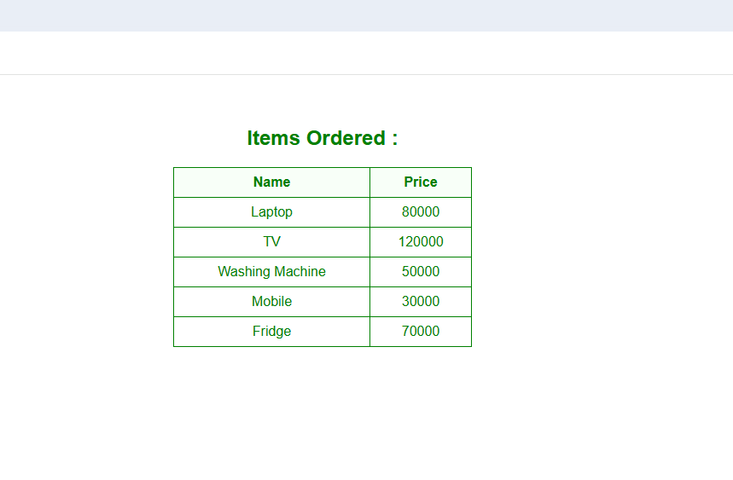

**8. ReactJS-HOL**

**index.js**

import React from 'react';

import ReactDOM from 'react-dom/client';

import CountPeople from './CountPeople';

const root = ReactDOM.createRoot(document.getElementById('root'));

root.render(<CountPeople />);

**CountPeople.js**

import React from 'react';

import './CountPeople.css';

class CountPeople extends React.Component {

  constructor(props) {

    super(props);

    this.state = {

      entrycount: 0,

      exitcount: 0

    };

  }

UpdateEntry = () => {

    this.setState(prevState => ({

      entrycount: prevState.entrycount + 1

    }));

  }

UpdateExit = () => {

    this.setState(prevState => ({

      exitcount: prevState.exitcount + 1

    }));

  }

render() {

    return (

      <div className="container">

        <p> {this.state.entrycount} People Entered!!!</p>

        <p> {this.state.exitcount} People Left!!!</p>

        <button onClick={this.UpdateEntry}>Login</button>

        <button onClick={this.UpdateExit}>Exit</button>

      </div>

    );

  }

}

export default CountPeople;

**CountPeople.css**

.container {

  text-align: center;

  margin-top: 100px;

  font-family: Arial, sans-serif;

}

button {

  margin: 10px;

  padding: 10px 20px;

  font-size: 16px;

  background-color: lightgreen;

  border: none;

  border-radius: 5px;

  cursor: pointer;

}

button:hover {

  background-color: darkgreen;

}

**Output:**

