**WEEK-7**

**React**

**9. ReactJS-HOL**

**App.js**

import React from 'react';

import IndianPlayers from './components/IndianPlayers';

import ListofPlayers from './components/ListOfPlayers';

function App() {

  const flag = true;

  return (

    <div className="App">

      <h1>Cricket App Dashboard</h1>

      {flag ? <ListofPlayers/> : <IndianPlayers/>}

    </div>

  );

}

export default App;

**index.js**

import React from 'react';

import ReactDOM from 'react-dom/client';

import App from './App';

const root = ReactDOM.createRoot(document.getElementById('root'));

root.render(<App />);

**ListOfPlayers.js**

import React from 'react';

function ListofPlayers() {

  const players = [

    { name: 'Virat', score: 95 },

    { name: 'Rohit', score: 85 },

    { name: 'Rahul', score: 40 },

    { name: 'Jadeja', score: 50 },

    { name: 'Bumrah', score: 90 },

    { name: 'Shami', score: 60 },

    { name: 'Iyer', score: 75 },

    { name: 'Pant', score: 45 },

    { name: 'Gill', score: 35 },

    { name: 'Ashwin', score: 80 },

    { name: 'Suryakumar', score: 100 }

  ];

  const filteredPlayers = players.filter(p => p.score < 70);

return (

    <div>

      <h2>List of All Players</h2>

      <ul>

        {players.map((player, index) => (

          <li key={index}>{player.name} - {player.score}</li>

        ))}

      </ul>

<h2>Players with score below 70</h2>

      <ul>

        {filteredPlayers.map((player, index) => (

          <li key={index}>{player.name} - {player.score}</li>

        ))}

      </ul>

    </div>

  );

}

export default ListofPlayers;

**IndianPlayers.js**

import React from 'react';

function IndianPlayers() {

  const players = ['Virat', 'Rohit', 'Rahul', 'Jadeja', 'Bumrah', 'Shami'];

  const evenPlayers = players.filter((_, i) => i % 2 === 0);

  const oddPlayers = players.filter((_, i) => i % 2 !== 0);

  const T20players = ['Virat', 'Rohit', 'Suryakumar'];

  const RanjiPlayers = ['Shaw', 'Sarfaraz', 'Ishan'];

  const mergedPlayers = [...T20players, ...RanjiPlayers];

return (

    <div>

      <h2>Odd Team Players</h2>

      <ul>

        {oddPlayers.map((name, i) => (

          <li key={i}>{name}</li>

        ))}

      </ul>

      <h2>Even Team Players</h2>

      <ul>

        {evenPlayers.map((name, i) => (

          <li key={i}>{name}</li>

        ))}

      </ul>

      <h2>List of Indian Players Merged</h2>

      <ul>

        {mergedPlayers.map((name, i) => (

          <li key={i}>{name}</li>

        ))}

      </ul>

    </div>

  );

}

export default IndianPlayers;

**Output:**

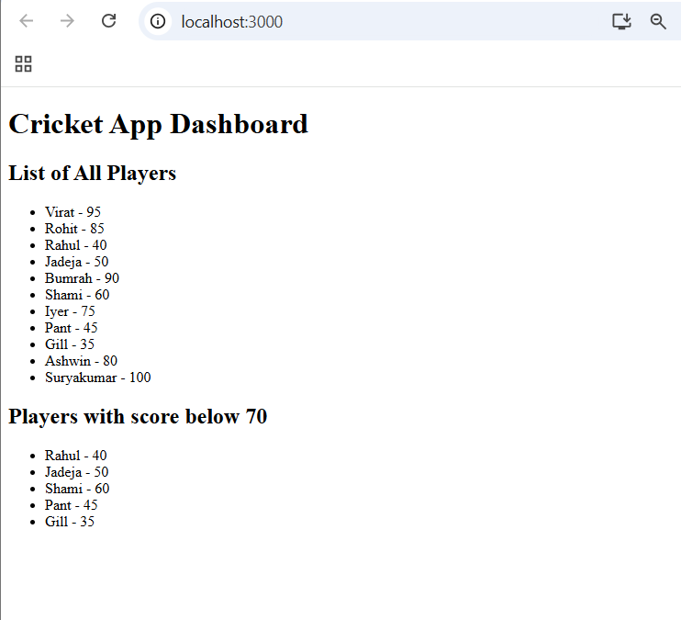

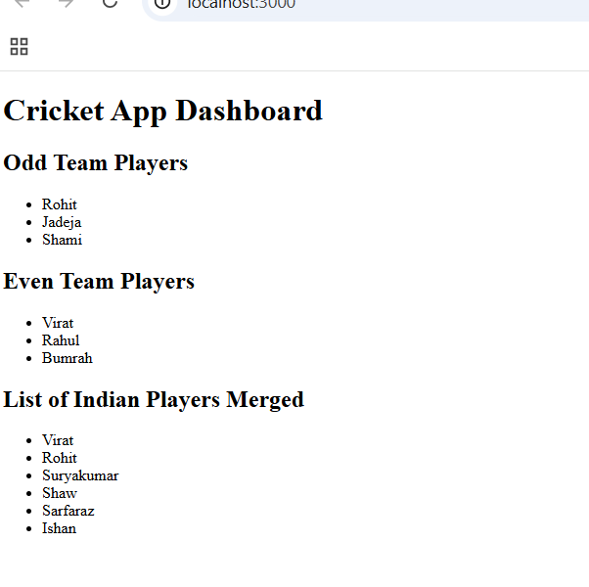

**10.ReactJS-HOL**

**App.js**

import React from 'react';

import OfficeSpaces from './OfficeSpaces';

function App() {

  return (

    <div>

      <OfficeSpaces />

    </div>

  );

}

export default App;

**OfficeSpaces.js**

import React from 'react';

function OfficeSpaces() {

  const offices = [

    {

      name: "TechPark Building",

      rent: 55000,

      address: "Hitech City, Hyderabad",

      image: "https://images.unsplash.com/photo-1504384308090-c894fdcc538d?fit=crop&w=600&q=80"

    },

    {

      name: "Business Tower",

      rent: 75000,

      address: "Whitefield, Bangalore",

     image: "https://images.unsplash.com/photo-1507679799987-c73779587ccf?auto=format&fit=crop&w=600&q=80"

    },

    {

      name: "Corporate Hub",

      rent: 60000,

      address: "Cyber City, Gurgaon",

      image: "https://images.unsplash.com/photo-1568605114967-8130f3a36994?fit=crop&w=600&q=80"

    }

  ];

  return (

    <div style={{ textAlign: 'center', fontFamily: 'Arial' }}>

      <h1 style={{ color: 'black' }}>

        Office Space ,at Affordable Range</h1>

      {offices.map((office, index) => {

        const rentStyle = {

          color: office.rent < 60000 ? 'red' : 'green',

          fontWeight: 'bold'

        };

        return (

          <div

            key={index}

            style={{

              margin: '20px auto',

              padding: '15px',

              width: '60%',

              borderRadius: '10px',

            }}

          >

            <img

              src={office.image}

              alt={office.name}

              style={{ width: '100%', height: '150px', objectFit: 'cover', borderRadius: '5px' }}

            />

            <h2>{office.name}</h2>

            <p style={rentStyle}>Rent: ₹{office.rent}</p>

            <p>Address: {office.address}</p>

          </div>

        );

      })}

    </div>

  );

}

export default OfficeSpaces;

**Output:**



**11. ReactJS-HOL**

**App.js**

import React, { Component } from 'react';

import CurrencyConvertor from './CurrencyConvertor';

import './App.css';

class App extends Component {

  constructor(props) {

    super(props);

    this.state = {

      counter: 0

    };

  }

  increment = () => {

    this.setState(prevState => ({

      counter: prevState.counter + 1

    }));

    this.sayHello();

  };

  sayHello = () => {

    alert("Hello! Member.");

  };

  decrement = () => {

    this.setState(prevState => ({

      counter: prevState.counter - 1

    }));

  };

  sayWelcome = (msg) => {

    alert(`Welcome`);

  };

  handleClick = (event) => {

    alert("I was clicked");

  };

  render() {

    return (

      <div className="App">

        <h2>Counter: {this.state.counter}</h2>

        <button onClick={this.increment}>Increment</button>

        <br />

        <button onClick={this.decrement}>Decrement</button>

        <br />

        <button onClick={() => this.sayWelcome("welcome")}>Say Welcome</button>

        <br />

        <button onClick={this.handleClick}>Click on me</button>

        <br /><br />

        <CurrencyConvertor />

      </div>

    );

  }

}

export default App;

**App.css**

.App {

  text-align: left;

  font-family: Arial, sans-serif;

  margin-top: 30px;

}

button {

  margin: 4px;

  padding: 10px;

  font-size: 16px;

}

**CurrencyConvertor.js**

import React, { Component } from 'react';

class CurrencyConvertor extends Component {

  constructor(props) {

    super(props);

    this.state = {

      rupees: '',

      euro: ''

    };

  }

  handleChange = (event) => {

    this.setState({ rupees: event.target.value });

  };

  handleSubmit = () => {

    const rate = 0.011;

    const result = this.state.rupees * rate;

    this.setState({ euro: result.toFixed(2) }, () => {

      alert(`Converting to Euro Amount is: ${this.state.euro}`);

    });

  };

  render() {

    return (

      <div>

        <h2>Currency Convertor</h2>

        <label>Amount: </label>

        <input

          type="number"

          value={this.state.rupees}

          onChange={this.handleChange}

        />

        <br></br>

        <button onClick={this.handleSubmit}>Submit</button>

      </div>

    );

  }

}

export default CurrencyConvertor;

**Output:**

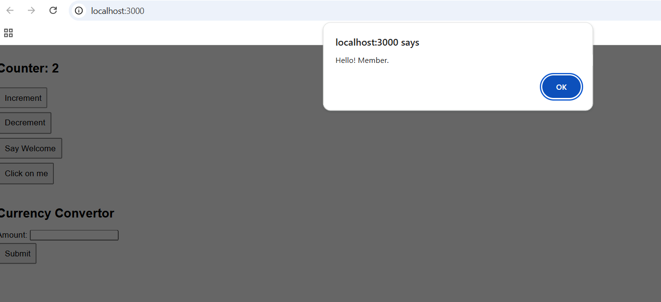

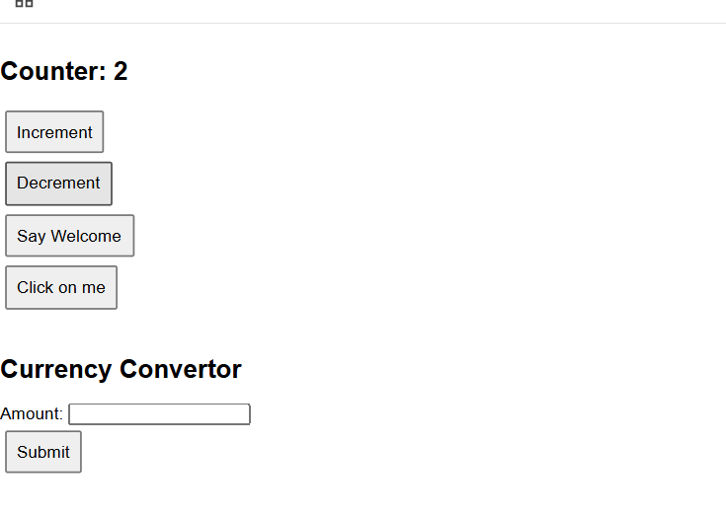

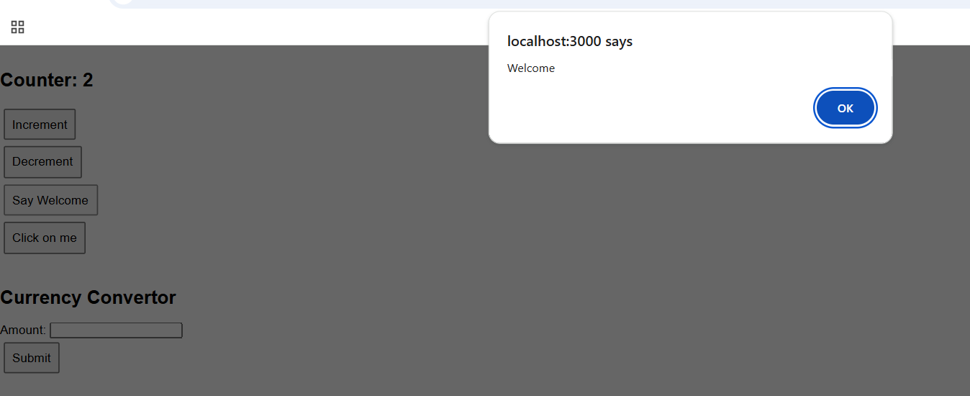

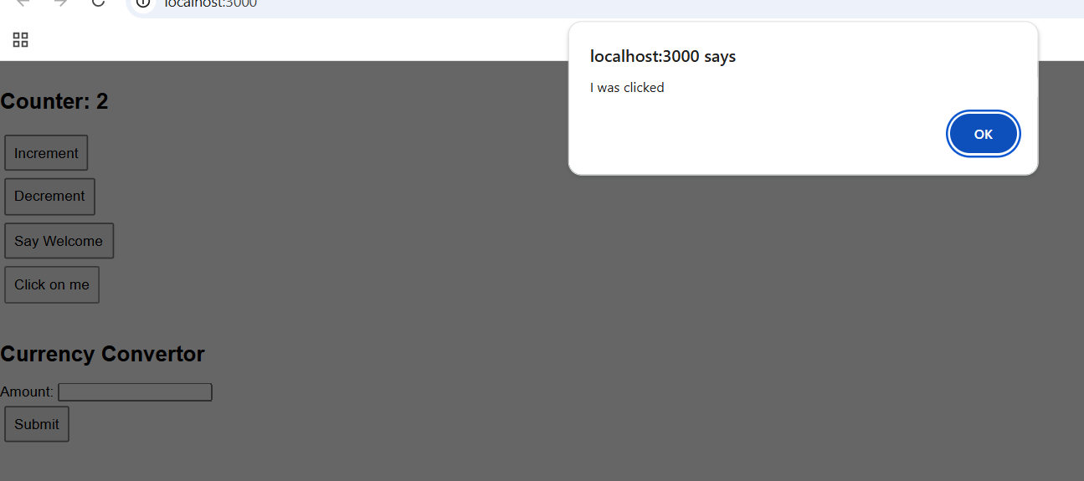

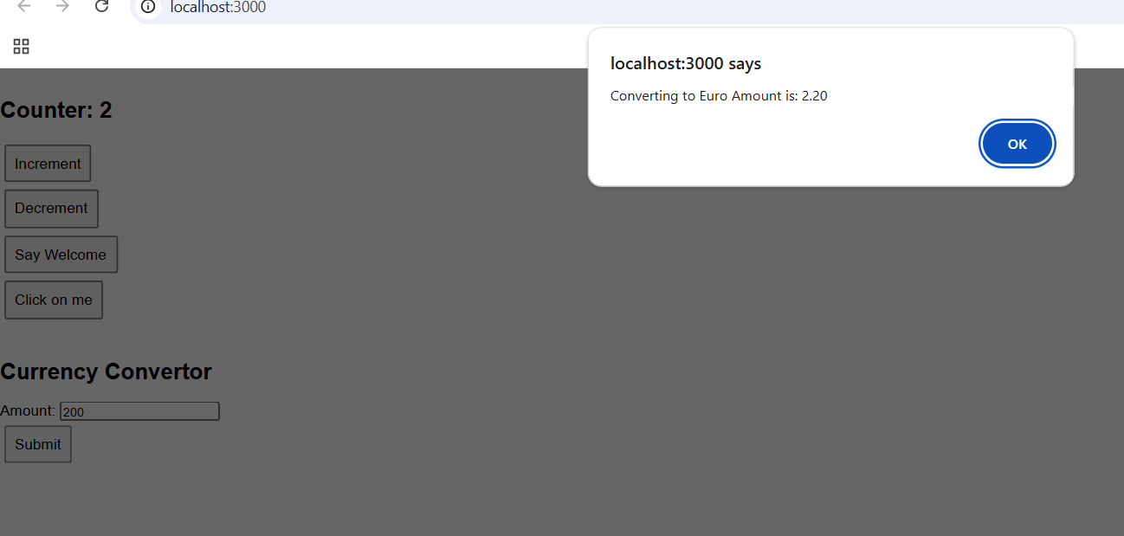

**12. ReactJS-HOL**

**App.js**

import React from 'react';

import './App.css';

import LoginControl from './LoginControl';

function App() {

  return (

    <div className="App">

      <LoginControl />

    </div>

  );

}

export default App;

**User.js**

import React from 'react';

function User() {

  return (

    <div>

      <h2>Welcome back!</h2>

    </div>

  );

}

export default User;

**Guest.js**

import React from 'react';

function Guest() {

  return (

    <div>

      <h2>Please sign up!</h2>

    </div>

  );

}

export default Guest;

**LoginControl.js**

import React, { Component } from 'react';

import Guest from './Guest';

import User from './User';

class LoginControl extends Component {

  constructor(props) {

    super(props);

    this.state = {

      isLoggedIn: false

    };

  }

handleLogin = () => {

    this.setState({ isLoggedIn: true });

  };

  handleLogout = () => {

    this.setState({ isLoggedIn: false });

  };

  render() {

    const { isLoggedIn } = this.state;

    const button = isLoggedIn ? (

      <button onClick={this.handleLogout}>Logout</button>

    ) : (

      <button onClick={this.handleLogin}>Login</button>

    );

    const content = isLoggedIn ? <User /> : <Guest />;

    return (

      <div>

        {content}

        {button}

      </div>

    );

  }

}

export default LoginControl;

**Output:**

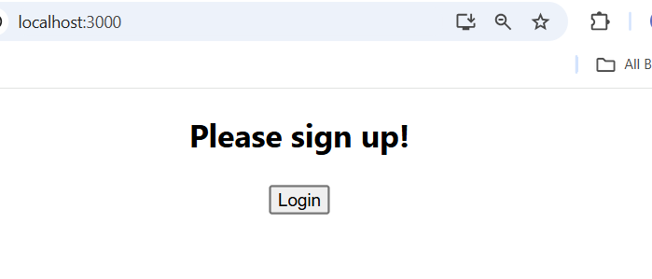

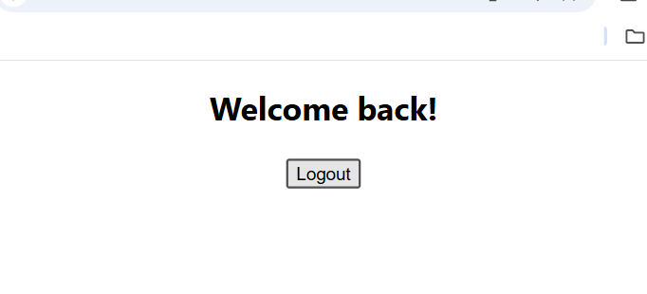

**13. ReactJs-HOL**

**App.js**

import React, { Component } from 'react';

import './App.css';

import BookDetails from './BookDetails';

import BlogDetails from './BlogDetails';

import CourseDetails from './CourseDetails';

class App extends Component {

  constructor(props) {

    super(props);

    this.state = {

      showComponent: 'book'

    };

  }

  renderComponentUsingIfElse() {

    if (this.state.showComponent === 'book') {

      return <BookDetails />;

    } else if (this.state.showComponent === 'blog') {

      return <BlogDetails />;

    } else {

      return <CourseDetails />;

    }

  }

  render() {

    const { showComponent } = this.state;

    return (

      <div className="App">

        <h1>Blogger App Dashboard</h1>

        <button onClick={() => this.setState({ showComponent: 'book' })}>Show Book</button>

        <button onClick={() => this.setState({ showComponent: 'blog' })}>Show Blog</button>

        <button onClick={() => this.setState({ showComponent: 'course' })}>Show Course</button>

        <hr />

        {this.renderComponentUsingIfElse()}

        <hr />

        {showComponent === 'book' ? <BookDetails /> :

          showComponent === 'blog' ? <BlogDetails /> :

            <CourseDetails />

        }

        <hr />

        {showComponent === 'book' && <BookDetails />}

      </div>

    );

  }

}

export default App;

**App.css**

.App {

  text-align: center;

  font-family: sans-serif;

  margin-top: 30px;

}

button {

  margin: 10px;

  padding: 10px 20px;

  font-size: 16px;

}

**CourseDetails.js**

import React from 'react';

function CourseDetails() {

  return (

    <div>

      <h2> Course Details</h2>

      <h2>Angular</h2>

      <b>4/5/2021</b>

      <h2>React</h2>

      <b>6/3/2025</b>

    </div>

  );

}

export default CourseDetails;

**BlogDetails.js**

import React from 'react';

function BlogDetails() {

  return (

    <div>

      <h2> Blog Details</h2>

      <h2>React Learning</h2>

      <b>Stephen Biz</b>

      <p>Welcome to learning React!</p>

      <h2>Installation</h2>

      <b>Schewzdenier</b>

      <p>You can install React from npm</p>

    </div>

  );

}

export default BlogDetails;

**BookDetails.js**

import React from 'react';

function BookDetails() {

  return (

    <div>

      <h2>Book Details</h2>

      <h2>Master React</h2>

      <b>670</b>

      <h2>Deep Dive into Angular 11</h2>

      <b>800</b>

      <h2>Mongo Essentials</h2>

      <b>450</b>

    </div>

  );

}

export default BookDetails;

**Output:**

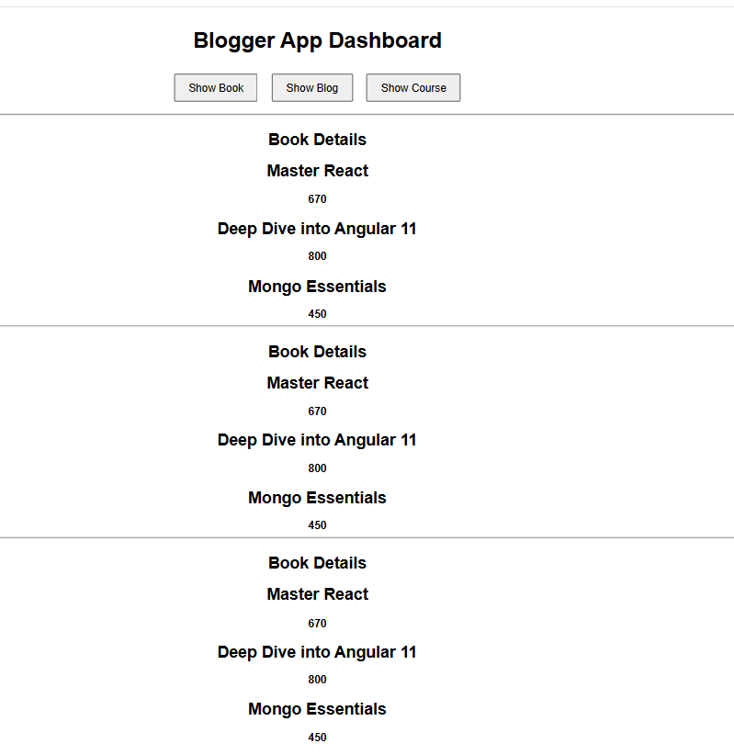

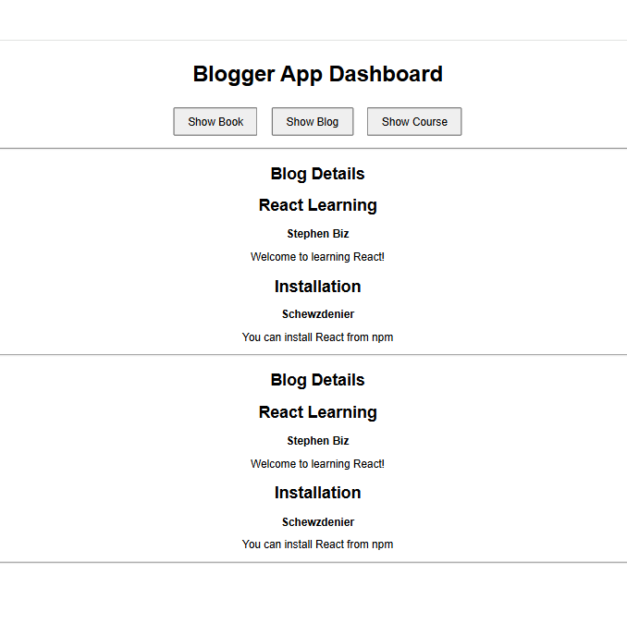

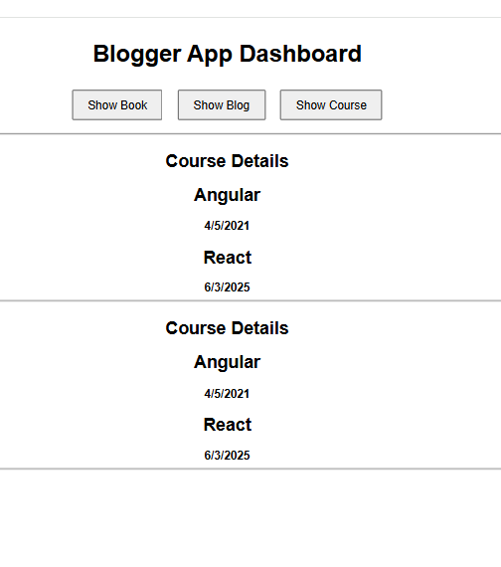

**14. ReactJS-HOL**

**App.js**

import logo from './logo.svg';

import './App.css';

import { EmployeesData } from './Employee';

import EmployeesList from './EmployeesList';

import { useState } from 'react';

function App() {

  const Employees = EmployeesData;

  const [theme, setTheme] = useState('light');

return (

    <>

      <div>

        <label>SELECT A THEME </label>

        <select onChange={(e) => setTheme(e.target.value)}>

          <option value='light'>Light</option>

          <option value='dark'>Dark</option>

        </select>

      </div>

      <EmployeesList theme={theme} employees={Employees} />

    </>

  );

}

export default App;

**App.css**

a {

  display: inline-block;

  margin:3px 5px;

  padding: 5px 5px;

  border-radius: 3px;

 text-decoration: none;

}

a.dark{

background-color: #333;

color:#eee;

}

a.light{

 background-color: #eee;

 color:#333;

}

**Employee.js**

class Employee {

    constructor(id, name, email, phone){

        this.id=id;

        this.name=name;

        this.email=email;

        this.phone=phone;

    }

}

const EmployeesData=[

    new Employee(101,'Jojo','jojo@congizant.com','98238971234'),

    new Employee(102,'Sam','sam@congizant.com', '9981184126'),

    new Employee(103,'Elisa','elisa@cognizant.com','9989389735')

];

export default Employee;

export {EmployeesData};

**EmployeeCard.js**

import React from 'react';

import './App.css';

function EmployeeCard({ employee, theme }) {

  return (

    <div>

      <a href="#" className={theme}>

        <p><strong>Name:</strong> {employee.name}</p>

        <p><strong>Email:</strong> {employee.email}</p>

        <p><strong>Phone:</strong> {employee.phone}</p>

      </a>

    </div>

  );

}

export default EmployeeCard;

**EmployeeCard.css**

.Card{

    display: inline-block;

    width: 25%;

    border:1px solid #999;

    border-radius: 5px;

    margin:10px;

    padding:10px;

}

**EmployeesList.js**

import EmployeeCard from './EmployeeCard';

function EmployeesList(props) {

    return (

        <div>

            <h1>Employees List</h1>

            {

                props.employees.map(employee =>

                    <EmployeeCard theme={props.theme} employee={employee} key={employee.id} />

                )

            }

        </div>

    );

}

export default EmployeesList;

**ThemeContext.js**

import React from 'react';

const ThemeContext = React.createContext('light');

export default ThemeContext;

**Output:**

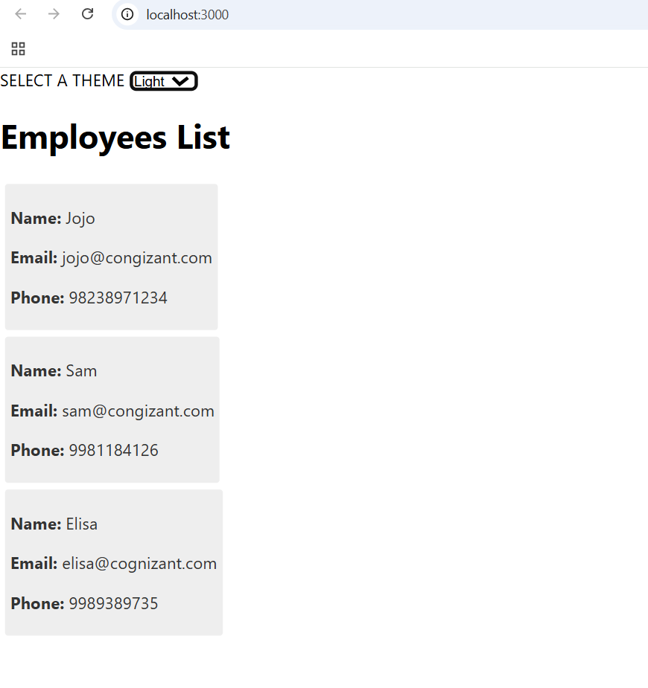

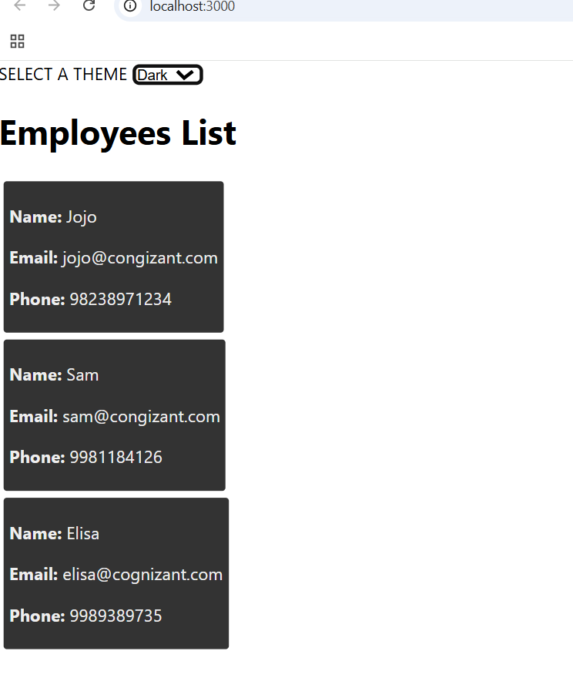

**15. ReactJS-HOL**

**App.js**

import React from "react";

import ComplaintRegister from "./ComplaintRegister";

function App() {

  return (

    <div className="App">

      <ComplaintRegister />

    </div>

  );

}

export default App;

**ComplaintRegister.js**

import React, { useState } from "react";

const ComplaintRegister = () => {

  const [employeeName, setEmployeeName] = useState("");

  const [complaint, setComplaint] = useState("");

const handleSubmit = (e) => {

    e.preventDefault();

    if (employeeName.trim() === "" || complaint.trim() === "") {

      alert("Please fill all fields.");

      return;

    }

    const id = + Math.floor(Math.random() * 100);

    alert(

      `Thanks ${employeeName} \n

      Your Complaint was Submitted!\n

      Transaction ID is: ${id}`

    );

    setEmployeeName("");

    setComplaint("");

  };

  return (

    <div style={{ margin: "50px auto", width: "50%" }}>

      <h2>Complaint Register</h2>

      <form onSubmit={handleSubmit}>

        <div style={{ marginBottom: "20px" }}>

          <label>Name:</label>

          <input

            type="text"

            value={employeeName}

            onChange={(e) => setEmployeeName(e.target.value)}

            placeholder="Enter your name"

          />

        </div>

        <div style={{ marginBottom: "20px" }}>

          <label>Complaint: </label>

          <textarea

            value={complaint}

            onChange={(e) => setComplaint(e.target.value)}

            placeholder="Describe your complaint"

          />

        </div>

        <button type="submit" style={{ padding: "10px 20px" }}>

          Submit

        </button>

      </form>

    </div>

  );

};

export default ComplaintRegister;

**Output:**

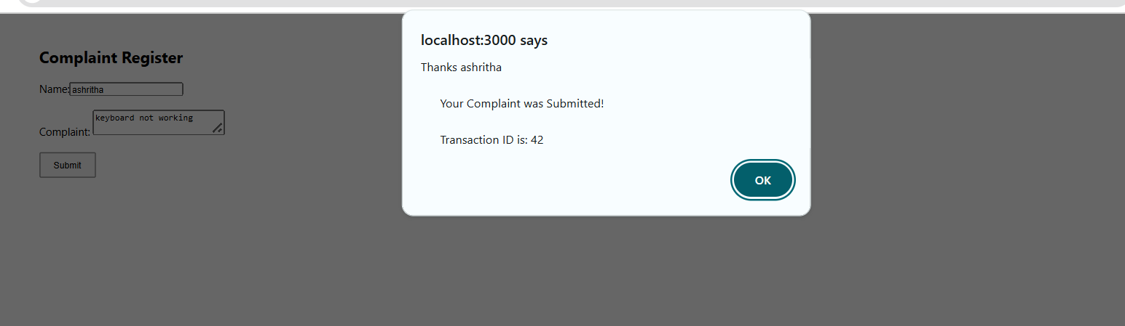

**16. ReactJS-HOL**

**App.js**

import React from "react";

import Register from "./register";

function App() {

  return (

    <div className="App">

      <Register />

    </div>

  );

}

export default App;

**register.js**

import React, { useState } from "react";

const Register = () => {

  const [formData, setFormData] = useState({

    name: "",

    email: "",

    password: ""

  });

  const handleChange = (e) => {

    const { name, value } = e.target;

    setFormData({ ...formData, [name]: value });

  };

  const handleSubmit = (e) => {

    e.preventDefault();

    if (!formData.name || formData.name.length < 5) {

      alert("Full Name must be 5 characters long!");

      return;

    }

    if (!formData.email.includes("@") || !formData.email.includes(".")) {

      alert("Email is not valid");

      return;

    }

    if (!formData.password || formData.password.length < 8) {

      alert("Password must be 8 characters long!");

      return;

    }

    alert(

      `Registration Successful!\nName: ${formData.name}\nEmail: ${formData.email}`

    );

    setFormData({ name: "", email: "", password: "" });

  };

  return (

    <div style={{ margin: "50px auto", width: "40%" }}>

      <h2 style={{ color:"red" }}>Register Here!!!</h2>

      <form onSubmit={handleSubmit}>

        <div style={{ marginBottom: "15px" }}>

          <label>Name:</label>

          <input

            type="text"

            name="name"

            value={formData.name}

            onChange={handleChange}

            style={{ width: "100%", padding: "8px", marginTop: "5px" }}

          />

        </div>

        <div style={{ marginBottom: "15px" }}>

          <label>Email:</label>

          <input

            type="text"

            name="email"

            value={formData.email}

            onChange={handleChange}

            style={{ width: "100%", padding: "8px", marginTop: "5px" }}

          />

        </div>

        <div style={{ marginBottom: "15px" }}>

          <label>Password:</label>

          <input

            type="password"

            name="password"

            value={formData.password}

            onChange={handleChange}

            style={{ width: "100%", padding: "8px", marginTop: "5px" }}

          />

        </div>

        <button type="submit" style={{ padding: "10px 20px" }}>

          Submit

        </button>

      </form>

    </div>

  );

};

export default Register;

**Output:**

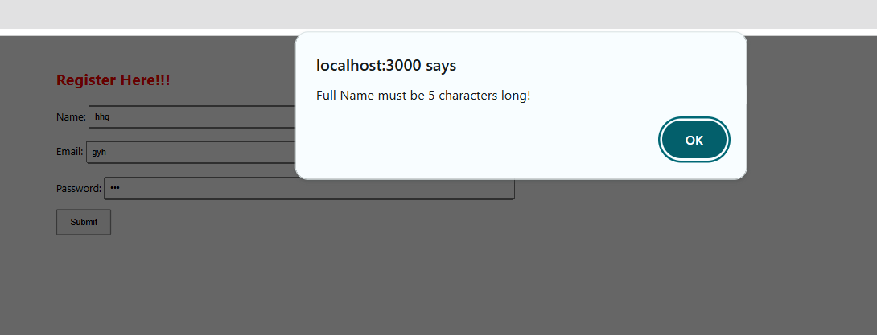

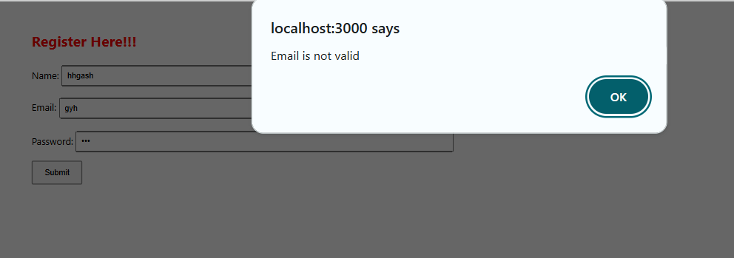

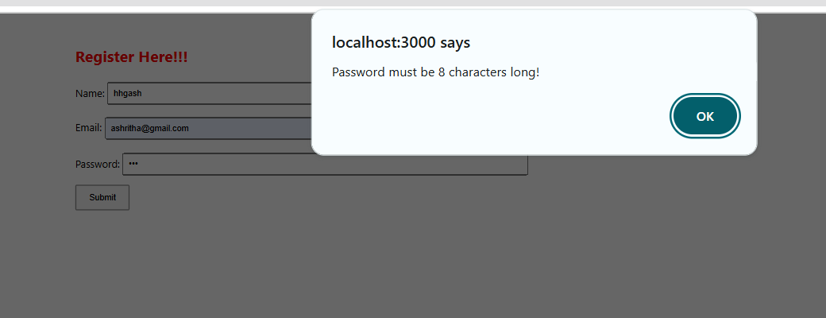

**17. ReactJS-HOL**

**App.js**

import React from "react";

import Getuser from "./Getuser";

function App() {

  return (

    <div className="App">

      <Getuser />

    </div>

  );

}

export default App;

**Getuser.js**

import React, { Component } from "react";

class Getuser extends Component {

  constructor(props) {

    super(props);

    this.state = {

      title: "",

      firstName: "",

      image: ""

    };

  }

componentDidMount() {

    fetch("https://api.randomuser.me/")

      .then((response) => response.json())

      .then((data) => {

        const user = data.results[0];

        this.setState({

          title: user.name.title,

          firstName: user.name.first,

          image: user.picture.large

        });

      })

      .catch((error) => console.error("Error fetching user:", error));

  }

render() {

    return (

      <div style={{ margin: "50px auto", textAlign: "center" }}>

        <h3>

          {this.state.title} {this.state.firstName}

        </h3>

        {this.state.image && (

          <img

            src={this.state.image}

            alt="User"

            style={{ borderRadius: "50%", marginTop: "10px" }}

          />

        )}

      </div>

    );

  }

}

export default Getuser;

**Output:**

