Team: Queue-Crew

Draft Project Report: Quiz Answer Auto-Grader

1. Introduction
The Quiz Answer Auto-Grader is a C-based program designed to automatically evaluate short-answer quizzes. The system reads model answers and student responses from CSV files, compares them using efficient data structures, and calculates similarity scores to provide automatic grading.
The main objective is to reduce manual grading time and ensure fair and consistent evaluation. This project demonstrates the practical application of data structures such as arrays, hash maps, and tries.

2. Problem Statement
Manual grading of short-answer quizzes is time-consuming and prone to human bias. The challenge is to design an automated system that can: - Compare student answers with model answers accurately. - Handle large sets of quiz data efficiently. - Provide meaningful feedback and partial scoring.

3. Objectives
- Automatically grade short-answer quizzes.
- Use appropriate data structures for efficiency.
- Provide feedback and scoring.
- Enable future extensions like semantic matching and detailed reports.

4. Data Structures Used
Data Structure | Type | Purpose | Reason for Selection
Array | Linear | Store questions and student answers sequentially. | Simple and efficient for fixed-size data.
Hash Map | Linear (with chaining) | Map each question to its corresponding model answer. | Provides O(1) average time complexity for lookups.
Trie | Non-linear | Store and search words in model answers efficiently. | Enables quick and case-insensitive word-level matching.

5. Abstract Data Type (ADT) Definitions

Trie ADT
- Data: Alphabet characters (a–z), each node with up to 26 children.
- Operations:
  - createTrieNode(): Initializes a new node.
  - insertTrie(): Inserts a word character by character.
  - searchTrie(): Checks whether a word exists.
- Algorithm:
  - Start from root, traverse each character.
  - Create child nodes if they don’t exist.
  - Mark isEndOfWord at the last character.

Hash Map ADT
- Data: Array of linked lists (buckets) storing key-value pairs.
- Operations:
  - hashFunction(): Converts key string into numeric index.
  - insertHash(): Inserts (key, value) pair using chaining.
  - searchHash(): Traverses linked list to find matching key.
- Algorithm:
  - Compute index = hash(key) % HASH_SIZE.
  - Insert new node at the head of the chain.

6. Program Flow
- Open two CSV files: quiz.csv (model answers) and student_answers.csv.
- Read model questions and store them in HashMap and arrays.
- Read student answers and store them in arrays.
- For each question:
  - Retrieve model answer using HashMap.
  - Compare words using Trie.
  - Calculate similarity score.
- Compute average score and display results.

7. Implementation Details

Hash Function:
Uses polynomial rolling hash: (hash * 31) + char and modulus by 101 (a prime number). Ensures even key distribution and reduces collisions.

Partial Credit Heuristics:
Currently based on the ratio (matched words / total model words). Future versions will: - Assign higher weights to keywords. - Apply spelling tolerance using edit distance. - Provide word-level feedback.

8. Output Screenshot
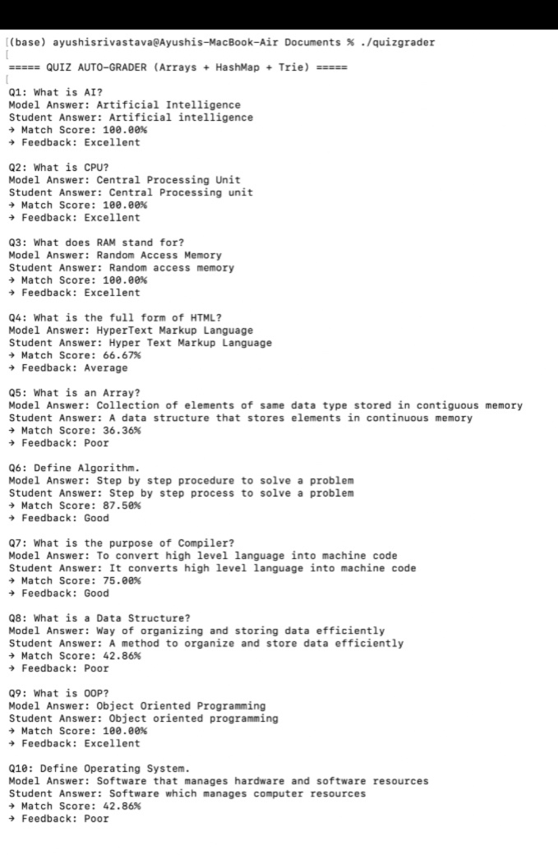
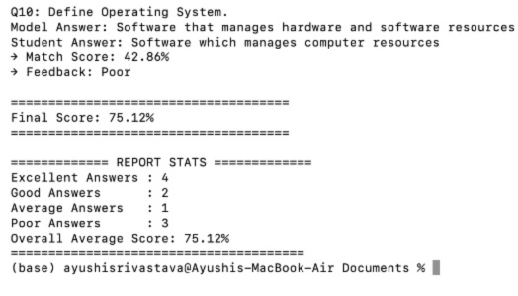

9. Input and Output

Input:
- quiz.csv: Contains model questions and answers.
- student_answers.csv: Contains student responses.

Output:
Displays: - Each question with model and student answers. - Word match percentage per question. - Final average score.

10. Results and Discussion
- The system correctly identifies matching words regardless of case.
- Provides accurate percentage-based scoring.
- Achieved efficiency using HashMap (O(1)) and Trie (O(L)).
- GUI integration and semantic understanding can enhance usability and accuracy.

11. Future Enhancements
- Add semantic matching to recognize meaning-based similarity.
- Provide graphical feedback reports.
- Extend system to handle multiple students and online submissions.

12. Conclusion
This project successfully automates short-answer grading using fundamental data structures. The integration of Array, HashMap, and Trie ensures efficient data storage, lookup, and comparison. Future enhancements can make the system more robust, intelligent, and user-friendly.

13. Division of Work
Member | Role | Contribution
1 | Trie Implementation | Built Trie functions for word storage/search.
2 | HashMap Implementation | Developed HashMap functions for question–answer mapping.
3 | Matching Algorithm | Created word matching and scoring logic.
4 | Main Program | Integrated modules, handled file I/O, and displayed results.

