NAME:M.ASHRITHA
REG NO:192372349
Course code:DSA1604

KNOWLEDGE ENGINEERING LAB PROGRAMS
PROGRAM 1: RULE-BASED EXPERT SYSTEM FOR NETWORK TROUBLESHOOTING
AIM
To develop a rule-based expert system that identifies common network problems and suggests possible troubleshooting actions based on user-provided symptoms.
SOFTWARE REQUIRED
- Python 3.x
- Any Python IDE or editor, such as IDLE, VS Code or PyCharm
PROCEDURE
- Start the Python interpreter or open a Python IDE.
- Define a set of troubleshooting rules using IF–THEN conditions.
- Ask the user to enter symptoms such as whether the device is connected to Wi-Fi, whether the router is powered on, and whether websites can be opened.
- Compare the answers with the predefined rules.
- Display the most relevant possible problem and recommended troubleshooting action.
- Run the program with sample inputs and verify the result.
PROGRAM
def network_troubleshooter():
print("RULE-BASED NETWORK TROUBLESHOOTING SYSTEM")
print("Answer each question with yes or no.")

router_on = input("Is the router powered on? ").strip().lower()
wifi_connected = input("Is your device connected to Wi-Fi? ").strip().lower()
other_devices_work = input("Do other devices have internet access? ").strip().lower()
website_works = input("Can you open a website? ").strip().lower()

print("\nTroubleshooting result:")

if router_on == "no":
print("Possible problem: Router is switched off.")
print("Action: Turn on the router and check its power adapter.")
elif wifi_connected == "no":
print("Possible problem: Device is not connected to Wi-Fi.")
print("Action: Enable Wi-Fi and connect to the correct network.")
elif other_devices_work == "no":
print("Possible problem: Router or internet service may be unavailable.")
print("Action: Restart the router and check with your internet provider.")
elif website_works == "no":
print("Possible problem: DNS or browser connectivity issue.")
print("Action: Try another website and restart the browser.")
else:
print("No problem detected by these basic rules.")
print("Action: If the issue continues, check advanced network settings.")

print("\nNote: This is a basic rule-based guide, not a definitive diagnosis.")

if __name__ == "__main__":
network_troubleshooter()
INPUT
Sample input values (enter each answer when prompted):
- Is the router powered on? yes
- Is your device connected to Wi-Fi? yes
- Do other devices have internet access? no
- Can you open a website? no
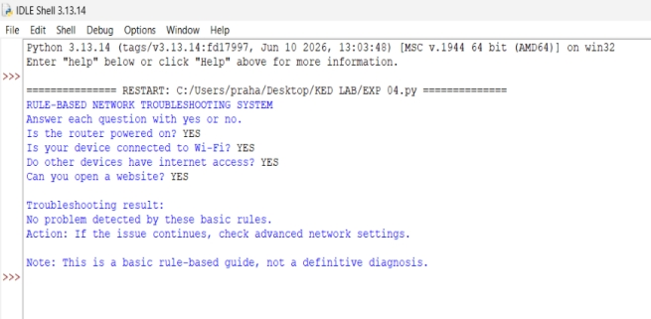
OUTPUT

PROGRAM 2: SEMANTIC NETWORK USING NETWORKX
AIM
To represent knowledge as a semantic network using the NetworkX Python library, where nodes represent concepts and directed edges represent relationships between them.
SOFTWARE REQUIRED
- Python 3.x
- NetworkX library
- Matplotlib library (optional, for drawing the network)
- Python IDE or editor such as IDLE, VS Code or PyCharm
INSTALLATION
Run the following command in a terminal or command prompt:
python -m pip install networkx matplotlib
PROCEDURE
- Install Python and the NetworkX library. Install Matplotlib if you want to display a graph.
- Import NetworkX and create a directed graph.
- Add nodes for concepts such as Student, Faculty, Subject and College.
- Add directed edges to represent relationships between the concepts.
- Print the nodes and relationships to display the semantic knowledge.
- Optionally draw the graph using Matplotlib and run the program.
PROGRAM
import networkx as nx
import matplotlib.pyplot as plt

# Create a directed semantic network
semantic_net = nx.DiGraph()

# Add concepts (nodes)
concepts = ["Student", "Faculty", "Subject", "College"]
semantic_net.add_nodes_from(concepts)

# Add relationships as directed edges
relationships = [
("Student", "Subject", "studies"),
("Faculty", "Subject", "teaches"),
("Student", "College", "belongs to"),
("Faculty", "College", "works at")
]

for source, target, relation in relationships:
semantic_net.add_edge(source, target, relation=relation)

# Display concepts
print("SEMANTIC NETWORK")
print("\nConcepts:")
for node in semantic_net.nodes:
print("-", node)

# Display relationships
print("\nRelationships:")
for source, target, data in semantic_net.edges(data=True):
print(f"{source} --{data['relation']}--> {target}")

# Draw the semantic network
positions = nx.spring_layout(semantic_net, seed=7)
nx.draw_networkx(
semantic_net,
positions,
node_color="lightgray",
node_size=2500,
font_size=10,
arrows=True
)
edge_labels = nx.get_edge_attributes(semantic_net, "relation")
nx.draw_networkx_edge_labels(semantic_net, positions, edge_labels=edge_labels)
plt.title("Semantic Network")
plt.axis("off")
plt.tight_layout()
plt.show()
INPUT
No keyboard input is required. The concepts and relationships are predefined in the program.
OUTPUT
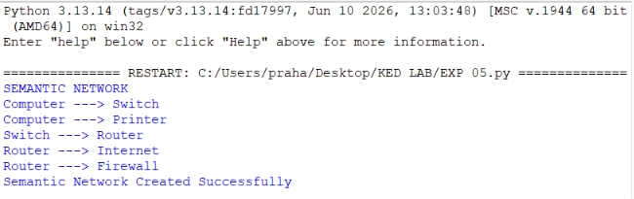
PROGRAM 3: PRODUCTION RULES AND FORWARD CHAINING
Note: This program interprets “protection rule” and “forward changing” as “production rules and forward chaining,” which are standard knowledge-engineering terms.
AIM
To implement a production-rule system that uses forward chaining to derive new facts from known facts by repeatedly applying IF–THEN rules until no more rules can be applied.
SOFTWARE REQUIRED
- Python 3.x
- Any Python IDE or editor, such as IDLE, VS Code or PyCharm
PROCEDURE
- Define the initial facts known to the system.
- Create production rules in IF–THEN form, with conditions and a conclusion.
- Begin with the initial facts in the working memory.
- Check each rule to see whether its conditions are satisfied by the known facts.
- If a rule matches, add its conclusion to the known facts if it is not already present.
- Repeat the rule-checking process until no new facts are added.
- Display the final set of facts derived by forward chaining.
PROGRAM
def forward_chaining(initial_facts, rules):
facts = set(initial_facts)
changed = True

print("Initial facts:", sorted(facts))

while changed:
changed = False

for conditions, conclusion in rules:
if conditions.issubset(facts) and conclusion not in facts:
facts.add(conclusion)
changed = True
print("Rule fired:", sorted(conditions), "->", conclusion)

return facts

# Production rules: (conditions, conclusion)
rules = [
({"has_wifi", "router_on"}, "connected_to_router"),
({"connected_to_router", "internet_service_active"}, "internet_available"),
({"internet_available", "device_configured"}, "network_working")
]

# Initial facts
initial_facts = {
"has_wifi",
"router_on",
"internet_service_active",
"device_configured"
}

final_facts = forward_chaining(initial_facts, rules)

print("\nFinal facts:")
for fact in sorted(final_facts):
print("-", fact)
INPUT
No keyboard input is required. The initial facts and production rules are predefined in the program.
Initial facts: has_wifi, router_on, internet_service_active, device_configured.
Example rule: IF has_wifi AND router_on THEN connected_to_router.
OUTPUT

