AI-BASED SUPPLY CHAIN
RISK ANALYSIS AND PREDICTION
Internship Project Report
AICTE | IBM SkillsBuild Data Analytics with AI Internship
BharatCares

Submitted by:
Ashritha Tallapally
Kakatiya Institute of Technology and Science, Warangal
+91 6302239563

Internship Duration: August 17, 2026 – September 30, 2026

Table of Contents
- Abstract
- Introduction
- Problem Statement
- Objectives
- Dataset Description
- Data Cleaning and Preparation
- Target Leakage Check
- Exploratory Data Analysis
- Summary of Observations
- Key Insights
- Hypotheses
- Machine Learning Methodology
- Model Evaluation
- Risk Probability and Risk Levels
- Business Recommendations
- Limitations
- Future Scope
- Conclusion
- Technologies Used
- Project Workflow
- References
- Appendix

Abstract
Supply-chain operations depend on coordinated ordering, transportation, supplier performance, and delivery processes. This project examines a supply-chain dataset containing 1,000 orders and 24 variables to identify patterns associated with delivery delays and supply risk.

The analysis combines exploratory data analysis with a basic machine-learning approach. Five visualizations were developed to examine order distribution, shipping-mode delays, categorylevel delays, disruption-related delays, and monthly delivery performance. The analysis was then extended to a Logistic Regression model designed to estimate the Supply Risk Flag from business-relevant information that could be available before a risk event.

Target leakage was examined before model training. Variables directly tied to disruption outcomes or delivery delays were excluded from the predictive feature set. The final model used product category, quantity ordered, shipping mode, order value, historical disruption count, and supplier reliability score.

The model was evaluated on 200 unseen test orders and produced an accuracy of 49.50%, precision of 50.85%, and recall of 58.25%. These results indicate that the selected pre-event variables provide limited predictive information for the target in this dataset. The model is therefore treated as a baseline for future investigation rather than as a production prediction system.

Introduction
Supply-chain activities generate data at many stages, including ordering, supplier coordination, transportation, dispatch, and delivery. Examining this information can help organizations understand where delays and operational risks appear in historical records.

This project applies a structured data-analytics workflow to a supply-chain dataset. The work begins with data inspection and preparation, followed by exploratory analysis to identify meaningful patterns. The project then develops a simple predictive model while taking care to avoid target leakage. The final stage translates the findings into practical areas for operational review.

Problem Statement
Supply-chain datasets contain many variables that describe both the conditions surrounding an order and the outcome of that order. Some variables, however, become known only after a disruption or delay has occurred. Using such variables in a predictive model can produce misleading results.

The project therefore addresses the following question:

How can historical supply-chain order data be analyzed to identify patterns in delivery delays and develop a leakage-aware baseline model for estimating supply risk from relevant pre-event information?

Objectives
- Inspect the structure and quality of the supply-chain dataset.
- Identify missing values and duplicate records.
- Study order distribution across product categories and shipping modes.
- Analyze delivery-delay patterns by shipping mode, product category, disruption type, and month.
- Develop five observations and five data-supported insights.
- Formulate three possible hypotheses without treating them as confirmed causes.
- Develop three practical recommendations based on the observed patterns.
- Check for target leakage before predictive modeling.
- Train a Logistic Regression baseline using selected pre-event features.
- Evaluate the model using accuracy, precision, recall, and a confusion matrix.
- Generate probability-based supply-risk levels for the test observations.

Dataset Description
The project uses the US Supply Chain Risk Analysis Dataset obtained from Kaggle. The working dataset contains 1,000 order records and 24 columns covering order identifiers, buyers, suppliers, product categories, quantities, dates, transportation, order values, delays, disruptions, supplier reliability, and supply risk.
Attribute | Value
Number of records | 1,000 orders
Number of variables | 24
Time period | 2023
Product categories | Electronics, Textiles, Machinery, Food, Pharma
Shipping modes | Air, Road, Rail, Sea
Target | Supply_Risk_Flag
The target distribution contains 486 records with Supply_Risk_Flag = 0 and 514 records with Supply_Risk_Flag = 1.

Data Cleaning and Preparation
The dataset was inspected for dimensions, column names, data types, missing values, and duplicate rows. The analysis found 486 missing values in Disruption_Type and 486 in Disruption_Severity. No duplicate rows were identified.
Order_Date, Dispatch_Date, and Delivery_Date were converted to datetime format so that timebased analysis could be performed.
For exploratory analysis, missing disruption types were represented as “No Disruption” where this interpretation was appropriate. The predictive dataset was prepared separately so that variables unsuitable for prediction were excluded.
Identifier fields such as Order_ID, Buyer_ID, Supplier_ID, and Organization_ID were not used as model predictors. Post-event and leakage-prone variables were also excluded.

Target Leakage Check
A specific leakage check was performed before model training. Supply_Risk_Flag was compared with disruption information and delivery delay. The comparison showed a direct relationship between the target and disruption-related fields: records with no recorded disruption had a risk flag of 0, while records with recorded disruption types or severities had a risk flag of 1. In addition, the no-risk group had an average Delay_Days value of 0, whereas the risk group had an average delay of approximately 3.78 days.
Because Disruption_Type, Disruption_Severity, and Delay_Days effectively reveal information about the outcome in this dataset, they were not used as prediction features. This decision keeps the model focused on information that can serve as a pre-event baseline rather than allowing the model to learn the target directly.

Exploratory Data Analysis

Orders by Product Category
Observation: Electronics recorded 210 orders. Textiles recorded 206, Machinery 204, while Food and Pharma each recorded 190 orders.
Insight: The order counts are fairly balanced across the five categories, so the dataset does not show a strong concentration of order volume in one category.
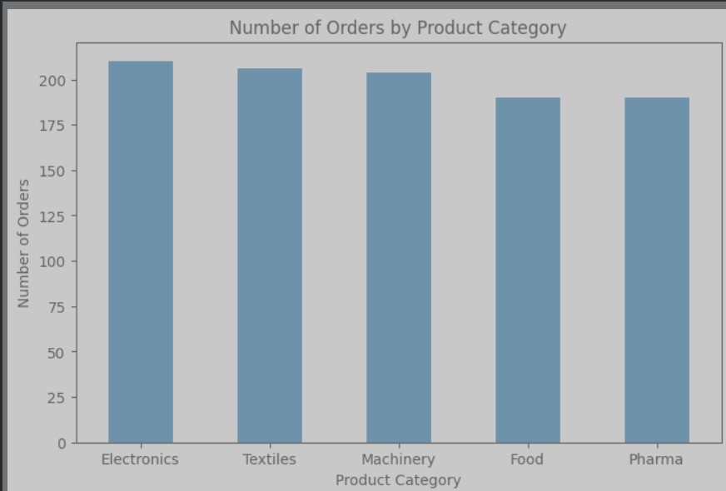

Average Delay by Shipping Mode
Observation: Average delay differed across transportation modes, with Sea and Rail showing higher average delays than Air and Road.
Insight: Shipping mode is associated with differences in delivery performance. Transportation schedules, handling, and coordination may therefore be useful areas for additional investigation.
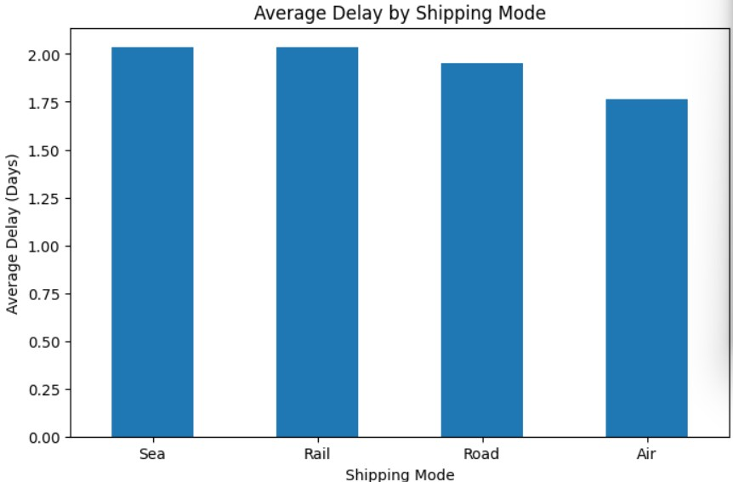

Average Delay by Product Category
Observation: Textiles had the highest average delay at approximately 2.11 days, while Food had the lowest at approximately 1.70 days.
Insight: Delivery performance varies across product categories. Category-specific operational or handling requirements could be investigated further, although the current data does not establish a specific cause.
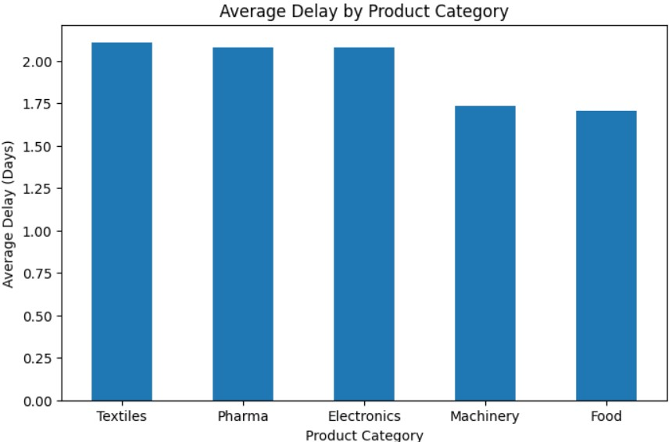

Average Delay by Disruption Type
Observation: Orders with recorded disruptions had substantially higher average delays than orders without recorded disruptions. Weather, Shortage, Customs, and Strike were the recorded disruption categories.
Insight: Recorded disruptions are strongly associated with delivery delays, making disruption monitoring a potentially useful part of supply-chain risk analysis.
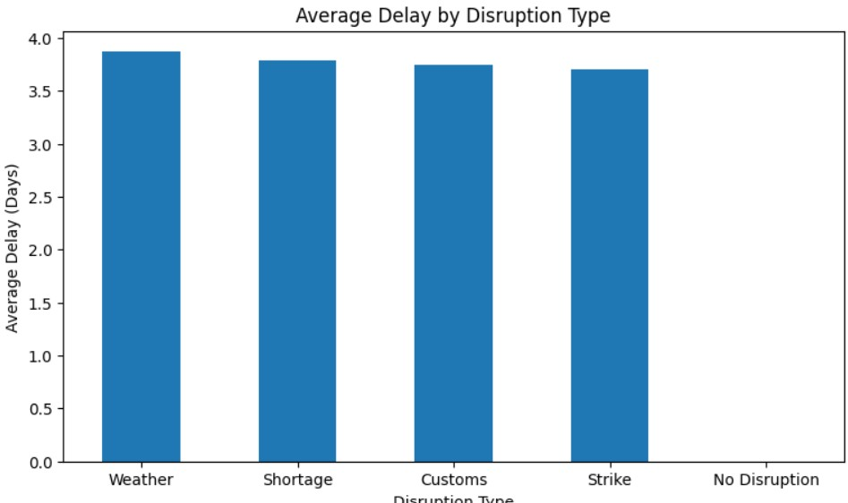

Average Delivery Delay by Month
Observation: September had the highest average delay at approximately 2.46 days, while February had the lowest at approximately 1.56 days.
Insight: Delivery performance varies across the year. High-delay periods should be investigated using additional operational information not available in the current dataset.
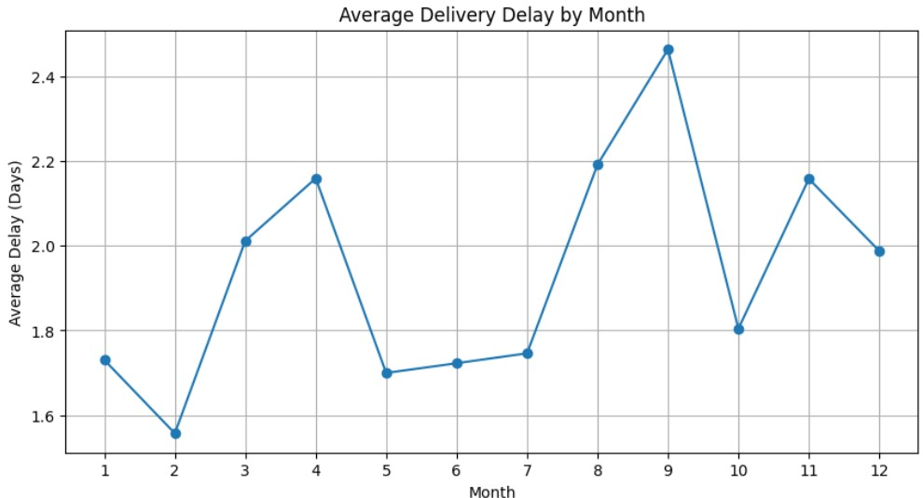

Summary of Observations
- Electronics had the highest order count at 210, while Food and Pharma each had 190.
- Sea and Rail showed higher average delivery delays than Air and Road.
- Textiles had the highest average category delay at about 2.11 days, while Food had the lowest at about 1.70 days.
- Orders with recorded disruptions had substantially higher delays than orders without recorded disruptions.
- September had the highest monthly average delay at about 2.46 days, while February had the lowest at about 1.56 days.

Key Insights
- The distribution of order volume across product categories is relatively balanced, so no single category dominates the dataset by order count.
- Transportation mode is associated with differences in delivery performance, with Sea and Rail showing higher average delays.
- Product categories display different average delivery performance, suggesting that categorylevel operational factors merit further review.
- Recorded disruptions are associated with substantially higher delivery delays, highlighting the value of monitoring disruption events.
- Monthly delay levels vary across the year, indicating that delivery performance should be tracked over time rather than viewed as a constant measure.

Hypotheses
- Hypothesis 1 – Transportation and handling: The higher delays observed for Sea and Rail might be related to longer transportation or handling processes associated with these shipping modes.
- Hypothesis 2 – Product-specific handling: Differences in category-level delays could possibly be associated with differences in supply-chain handling, transportation, or processing requirements.
- Hypothesis 3 – Monthly operational conditions: The higher average delay observed in September might be associated with operational or transportation conditions that are not captured by the current dataset.
These statements are hypotheses rather than established causal explanations. Additional data would be required to test them.

Machine Learning Methodology

Target Variable
Supply_Risk_Flag was selected as the binary target. A value of 0 represents the no-risk class and a value of 1 represents the risk class.

Selected Features
- Product_Category
- Quantity_Ordered
- Shipping_Mode
- Order_Value_USD
- Historical_Disruption_Count
- Supplier_Reliability_Score

Categorical Encoding
Product_Category and Shipping_Mode were converted into numerical columns using one-hot encoding. After encoding, the six selected business variables produced 11 model input columns.

Train-Test Split
The data was divided into 800 training records and 200 testing records using an 80:20 stratified split. Stratification was used to preserve the target-class distribution between the two subsets.

Scaling and Model
StandardScaler was applied to the model inputs. Logistic Regression was then trained as a simple baseline classification model. Predictions and class probabilities were generated for the unseen test set.

Model Evaluation
Metric | Result
Accuracy | 49.50%
Precision | 50.85%
Recall | 58.25%
Training records | 800
Testing records | 200
The model's accuracy, precision, and recall indicate limited predictive performance using the selected pre-event variables. The results should therefore be interpreted as a baseline rather than evidence that the model is suitable for production use.

Confusion Matrix
 | Predicted No Risk | Predicted Risk
Actual No Risk | 39 | 58
Actual Risk | 43 | 60
The matrix contains 39 true negatives, 58 false positives, 43 false negatives, and 60 true positives. The number of false predictions demonstrates the uncertainty of the current baseline model.

Risk Probability and Risk Levels
The model generated a probability of the positive risk class for each test record. For project reporting, these probabilities were converted into three risk categories using predefined thresholds.
Probability |  | Risk Level
Below 0.45 |  | Low Risk
0.45 to 0.55 |  | Medium Risk
Above 0.55 |  | High Risk
Risk Level | Or | ders | Percentage
Low Risk | 9 |  | 4.5%
Medium Risk | 1 | 51 | 75.5%
High Risk | 4 | 0 | 20.0%
Total | 2 | 00 | 100%
The thresholds are project-defined and were not validated against real operational costs or outcomes.

Business Recommendations

Recommendation 1: Review Sea and Rail transportation operations
Because Sea and Rail showed higher average delays, operational teams could examine transportation schedules, handling stages, handover times, and coordination with carriers.

Recommendation 2: Monitor categories with higher average delays
Categories such as Textiles, Pharma, and Electronics could be monitored separately to identify whether processing, handling, supplier, or transportation characteristics are associated with their delay patterns.

Recommendation 3: Investigate high-delay periods
Unusually high-delay periods such as September could be reviewed alongside route, supplier, inventory, transportation-capacity, and seasonal information to identify factors not represented in the current dataset.

Limitations
- The dataset contains only 1,000 orders, limiting the amount of information available for modeling.
- The dataset covers one calendar year, so longer-term trends and recurring multi-year patterns cannot be assessed.
- Several variables closely tied to the target had to be excluded because they introduced leakage risk.
- The selected pre-event variables produced limited predictive performance.
- The Low, Medium, and High Risk probability thresholds were defined for this project and were not externally validated.
- The dataset does not include every operational factor that may influence supply-chain risk.
- The analysis identifies associations and patterns; it does not establish causal relationships.

Future Scope
- Add longer-term supplier performance histories.
- Include transportation route, distance, carrier, and handling-time information.
- Use multi-year data to study recurring seasonal patterns.
- Compare additional classification algorithms with the Logistic Regression baseline.
- Calibrate risk thresholds using real business costs and operational outcomes.
- Expand data-quality validation for supplier, buyer, transportation, and disruption fields.

Conclusion
This project examined 1,000 supply-chain orders to understand delivery-delay patterns and explore supply-risk prediction. Exploratory analysis identified differences across transportation modes, product categories, disruption types, and months.

A leakage-aware Logistic Regression model was developed using six pre-event features: product category, quantity ordered, shipping mode, order value, historical disruption count, and supplier reliability score. The model was evaluated on 200 unseen records and achieved 49.50% accuracy, 50.85% precision, and 58.25% recall.

The results show that these selected pre-event variables alone provide limited predictive information for the dataset's Supply Risk Flag. The model is therefore best treated as a baseline for further analysis. The project also demonstrates why target leakage must be considered when building predictive systems: variables that directly reveal an outcome can make a model appear more capable than it really is.

Further work using richer supplier histories, transportation characteristics, inventory information, and multi-year operational data could provide a stronger basis for future predictive analysis.

Technologies Used
- Python
- Google Colab
- Pandas
- NumPy
- Matplotlib
- Scikit-learn
- Logistic Regression
- StandardScaler
- One-Hot Encoding

Project Workflow
- Dataset Collection
- Data Loading
- Data Inspection
- Missing-Value and Duplicate Check
- Data Cleaning and Date Conversion
- Exploratory Data Analysis
- Observations and Insights
- Hypotheses
- Target Leakage Check
- Feature Selection
- Categorical Encoding
- Train-Test Split
- Feature Scaling
- Logistic Regression
- Model Evaluation
- Risk Probability Generation
- Risk-Level Classification
- Business Recommendations

References
- Kaggle. US Supply Chain Risk Analysis Dataset. Dataset used for the project.
- BharatCares. AICTE | IBM SkillsBuild Data Analytics with AI Internship – Masterclass 2:
AI Discovers the Story. Student Hands-On Guide.
- BharatCares. AICTE | IBM SkillsBuild Data Analytics with AI Internship – Masterclass 3: AI Predicts What Happens Next. Student Hands-On Guide.
- IBM SkillsBuild. Data Analytics with AI: Foundation to Implementation. Internship learning materials.

Appendix
The project notebook contains the complete implementation and outputs, including dataset inspection, cleaning, exploratory charts, leakage analysis, model training, predictions, evaluation metrics, risk probabilities, and the final risk-level results table.
- Dataset preview and structure
- Missing-value and duplicate analysis
- Five exploratory visualizations
- Target leakage analysis
- Logistic Regression training
- Accuracy, precision, and recall
- Confusion matrix
- Risk probability output
- Risk-level distribution
- Final prediction table

