


Project Report

Two Pass SIC/XE Assembler

Project Group # 7

Group Contact: Sulakshana Padwal

Gregory King
Ravneet Gill
Sulakshana Padwal
Ziauddin Babar

Table of Contents
1. Introduction 4
2. SIC/XE Assembler 4
3. Instruction Set 5
4. Software Architecture 6
4.1 Main 6
4.2 symTable 6
4.3 opTable 7
4.4 sourceCode 7
4.5 sourceLine 7
4.6 intermediateFile 7
4.7 assemblyListing 7
4.8 objectProgram 7
5. Design Analysis 7
5.1 Pass 1 operation 8
5.2 Pass 2 operation 9
6. SIC/XE Assembler Features 9
6.1 Literals 10
6.2 Symbol-Defining Statements 10
6.3 Expressions 10
6.4 Program Blocks 10
6.5 Control-Sections and Program Linking 11
7. Algorithms 11
Algorithm for Pass1 11
Algorithm for Pass2 12
8. Development Environment 13
9. Implementation 14
7.1 Datastructs.h 14
7.2 Datatypes.h 15
7.3 Datafiles.h 15
7.4 Util.h 16
7.5 Util.cpp 16
7.6 OpTable.h 17
7.7 OpTable.cpp 18
7.8 SymTable.h 19
7.9 SymTable.cpp 20
7.10 Main.cpp 22
7.11 sourceCode.h 23
7.12 sourceCode.cpp 24
7.13 sourceLine.h 26
7.14 sourceLine.cpp 26
7.15 intermediateFile.h 29
7.16 intermediateFile.cpp 30
7.17 objectProgram.h 32
7.18 objectProgram.cpp 32
7.19 assemblyListing.h 35
7.20 assemblyListing.cpp 35
7.21 diagRoutines.h 36
7.22 diagRoutines.cpp 36
10. Inputs to SIC/XE 37
Source Program 38
11. Outputs 39
Symbol Table from Pass1 39
Object Program 39
12. Conclusion 39
13. Project Team Experience 40
14. References 41

Introduction

An assembler is system software that takes input source code, in the form of an assembly program, and outputs machine language, or object code. The object code can then be loaded into memory by means of other system software, i.e. a linking loader, and executed by the CPU. The goal of our project is to design and implement a two pass SIC/XE assembler with the ability to handle several common machine-independent assembler features. These features include the following: literals, symbol-defining statements, expressions, program blocks, control sections, and program linking.

SIC/XE Assembler

The SIC/XE assembler is a two pass assembler that can handle multiple instruction formats that take advantage of a more advanced architecture. The two major internal data structures this assembler uses are the Operation Code Table(OPTAB) and the Symbol Table(SYMTAB). The OPTAB is a static data structure used to look up mnemonic operation codes and translate them to machine code. The SYMTAB is a dynamic data structure used to store values assigned to labels. A variable called the Location Counter(LOCCTR) is also used to help in the assignment of addresses. The LOCCTR stores the current address of the instruction that the assembler is processing as it makes a pass over the assembly code. We plan to use these data structures/variables as part of our project.

The major tasks that pass one is to perform are the following: assign addresses to all statements in the program, save the addresses assigned to all labels in the SYMTAB, and perform some processing of assembler directives. One significant purpose of the first pass is to resolve forward references in the code so that the second pass can be aware of the address locations of all labels.

The second pass is in charge of assembling instructions and generating an object program. It does this by first assembling instructions by translating operation codes using the OPTAB and looking up addresses in the SYMTAB. It also generates data values defined by assembler directives such as BYTE and WORD. Other assembler directives which were not taken care of in pass on are also dealt with. Finally, pass two outputs an assembly listing and object program.

Algorithms for pass one and two are shown on page 53 of our textbook entitled System Software by Leland L. Beck. Our group will use these algorithms as guidelines for creating a SIC/XE two pass assembler. However, modifications will need to be made to these algorithms to deal with the multiple instruction formats used in SIC/XE in addition to the features we plan to incorporate.

Instruction Set

The following are the 40 instructions that we plan to implement in our assembler.

Mnemonic | Format | Opcode | Effect
ADD m | 3 / 4 | 18 | A←(A) + (m..m+2)
ADDR r1,r2 | 2 | 90 | r2←(r2) + (r1)
AND m | 3 / 4 | 40 | A←(A) & (m..m+2)
CLEAR r1 | 2 | B4 | r1←0
COMP m | 3 / 4 | 28 | (A) : (m..m+2)
COMPR r1,r2 | 2 | A0 | (r1) : (r2)
DIV m | 3 / 4 | 24 | A←(A) / (m..m+2)
DIVR r1,r2 | 2 | 9C | A←(r1) / (r2)
J m | 3 / 4 | 3C | PC ← m
JEQ m | 3 / 4 | 30 | PC ← m if CC set to =
JGT m | 3 / 4 | 34 | PC ← m if CC set to >
JLT m | 3 / 4 | 38 | PC ← m if CC set to <
JSUB m | 3 / 4 | 48 | L←(PC); PC ← m
LDA m | 3 / 4 | 00 | A←(m..m+2)
LDB m | 3 / 4 | 68 | B←(m..m+2)
LDCH m | 3 / 4 | 50 | A[rightmost byte]←(m)
LDL m | 3 / 4 | 08 | L←(m..m+2)
LDS m | 3 / 4 | 6C | S←(m..m+2)
LDT m | 3 / 4 | 74 | T←(m..m+2)
LDX m | 3 / 4 | 04 | X←(m..m+2)
MUL m | 3 / 4 | 20 | A←(A) * (m..m+2)
MULR r1,r2 | 2 | 98 | r2←(r2) * (r1)
OR m | 3 / 4 | 44 | A←(A) | (m..m+2)
RD m | 3 / 4 | D8 | A[rightmost byte]←data from device specified by (m)
RMO r1,r2 | 2 | AC | r2←(r1)
RSUB | 3 / 4 | 4C | PC ← (L)
SHIFTL r1,n | 2 | A4 | r1←(r1); left circular shift n bits.
SHIFTR r1,n | 2 | A8 | r1←(r1); right shift n bits, with vacated bit positions set equal to leftmost bit or (r1)
STA m | 3 / 4 | 0C | m..m+2←(A)
STB m | 3 / 4 | 78 | m..m+2←(B)
STCH m | 3 / 4 | 54 | m←(A)[rightmost byte]
STL m | 3 / 4 | 14 | m..m+2←(L)
STS m | 3 / 4 | 7C | m..m+2←(S)
STSW m | 3 / 4 | E8 | m..m+2←(SW)
STX m | 3 / 4 | 10 | m..m+2←(X)
SUB m | 3 / 4 | 1C | A←(A) - (m..m+2)
SUBR r1,r2 | 2 | 94 | r2←(r2) - (r1)
TD m | 3 / 4 | E0 | Test device specified by (m)
TIX m | 3 / 4 | 2C | X←(X)+1; (X): (m..m+2)
TIXR r1 | 2 | B8 | X←(X)+1; (X): (r1)
WD m | 3 / 4 | DC | Device specified by (m)←(A)[rightmost byte]

Software Architecture

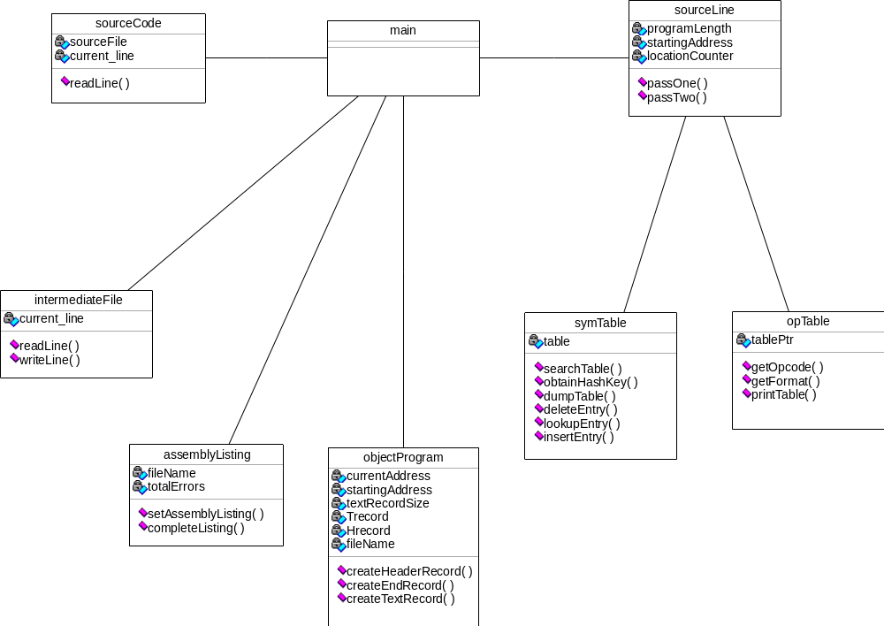

4.1 Main

This is the ‘driver’ of the entire Assembler. It controls all operations that should be carried out. Nearly all inter-object correspondence goes through it. This enables the design of the software to be very modular.

4.2 symTable

symTable is an object which manages the SYMTABLE. This let’s us search the SYMTABLE for existing entries, or insert new entries into the SYMTABLE. Also provided are diagnostic routines to dump the contents of the SYMTABLE.

4.3 opTable

opTable is an object which manages the OPTABLE. The OPTABLE is created in the constructor of this object. This objects let’s us access the OPTABLE to lookup the operations that we are supporting. Also provided is a diagnostic routine which let’s us dump the contents of the OPTABLE.

4.4 sourceCode

This object manages the source code program. It is rather simple with just one method, readLine(). This routine accesses the source code program and reads the next line when called.

4.5 sourceLine

This is one of the main objects in the project. It contains the algorithm for both pass 1 and pass 2 operations. It interacts with the symTable and opTable objects.

4.6 intermediateFile

This object manages the intermediate file which is created during Pass 1 and Pass 2 operations. The intermediate file is created when this object is instantiated and deleted once this object is destroyed.

4.7 assemblyListing

This object manages the assembly listing file which is created as part of the output of the assembler. When the object is instantiated, it creates the assembly listing file, but only closes it and does not delete it when it is destroyed.

4.8 objectProgram

This object manages the object program file is which created as part of the output of the assembler. When the object is instantiated, it creates the object program file, but only closes it and does not delete it when it is destroyed.

Design Analysis

The main routine is the driver of the Assembler. First it would call the sourceCode object asking for the next time. The sourceCode object returns the line in the form of a data structure. This is passed on to the sourceLine object which would perform a pass 1 operation on it. For the the sourceLine object would need to access the symTable object which provides access to the SYMTAB. The sourceLine object returns back a data structure to main, which in turn passes it to the intermediateFile data object. This object provides access to the intermediate file.

For pass two, the main routine now calls the intermediateFile data structure and asks for the next time which is again passed to sourceLine. This time round, sourceLine access the OPTABLE through the opTable object.

The pass two operation causes the opcode to be generated. This is written to the object program using the objectProgram object. Similarly, the assembly listing is written through the assemblerListing object.

5.1 Pass 1 operation

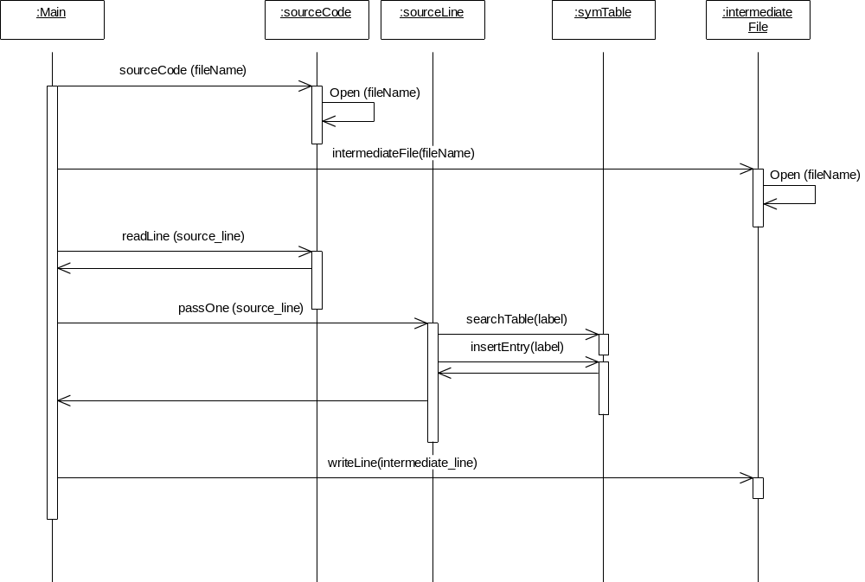

5.2 Pass 2 operation

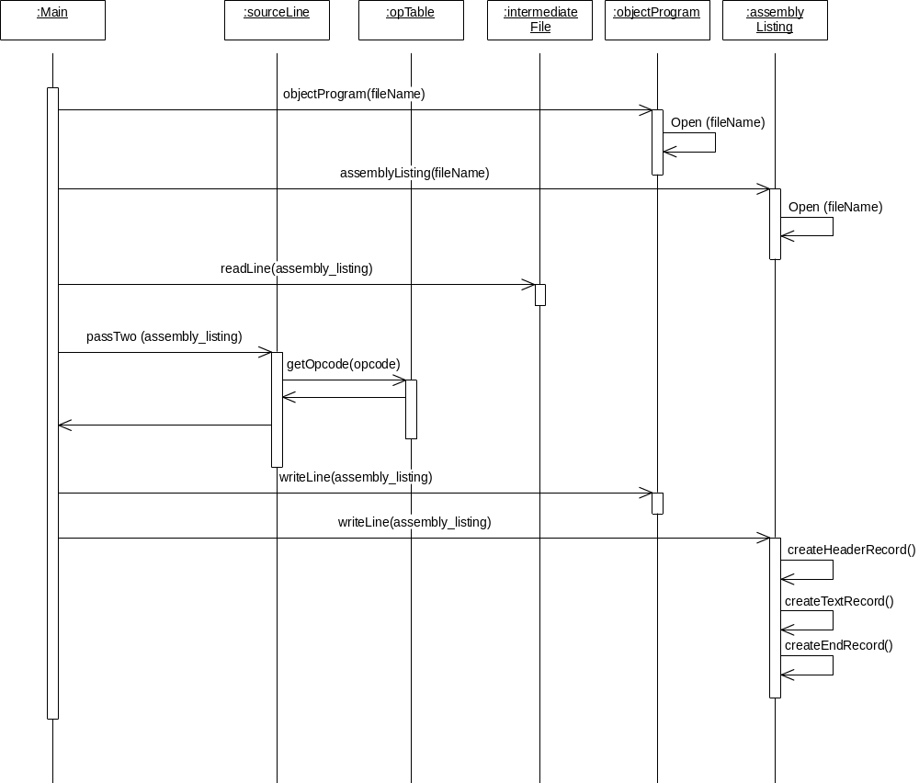

SIC/XE Assembler Features

These are the features that we’d like to implement in our two-pass SIC / XE assembler.

6.1 Literals
- A literal is a constant operand whose value is written as a part of the instruction that uses it. This avoids having to define the constant somewhere else in the program and make up a label for it.
- A literal is identified with a prefix =, which is followed by a specification of the literal value.
- All literal operands used in a program are gathered into one or more literal pools, normally placed at the end of the program.
- LTORG assembler directive creates a literal pool that contains all of the literal operands used since previous LTORG (or the beginning of the program).
- The basic data structure used to handle literals is literal table LITTAB. For each literal used, this table contains the literal name, the operand value and length, and the address assigned to the operand when it is placed in a literal pool

6.2 Symbol-Defining Statements
- EQU assembler directive is used to define symbols and specify their values.
- EQU is used to establish symbolic names that can be used to improve readability in place of numeric value. Also it is used in defining mnemonic names for registers.
- ORG assembler directive is used to indirectly assign values to symbols.
- When the above statement is encountered during assembly of a program, the assembler resets its location counter (LOCCTR) to the specified value.
- ORG statement affects the values of all labels defined until next ORG.

6.3 Expressions
- Assemblers allow arithmetic expressions using the operators +, -, *, /. Division is usually defined to produce an integer result.
- Individual terms in the expressions may be constants, user-defined symbols, or special terms.
- Expressions are classified as either absolute expressions or relative expressions depending upon the type of value they produce.
- Absolute expressions are expressions that contains only absolute terms or may contain relative terms provided the relative terms occurring pairs and the terms in each such pair have opposite signs.
- Relative expressions are an expression in which all of the relative terms except one can be paired as described above; the remaining unpaired relative term must have a positive sign.

6.4 Program Blocks
- Program blocks refer to segments of code that are rearranged within a single object program unit.
- USE assembler directive indicates which portions of the source program belong to the various blocks
- At the beginning of the program, statements are assumed to be part of the unnamed (default) block. If no USE statements are included, the entire program belongs to a single block
- At the end of Pass1 the assembler constructs a table that contains starting address and lengths for all blocks

6.5 Control-Sections and Program Linking
- Control sections refer to segments that are translated into independent object program units. It maintains its identity after assembly; each control section can be loaded and relocated independently of the others.
- Two assembler directives EXTDEF and EXTREF are used to identify the symbols defined in one control section and referred to in another control section
- EXTDEF – assembler directive in a control section names symbols, called external symbols, that are defined in this control section and maybe used in other control sections
- EXTREF – assembler directive names symbols that are used in this control section but defined in some other control section.
- Define and Refer records in the object program for each control section include the symbols named in EXTDEF and EXTREF statements

Algorithms
Following basic Pass1 and Pass2 algorithms are used in our implementation. These algorithms have been enhanced in our implementation for SIC/XE

Algorithm for Pass1

Begin
Read first input line
If OPCODE = ‘START’ then
Begin
Save #[OPERAND] as starting address
Initialize LOCCTR to starting address
Write line to intermediate file
Read next input line
End
Else
Initialize LOCCTR to 0
While OPCODE != ‘END’ do
Begin
If this is not a comment line then
Begin
If there is a symbol in the label field then
Begin
Search SYMTAB for LABEL
If found then
Set error flag (duplicate symbol)
Else
Insert (LABEL,LOCCTR) into SYMTAB
End
Search OPTAB for OPCODE
If found then
Add 3 {instruction length} to LOCCTR
Else if OPCODE = ‘WORD’
Add 3 to LOCCTR
Else if OPCODE = ‘RESW’
Add 3 * #[OPERAND] to LOCCTR
Else if OPCODE = ‘RESB’
Add #[OPERAND] to LOCCTR
Else if OPCODE = ‘BYTE’
Begin
Find length of constant in bytes
Add length to LOCCTR
End
Else
Set error flag (invalid operation code)
End
Write line to intermediate file
Read next input line
End
Write last line to intermediate file
Save (LOCCTR – starting address) as program length
End {Pass1}

Algorithm for Pass2

begin
read first input line (from intermediate file)
if OPCODE = 'START' then
begin
write listing line
read next input line
end {if START}
write Header record to object program
initialize first Text record
while OPCODE != 'END' do
begin
if this is not a comment line then
begin
search OPTAB for OPCODE
if found then
begin
if there is a symbol in OPERAND field then
begin
search SYMTAB for OPERAND
if found then
store symbol value as opearnd address
else
begin
store 0 as opearnd address
set error flag (undefined symbol)
end
end {if symbol}
else
store 0 as operand address
assemble the object code instruction
end {if opcode found}
else if OPCODE = 'BYTE' or 'WORD' then
convert constant to object code
if object code will not fit into the current Text record then
begin
write Text record to object program
initialize new Text record
end
add object code to Text record
end {if not comment}
write listing line
read next input line
end {while not END}
write last Text record to object program
write End record to object program
write last listing line
end {Pass 2}

Development Environment

This SIC/XE assembler has been implemented by using Microsoft Visual C++ 6.0

Implementation

7.1 Datastructs.h

/*
* datastructs.h
*/

#ifndef _DATA_STRUCTS_H_
#define _DATA_STRUCTS_H_

#include <afx.h>
#include <string>

#include "datatypes.h"

using namespace std;

/* Symbol Table data structure */
typedef struct _symTable {
char symbol[10];
uint32_t value;
uint16_t flags;
} symTable_t;

/* Operand Table data structure */
typedef struct _opTableEntry {
char mnemonic[10];
uint8_t format;
uint8_t opcode;
} opTableEntry_t;

/* Source line data structure */
typedef struct _sourceLine {
CString label;
string operation;
string prefix;
string operand; /* have multiple operands??? */
string comment;
string comment_line;
} sourceLine_t;

/* Assembly listing data structure */
typedef struct _assemblyListing {
sourceLine_t source_line;
uint16_t object_code;
uint32_t location;
status_t status;

public:
string getOperand(){
return (source_line.operand);
}
string getLabel(){
return (source_line.label);
}
uint32_t getLocation() {
return (location);
}
uint32_t getObjectcode() {
return (object_code);
}
int16_t getObjectSize(){ // Depending upon format 3 or 4 it returns 3 or 4 bytes
return (source_line.prefix == "+") ? 4 : 3;
}
} assemblyListing_t;

#endif /* _DATA_STRUCTS_H_ */

7.2 Datatypes.h

/*
* datatypes.h
*/

#ifndef _DATA_TYPES_H_
#define _DATA_TYPES_H_

typedef char int8_t;
typedef char uint8_t;
typedef short int16_t;
typedef unsigned short uint16_t;
typedef int int32_t;
typedef unsigned int uint32_t;
typedef long int64_t;
typedef unsigned long uint64_t;

typedef enum _status {
STATUS_SUCCESS = 0,
STATUS_FAILURE,
STATUS_NOT_IMPLEMENTED,
STATUS_DUPLICATE_ENTRY,
STATUS_ENTRY_NOT_FOUND,
STATUS_UNDEFINED_SYMBOL,
STATUS_INVALID_OPCODE,
STATUS_LABEL_NOT_USED,
STATUS_FILE_NOT_FOUND,
STATUS_FILE_READ_FAILURE,
STATUS_FILE_WRITE_FAILURE,
STATUS_INVALID_INSTRUCTION,
} status_t;

#endif /* _DATA_TYPES_H_ */

7.3 Datafiles.h

/*
* datafiles.h
*/

#define SOURCE_LINE_START (0)

#define LABEL_FIELD_START (SOURCE_LINE_START)
#define LABEL_FIELD_SIZE (10)
#define LABEL_FIELD_END (LABEL_FIELD_START + LABEL_FIELD_SIZE - 1)

#define OPERATION_FIELD_START (LABEL_FIELD_END + 1)
#define OPERATION_FIELD_SIZE (10)
#define OPERATION_FIELD_END (OPERATION_FIELD_START + OPERATION_FIELD_SIZE - 1)

#define PREFIX_FIELD_START (OPERATION_FIELD_END + 1)
#define PREFIX_FIELD_SIZE (1)
#define PREFIX_FIELD_END (PREFIX_FIELD_START + PREFIX_FIELD_SIZE - 1)

#define OPERAND_FIELD_START (PREFIX_FIELD_END + 1)
#define OPERAND_FIELD_SIZE (19)
#define OPERAND_FIELD_END (OPERAND_FIELD_START + OPERAND_FIELD_SIZE - 1)

#define COMMENT_FIELD_START (OPERAND_FIELD_END + 1)
#define COMMENT_FIELD_SIZE (40)
#define COMMENT_FIELD_END (COMMENT_FIELD_START + COMMENT_FIELD_SIZE - 1)

#define SOURCE_LINE_SIZE (COMMENT_FIELD_END - LABEL_FIELD_START + 1)
#define SOURCE_LINE_END (SOURCE_LINE_START + SOURCE_LINE_SIZE - 1)

#define INTERMEDIATE_LINE_OFFSET (10)

7.4 Util.h

// Util.h: interface for the CUtil class.
//
//////////////////////////////////////////////////////////////////////

#if !defined(AFX_UTIL_H__DEAB2B9E_598F_423D_AB2C_43581D469F73__INCLUDED_)
#define AFX_UTIL_H__DEAB2B9E_598F_423D_AB2C_43581D469F73__INCLUDED_

#if _MSC_VER > 1000
#pragma once
#endif // _MSC_VER > 1000

#include <string>

#include "datatypes.h"

using namespace std;

class CUtil
{
public:
static uint32_t StrtoHex (string str);
static uint8_t ctoi (char c);
CUtil();
virtual ~CUtil();

};

#endif // !defined(AFX_UTIL_H__DEAB2B9E_598F_423D_AB2C_43581D469F73__INCLUDED_)

7.5 Util.cpp

// Util.cpp: implementation of the CUtil class.
//
//////////////////////////////////////////////////////////////////////

#include <math.h>

#include "Util.h"

//////////////////////////////////////////////////////////////////////
// Construction/Destruction
//////////////////////////////////////////////////////////////////////

CUtil::CUtil()
{

}

CUtil::~CUtil()
{

}

int8_t CUtil::ctoi(char c)
{
int8_t i;
if(c >= 'A' && c <= 'F')
i = c-65 + 10;
else
if(c >= 'a' && c <= 'f')
i = c-97 + 10;
else
if ( c>=48 && c<=57)
i=c-48;
else
i=-1;
return i;
}

uint32_t CUtil::StrtoHex(string str)
{
uint32_t ret=0 ;
for(int j=0,i=str.length()-1; i>=0; i--,j++)
{
ret = ret + ctoi(str.at(i)) * pow(16, j);
}
return ret;
}

7.6 OpTable.h

#include <string>
#include <iostream>
#include <cstdlib>
#include "datatypes.h"
using namespace std;

typedef string ListElementType;
typedef struct node{
ListElementType operation;
ListElementType format;
ListElementType opcode;
}Node;

class opTable{
public:
opTable();
status_t getOpcode(ListElementType& operation, ListElementType& opcode);
status_t getFormat(ListElementType& operation, ListElementType& format);
void PrintTable();
private:
Node* table_ptr;
};

7.7 OpTable.cpp

#include "opTable.h"

opTable::opTable(){
table_ptr = new Node[41];

table_ptr[0].operation = "ADD"; table_ptr[0].opcode = "18"; table_ptr[0].format = "3/4";
table_ptr[1].operation = "ADDR"; table_ptr[1].opcode = "90"; table_ptr[1].format = "2";
table_ptr[2].operation = "AND"; table_ptr[2].opcode = "40"; table_ptr[2].format = "3/4";
table_ptr[3].operation = "CLEAR"; table_ptr[3].opcode = "B4"; table_ptr[3].format = "2";
table_ptr[4].operation = "COMP"; table_ptr[4].opcode = "28"; table_ptr[4].format = "3/4";
table_ptr[5].operation = "COMPR"; table_ptr[5].opcode = "A0"; table_ptr[5].format = "2";
table_ptr[6].operation = "DIV"; table_ptr[6].opcode = "24"; table_ptr[6].format = "3/4";
table_ptr[7].operation = "DIVR"; table_ptr[7].opcode = "9C"; table_ptr[7].format = "2";
table_ptr[8].operation = "J"; table_ptr[8].opcode = "3C"; table_ptr[8].format = "3/4";
table_ptr[9].operation = "JEQ"; table_ptr[9].opcode = "30"; table_ptr[9].format = "3/4";
table_ptr[10].operation = "JGT"; table_ptr[10].opcode = "34"; table_ptr[10].format = "3/4";
table_ptr[11].operation = "JLT"; table_ptr[11].opcode = "38"; table_ptr[11].format = "3/4";
table_ptr[12].operation = "JSUB"; table_ptr[12].opcode = "48"; table_ptr[12].format = "3/4";
table_ptr[13].operation = "LDA"; table_ptr[13].opcode = "00"; table_ptr[13].format = "3/4";
table_ptr[14].operation = "LDB"; table_ptr[14].opcode = "68"; table_ptr[14].format = "3/4";
table_ptr[15].operation = "LDCH"; table_ptr[15].opcode = "50"; table_ptr[15].format = "3/4";
table_ptr[16].operation = "LDL"; table_ptr[16].opcode = "08"; table_ptr[16].format = "3/4";
table_ptr[17].operation = "LDS"; table_ptr[17].opcode = "6C"; table_ptr[17].format = "3/4";
table_ptr[18].operation = "LDT"; table_ptr[18].opcode = "74"; table_ptr[18].format = "3/4";
table_ptr[19].operation = "LDX"; table_ptr[19].opcode = "04"; table_ptr[19].format = "3/4";
table_ptr[20].operation = "MUL"; table_ptr[20].opcode = "20"; table_ptr[20].format = "3/4";
table_ptr[21].operation = "MULR"; table_ptr[21].opcode = "98"; table_ptr[21].format = "2";
table_ptr[22].operation = "OR"; table_ptr[22].opcode = "44"; table_ptr[22].format = "3/4";
table_ptr[23].operation = "RD"; table_ptr[23].opcode = "D8"; table_ptr[23].format = "3/4";
table_ptr[24].operation = "RMO"; table_ptr[24].opcode = "AC"; table_ptr[24].format = "2";
table_ptr[25].operation = "RSUB"; table_ptr[25].opcode = "4C"; table_ptr[25].format = "3/4";
table_ptr[26].operation = "SHIFTL"; table_ptr[26].opcode = "A4"; table_ptr[26].format = "2";
table_ptr[27].operation = "SHIFTR"; table_ptr[27].opcode = "A8"; table_ptr[27].format = "2";
table_ptr[28].operation = "STA"; table_ptr[28].opcode = "0C"; table_ptr[28].format = "3/4";
table_ptr[29].operation = "STB"; table_ptr[29].opcode = "78"; table_ptr[29].format = "3/4";
table_ptr[30].operation = "STCH"; table_ptr[30].opcode = "54"; table_ptr[30].format = "3/4";
table_ptr[31].operation = "STL"; table_ptr[31].opcode = "14"; table_ptr[31].format = "3/4";
table_ptr[32].operation = "STS"; table_ptr[32].opcode = "7C"; table_ptr[32].format = "3/4";
table_ptr[33].operation = "STSW"; table_ptr[33].opcode = "E8"; table_ptr[33].format = "3/4";
table_ptr[34].operation = "STX"; table_ptr[34].opcode = "10"; table_ptr[34].format = "3/4";
table_ptr[35].operation = "SUB"; table_ptr[35].opcode = "1C"; table_ptr[35].format = "3/4";
table_ptr[36].operation = "SUBR"; table_ptr[36].opcode = "94"; table_ptr[36].format = "2";
table_ptr[37].operation = "TD"; table_ptr[37].opcode = "E0"; table_ptr[37].format = "3/4";
table_ptr[38].operation = "TIX"; table_ptr[38].opcode = "2C"; table_ptr[38].format = "3/4";
table_ptr[39].operation = "TIXR"; table_ptr[39].opcode = "B8"; table_ptr[39].format = "2";
table_ptr[40].operation = "WD"; table_ptr[40].opcode = "DC"; table_ptr[40].format = "3/4";
}

status_t opTable::getOpcode(ListElementType& operation, ListElementType& opcode){
for(int i = 0; i < 41; i++){
if(!table_ptr[i].operation.compare(operation)){
opcode = table_ptr[i].opcode;
return STATUS_SUCCESS;
}
}
return STATUS_INVALID_INSTRUCTION;
}

status_t opTable::getFormat(ListElementType& operation, ListElementType& format){
for(int i = 0; i < 41; i++){
if(!table_ptr[i].operation.compare(operation)){
format = table_ptr[i].format;
return STATUS_SUCCESS;
}
}
return STATUS_INVALID_INSTRUCTION;
}

void opTable::PrintTable(){
for(int i = 0; i < 41; i++){
cout << "operation: " << table_ptr[i].operation << " format: " << table_ptr[i].format
<< " opcode: " << table_ptr[i].opcode << endl;
}
}

7.8 SymTable.h

// symTable.h: interface for the symTable class.
//
//////////////////////////////////////////////////////////////////////

#if !defined(AFX_SYMTABLE_H__9E4A5808_B96A_4F10_9806_D51F0D752BE6__INCLUDED_)
#define AFX_SYMTABLE_H__9E4A5808_B96A_4F10_9806_D51F0D752BE6__INCLUDED_

#if _MSC_VER > 1000
#pragma once
#endif // _MSC_VER > 1000

#include <iostream>
#include <cstdlib>
#include <string>
#include "datatypes.h"

using namespace std;

const int MAX_TABLE = 11;

struct Node;

struct Node {
string key;
int data;
Node* next;
};

class symTable
{
public:
bool searchKey (Node *&slotPointer, const string &target);
int obtainHashKey (const string &label);
void dumpTable (void);
void deleteEntry (const string &key);
status_t lookupEntry (const string &key, int &data);
void insertEntry (const string &key, const int &data);
symTable ();
virtual ~symTable ();

private:
Node* T[MAX_TABLE];
};

#endif // !defined(AFX_SYMTABLE_H__9E4A5808_B96A_4F10_9806_D51F0D752BE6__INCLUDED_)

7.9 SymTable.cpp

// symTable.cpp: implementation of the symTable class.
//
//////////////////////////////////////////////////////////////////////

#include "symTable.h"

//////////////////////////////////////////////////////////////////////
// Construction/Destruction
//////////////////////////////////////////////////////////////////////

symTable::symTable()
{
int i;

for (i = 0; i < MAX_TABLE; i++) {
T[i] = NULL;
}
}

symTable::~symTable()
{

}

void symTable::insertEntry(const string &key, const int &data)
{
int pos(obtainHashKey(key)); //find a position to insert the item
Node* sp = T[pos];

if (!searchKey(sp, key)) { // key was not in the table
// insert new item at beginning of list
Node* insertedSlot = new Node;
insertedSlot->key = key;
insertedSlot->data = data;
insertedSlot->next = T[pos];
T[pos] = insertedSlot;
}
else // found old record -- update the data
sp->data = data;
}

status_t symTable::lookupEntry(const string &key, int &data)
{
int pos(obtainHashKey(key));
Node* sp = T[pos];
if(searchKey(sp, key)){
data = sp->data;
return STATUS_SUCCESS;
}
else
return STATUS_FAILURE;
}

void symTable::deleteEntry(const string &key)
{
// need to find pointer to item preceding the slot
// to delete
int pos(obtainHashKey(key));
Node* p;
if (0 == T[pos]) // there’s nothing here
return;
if (T[pos]->key == key) { // special case, for first item
// in chain
Node* deleteSlot = T[pos];
T[pos] = T[pos]->next;
delete deleteSlot;
}
else{
for(p = T[pos]; p->next; p = p->next){
if(p->next->key == key){
Node* deleteSlot = p->next;
p->next = p->next->next;
delete deleteSlot;
break;
}
}
}
}

void symTable::dumpTable()
{
Node* cursor;
for (int i = 0; i < MAX_TABLE; i++){
if(T[i] != NULL){
for(cursor = T[i]; cursor; cursor = cursor->next){
std::cout << cursor->key << " : " << cursor->data << std::endl;
}
}
}
}

int symTable::obtainHashKey(const string &label)
{
int len,key(0);

len = label.length();
for(int i = 0; i < len; i++){
key += (int)label[i] * (i+1);
}

return key % MAX_TABLE;
}

bool symTable::searchKey(Node *&slotPointer, const string &target)
{
// search for target, starting at slotPointer
for ( ; slotPointer; slotPointer = slotPointer -> next)
if (slotPointer->key == target)
return true;
return false;
}

7.10 Main.cpp

#include <iostream>
#include <string>

#include "datatypes.h"
#include "datastructs.h"

#include "sourceCode.h"
#include "sourceLine.h"
#include "intermediateFile.h"
#include "objectProgram.h"
#include "diagRoutines.h"

using namespace std;

uint8_t debugLevel = 0;

int main(int argc, char *argv[])
{
status_t status;
sourceLine_t line;
assemblyListing_t listing;

// check for input parameters
if (argc < 2) {
cout << "Source file name not entered, aborting..." << endl;
return -1;
}

if ((argc > 2) && (argv[2])) {
debugLevel = atoi(argv[2]);
}

if (debugLevel >= 3) {
dumpFileStructure();
}

cout <<"Opening the source file " << argv[1] << "....";

sourceCode source_code(argv[1]);
sourceLine source_line(argv[1]);
// intermediateFile intermediate_file(argv[1]);

cout << "success" << endl;

// passOne code
while (source_code.readLine (&line) == STATUS_SUCCESS) {
status = source_line.passOne (&line /*, &listing */);

if (status != STATUS_SUCCESS) {
cout << "Pass one operation failed with status " \
<< status << ", aborting...." << endl;
return -1;
}

// write line to intermediate file
// status = intermediate_file.writeLine(&listing);
}

objectProgram object_program(argv[1]);

// passTwo code
while (1) { // read from intermediate file
status = source_line.passTwo (&listing);

if (status != STATUS_SUCCESS) {
return -1;
}

// write line to object program and assmebler listing
}

return 0;
}

7.11 sourceCode.h

// sourceCode.h: interface for the sourceCode class.
//
//////////////////////////////////////////////////////////////////////

#if !defined(AFX_SOURCECODE_H__E60168AD_FC2C_4E9A_A905_C4B26FA3082C__INCLUDED_)
#define AFX_SOURCECODE_H__E60168AD_FC2C_4E9A_A905_C4B26FA3082C__INCLUDED_

#if _MSC_VER > 1000
#pragma once
#endif // _MSC_VER > 1000

#include <string>
#include <afx.h>

#include "datatypes.h"
#include "datastructs.h"

using namespace std;

class sourceCode
{
public:
sourceCode(char *file_name);
virtual ~sourceCode();

status_t readLine (sourceLine_t *source_line);

private:
char file_name[12];
uint16_t current_line;

CStdioFile sourceFile;
};

#endif // !defined(AFX_SOURCECODE_H__E60168AD_FC2C_4E9A_A905_C4B26FA3082C__INCLUDED_)

7.12 sourceCode.cpp

// sourceCode.cpp: implementation of the sourceCode class.
//
//////////////////////////////////////////////////////////////////////

#include <iostream>

#include "datafiles.h"

#include "sourceCode.h"

extern uint8_t debugLevel;

using namespace std;

//////////////////////////////////////////////////////////////////////
// Construction/Destruction
//////////////////////////////////////////////////////////////////////

sourceCode::sourceCode(char *file_name)
{
current_line = 0;

if (!sourceFile.Open (file_name, CFile::modeRead), NULL) {
cout << "Could not open file" << endl;
}

sourceFile.Seek( 0, CFile::begin );
}

sourceCode::~sourceCode()
{
sourceFile.Close();
}

status_t sourceCode::readLine(sourceLine_t *source_line)
{
uint8_t i;
// uint8_t bytes_read;
char *temp8;
bool endOfLine = false;
char buffer[SOURCE_LINE_SIZE];

// read in the next line from the file
sourceFile.ReadString (buffer, SOURCE_LINE_SIZE);

// print out the recently read line
if (debugLevel >= 2) {
cout << "line " << current_line << ": " << buffer << endl;
}

if (*(buffer+SOURCE_LINE_START) == '.') {
// this is a comment line
source_line->comment_line = buffer;
return STATUS_SUCCESS;
}
else {
// this is not a comment line,
source_line->comment_line.empty();
}

temp8 = (uint8_t *) &(source_line->label);
for (i=LABEL_FIELD_START; i<LABEL_FIELD_END; i++) {
if (*(buffer+i) != ' ') {
*(temp8++) = *(buffer+i);
}
else {
*(temp8++) = '\0';
break;
}
}

temp8 = (uint8_t *) &(source_line->operation);
for (i=OPERATION_FIELD_START; i<OPERATION_FIELD_END; i++) {
if (*(buffer+i) != ' ') {
*(temp8++) = *(buffer+i);
}
else {
*(temp8++) = '\0';
break;
}
}

temp8 = (uint8_t *) &(source_line->prefix);
*temp8 = *(buffer+PREFIX_FIELD_START);

temp8 = (uint8_t *) &(source_line->operand);
for (i=OPERAND_FIELD_START; i<OPERAND_FIELD_END; i++) {
if (*(buffer+i) == ' ') {
*temp8 = '\0';
break;
}
else if (*(buffer+i) == '\n') {
endOfLine = true;
*temp8 = '\0';
break;
}
else {
*(temp8++) = *(buffer+i);
}
}

temp8 = (uint8_t *) &(source_line->comment);
if (!endOfLine) {
for (i=COMMENT_FIELD_START; i<COMMENT_FIELD_END; i++) {
if (*(buffer+i) != '\n') {
*(temp8++) = *(buffer+i);
}
else {
*(temp8++) = '\0';
break;
}
}
}
else {
*temp8 = '\0';
}

if (debugLevel >= 3) {
cout << "current line: " << current_line << endl;
cout << " label : " << source_line->label << endl;
cout << " operation : " << source_line->operation << endl;
cout << " prefix : " << source_line->prefix << endl;
cout << " operand : " << source_line->operand << endl;
cout << " comment : " << source_line->comment << endl;
}

current_line++;

return STATUS_SUCCESS;
}

7.13 sourceLine.h

// sourceLine.h: interface for the sourceLine class.
//
//////////////////////////////////////////////////////////////////////

#if !defined(AFX_SOURCELINE_H__B5C850FB_1C8D_468E_A26E_CCED646545B9__INCLUDED_)
#define AFX_SOURCELINE_H__B5C850FB_1C8D_468E_A26E_CCED646545B9__INCLUDED_

#if _MSC_VER > 1000
#pragma once
#endif // _MSC_VER > 1000

#include "datatypes.h"
#include "datastructs.h"

class sourceLine
{
public:
sourceLine(char *file_name);
virtual ~sourceLine();

status_t passOne(sourceLine_t *source_line);
status_t passTwo(assemblyListing_t *assembly_listing);

private:
uint32_t programLength;
uint32_t startingAddress;
uint32_t locationCounter;
};

#endif // !defined(AFX_SOURCELINE_H__B5C850FB_1C8D_468E_A26E_CCED646545B9__INCLUDED_)

7.14 sourceLine.cpp

// sourceLine.cpp: implementation of the sourceLine class.
//
//////////////////////////////////////////////////////////////////////

#include <iostream>

#include "Util.h"

#include "sourceLine.h"

extern uint8_t debugLevel;

//////////////////////////////////////////////////////////////////////
// Construction/Destruction
//////////////////////////////////////////////////////////////////////

sourceLine::sourceLine(char *file_name)
{
startingAddress = 0;
locationCounter = 0;
}

sourceLine::~sourceLine()
{

}

status_t sourceLine::passOne(sourceLine_t *source_line)
{
//
// Pass 1 algorithm
//
// begin
// read first input line
// if OPCODE = 'START' then
// begin
// save #[OPERAND] as starting address
// initialize LOCCTR to starting address
// write line to intermediate file
// read next input line
// end {if START}
// else
// initialize LOCCTR to 0
// while OPCODE != 'END' do
// begin
// if this is not a comment line then
// begin
// if there is a symbol in the LABEL field then
// begin
// search SYMTAB for LABEL
// if found then
// set error flag (duplicate symbol)
// else
// insert (LABEL, LOCCTR) into SYMTAB
// end {if symbol}
// search OPTAB for OPCODE
// if found then
// add 3 {instruction length} to LOCCTR
// else if OPCODE = 'WORD' then
// add 3 to LOCCTR
// else if OPCODE = 'RESW' then
// add 3 * #[OPERAND] to LOCCTR
// else if OPCODE = 'RESB' then
// add 3 #[OPERAND] to LOCCTR
// else if OPCODE = 'BYTE' then
// begin
// find length of constant in bytes
// add length to LOCCTR
// end {if BYTE}
// else
// set error flag (invalid operation code)
// end {if not a comment}
// write line to intermediate file
// read next input line
// end {while not END}
// write last line to intermediate file
// save (LOCCTR - starting address) as program length
// end {Pass 1}
#if 0

if (!(strcmp(source_line->operation, "START"))) {
//
// this is the starting line, store the starting address
// and intialize the location counter
//
startingAddress = CUtil::StrtoHex (source_line->operand);
locationCounter = startingAddress;

if (debugLevel >= 2) {
cout << "Read starting line from source code, starting address: " \
<< startingAddress << endl;
}

return STATUS_SUCCESS;
}

if (!(strcmp (source_line->comment_line, NULL))) {
// this is not a comment line
if (source_line->label) {
// if label exists
if (/* search symTable for label */ == TRUE) {
return STATUS_DUPLICATE_SYMBOL;
}
else {
/* insert symbol in symTable */
/* source_line->label, locationCounter */
}
}

if (source_line->operation /* if operation exists in opTable */ == TRUE) {
locationCounter += 3;
}
else if (strcmp (source_line->operation, "WORD")) {
locationCounter += 3;
}
else if (strcmp (source_line->operation, "RESW")) {
locationCounter = 3 * StrtoHex(source_line->operand);
}
else if (strcmp (source_line->operation, "RESB")) {
locationCounter += StrtoHex (source_line->operand);
}
else if (strcmp (source_line->operation, "BYTE")) {
locationCounter += /* add to constant */
}
else {
return STATUS_FAILURE;
}

return STATUS_SUCCESS;
}
#endif
programLength = locationCounter - startingAddress;

return STATUS_SUCCESS;

}

status_t sourceLine::passTwo(assemblyListing_t *assembly_listing)
{
//
// Pass 2 algorithm
//
// begin
// read first input line (from intermediate file)
// if OPCODE = 'START' then
// begin
// write listing line
// read next input line
// end {if START}
// write Header record to object program
// initialize first Text record
// while OPCODE != 'END' do
// begin
// if this is not a comment line then
// begin
// search OPTAB for OPCODE
// if found then
// begin
// if there is a symbol in OPERAND field then
// begin
// search SYMTAB for OPERAND
// if found then
// store symbol value as opearnd address
// else
// begin
// store 0 as opearnd address
// set error flag (undefined symbol)
// end
// end {if symbol}
// else
// store 0 as operand address
// assemble the object code instruction
// end {if opcode found}
// else if OPCODE = 'BYTE' or 'WORD' then
// convert constant to object code
// if object code will not fit into the current Text record then
// begin
// write Text record to object program
// initialize new Text record
// end
// add object code to Text record
// end {if not comment}
// write listing line
// read next input line
// end {while not END}
// write last Text record to object program
// write End record to object program
// write last listing line
// end {Pass 2}
//

return STATUS_NOT_IMPLEMENTED;
}

7.15 intermediateFile.h

// intermediateFile.h: interface for the intermediateFile class.
//
//////////////////////////////////////////////////////////////////////

#if !defined(AFX_INTERMEDIATEFILE_H__89BD9BF7_2747_40B6_8D40_CB151E0F1D60__INCLUDED_)
#define AFX_INTERMEDIATEFILE_H__89BD9BF7_2747_40B6_8D40_CB151E0F1D60__INCLUDED_

#if _MSC_VER > 1000
#pragma once
#endif // _MSC_VER > 1000

#include "datatypes.h"
#include "datastructs.h"

class intermediateFile
{
public:
intermediateFile();
virtual ~intermediateFile();

status_t readLine();
status_t writeLine();

private:
char file_name[12];
uint16_t current_line;

};

#endif // !defined(AFX_INTERMEDIATEFILE_H__89BD9BF7_2747_40B6_8D40_CB151E0F1D60__INCLUDED_)

7.16 intermediateFile.cpp

// intermediateFile.cpp: implementation of the intermedaitFile class.
//
//////////////////////////////////////////////////////////////////////

#include <iostream>
#include <string>
#include "datatypes.h"
#include "datastructs.h"
#include "intermediateFile.h"
#include <afx.h>
#include "Util.h"
using namespace std;

//////////////////////////////////////////////////////////////////////
// Construction/Destruction
//////////////////////////////////////////////////////////////////////

intermediateFile::intermediateFile(string fileName)
{
if (!itm_File.Open ((fileName + ".itm").c_str(), CFile::modeCreate \
| CFile::modeReadWrite | CFile::shareExclusive), NULL)
{
cout << "Could not open file " << fileName << endl;
}
current_line = 0;
}

intermediateFile::~intermediateFile()
{
itm_File.Close();
}

/////////////////////////////////////////////////////
status_t intermediateFile::writeLine(assemblyListing_t &listing)
{
char record[100];
sprintf(record, "%-10X", listing.getLocation());
sprintf(record + 10, "%-10s", listing.getLabel());
record[20] = listing.getPrefix();
sprintf(record + 21, "%-10s", listing.getOperation());
sprintf(record + 31, "%-19s", listing.getOperand());
sprintf(record + 51, "%-40s", listing.source_line.comment);

sprintf(record + 92, "%2s", "\r\n");

itm_File.Write(record,94);

return STATUS_SUCCESS;
}

//End writeLine

/////////////////////////////////////////////////////////

//Start readLine

status_t intermediateFile::readLine(assemblyListing_t
&listing)
{
char record[100];
uint16_t bytesRead;
if(current_line == 0)
itm_File.SeekToBegin();

bytesRead = itm_File.Read(record, 94);

if(!bytesRead)
{
cout << " end of file reached";
listing.status = STATUS_FILE_READ_FAILURE;
return STATUS_FAILURE;
}

current_line = current_line + 1;

char buffer[45];

strncpy(buffer, record, 10);
buffer[getSpacePtr(buffer, 10)] = '\0';
listing.location = CUtil::StrtoHex(buffer);

strncpy(buffer, record + 10, 10);
buffer[getSpacePtr(buffer, 10)] = '\0';
strcpy(listing.source_line.label, buffer);

listing.source_line.prefix = record[20];

strncpy(buffer, record + 21, 10);
buffer[getSpacePtr(buffer, 10)] = '\0';
strcpy(listing.source_line.operation, buffer);

strncpy(buffer, record + 31, 19);
buffer[18] = '\0';
strcpy(listing.source_line.operand, buffer);

strncpy(buffer, record + 51, 40);
buffer[39] = '\0';
strcpy(listing.source_line.comment, buffer);

return STATUS_SUCCESS;
}

// While writing to file spaces were introduces to fill the position of the fields
// While reading they have to be removed.
int intermediateFile::getSpacePtr(char * buffer, uint16_t length)
{
for(int i=0; i < length; i++)
{
if(buffer[i] == ' ')
break;
}
return i;
}

////////////////////////////////////////////////////////////////////////////////////

7.17 objectProgram.h

// objectProgram.h: interface for the objectProgram class.
//
//////////////////////////////////////////////////////////////////////

#if !defined(AFX_OBJECTPROGRAM_H__5384457D_8AB5_46AA_8182_8BE9FFE3E255__INCLUDED_)
#define AFX_OBJECTPROGRAM_H__5384457D_8AB5_46AA_8182_8BE9FFE3E255__INCLUDED_

#if _MSC_VER > 1000
#pragma once
#endif // _MSC_VER > 1000

#include <string>
#include <afx.h>

#include "datatypes.h"
#include "datastructs.h"

#define size_trecord 25

using namespace std;

class objectProgram
{
public:
objectProgram(string fileName);
virtual ~objectProgram();

void Write (char * record, int length);
status_t createEndRecord(assemblyListing_t &assembly_listing);
status_t createTextRecord(assemblyListing_t & assembly_listing);
status_t createHeaderRecord (assemblyListing_t &assembly_listing);

private:
uint16_t textRecordSize;
uint32_t startingAddress;
uint32_t currentAddress;
char Trecord[size_trecord];
char Hrecord[19];
CFile m_file;

};

#endif // !defined(AFX_OBJECTPROGRAM_H__5384457D_8AB5_46AA_8182_8BE9FFE3E255__INCLUDED_)

7.18 objectProgram.cpp

// objectProgram.cpp: implementation of the objectProgram class.
//
//////////////////////////////////////////////////////////////////////

#include <iostream>

#include "Util.h"

#include "objectProgram.h"

using namespace std;

//////////////////////////////////////////////////////////////////////
// Construction/Destruction
//////////////////////////////////////////////////////////////////////

objectProgram::objectProgram(string fileName)
{
if (!m_file.Open ((fileName + ".obj").c_str(), CFile::modeCreate \
| CFile::modeWrite | CFile::shareExclusive), NULL) {
cout << "Could not open file " << fileName << endl;
}

memset(Trecord, '\0', sizeof (Trecord));
memset(Hrecord, '\0', sizeof (Hrecord));
}

objectProgram::~objectProgram()
{
m_file.Close();
}

status_t objectProgram::createHeaderRecord(assemblyListing_t &assembly_listing)
{
try
{
startingAddress = CUtil::StrtoHex(assembly_listing.getOperand());
} catch(int e)
{
printf("\nInvalid Hex Digit Encountered in Starting Address");
e = e;
return STATUS_FAILURE;
}

char temp[15];
int pos = 0;
Hrecord[pos] = 'H';

pos++;
sprintf(temp, "%-6s", assembly_listing.getLabel());
memcpy(Hrecord + pos, temp, 6);
pos += 6;
sprintf(temp, "%06s", assembly_listing.getOperand());
memcpy(Hrecord + pos, temp, 6);

Write(Hrecord, sizeof(Hrecord));

// Initialize T record
textRecordSize = 0;
Trecord[0] = 'T';
sprintf(Trecord + 1, "%06s", assembly_listing.getOperand());
textRecordSize += 8; //6 places for address and 2 for lenght of T record
currentAddress = startingAddress;
return STATUS_SUCCESS;
}

status_t objectProgram::createTextRecord(assemblyListing_t &assembly_listing)
{
int minReqdSize = size_trecord - (assembly_listing.getObjectSize() * 2);
int addrdiff = assembly_listing.getLocation() - currentAddress;
char temp[15];

if(textRecordSize < minReqdSize && addrdiff <= 1)
{
if (assembly_listing.getObjectSize() == 3)
{
sprintf(temp, "%06X", assembly_listing.getObjectcode());
memcpy(Trecord + textRecordSize, temp, 6);
}
else
{
sprintf(temp, "%08X", assembly_listing.getObjectcode());
memcpy(Trecord + textRecordSize, temp, 8);
}

textRecordSize = textRecordSize + (assembly_listing.getObjectSize() * 2);
currentAddress = currentAddress + assembly_listing.getObjectSize();
}
else
{
ASSERT ( textRecordSize < size_trecord);
sprintf(temp, "%02X", (textRecordSize-9)/2);
memcpy(Trecord + 7, temp, 2);
Write(Trecord, textRecordSize);

//Initialize new Trecord
textRecordSize = 0;
currentAddress = assembly_listing.getLocation();
Trecord[textRecordSize] = 'T';
textRecordSize ++;

sprintf(Trecord + textRecordSize, "%06X", currentAddress);
textRecordSize += 8;
if (assembly_listing.getObjectSize() == 3)
{
sprintf(temp, "%06X", assembly_listing.getObjectcode());
memcpy(Trecord + textRecordSize, temp, 6);
}
else
{
sprintf(temp, "%08X", assembly_listing.getObjectcode());
memcpy(Trecord + textRecordSize, temp, 8);
}

textRecordSize = textRecordSize + (assembly_listing.getObjectSize() * 2);

currentAddress = currentAddress + assembly_listing.getObjectSize();
}
return STATUS_SUCCESS;
}

status_t objectProgram::createEndRecord(assemblyListing_t &assembly_listing)
{
char temp[15];
if(textRecordSize > 9)
{
ASSERT ( textRecordSize < size_trecord);
sprintf(temp, "%02X", (textRecordSize-9)/2);
memcpy(Trecord + 7, temp, 2);
Write(Trecord, textRecordSize);
textRecordSize = 0;
}
char Erecord[10];
Erecord[0] = 'E';
sprintf(Erecord + 1, "%06X", startingAddress);
Write(Erecord, 7);

uint32_t progLength;
progLength = assembly_listing.getLocation() - startingAddress;
sprintf(temp, "%06X", progLength);
memcpy(Hrecord + 13, temp, 6);
m_file.SeekToBegin();
Write(Hrecord, sizeof(Hrecord));
return STATUS_SUCCESS;
}

void objectProgram::Write(char *record, int length)
{
m_file.Write(record, length);
m_file.Write("\r\n", 2);
return;
}

7.19 assemblyListing.h

// assemblerListing.h: Class to handle writing assembler Listing
//
//////////////////////////////////////////////////////////////////////
#if !defined(SULAKSHANA_ASSEMBLER_LISTING_H__INCLUDED_)
#define SULAKSHANA_ASSEMBLER_LISTING_H__INCLUDED_

#include <string.h>
#include <Afx.h>
#include "datatypes.h"
#include "datastructs.h"

using namespace std;

class assemblerListing {
public:
assemblerListing(string fileName);
~assemblerListing();
status_t setListingLine(assemblyListing_t &listing_line);
status_t completeListing();
private:
CFile m_file;
uint32_t totalErrors;
};
#endif

7.20 assemblyListing.cpp

#include <iostream>
#include "Util.h"
#include "assemblerListing.h"
using namespace std;

assemblerListing::assemblerListing(string fileName)
{
if (!m_file.Open ((fileName + ".obj").c_str(), CFile::modeCreate \
| CFile::modeWrite | CFile::shareExclusive), NULL) {
cout << "Could not open file " << fileName << endl;
}

totalErrors = 0;
}

assemblerListing::~assemblerListing()
{
}

status_t assemblerListing::setListingLine(assemblyListing_t &listing_line)
{
string record;
char buffer[10];
itoa(listing_line.getLocation(), buffer, 16);
cout << "Value of itoa %x", buffer;
record.assign(buffer);
record.append("\t");
record.append(listing_line.getLabel());
record.append("\t");
record.append(listing_line.getOperation());
if(listing_line.getPrefix() == '+')
record.append("+ ");
record.append("\t");
record.append(listing_line.getOperand());
record.append("\t");
itoa(listing_line.getObjectcode(), buffer, 16);
cout << "Value of itoa %x", buffer;
record.append(buffer);
record.append("\t");
record.append(listing_line.source_line.comment);
record.append("\r\n");

if( listing_line.status != STATUS_SUCCESS)
{
record.append(" Error in the above line !!\r\n\r\n");
totalErrors = totalErrors + 1;
}

m_file.Write(record.c_str(), record.length());

return STATUS_SUCCESS;
}

status_t assemblerListing::completeListing()
{
char temp[5];
string line;
itoa(totalErrors, temp, 10);
line.assign("\r\n");
line.append("Total errors ");
line.append(temp);
m_file.Write(line.c_str(), line.length());
return STATUS_SUCCESS;
}

7.21 diagRoutines.h

void dumpFileStructure(void);

7.22 diagRoutines.cpp

#include <iostream>

#include "datafiles.h"
#include "datatypes.h"

using namespace std;

void dumpFileStructure(void)
{
cout << "Source line range: " << SOURCE_LINE_START << " - " << SOURCE_LINE_END << endl;
cout << "Label field range: " << LABEL_FIELD_START << " - " << LABEL_FIELD_END << endl;
cout << "Operation field range: " << OPERATION_FIELD_START << " - " << OPERATION_FIELD_END << endl;
cout << "Prefix field range: " << PREFIX_FIELD_START << " - " << PREFIX_FIELD_END << endl;
cout << "Operand field range: " << OPERAND_FIELD_START << " - " << OPERAND_FIELD_END << endl;
cout << "Comment field range: " << COMMENT_FIELD_START << " - " << COMMENT_FIELD_END << endl;
}

Inputs to SIC/XE

Source Program

COPY START 1000 COPY FILE FROM INPUT TO OUTPUT
FIRST STL RETADR SAVE RETURN ADDRESS
CLOOP JSUB RDREC READ INPUT RECORD
LDA LENGTH TEST FOR EOF (LENGTH = 0)
COMP ZERO
JEQ ENDFIL EXIT IF EOF FOUND
JSUB WRREC WRITE OUTPUT RECORD
J CLOOP LOOP
ENDFIL LDA EOF INSERT END OF FILE MARKER
STA BUFFER
LDA THREE SET LENGTH = 3
STA LENGTH
JSUB WRREC WRITE EOF
LDL RETADR GET RETURN ADDRESS
RSUB RETURN TO CALLER
EOF BYTE C'EOF'
THREE WORD 3
ZERO WORD 0
RETADR RESW 1
LENGTH RESW 1 LENGTH OF RECORD
BUFFER RESB 4096 4096-BYTE BUFFER AREA
.
. SUBROUTINE TO READ RECORD INTO BUFFER
.
RDREC LDX ZERO CLEAR LOOP COUNTER
LDA ZERO CLEAR A TO ZERO
RLOOP TD INPUT TEST INPUT DEVICE
JEQ RLOOP LOOP UNTIL READY
RD INPUT READ CHARACTER INTO REGISTER A
COMP ZERO TEST FOR END OF RECORD (X'00')
JEQ EXIT EXIT LOOP IF EOR
STCH BUFFER, X STORE CHARACTER IN BUFFER
TIX MAXLEN LOOP UNLESS MAX LENGTH
JLT RLOOP HAS BEEN REACHED
EXIT STX LENGTH SAVE RECORD LENGTH
RSUB RETURN TO CALLER
INPUT BYTE X'F1' CODE FOR INPUT DEVICE
MAXLEN WORD 4096
.
. SUBROUTINE TO WRITE RECORD FROM BUFFER
.
WRREC LDX ZERO CLEAR LOOP COUNTER
WLOOP TD OUTPUT TEST OUTPUT DEVICE
JEQ WLOOP LOOP UNTIL READY
LDCH BUFFER, X GET CHARACTER FROM BUFFER
WD OUTPUT WRITE CHARACTER
TIX LENGTH LOOP UNTIL ALL CHARACTERS
JLT WLOOP HAVE BEEN WRITTEN
RSUB RETURN TO CALLER
OUTPUT BYTE X'05' CODE FOR OUTPUT DEVICE
END FIRST

Outputs

Symbol Table from Pass1

Object Program

Conclusion

A two pass SIC/XE assembler has been successfully implemented with the ability to handle several common machine-independent assembler features. These features include the following: literals, symbol-defining statements, expressions, program blocks, control sections, and program linking. It takes input source code, in the form of an assembly program, and outputs machine language, or object code. The object code can then be loaded into memory by means of other system software, i.e. a linking loader, and executed by the CPU.

Project Team Experience

Thanks to a well thought out approach for working on our project, we were able to minimize debugging time. Given the data structures and algorithm from the text book, our approach was to start off by defining the necessary modules and classes to perform the required tasks. The next step was to agree upon common data types/data structures to use throughout the assembler program so that group members would know what to expect in terms of module communication. Once we had the modules and their interfaces defined, we were then able to divide the work amongst ourselves and start coding individually.
At the same time we had to decide what algorithm to code. We broke down the work for achieving a fully functional SIC/XE assembler into steps to simplify the job. Our first step was to come up with a SIC assembler. Once we were happy with how the SIC assembler was working we then went on to add the needed features for a SIC/XE assembler.
Since coming up with the SIC assembler was our first goal, we divided the work into modules according to the needs of a SIC assembler. After working together to decide the modules and their interface, we were able to individually code the modules of the SIC version of the assembler. However, once we started working on the additional features for the SIC/XE assembler, it was again necessary to do the coding together since there no longer existed a clear way to group the coding into specific modules.
For a few, if not all of our group members, this assembler project has been the largest project we have ever worked on. The experience of working on a project of this magnitude was certainly a good one though. Those of us that plan to work in industry as software engineers will undoubtedly have to tackle equally large or even larger projects. Thanks to the experience of designing and coding an assembler as a group each of us will have a better idea as to how to formulate an optimal strategy for solving and completing future software projects.

References

Books
Systems Software (3rd edition), by Leland L. Beck, Addison Wesley, 1997

Internet
http://msdn.microsoft.com

