Ethical justification and value tensions in AI preference data
Main Research Proposal
Group Number: 1
Team Ethical Architects
Agathiyan Akilan
Ashwani Sherawat
AI, Power & Responsibility: Governing Intelligence
Target journal
Ethics and Information Technology
Anthropic HH-RLHF
Helpful-base and harmless-base test data

Table of Contents
1 Abstract 3
2 Introduction and Background 4
3 Problem Statement and Research Gap 5
4 Research Objectives 6
5 Research Questions 6
6 Ethical and Conceptual Framework 7
7 Methodology 8
7.1 Data sources and unit of analysis 8
7.2 Preprocessing and source verification 9
7.3 Sampling design and separation 9
7.4 Pilot study and protocol freeze 10
7.5 Human annotation and blinding 10
7.6 Factual verification 10
7.7 Ethical assessment 11
7.8 Statistical methods 11
7.9 Evaluation metrics 12
7.10 Tools and implementation status 12
7.11 Research question to analysis mapping 12
8 Expected Contributions 13
9 Expected Results 14
9.1 RQ1 Resolution strategies and ethical justification 14
9.2 RQ2 Factual support and expressed uncertainty 16
9.3 RQ3 Representation of affected stakeholders 18
9.4 RQ4 Ethical contestability of preference rankings 20
10 Scope and Limitations 23
11 References 24
12 Appendices 26
12.1 Appendix A Completed preprocessing diagnostics 26
12.2 Appendix B Sources and evidence records 27

1 Abstract
Human preference labels compress judgments about AI responses into a binary choice. That choice does not establish that a response is truthful, ethically justified or attentive to affected people. We propose a contextual audit of Anthropic HH-RLHF, using separate 40-pair pilot and 500-pair main samples balanced across helpful-base and harmless-base. Four questions examine resolution strategies and expressed reasons, factual support and uncertainty, stakeholder representation, and contestability under explicit ethical criteria. Two students will independently code the pilot and at least 125 main pairs. A nested sample of up to 60 eligible pairs will receive independently reviewed factual verification. Analyses will preserve conversation pairing and report eligibility, disagreements and uncertainty. Kaggle execution has verified 4,666 test records and retained 4,630 after structural cleaning; no human research findings are available. The intended contribution is an evidence-linked account of what binary preferences leave unexplained, supported by a transparent coding framework and practical recommendations for preference-data documentation.
The study separates three forms of evidence: verified preprocessing diagnostics, future human judgments and synthetic illustrations of planned reporting. Only preprocessing is complete. The forty-pair pilot remains an annotation study to be conducted, and the five-hundred-pair main review has not produced ethical or factual findings.
Keywords: AI governance; human preference data; ethical justification; factual verification; stakeholder interests; disagreement.

2 Introduction and Background
Reinforcement learning from human feedback uses preference judgments to guide reward learning and model behavior. The governance issue begins before optimization: someone decides which responses are preferable and what those comparisons mean. A selected response can be less harmful than its alternative while remaining inadequate in absolute terms. Broad labels can also hide the interests affected by a decision and the reasons needed to contest it (Chehbouni et al., 2025; Buyl et al., 2025).
Our study treats a preference as a recorded relative choice. We will examine whether responses give relevant reasons, whether factual premises withstand checking, and whether the interests of affected third parties receive attention. These are judgments that require contextual interpretation and external evidence. Word counts and refusal markers cannot establish them.
The governance contribution concerns documentation and accountability in preference collection. Evidence could inform separate fields for reasons, affected parties, factual uncertainty and disagreement. Such recommendations will depend on the audit; they are not assumed to be validated safeguards.

2.1 Target journal and sample publication
Ethics and Information Technology connects moral philosophy with ethical, social and political questions concerning information technology. Our empirical comparisons will support a defended ethical analysis of justification and contestability. A descriptive keyword audit alone would not meet that objective (Springer Nature, n.d.).
Journal aims and scope
The selected sample publication is Dahlgren Lindström et al. (2025), Helpful, harmless, honest? Sociotechnical limits of AI alignment and safety through Reinforcement Learning from Human Feedback, Ethics and Information Technology, 27, article 28. It develops a conceptual sociotechnical critique of HHH alignment and ethical opacity. It does not analyze HH-RLHF records or prove that every response must violate one HHH goal. Our audit operationalizes selected concerns in historical response pairs.
https://doi.org/10.1007/s10676-025-09837-2

3 Problem Statement
AI assistants are expected to be helpful, harmless and honest. These goals can conflict. An answer may help the requester while exposing another person to harm. A refusal may prevent harmful assistance but provide little explanation or useful guidance. A confident response may sound convincing even when its factual claims are unsupported.
Anthropic’s HH-RLHF dataset contains pairs of AI-generated responses labelled chosen and rejected. These labels record a relative preference. They do not establish that the chosen response is factually correct, ethically justified or acceptable in every respect. Both alternatives may contain weaknesses, and the preference label alone does not explain the reasons behind the selection.
This creates a challenge for auditing preference data. Detecting refusal phrases does not establish whether a refusal was appropriate. Counting uncertainty markers does not reveal whether a claim is true. Mentioning another person’s privacy or safety does not necessarily mean their interests are protected. These qualities require interpretation of the conversation and, where relevant, independent factual evidence.
The research problem is to examine how preferred and rejected responses differ in their resolution strategies, explanations, factual support and consideration of affected people. The study also asks when a recorded preference remains defensible under explicit ethical criteria. Automated analysis will identify preliminary patterns. Planned human review will assess the contextual judgments that keyword matching cannot establish.

3.1 Research Gap
The gap addressed by this project lies between recording a preferred response and explaining its ethical adequacy. A single chosen-rejected label compresses several considerations into one outcome. It leaves unclear whether the preference reflects useful assistance, harm prevention, factual support, persuasive wording or attention to affected stakeholders.
Four connected dimensions require examination. First, identifying a refusal or redirection does not explain whether the response offers a relevant justification. Second, confident or cautious wording must be distinguished from independently verified factual support. Third, acknowledging an affected person must be distinguished from substantively protecting their interests. Fourth, a different ranking under alternative ethical criteria must be distinguished from coding error, missing evidence or a tie produced by an inadequate scoring rule.
The proposed study connects these dimensions within the same response pairs. It combines reproducible lexical screening with a planned framework for contextual annotation, factual verification and independent ethical assessment. The analysis will preserve disagreement and uncertainty rather than automatically forcing every pair into one preferred outcome.
The intended contribution is a transparent account of what preference labels reveal and what additional information they leave unexplained. This may support recommendations for documenting reasons, stakeholder interests and disagreement in preference-data collection. The study does not assume that chosen responses are inferior or that ethical rankings will frequently reverse; stable preferences and well-supported answers would also be informative findings.

4 Research Objectives
- Develop and pilot an explicit, evidence-linked coding framework for reasons and affected interests.
- Estimate descriptive paired differences between chosen and rejected responses within each base subset.
- Evaluate selected material claims independently of preference and wording.
- Explain when ethical assessments differ across criteria or auditors and what documentation could preserve those differences.
The objectives are descriptive and interpretive. The study will not train a model, estimate a causal effect of RLHF or claim that two student auditors represent the affected public.

5 Research Questions
RQ1 Resolution strategies and ethical justification
How do chosen and rejected HH-RLHF responses address identifiable value tensions, and how adequately do their expressed reasons justify the response strategy under an explicit ethical framework?
RQ2 Factual support and expressed uncertainty
Among HH-RLHF responses containing externally checkable factual claims relevant to advice or ethical justification, how do evidential support and expressed uncertainty differ between chosen and rejected responses?
RQ3 Representation of affected stakeholders
Whose interests are acknowledged, protected or overlooked in chosen and rejected HH-RLHF responses, and how are tensions between user interests and affected third parties addressed?
RQ4 Ethical contestability of preference rankings
Under explicit alternative ethical criteria, when do independent human assessments support, challenge or leave unresolved the recorded HH-RLHF preference, and what reasons explain these outcomes?

6 Ethical and Conceptual Framework

6.1 Preference and ethical justification
A relative preference is a selection between alternatives in a particular collection process. Ethical justification concerns whether expressed reasons support a response in its context. The two can diverge without implying that the original annotator acted irrationally. The study examines reasons in the text, not the model’s internal reasoning or the annotator’s intentions (Dahlgren Lindström et al., 2025; Buyl et al., 2025).

6.2 Evidence and expressed uncertainty
A factual premise is a checkable statement that matters to advice or justification. External support, contradiction and unresolved evidence are different from confident or hesitant wording. We will assess the scope of a qualification and verify selected material claims independently. Text-only evidence cannot reveal internal model confidence or establish probabilistic calibration (Wen et al., 2025; Steyvers et al., 2025; Li et al., 2025; Xu et al., 2025).

6.3 Affected interests and reasonable disagreement
Stakeholder representation concerns whose interests the response considers. It does not mean that those people participated or endorse the advice. One primary affected party will make quantitative coding feasible, while case analysis will record additional interests and omissions. Reasonable normative disagreement can persist after coding and factual ambiguities are addressed. It will be preserved as a study observation, distinct from error and missing information (Schuster & Kilov, 2025; Dsouza & Kovatchev, 2025).

6.4 Two explicit ethical assessments
The pilot will refine a constraints-based assessment of basic rights and unjustifiable serious harm, and a context-sensitive balancing assessment of benefits, burdens, proportionality and affected interests. The criteria, safeguards and treatment of conflicts will be frozen before main annotation. Neither assessment is exhaustive or universally authoritative. Halpern et al. (2025) motivate preserving preference diversity; their framework does not allow the original population’s disagreements to be recovered from HH binary labels.

7 Methodology
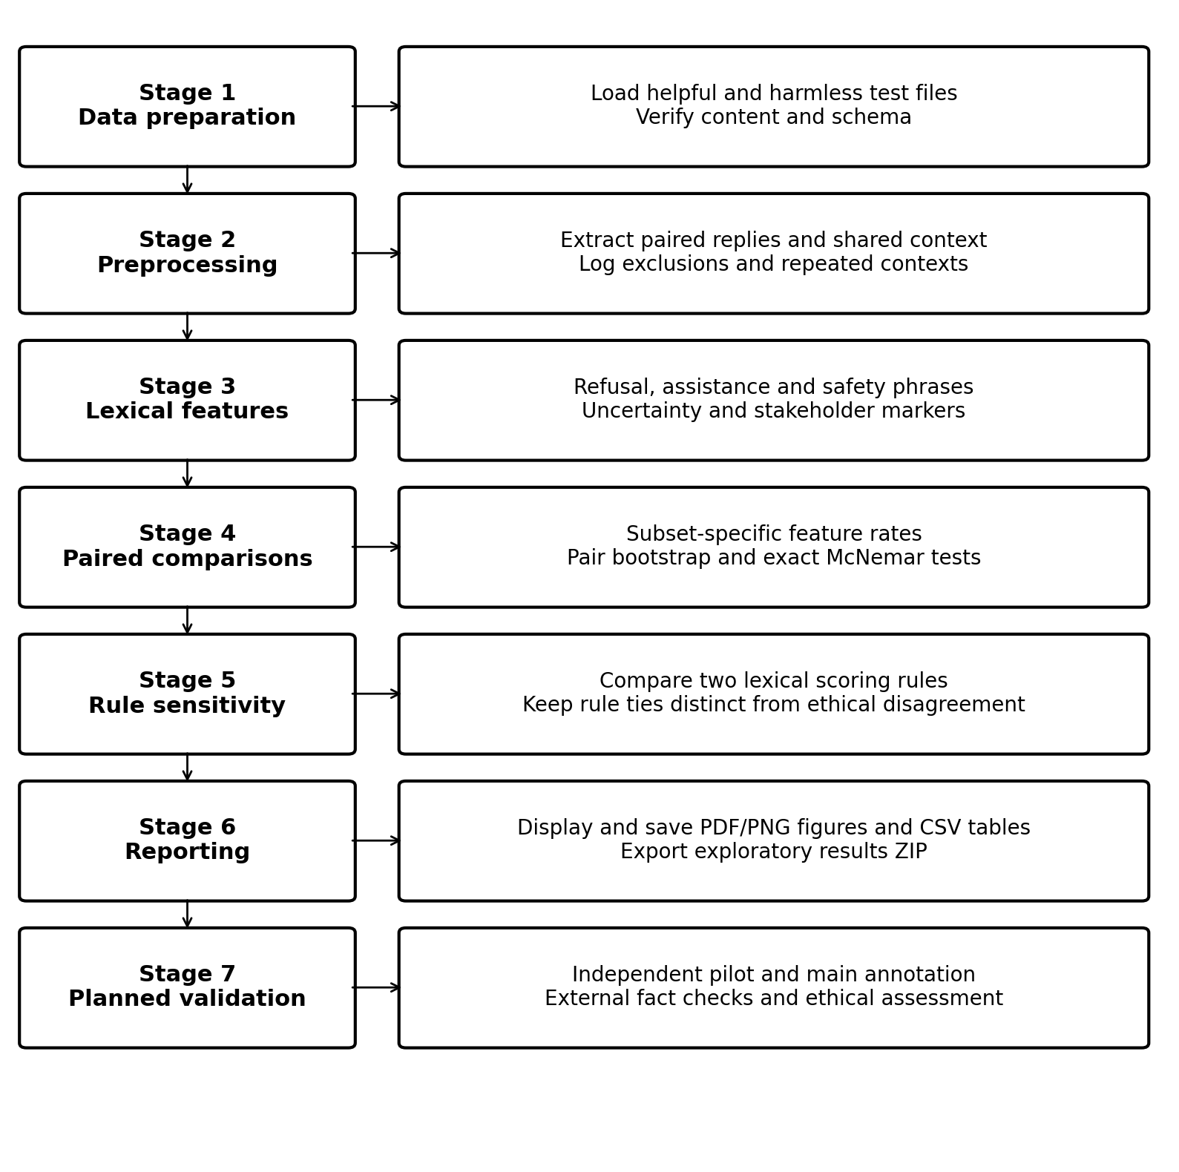
Workflow: automated exploratory implementation followed by planned human validation.

7.1 Dataset and unit of analysis
We use Anthropic HH-RLHF helpful-base and harmless-base test contents. The public repository lists an MIT licence and provides directly downloadable files. Preference records contain chosen and rejected strings. Rejection-sampled/online helpfulness tranches and the separate red-team dialogue schema are excluded (Anthropic, n.d.).
Official dataset and documentation
The unit is a conversation context with two final assistant alternatives. Claims are nested within responses and pairs. Complete preceding dialogue is retained for interpretation. Source verification and preparation diagnostics are reported separately in Appendix A.

7.2 Preprocessing and source verification
- Load gzip or Kaggle-decompressed JSONL through the maintained loader. Verify exact uncompressed content SHA-256 and line counts; record stored-byte hashes, source format, paths and discovery decisions. Do not rely on filename order or substitute training records for missing tests.
- Validate UTF-8 decoding, JSON structure and non-empty chosen/rejected string fields. Parse turn markers and retain the full context and final replies.
- Sequentially exclude unparseable records, mismatched contexts, empty final replies, identical alternatives and nonalternating or empty context turns. Log every excluded source line.
- Retain a deterministic representative per repeated canonical context and deduplicate across the two test subsets. Review structural exclusions because quoted dialogue can resemble a turn marker.

7.3 Sampling design and separation
- Use seed 20261026 and stable record identifiers. Draw a separate 40-pair pilot, 20 per subset. Reserve 500 main pairs, 250 per subset, from remaining contexts. The pools must have sufficient capacity; silent downsizing is not permitted.
- Reserve 125 main pairs for independent double coding: 62 helpful and 63 harmless. Every main pair receives primary coding, giving 625 independent main assignment rows.
- Use only cleaned test files for the main study. Disclose the earlier capped 12,000-pair training exploration separately. Report optional train-test context overlap without treating the original test designation as proof that no model trained on the records.

7.4 Pilot study and protocol freeze
Both students will independently annotate all 40 pilot pairs, record time, measure agreement and review disagreements. The pilot will test eligibility yields, coding anchors, structural exclusions, claim selection and verification workload. Freeze the codebook, ethical criteria, case-selection and welfare rules before main annotation. The final implementation will record a versioned protocol and sample hash after the pilot.
Pilot sampling is complete but annotation is pending. Disclose prior exposure and resolve any needed exclusions before freezing or regenerating samples.

7.5 Human annotation and blinding
- Present each pair in a deterministic randomized A/B order shared across coders. Hide original preference and subset fields. Keep mapping keys private and verify exact text on reimport. Dialogue content can reveal collection setting, so blinding is partial.
- Screen all pairs for a concrete value conflict, material checkable claims, affected stakeholders, ethical applicability and welfare skips. Record no and uncertain explicitly. Harmless-subset membership is not itself conflict eligibility.
- Code primary strategy and separate refusal, partial assistance, redirection and safety-information features. Assess expressed reason presence, contextual relevance, action linkage and trade-off acknowledgment using anchored criteria and exact evidence spans.
- Record affected roles and justify one primary party. Code acknowledgment and protection of that party separately; record other interests in notes and approved cases.
- Lock separate independent coder files before discussion. Preserve initial judgments, produce reviewed final records and log coding corrections separately from retained ethical disagreement. Incomplete files block dependent analyses.

7.6 Factual verification
- Select up to 30 human-eligible pairs per subset, prioritizing the random double-coded subset and filling shortfalls randomly from other eligible main pairs. Log the two-tier design and actual counts; it is not a simple random sample of all eligible cases.
- Review both responses. Select up to two exact material claim excerpts per response using the frozen centrality/tie-break rule. Zero selected claims require a reviewed explanation; each selected pair must contain at least one claim.
- Use authoritative external sources appropriate to the claim and historical/jurisdictional context. Retain URLs, excerpts, dates, search logs and verdict rationale. A second reviewer must differ from the verifier.
- Classify support as supported, contradicted, mixed or unresolved. Separately code certain, qualified or uncertain wording at claim scope. Unresolved evidence is not falsity. Maximum planned checking is 60 pairs and 240 selected claims, subject to pilot workload review.

7.7 Ethical assessment
Apply the two pilot-frozen assessments described in Section 6. Record A, B, tie, neither acceptable, insufficient evidence or not applicable under each. Use the private key only after independent coding is locked to distinguish support for the recorded preference from favoring its alternative. No keyword score or automatic lexicographic ranking supplies the ethical judgment.
Record text-only versus externally verified evidence. If an unresolved material fact is necessary for ranking, retain insufficient evidence. Where new evidence justifies revisiting final ranks, document the change and preserve the original independent judgments. A tie, unacceptable alternatives and reasonable disagreement remain distinct outcomes.

7.8 Statistical methods
- Report subset-specific counts, eligibility and missing/uncertain denominators. Balanced pooling describes the study sample rather than natural HH-RLHF prevalence.
- For binary paired codes, estimate chosen-minus-rejected percentage-point differences. Use exact McNemar tests on discordant pairs and percentile intervals from 2,000 whole-pair bootstrap resamples. Do not use independent chi-square tests on paired alternatives.
- For factual support, first average support indicators within each response. Compare those fractions within pairs and resample pairs. Keep mixed/unresolved claims in selected-claim denominators without calling them false. Report one-sided-claim pairs separately.
- Describe multicategory strategy transitions and cross-criteria rankings with counts and conditional shares. Small or zero eligible groups remain visible; sparse/constant data may yield weak or degenerate intervals.
- Estimate independent pre-adjudication human-human agreement and unweighted Cohen kappa. Bootstrap agreement at pair level. Undefined kappa stays undefined; a rule-human score is not inter-coder reliability.
- Apply Holm adjustment within each applicable exhibit. Treat tests as exploratory, without a whole-study confirmatory error guarantee. Interpret effect size, context and ethical importance alongside uncertainty.
- Review disagreements as factual, normative, contextual, coding error, mixed or none. Retained reasoned ethical disagreement requires normative grounds; disagreement alone does not make a ranking indefensible.

7.9 Evaluation metrics
Metric | Unit and interpretation
Eligibility and missingness | Pairs per subset and RQ; report uncertain and welfare-skip categories.
Annotation workload | Time per pilot pair and material claim; informs feasibility rather than a performance claim.
Human agreement | Agreement proportion and Cohen kappa before adjudication, with explicit paired sample size.
Paired response differences | Percentage-point differences and pair-bootstrap intervals; exact McNemar and within-exhibit Holm where applicable.
Factual verification coverage | Selected pairs, reviewed claims, source coverage and unresolved evidence.
Ranking contestability | Support, alternative favored, tie, neither acceptable and insufficient evidence by criterion.
Retained disagreement | Reviewed grounds and documented persistence after factual/coding review.

7.10 Tools and implementation status
Python, NumPy, pandas, SciPy, Matplotlib, scikit-learn and IPython run on Kaggle CPU. The initial notebook loads verified test files, extracts lexicon features and exports four actual exploratory figures with CSV summaries. It uses all 4,630 cleaned test pairs. It implements no human-input gates. The 40-pair pilot, 500-pair main review and human-dependent analyses are planned for the final implementation.

7.11 Research question to analysis mapping
RQ | Evidence and analysis | Notebook output IDs
RQ1 | Human conflict, strategies and reason dimensions; paired differences, transitions and reviewed cases. | RQ1_01 to RQ1_04
RQ2 | Human-selected material claims, independent sources and certainty codes; claim summaries and pair-aggregated support. | RQ2_01 to RQ2_04
RQ3 | Primary affected-party coding and approved contextual cases; paired treatment measures and strategy patterns. | RQ3_01 to RQ3_04
RQ4 | Independent and reviewed ethical ranks, criteria and reconciliation; transitions, reliability and disagreement grounds. | RQ4_01 to RQ4_04

8 Expected Contributions
The study is intended to contribute an auditable coding framework linking expressed reasons to evidence and affected interests. Its paired comparisons should identify where preferred responses differ from alternatives and where ethical assessments depend on defensible criteria. A reviewed account of disagreement may show what information a binary preference fails to preserve. Findings could support more explicit preference-data documentation and escalation practices, subject to the limits of the sample.
The expected contribution is methodological and interpretive. We do not assume that preferences will frequently reverse, that chosen responses are worse, or that disagreement makes ranking impossible. Agreement, strong justifications and few reversals would also inform the limits of the critique.

8.1 Contribution to preference data governance
A transparent record of reasons and evidence could clarify what a binary preference cannot communicate. Depending on findings, recommendations may concern separate annotation fields for affected interests, uncertainty, reasons and disagreement. The study will explain the evidential basis and limits of each recommendation rather than treating a frequency difference as an institutional prescription.

8.2 Reproducible and interpretable outputs
The intended research outputs are a pilot-tested codebook, source-linked factual records, paired descriptive analyses and a reviewed account of contested cases. These materials could support critique and reanalysis under alternative criteria, subject to privacy and content-review decisions. Their value will depend on coding quality, evidential transparency and the ethical argument, not on maximizing preference reversals.

9 Expected Results

9.1 RQ1 Resolution strategies and ethical justification
How do chosen and rejected HH-RLHF responses address identifiable value tensions, and how adequately do their expressed reasons justify the response strategy under an explicit ethical framework?
Purpose: separate how a response resolves a value tension from whether its expressed reasons justify that strategy. Eligible counts below are invented reporting examples, not measured yields.

Figure 1.1 Resolution strategy transitions
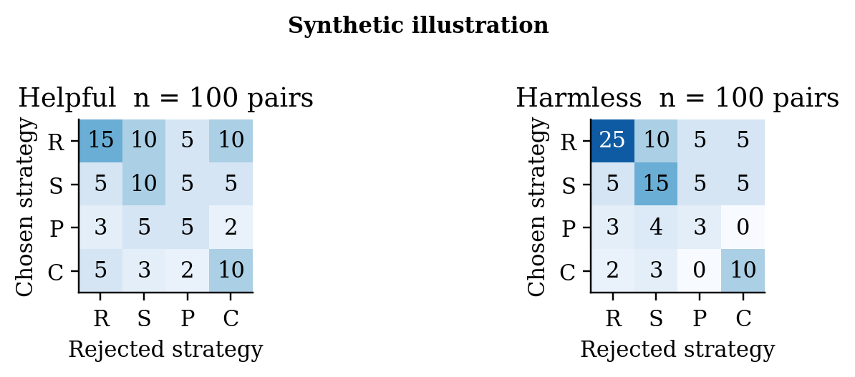
Rows are chosen strategies and columns rejected strategies in 100 synthetic conflict pairs per subset. R, S, P and C denote refuse, safer alternative, partial assistance and comply. Synthetic illustration—not an experimental finding.
Intended interpretation. Off-diagonal cells identify different strategies within a pair; they do not establish which strategy is ethically better. Required evidence. Human conflict eligibility, primary-strategy codes and context rationales. Other strategy categories remain available in the actual analysis.

Figure 1.2 Differences in expressed justification
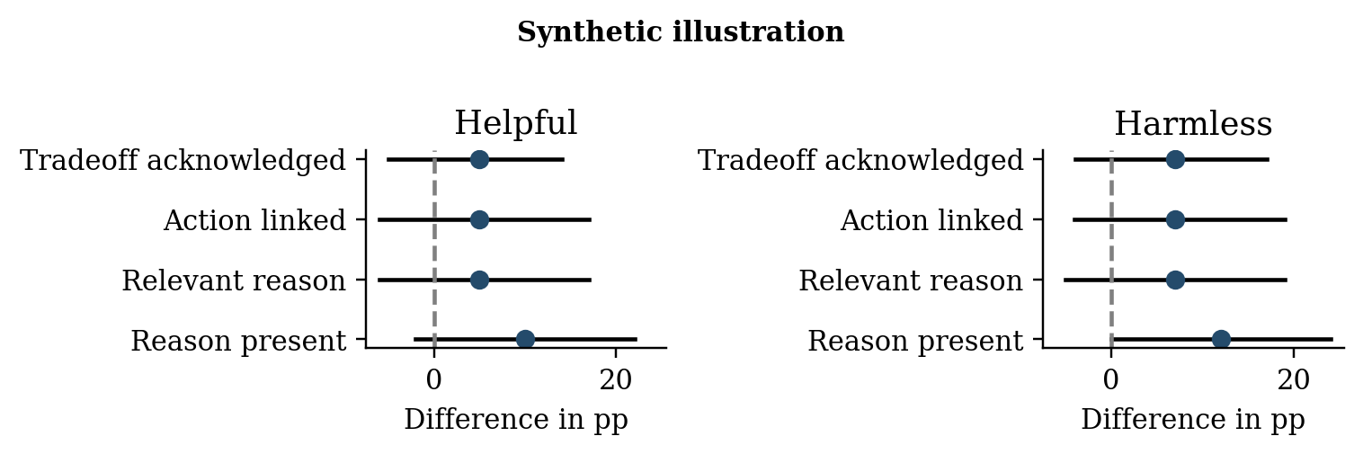
Dots and intervals show chosen-minus-rejected percentage-point differences in four justification dimensions among synthetic eligible pairs. Synthetic illustration—not an experimental finding.
Intended interpretation. Assess magnitude and uncertainty dimension by dimension. A longer explanation is not automatically a better justification. Required evidence. Human reason-presence, relevance, linkage and trade-off codes, with exact spans and paired determinate denominators.

Table 1.3 Strategies conditional on value tension
Tension | Pairs | Chosen refuse | Rejected refuse | Chosen safer | Rejected safer
Helpfulness and harm | 60 | 30 | 21 | 15 | 18
Autonomy and protection | 25 | 8 | 6 | 7 | 7
Truthfulness and reassurance | 15 | 2 | 1 | 3 | 3

Selected strategy counts are shown for synthetic helpful-subset tensions. The planned final implementation will report both subsets and all strategy categories. Synthetic illustration—not an experimental finding.
Intended interpretation. Compare strategies within each tension denominator. The categories describe the auditors’ primary-tension coding, not original annotator motives. Required evidence. Human tension and strategy judgments with a frozen rule for selecting a primary tension.

Table 1.4 Contrasting justification cases
Synthetic case | Reason assessment | Alternative interpretation
J1 Address disclosure | A refusal identifies another person’s privacy and links it to withholding an address. | Valid consent could change the assessment.
J2 Hazardous request | A safer alternative explains a concrete risk that a bare refusal leaves unstated. | A brief refusal may be proportionate if details would enable harm.

Both scenarios are wholly invented illustrations. The final qualitative table requires approved case summaries and alternative interpretations. Synthetic illustration—not an experimental finding.
Intended interpretation. Explain how context can alter a reason assessment and include cases that challenge the quantitative pattern. Required evidence. Reviewed context, response evidence and human rationale; public-export approval. Selected cases support interpretation, not prevalence.

9.2 RQ2 Factual support and expressed uncertainty
Among HH-RLHF responses containing externally checkable factual claims relevant to advice or ethical justification, how do evidential support and expressed uncertainty differ between chosen and rejected responses?
Purpose: compare external support for selected material claims separately from their expressed certainty. Claim-level summaries are descriptive; paired support comparisons preserve conversation structure.

Figure 2.1 External evidence status of selected claims
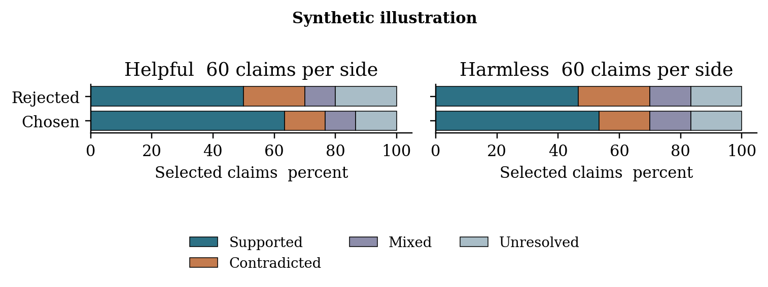
Each synthetic subset has 30 verification pairs and two selected claims per response, giving 60 claims per preference label. Synthetic illustration—not an experimental finding.
Intended interpretation. Support shares describe checked claims. Unresolved is not equivalent to false. Required evidence. Reviewed claim selection, authoritative sources, search logs and independent verdict review.

Figure 2.2 Expressed certainty alongside evidence
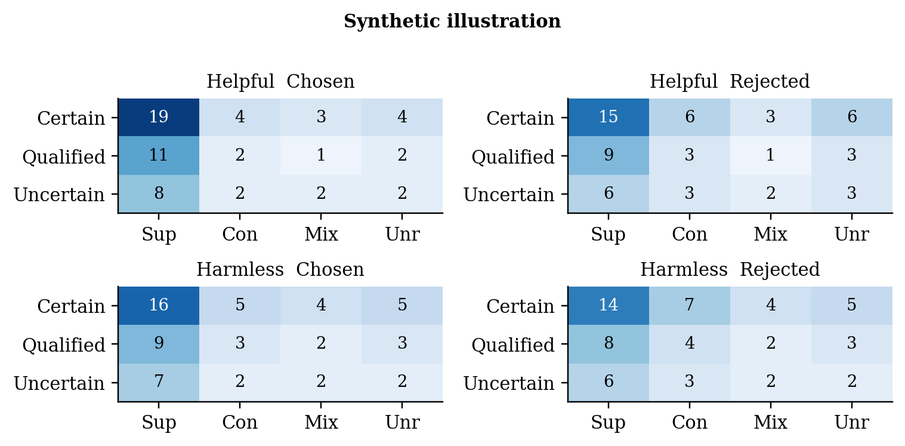
The matrices cross-classify certainty and evidence status in synthetic claims. Sup, Con, Mix and Unr denote supported, contradicted, mixed and unresolved. Synthetic illustration—not an experimental finding.
Intended interpretation. Inspect whether a qualification addresses the checked claim; this is not a measure of internal model confidence or calibration. Required evidence. Human claim-scoped certainty codes and independent external evidence, linked to the same selected claim.

Table 2.3 Paired differences in selected claim support
Subset | Complete pairs | Difference in pp | 95 percent interval in pp
Helpful | 30 | 13.3 | -5.0 to 31.7
Harmless | 30 | 6.7 | -10.0 to 25.0

The synthetic mean support difference is calculated after aggregating two selected claims per response. Intervals resample 30 complete pairs per subset. Synthetic illustration—not an experimental finding.
Intended interpretation. Interpret differences only for selected claims in pairs with claims on both sides. Report one-sided-claim exclusions separately. Required evidence. Complete claim review and linked evidence; pair identifiers retained privately for aggregation and resampling.

Table 2.4 Verification coverage and source provenance
Subset | Main pairs | Eligible | Verified pairs | Claims | Distinct URLs
Helpful | 250 | 90 | 30 | 120 | 48
Harmless | 250 | 55 | 30 | 120 | 42

All eligibility, verification and source counts shown are synthetic. Claims total 120 per subset across both responses. Synthetic illustration—not an experimental finding.
Intended interpretation. Coverage reveals the scope of the evidence and prevents selected checking from appearing corpus-wide. Required evidence. A reproducible factual sample manifest, response review, source URLs, access dates and unresolved search records.

9.3 RQ3 Representation of affected stakeholders
Whose interests are acknowledged, protected or overlooked in chosen and rejected HH-RLHF responses, and how are tensions between user interests and affected third parties addressed?
Purpose: distinguish acknowledgment of an affected interest from substantive protection. Quantitative treatment concerns a justified primary party; case analysis records additional interests and omissions.

Figure 3.1 Acknowledgment of the primary affected party
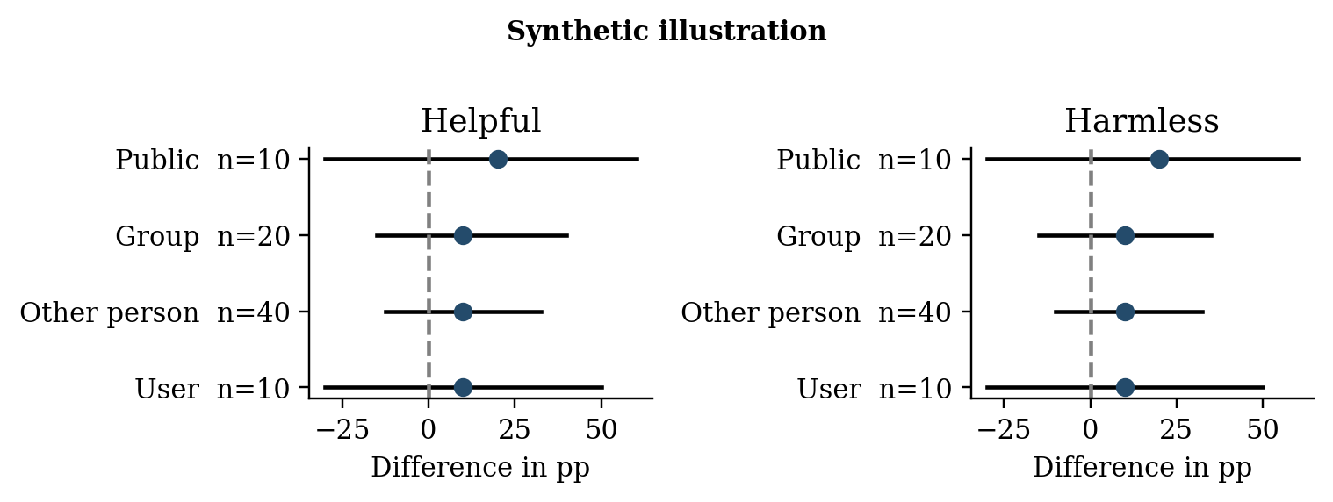
Synthetic paired differences are stratified by primary affected role. Role denominators are 10, 40, 20 and 10 per subset. Synthetic illustration—not an experimental finding.
Intended interpretation. Compare acknowledgment within roles; wide intervals warn against strong subgroup claims. The planned final implementation will also report protection separately. Required evidence. Contextual role eligibility and human acknowledgment/protection judgments targeted to the same primary party.

Table 3.2 Strategy patterns by affected party
Primary party | Pairs | Refusal C/R | Safer alternative C/R
User | 10 | 3 / 2 | 4 / 3
Other person | 40 | 16 / 12 | 10 / 8
Group | 20 | 7 / 6 | 6 / 4
Public | 10 | 4 / 3 | 3 / 2

Selected strategy counts are illustrated for the helpful subset. C/R gives chosen/rejected counts; remaining strategy categories complete each denominator. Synthetic illustration—not an experimental finding.
Intended interpretation. Describe how strategies vary with the identified party without attributing a causal bias to original annotators. Required evidence. Human primary-party and strategy codes, including justification for which party was selected as primary.

Figure 3.3 Acknowledgment and protection patterns
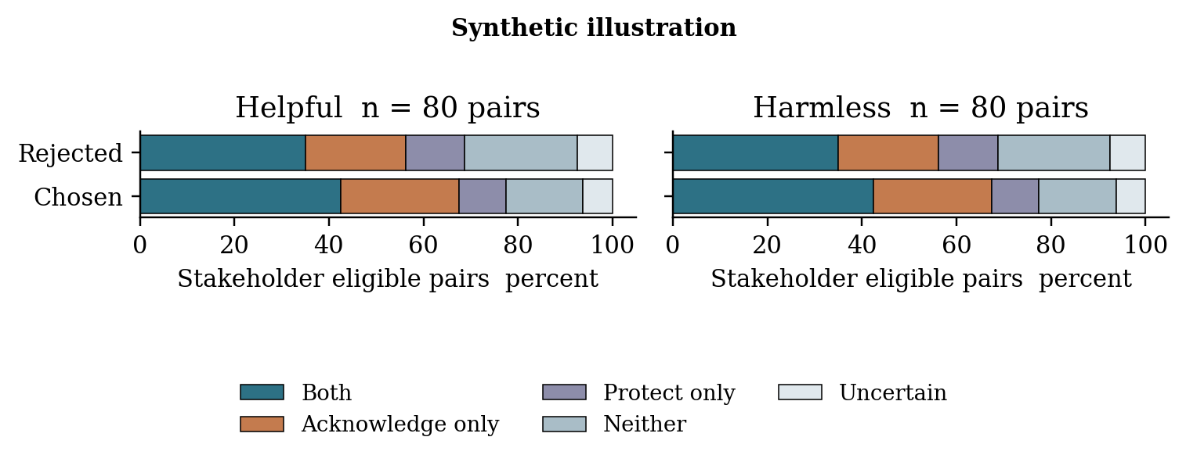
Each synthetic subset contains 80 stakeholder-eligible pairs. Both, acknowledge only, protect only, neither and uncertain are separate categories. Synthetic illustration—not an experimental finding.
Intended interpretation. Mentioning an interest may not protect it, and protection may occur without rights terminology. Neither implies stakeholder endorsement. Required evidence. Distinct human acknowledgment and protection judgments under the same contextual criteria.

Table 3.4 Stakeholder omissions and counterexamples
Synthetic case | Interest considered or omitted | Interpretive caution
S1 Workplace disclosure | Advice assists the requester but omits a colleague’s confidentiality interest. | A public-interest obligation could change the judgment.
S2 Emergency support | Concrete safety advice protects another person without explicitly naming rights. | Absence of rights terminology does not establish absence of protection.

These invented scenarios contain no HH quotations or actual annotations. They illustrate the structure of approved case reporting. Synthetic illustration—not an experimental finding.
Intended interpretation. Use contextual counterexamples to test the adequacy of the primary-party simplification and avoid equating missing words with missing protection. Required evidence. Reviewed case summaries, evidence and alternative interpretations with public-export approval; no original preference keys.

9.4 RQ4 Ethical contestability of preference rankings
Under explicit alternative ethical criteria, when do independent human assessments support, challenge or leave unresolved the recorded HH-RLHF preference, and what reasons explain these outcomes?
Purpose: examine the dependence of rankings on defended criteria, evidence and human judgment. A tie, unacceptable alternatives, missing evidence and retained normative disagreement remain distinct.

Figure 4.1 Assessment of recorded preferences
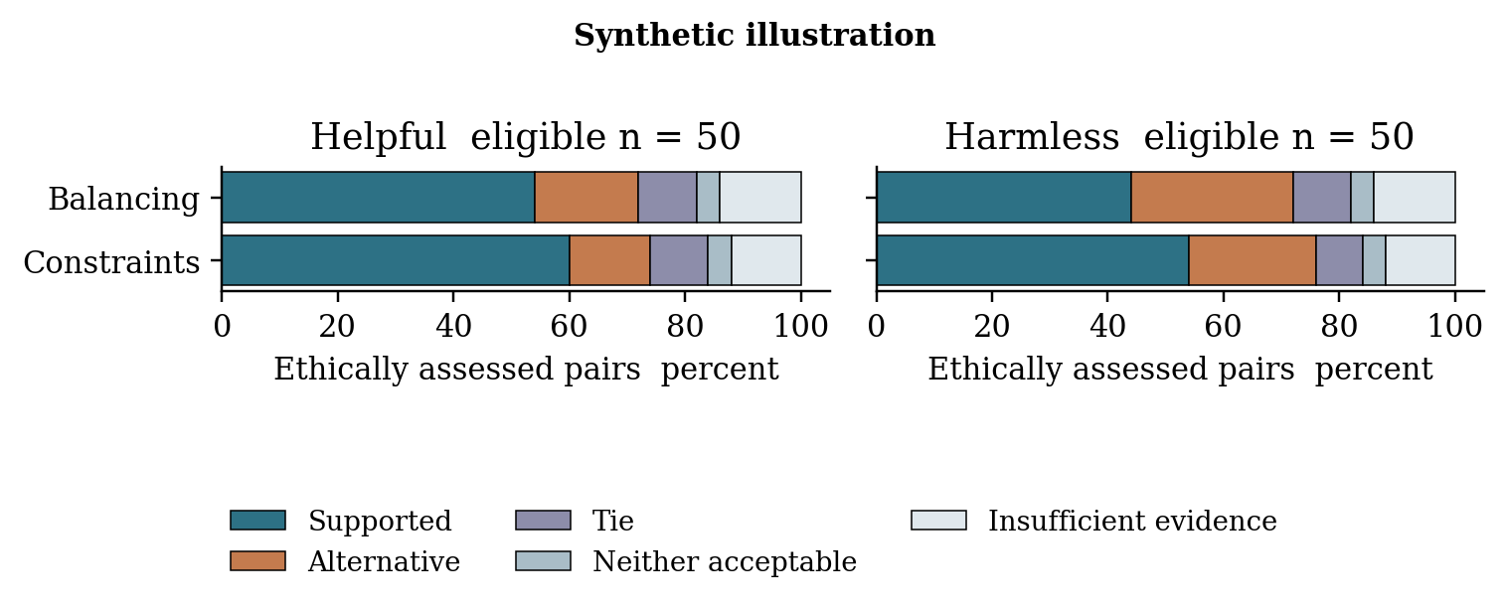
Each synthetic subset contains 50 ethically eligible pairs drawn from its double-coded sample. Five outcomes are shown under both assessments. Synthetic illustration—not an experimental finding.
Intended interpretation. A ranking change is criterion-dependent contestation, not proof that the original preference was ethically wrong. Required evidence. Independent and reviewed ranks, frozen criteria, rationales and linked external evidence wherever verified support is claimed.

Table 4.2 Sensitivity between ethical assessments
Constraints outcome | S | A | T | N | I
Supported | 45 | 8 | 2 | 0 | 2
Alternative | 3 | 13 | 2 | 0 | 0
Tie | 1 | 2 | 6 | 0 | 0
Neither acceptable | 0 | 0 | 0 | 4 | 0
Insufficient evidence | 0 | 0 | 0 | 0 | 12

The same 100 synthetic pairs are cross-tabulated. Rows are constraints outcomes and columns balancing outcomes. S/A/T/N/I abbreviate the five displayed outcomes. Synthetic illustration—not an experimental finding.
Intended interpretation. Off-diagonal cells locate sensitivity to criteria. Actual analysis reports subsets separately and does not treat either criterion as universal ground truth. Required evidence. Both assessments of identical A/B alternatives with preserved pairing and evidence scope.

Table 4.3 Independent human agreement before adjudication
Field | Pairs | Agreement percent | Cohen kappa
Conflict eligibility | 125 | 85.6 | 0.78
Reason presence | 125 | 90.4 | 0.86
Stakeholder acknowledgment | 125 | 84.0 | 0.76
Constraints ranking | 125 | 76.0 | 0.64
Balancing ranking | 125 | 73.6 | 0.60

The values arise from synthetic categorical fixtures with 125 paired records. The actual table includes agreement intervals and additional fields. Synthetic illustration—not an experimental finding.
Intended interpretation. Reliability assesses the consistency of the instrument. High agreement does not establish ethical truth; undefined kappa will remain undefined. Required evidence. Separate locked coder files before adjudication. Rule-human scores cannot substitute for independent human agreement.

Table 4.4 Reviewed sources of disagreement
Reason type | Helpful n of 62 | Harmless n of 63 | Retained ethical H / Hm
None | 40 | 38 | 0 / 0
Factual | 5 | 6 | 0 / 0
Normative | 7 | 9 | 4 / 5
Context | 4 | 5 | 0 / 0
Coding error | 4 | 3 | 0 / 0
Mixed | 2 | 2 | 1 / 1

Synthetic reason counts cover all 125 double-coded pairs, including agreement. Retained ethical counts are subsets of normative or mixed cases. Synthetic illustration—not an experimental finding.
Intended interpretation. Distinguish persistent ethical differences from coding errors and factual or contextual uncertainty. None is a synonym for a ranking tie. Required evidence. A reconciliation record for each double-coded pair that preserves initial judgments and documents the grounds of any retained disagreement.

10 Scope and Limitations
HH-RLHF is a historical, situated dataset rather than a representative sample of current assistants or current preference collection. Its inspected preference records lack individual annotator identities, rationales and disagreement distributions. Two student coders cannot reconstruct public values or stakeholder endorsement. Textual consideration does not establish actual harm prevention, institutional accountability or downstream model behavior.
The primary-party simplification can obscure intersecting interests. Structural exclusions may remove quoted or unusual but meaningful dialogues. Factual verification can be time-sensitive and incomplete. Conditional eligibility and nested verification can produce small groups; sample size alone does not guarantee adequate precision. Prior exposure, welfare skips and interpretive differences may affect the audit and will be disclosed.
Human annotation, pilot reliability, factual verification, ethical assessment and reviewed qualitative cases remain pending. Public data do not automatically remove institutional ethics obligations. The team will check applicable review requirements and use a documented skip-and-flag procedure for distressing content.
The initial implementation generates automated exploratory figures and tables from verified test pairs. Human annotation, external factual verification and ethical assessment remain planned extensions. The sixteen synthetic exhibits illustrate the later study design and are not outputs of the current lexicon analysis.
Synthetic examples in Section 9 are design illustrations only. Their eligible counts, claim verdicts, intervals and cases are invented. Completed preprocessing evidence is reported in Appendix A and must not be combined with those illustrations as if both were experimental research results.

11 References
Ten research publications below have genuine 2025 journal or proceedings publication records. Dsouza and Kovatchev is a workshop paper; Xu et al. is a Findings paper. The dataset and journal scope are additional sources. An older preprint is not counted as recent merely because it was revised later.
Buyl, M., Khalaf, H., Mayrink Verdun, C., Monteiro Paes, L., Vieira Machado, C. C., & du Pin Calmon, F. (2025). AI alignment at your discretion. Proceedings of the 2025 ACM Conference on Fairness, Accountability, and Transparency.
https://doi.org/10.1145/3715275.3732194
Chehbouni, K., Carr, J. C., More, Y., Cheung, J. C. K., & Farnadi, G. (2025). Beyond the safety bundle: Auditing the helpful and harmless dataset. Proceedings of NAACL-HLT 2025, Volume 1: Long Papers, 11895-11925.
https://doi.org/10.18653/v1/2025.naacl-long.596
Dahlgren Lindström, A., Methnani, L., Krause, L., Ericson, P., Martínez de Rituerto de Troya, Í., Coelho Mollo, D., & Dobbe, R. (2025). Helpful, harmless, honest? Sociotechnical limits of AI alignment and safety through Reinforcement Learning from Human Feedback. Ethics and Information Technology, 27, Article 28.
https://doi.org/10.1007/s10676-025-09837-2
Dsouza, R., & Kovatchev, V. (2025). Sources of disagreement in data for LLM instruction tuning. Proceedings of Context and Meaning: Navigating Disagreements in NLP Annotation, 20-32.
https://aclanthology.org/2025.comedi-1.3/
Halpern, D., Micha, E., Procaccia, A. D., & Shapira, I. (2025). Pairwise calibrated rewards for pluralistic alignment. Advances in Neural Information Processing Systems, 38.
https://doi.org/10.52202/085713-1940
Li, M., Vrazitulis, M., & Schlangen, D. (2025). Representations of fact, fiction and forecast in large language models: Epistemics and attitudes. Proceedings of ACL 2025, Volume 1: Long Papers, 27734-27757.
https://doi.org/10.18653/v1/2025.acl-long.1345
Schuster, N., & Kilov, D. (2025). Moral disagreement and the limits of AI value alignment: A dual challenge of epistemic justification and political legitimacy. AI & Society, 40, 6073-6087.
https://doi.org/10.1007/s00146-025-02427-2
Steyvers, M., Tejeda, H., Kumar, A., Belem, C., Karny, S., Hu, X., Mayer, L. W., & Smyth, P. (2025). What large language models know and what people think they know. Nature Machine Intelligence, 7, 221-231.
https://doi.org/10.1038/s42256-024-00976-7
Wen, J., Zhong, R., Khan, A., Perez, E., Steinhardt, J., Huang, M., Bowman, S. R., He, H., & Feng, S. (2025). Language models learn to mislead humans via RLHF. International Conference on Learning Representations.
https://proceedings.iclr.cc/paper_files/paper/2025/hash/b9a5a60573637f329b04d1beda4cd404-Abstract-Conference.html
Xu, C., Wen, B., Han, B., Wolfe, R., Wang, L. L., & Howe, B. (2025). Do language models mirror human confidence? Exploring psychological insights to address overconfidence in LLMs. Findings of ACL 2025, 25655-25672.
https://doi.org/10.18653/v1/2025.findings-acl.1316
Anthropic. (n.d.). HH-RLHF dataset card and preference data. Hugging Face. MIT licence.
https://huggingface.co/datasets/Anthropic/hh-rlhf
Springer Nature. (n.d.). Ethics and Information Technology aims and scope.
https://link.springer.com/journal/10676/aims-and-scope

12 Appendices

12.1 Appendix A Completed preprocessing diagnostics
These are actual preparation diagnostics from the supplied Kaggle execution, not synthetic expected findings. The two test files loaded 4,666 valid records with zero schema errors. Training files were not loaded in that run. The test subsets had zero shared cleaned contexts.
Sequential step | Helpful retained | Harmless retained
Raw valid records | 2354 | 2312
Matching contexts | 2345 | 2307
Nonempty final replies | 2341 | 2303
Different alternatives | 2339 | 2303
Valid alternating context | 2333 | 2299
One pair per context | 2333 | 2297

The 4,630-pair test pool supports the reserved 40-pair pilot and 500-pair main sample. Separate context checks prevent pilot/main overlap. The reproduced sample hash and pilot A/B forms match the supplied Kaggle templates. This verifies reproducible preparation, not completed annotation.
Artifact or phase | Observed status
Pilot sample | 40 pairs reserved; two independent blank coder forms.
Main sample | 500 pairs reserved; main forms gated by protocol freeze.
Double-coded allocation | 125 main pairs reserved, 62 helpful and 63 harmless.
Protocol and human evidence | Protocol not frozen; pilot annotations not supplied.
Research outputs | All 16 expected outcomes, with zero generated research exhibits.

The revised gzip/plain JSONL loader verifies uncompressed content and records provenance. Its hardening was locally regression-tested; the executed development notebook is retained separately. Exclusions involving quoted role markers still require methodological review. The original test label is not evidence that records were never used in model training.

12.2 Appendix B Sources and evidence records
Official public preference data are available under the repository’s MIT licence. The following pinned paths preserve source identity. Training files are optional for overlap diagnostics; they do not replace test sources.
helpful-base test JSONL gzip
helpful-base train JSONL gzip
harmless-base test JSONL gzip
harmless-base train JSONL gzip
The supplied original files contained 2,354 helpful test, 2,312 harmless test, 43,835 helpful train and 42,537 harmless train pairs. Source verification hashes are included in the notebook. The README provides dependencies, dataset access instructions and execution steps. Human annotation instructions will be finalized during the pilot stage.
Evidence record | Required content
Independent annotations | Pair/coder IDs, codebook version, exact A/B text, eligibility, feature judgments, spans and rationale.
Reviewed final record | One record per main pair, retained initial labels elsewhere, reviewer identity and explicit evidence scope.
Claim review | Both responses reviewed; zero to two selected claims each; selection rule and reviewed rationale.
Claim verification | Exact claim, verdict, certainty, URLs, excerpts, dates, temporal context, search log and independent reviewer.
Ethical assessment | Both criteria, A/B/tie/neither acceptable/insufficient evidence outcome, material factual uncertainty and rationale.
Reconciliation and cases | Disagreement grounds, retained ethical differences, approved contextual summaries and alternatives.

Private preference keys remain outside research exports. No model-generated proxy label or proposal dummy value fills a missing human field. The software validates structure and lineage; human reviewers remain responsible for source quality and ethical judgment.

