Project Proposal
Ethical justification and value tensions in AI preference data: an empirical audit of the Anthropic HH-RLHF dataset
Team: Ethical Architects (Gr01) — Agathiyan Akilan, Ashwani Sherawat
Course: Interdisciplinary Elective: AI, Power & Responsibility — Governing Intelligent Systems for Sustainability (PW26)
Catalogue project: 14 — Tensions in alignment preferences
Target journal: Ethics and Information Technology (Springer Nature; hybrid/subscription; 2025 JIF 5.5)
Anchor paper: Dahlgren Lindström et al. (2025), Helpful, harmless, honest? Sociotechnical limits of AI alignment and safety through RLHF. Ethics and Information Technology 27(2):28. https://doi.org/10.1007/s10676-025-09837-2
Dataset: Anthropic/hh-rlhf (Hugging Face, MIT licence) — helpful-base and harmless-base subsets. https://huggingface.co/datasets/Anthropic/hh-rlhf
Submission: 2 — Project proposal, initial presentation, initial code. Version of 2 November 2026.
This proposal follows the module's four-part structure: research questions, proposed methodology, expected results with four figures or tables per research question, and references. The expected results shown here are preliminary outputs from the Kaggle notebook's lexicon-based first pass over a 6,000-pair subset of the dataset (3,000 per subset). They demonstrate the pipeline and the shape of each result; the paper's findings will come from the blinded, double-coded human sample described in Section 2.

1. Research questions
AI assistants are tuned to be helpful, harmless and honest using human preference data: an annotator sees two model replies to the same conversation and picks the better one. The anchor paper argues that these three goals conflict, that preference labels record annotators' situated judgements rather than shared values, and that the method cannot represent parties outside the conversation. That argument is conceptual. We test how these concerns appear in the actual preference pairs. The preference label is treated throughout as a record of an annotator's choice, never as ethical ground truth.
RQ1 — Resolution strategies and their justification
RQ1a. Among pairs involving a helpfulness–harmlessness conflict, how do chosen and rejected responses differ in their resolution strategies — refusal, partial assistance, redirection, and safety information — coded as separate features because a response may combine them?
RQ1b. How adequately are refusals justified? Does the stated reason address the actual request and name a relevant risk (none / generic / specific)?
RQ1a asks whether the preference favours outright refusal or a harm-reducing middle path. RQ1b separates the safety decision from the explanation offered for it.
RQ2 — Factual support and expressed uncertainty
Among helpfulness-subset responses containing externally checkable claims, how are factual accuracy (supported / contradicted / unresolved) and expressed uncertainty associated with the chosen–rejected distinction? In particular, are responses that acknowledge uncertainty systematically rejected in favour of responses that assert without support? An unresolved claim is not treated as false, and confident wording is not treated as evidence of accuracy.
RQ3 — Representation of affected stakeholders
When a request could cause harm, who would bear that harm — the requester, an identifiable third party, or society — and do chosen and rejected responses treat these cases differently? When a conversation implicates third parties, how do responses acknowledge their privacy, autonomy, dignity and foreseeable harm? The analysis concerns interests represented in the text; it does not claim to reveal the original annotators' motives.
RQ4 — Ethical contestability of preference rankings
How often does the dataset's preference ranking remain stable, reverse, or become unresolved under explicitly justified ethical criteria (harm prevention, respect for affected parties, factual support) combined by a frozen lexicographic rule? Which cases retain reasoned disagreement after factual and coding ambiguities are addressed? Ties, insufficient evidence and persistent disagreement are distinguished; disagreement alone is not treated as proof that a pair has no defensible ranking.
Together the four questions form one argument: how conflicts are resolved and explained (RQ1), what that resolution costs in factual support (RQ2), who is protected by it (RQ3), and whether a single preference label is a defensible format for recording it (RQ4).
Problem statement, significance and novelty
Preference data is where values become code: a small, unidentified group of crowdworkers, working under brief instructions written by one company, decided what a model would say to hundreds of millions of people, and their single click per pair became training signal. The dataset is public, which makes this one of the few places where that upstream judgement can be inspected. The only existing audit of HH-RLHF (Chehbouni et al., 2024) counts harmful and unhelpful replies. This study extends it in three ways: it examines the reasons offered for safety decisions, not only the decisions; it compares how the preference treats harm to the requester, to third parties and to society; and it tests whether the ranking holds under different defensible ethical priorities. The contribution is a transparent coding framework, evidence-linked annotations, reproducible analysis, a catalogue of contested cases, and governance recommendations for how preference data should be collected and documented.

2. Proposed methodology
Data
- Dataset: Anthropic HH-RLHF, helpful-base and harmless-base. Train files hold 43,835 and 42,537 pairs; test files hold 2,354 and 2,312. Each record contains two full transcripts, chosen and rejected, identical except for the final assistant reply.
- Files were downloaded on 26 October 2026 (MIT licence); identifiers, sizes and download date are recorded in a provenance table generated by the notebook.
- The main sample is drawn from the test files because they are small enough to document completely and are held out from model training. Train files are retained for a robustness check.
Preparation
- Parse each transcript into turns; keep the preceding conversation for interpretation; isolate the final user turn and the two final assistant replies.
- Exclude pairs with mismatched contexts, empty replies or identical alternatives; keep one pair per repeated context. Log every exclusion in a data-flow table.
- Define eligibility separately per research question: conflict pairs (RQ1, RQ4), checkable claims in the helpful subset (RQ2), third-party cases (RQ3). Report eligible counts.
Sampling and blinding
- Pilot sample of 40 pairs (20 per subset) and a separate main sample of 500 pairs (250 per subset), both drawn with a fixed random seed; sample IDs are published.
- Coding sheets hide the chosen/rejected labels and present the two replies as Response A and Response B in randomised order. The key file is kept separate until adjudication.
Coding (eight dimensions, both replies in every pair)
- Resolution features: refuse, partial assistance, redirect, safety information — each yes/no.
- Justification of a refusal: none / generic / specific risk named.
- Factual support of selected checkable claims: supported / contradicted / unresolved / no claim, verified against reliable sources with links retained; a fixed rule selects which claims are checked.
- Expressed uncertainty: hedged / neutral / assertive.
- Harm bearer from the request: none / requester / third party / society.
- Stakeholder treatment in third-party cases: which reply acknowledges the third party's interests (A / B / both / neither).
- Conflict present: yes / no.
- Ethical rank under the frozen criteria: A / B / tie / insufficient evidence.
Procedure
- Both coders independently annotate the 40-pair pilot; revise the codebook and the ethical criteria; freeze both before the main analysis.
- Code the main sample; double-code at least 25%; compute percentage agreement and Cohen's kappa before discussing disagreements; log the reason for each adjudicated disagreement, since reasoned disagreement is data for RQ4.
- Apply the frozen criteria to every pair and record whether the dataset's ranking is stable, reversed or unresolved; run all six criterion orderings as a sensitivity analysis.
- Agree a coder welfare protocol with the supervisor before coding begins, because the harmless subset contains deliberately offensive prompts: scheduled breaks and a skip-and-flag rule.
Analysis
- Python (pandas, scipy, matplotlib) on CPU; no model training. Code is a single Kaggle notebook that loads the files, runs every step and zips all figures and tables.
- Paired differences with bootstrap 95% confidence intervals; chi-square tests with Cramér's V for contingency tables; odds ratios for 'the reply carrying the feature is the chosen one' computed on discordant pairs; paired Wilcoxon tests for rate differences.
- Subsets analysed separately; any combined summary describes the balanced study sample.
- A transparent lexicon-based first pass runs over all loaded pairs so that every figure can be regenerated; the human codes replace the lexicon codes for the paper, and kappa between lexicon and human coding is reported.

3. Expected results
Four figures or tables per research question. Figures are preliminary outputs of the notebook's lexicon pass over 3,000 pairs per subset of the train files; tables show the corresponding numbers. These illustrate the form of each result and the direction of the preliminary signal. Final values will come from the human-coded sample.

RQ1 — Resolution strategies and justification
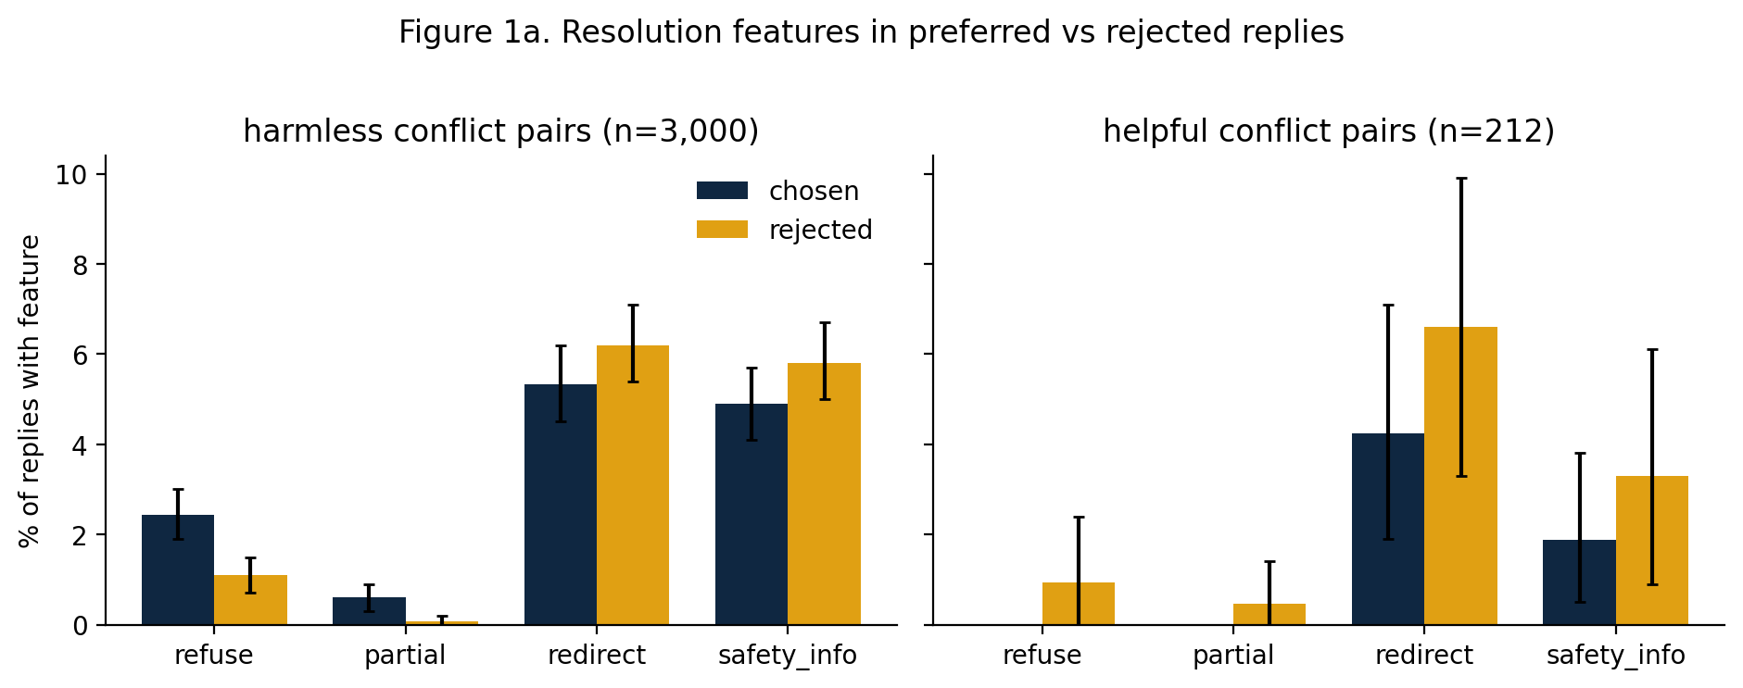
Figure 1a. Share of chosen and rejected replies carrying each resolution feature in conflict pairs, by subset, with bootstrap 95% CIs. Preliminary pass: refusals appear more often in chosen replies (2.4% vs 1.1%), while redirection and safety information appear slightly less often.
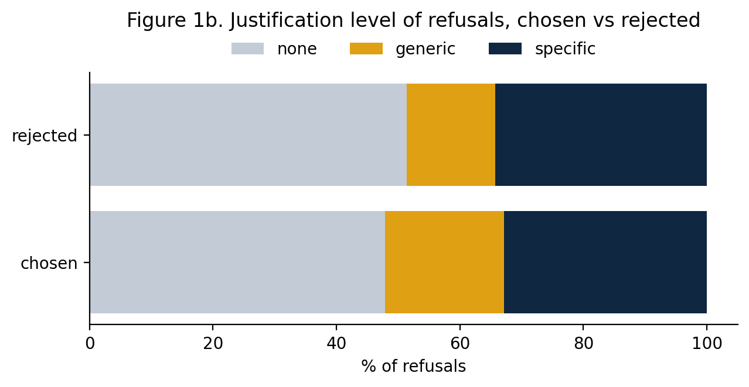
Figure 1b. Justification level of refusals, chosen vs rejected. Preliminary pass finds no difference in the share of refusals that name a specific risk (33% vs 34%), i.e. the decision to refuse was rewarded but a stated reason was not.
Table 1a. Resolution features: prevalence and odds of being the chosen reply (harmless subset, n = 3,000 conflict pairs)
Feature | Chosen % | Rejected % | OR (feature-bearing reply is chosen) | 95% CI | Discordant pairs
Refuse | 2.4 | 1.1 | 2.33 | [1.52, 3.58] | 70 / 30
Partial assistance | 0.6 | 0.1 | 9.00 | [2.09, 38.8] | 18 / 2
Redirect | 5.3 | 6.2 | 0.84 | [0.67, 1.05] | 136 / 162
Safety information | 4.9 | 5.8 | 0.82 | [0.65, 1.04] | 124 / 151
Final version: same layout from human codes, both subsets, with kappa per feature.
Table 1b. Justification level of refusals, chosen vs rejected (counts and row %)
Side | None | Generic | Specific | n | χ², p, Cramér's V
Chosen | 35 (47.9%) | 14 (19.2%) | 24 (32.9%) | 73 | 0.4, 0.82, 0.06
Rejected | 18 (51.4%) | 5 (14.3%) | 12 (34.3%) | 35
Final version adds the odds that a specific-reason refusal is chosen when both replies refuse (undefined in the preliminary pass: only 3 such pairs detected by the lexicon).

RQ2 — Factual support and expressed uncertainty
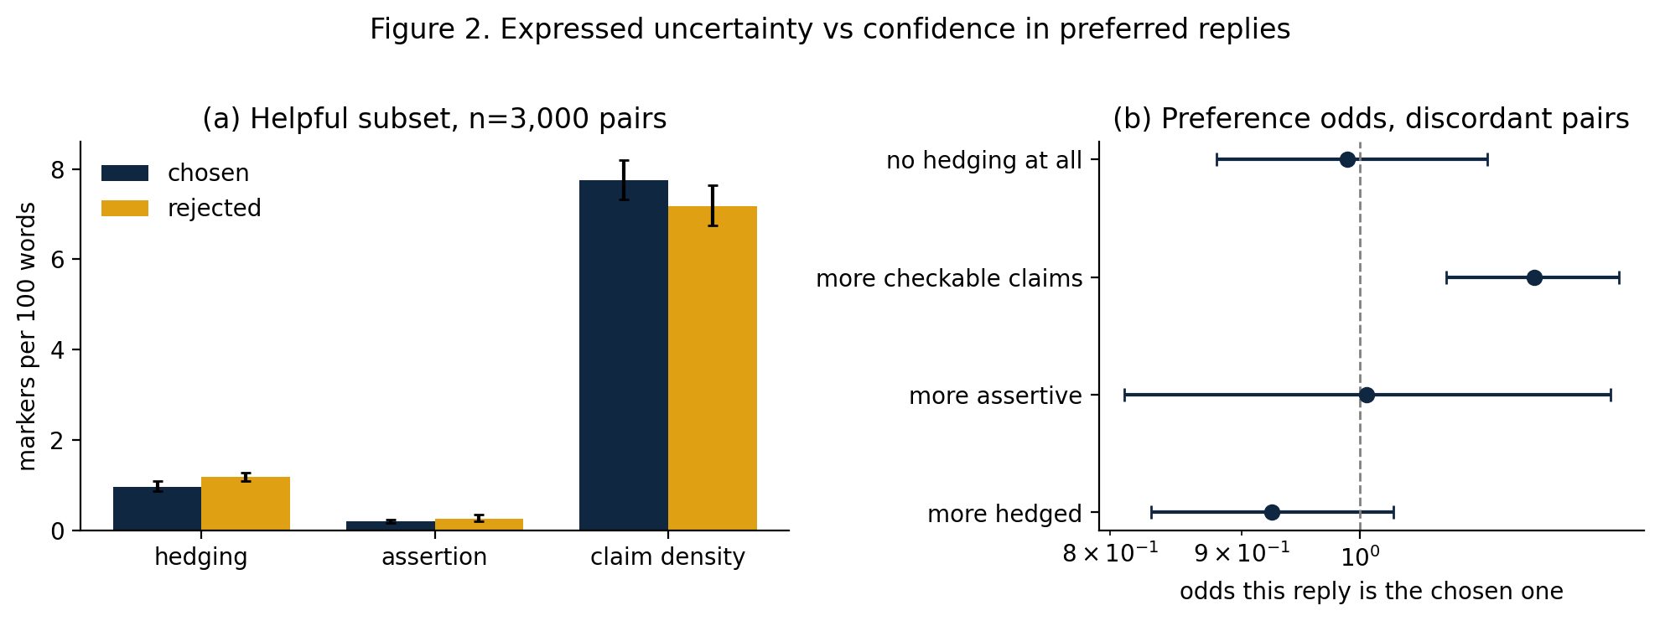
Figure 2a (left). Hedging markers, confident-assertion markers and checkable-claim density per 100 words in chosen vs rejected replies, helpful subset, with 95% CIs. Figure 2b (right). Odds that the more-hedged, more-assertive or claim-denser reply is the chosen one (discordant pairs, log scale). Preliminary pass: chosen replies hedge less (0.96 vs 1.17 per 100 words, Wilcoxon p < 0.001) and carry more checkable claims (OR 1.17 [1.08, 1.26]).
Table 2a. Expressed uncertainty and claim density (helpful subset, n = 3,000 pairs)
Feature | Chosen /100w [CI] | Rejected /100w [CI] | Wilcoxon p | OR more-X is chosen [CI]
Hedging markers | 0.96 [0.86, 1.08] | 1.17 [1.08, 1.27] | < 0.001 | 0.92 [0.83, 1.03]
Confident assertion | 0.20 [0.16, 0.24] | 0.25 [0.19, 0.35] | 0.70 | 1.01 [0.81, 1.25]
Checkable-claim density | 7.75 [7.32, 8.19] | 7.18 [6.74, 7.64] | < 0.001 | 1.17 [1.08, 1.26]
No hedging at all | — | — | — | 0.99 [0.88, 1.12]
Table 2b. Factual support of checked claims by side (template — filled from the human fact-check)
Side | Supported | Contradicted | Unresolved | Claims checked | Contradicted among hedged | Contradicted among assertive
Chosen | n (%) | n (%) | n (%) | N | n (%) | n (%)
Rejected | n (%) | n (%) | n (%) | N | n (%) | n (%)
Expected reading: if contradicted claims are not less frequent among chosen replies, and chosen replies hedge less, the training signal rewards confident wording independently of accuracy.

RQ3 — Representation of affected stakeholders
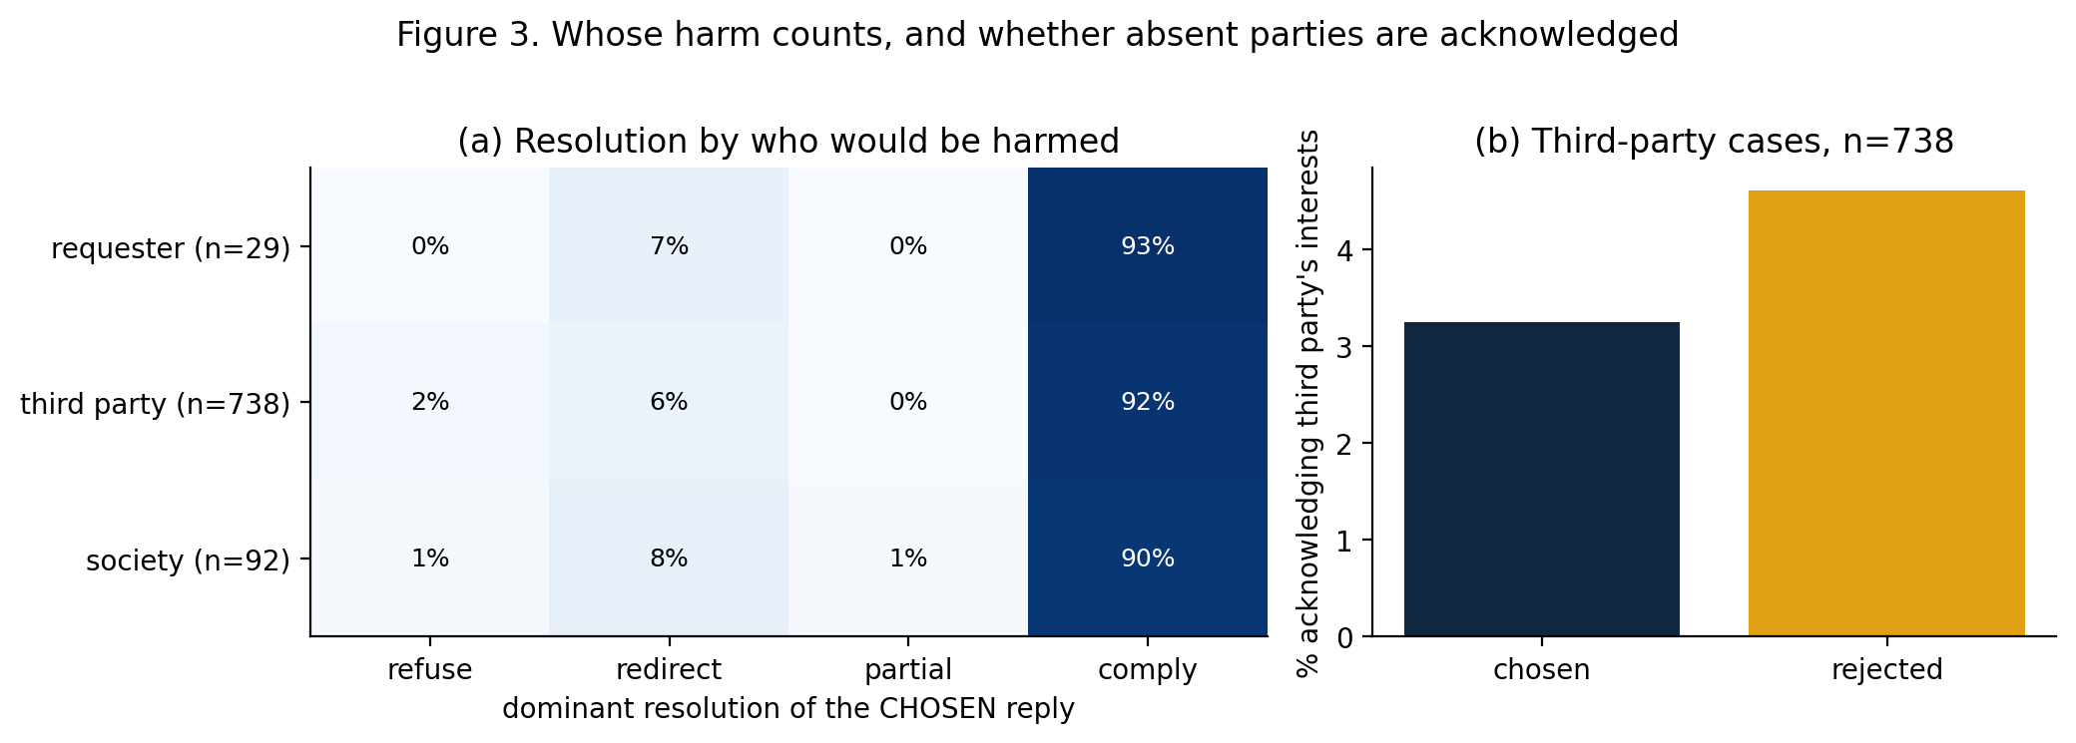
Figure 3a (left). Dominant resolution of the chosen reply by who would bear the harm, harmless subset; cells show row percentages. Figure 3b (right). In third-party cases, share of chosen vs rejected replies that acknowledge the third party's interests. Preliminary pass: compliance dominates for every harm bearer (90–93%), and acknowledgment of the third party is slightly lower in chosen replies (3.3% vs 4.6%; OR 0.69 [0.40, 1.18]).
Table 3a. Chosen-reply resolution by harm bearer (counts and row %)
Harm bearer | n | Refuse | Redirect | Partial | Comply
Requester | 29 | 0 (0.0%) | 2 (6.9%) | 0 (0.0%) | 27 (93.1%)
Third party | 738 | 17 (2.3%) | 44 (6.0%) | 1 (0.1%) | 676 (91.6%)
Society | 92 | 1 (1.1%) | 7 (7.6%) | 1 (1.1%) | 83 (90.2%)
χ² = 4.9, p = 0.56, Cramér's V = 0.05 in the preliminary pass; low refusal counts reflect both lexicon under-detection and the documented tendency of the 2022 harmless-base model to comply (Chehbouni et al., 2024).
Table 3b. Refusal and third-party acknowledgment rates per harm bearer, with 95% CIs
Harm bearer | n | Chosen refusal % [CI] | Chosen acknowledges % [CI] | Rejected acknowledges % [CI]
Requester | 29 | 0.0 [0.0, 0.0] | 0.0 [0.0, 0.0] | 6.9 [0.0, 17.2]
Third party | 738 | 2.3 [1.2, 3.4] | 3.3 [2.0, 4.6] | 4.6 [3.1, 6.1]
Society | 92 | 1.1 [0.0, 3.3] | 2.2 [0.0, 5.4] | 2.2 [0.0, 5.4]

RQ4 — Ethical contestability of preference rankings
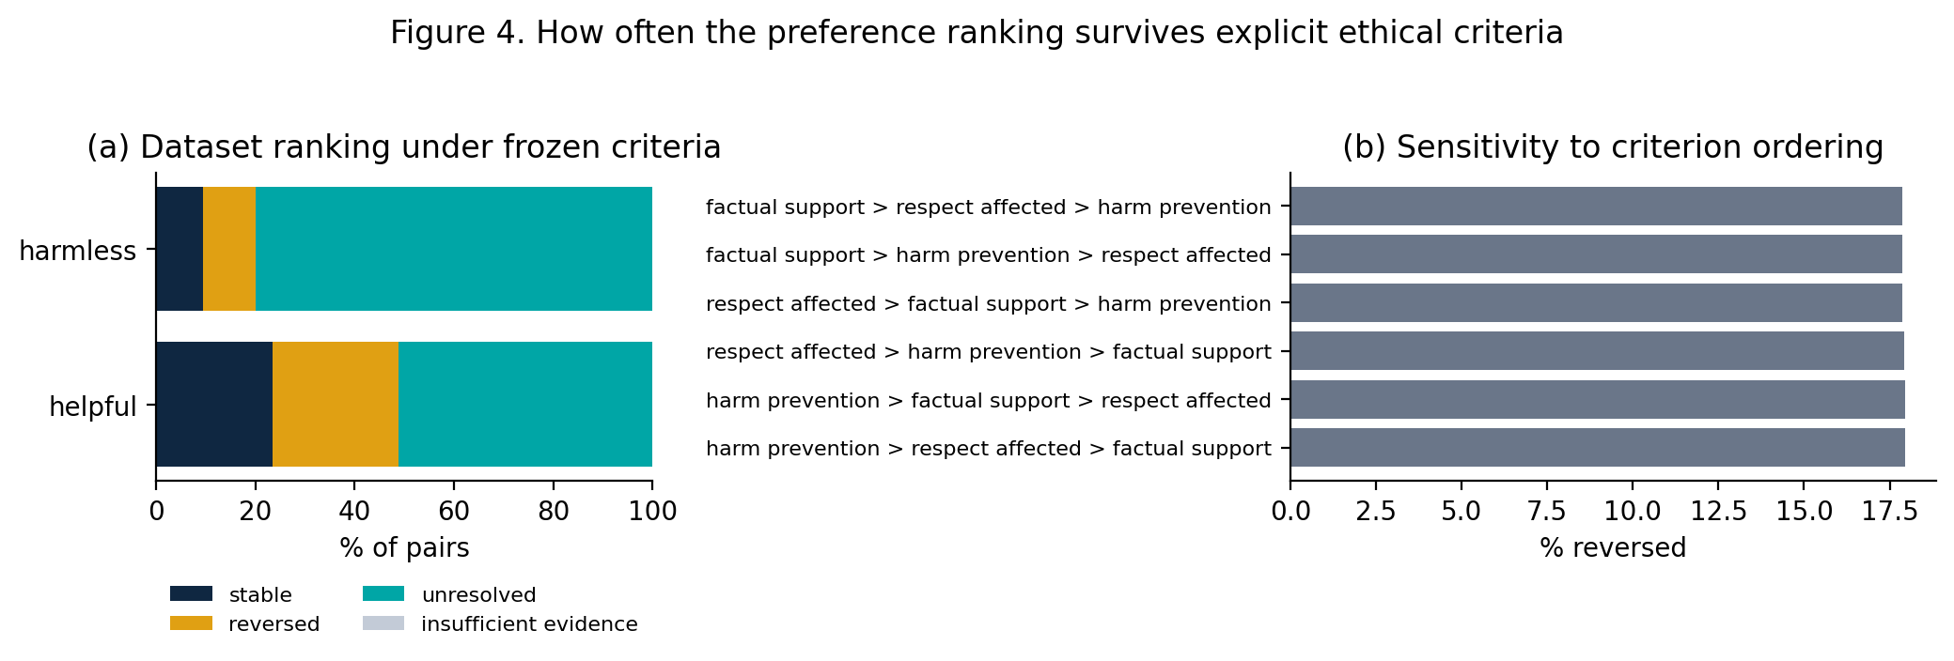
Figure 4a (left). Share of pairs whose dataset ranking is stable, reversed or unresolved under the frozen criteria (harm prevention > respect for affected parties > factual support), by subset. Figure 4b (right). Reversal share under all six criterion orderings. Preliminary pass: 18% of rankings reverse and 66% are unresolved; the orderings give near-identical results because the proxy criteria rarely apply to the same pair.
Table 4a. Outcome of re-ranking under the frozen criteria (share of pairs with 95% CIs)
Group | n | Stable | Reversed | Unresolved | Insufficient evidence
Helpful | 3,000 | 23.6 [22.0, 25.1] | 25.3 [23.7, 26.8] | 51.1 [49.3, 53.0] | 0.0
Harmless | 3,000 | 9.4 [8.4, 10.5] | 10.6 [9.6, 11.7] | 80.0 [78.5, 81.3] | 0.0
All | 6,000 | 16.5 [15.6, 17.4] | 18.0 [17.0, 19.0] | 65.6 [64.3, 66.7] | 0.0
Final version adds rows per harm bearer and splits 'unresolved' into ties vs insufficient evidence from the human codes.
Table 4b. Sensitivity of the reversal share to the ordering of the three criteria
Criterion ordering | Reversed % | Stable %
harm prevention > respect affected > factual support (frozen) | 17.95 | 16.50
harm prevention > factual support > respect affected | 17.95 | 16.50
respect affected > harm prevention > factual support | 17.93 | 16.52
respect affected > factual support > harm prevention | 17.87 | 16.58
factual support > harm prevention > respect affected | 17.88 | 16.57
factual support > respect affected > harm prevention | 17.88 | 16.57
Expected reading: with human codes, where conflict, claims and third parties co-occur, the orderings should diverge; the size of that divergence is itself an argument for publishing the ordering.
Supporting outputs (generated by the notebook)
- Provenance and data-flow tables (86,372 pairs loaded → 85,376 after exclusions → 6,000 in the computational pass).
- Eligibility counts per research question; blinded 40-pair pilot and 500-pair main coding sheets with separate key files; illustrative-case file; all figures as PDF and PNG, all tables as CSV, packaged in one zip.

4. References
Ten of the thirteen references are from 2024 or later.
Arzberger, A., Buijsman, S., Lupetti, M. L., Bozzon, A., & Yang, J. (2024). Nothing comes without its world — Practical challenges of aligning LLMs to situated human values through RLHF. Proceedings of the AAAI/ACM Conference on AI, Ethics, and Society, 7(1), 61–73. https://doi.org/10.1609/aies.v7i1.31617
Askell, A., Bai, Y., Chen, A., et al. (2021). A general language assistant as a laboratory for alignment. arXiv:2112.00861. https://doi.org/10.48550/arXiv.2112.00861
Bai, Y., Jones, A., Ndousse, K., et al. (2022). Training a helpful and harmless assistant with reinforcement learning from human feedback. arXiv:2204.05862. https://arxiv.org/abs/2204.05862
Casper, S., Davies, X., Shi, C., et al. (2023). Open problems and fundamental limitations of reinforcement learning from human feedback. Transactions on Machine Learning Research. https://arxiv.org/abs/2307.15217
Chehbouni, K., Jacobs, A., et al. (2024; rev. 2025). Beyond the safety bundle: Auditing the helpful and harmless dataset. arXiv:2411.08243v3. https://arxiv.org/abs/2411.08243
Conitzer, V., Freedman, R., Heitzig, J., et al. (2024). Position: Social choice should guide AI alignment in dealing with diverse human feedback. Proceedings of the 41st International Conference on Machine Learning. https://arxiv.org/abs/2404.10271
Cui, J., Chiang, W.-L., Stoica, I., & Hsieh, C.-J. (2025). OR-Bench: An over-refusal benchmark for large language models. Proceedings of the 42nd International Conference on Machine Learning. https://arxiv.org/abs/2405.20947
Dahlgren Lindström, A., et al. (2025). Helpful, harmless, honest? Sociotechnical limits of AI alignment and safety through reinforcement learning from human feedback. Ethics and Information Technology, 27(2), 28. https://doi.org/10.1007/s10676-025-09837-2
Kirk, H. R., Vidgen, B., Röttger, P., & Hale, S. A. (2024). The benefits, risks and bounds of personalizing the alignment of large language models to individuals. Nature Machine Intelligence, 6(4), 383–392. https://doi.org/10.1038/s42256-024-00820-y
Röttger, P., Kirk, H. R., Vidgen, B., Attanasio, G., Bianchi, F., & Hovy, D. (2024). XSTest: A test suite for identifying exaggerated safety behaviours in large language models. Proceedings of NAACL 2024. https://arxiv.org/abs/2308.01263
Sharma, M., Tong, M., Korbak, T., et al. (2024). Towards understanding sycophancy in language models. Proceedings of the International Conference on Learning Representations (ICLR 2024). https://arxiv.org/abs/2310.13548
Sorensen, T., Moore, J., Fisher, J., et al. (2024). Position: A roadmap to pluralistic alignment. Proceedings of the 41st International Conference on Machine Learning, PMLR 235, 46280–46302.
Zhang, M. J. Q., Wang, Z., Hwang, J. D., et al. (2024). Diverging preferences: When do annotators disagree and do models know? arXiv:2410.14632. https://arxiv.org/abs/2410.14632
Dataset: Anthropic. HH-RLHF: Human preference data about helpfulness and harmlessness. https://huggingface.co/datasets/Anthropic/hh-rlhf (MIT licence; accessed 26 October 2026).

