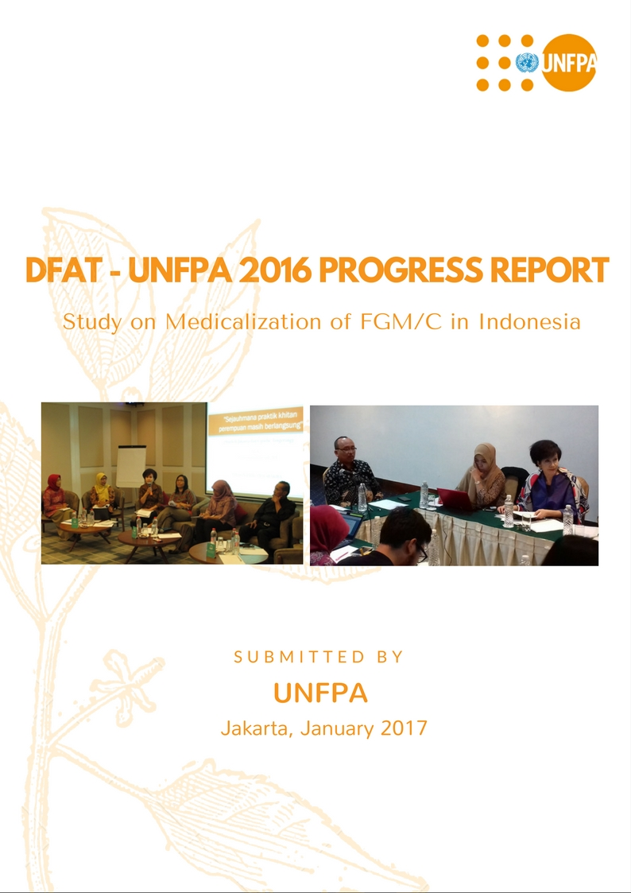

Foto caption:

* Left: Stakeholder workshop on FGM/C organized by Ministry of Women Empowerment and Child Protection with UNFPA support (Jakarta, 13 December 2016)
* Right: Validation meeting on stakeholder mapping analysis chaired by the Deputy of Child Protection – Ministry of Women Emporment and Child Protection (Jakarta, 28 December 2016)

**DFAT - UNFPA 2016 Progress Report**

**Study on Medicalization of FGM/C in Indonesia**

**Submitted: January 19, 2017**

1. **Background**

The issue of FGM/C (Female Genital Mutilation/ Cutting) remains a challenge in many countries, including in Indonesia. In Indonesia, the issue of FGM/C is complex as it is a mixture of several different issues at once, namely culture, religious belief and political interest, human rights and health. There is no clear evidence on when FGM/C was first practiced, who brought this to Indonesia, and which sub-culture started the practice. The issue of FGM/C, however, is often associated with Muslim communities since some believe that the practice is related to the Islamic teachings, although others argue that FGM/C had been practiced before the arrival of Islam in the country.

The United Nations maintains that the underlying reasons for the practice vary across cultures, between and within communities; however, under the cultural, religious and social surface, it becomes clear that the practice is deeply rooted in gender-based discrimination and harmful gender stereotypes about the role of women and girls in society (General Assembly of Human Rights Council, the United Nations, 2015). The 2013 National Basic Health Research/RISKESDAS conducted by Health Research and Development Board/Balitbangkes of MOH found that 51% of girls aged 0-11 years experienced FGM/C

In 2006, the Ministry of Health (MoH) issued a decree that banned all forms of Female Genital Cutting by medical professionals. The decree then was pressured by the Indonesian Council of Ulama (MUI), who issued a *fatwa* in 2008 declaring that the banning of FGM/C is against Islamic law. The MUI considered FGM/C as: *fitrah, syiar Islam and makrumah* (The Fatwa Commission of The Indonesia Ulema Council, 2009)*.* In 2010, the MoH issued a decree on FGM/C technical guidelines, based on the MUI fatwa, allowing medical professionals to perform FGM/C (Berita Negara Republik Indonesia, 2010 No. 672). The MoH decree was considered by many observers as a form of legitimizing the practice.

In 2014, the MoH issued a ministerial decree as quoted below, with a specific clause revoking the 2010 decree (article 1), considering the lack of health benefits and the harmful risk brought about by this practice (Berita Negara Republik Indonesia, 2014 No. 185). For many, the 2014 MoH regulation does not provide a clear stance whether Indonesia bans or allows medical FGM/C due to the existence of the article 2 of the 2014.

One of the conclusions is that there is a lack of evidence on FGM/C practices to support evidence based policy formulation. UNFPA discussed the initiative to conduct an FGM/C study, specifically the medicalization aspect with MOWE CP and MoH. The MoH, in particular, has expressed their interest in supporting the study and being involved in every step of the study. With the support of DFAT, UNFPA, in collaboration with National Commission on Violence Against Women (NCVAW) and Center for Population and Policy Studies Gajah Mada University (CPPS – GMU), is conducting the study on medicalization of FGM/C, for the period of June 2016 until December 2017.

The design of the study will use descriptive cross sectional study design applying both qualitative and quantitative approaches; utilizing structured questionnaire, in-depth interviews and focus-group discussions (FGDs) techniques amongst health workers and the community.  Samples will be drawn from 2010 Population and Housing Census. The sampling frame used is a multi stage random sampling at district level in ten provinces with 17 selected districts.

**Policy Principal to Protect the Rights of Children**

The study will be governed by the United Nations Human Rights Treaties and Treaty Bodies, notably CEDAW, CAT, and CRC. The two institutions that will be working with UNFPA, National Commission on Violence Against Women (NCVAW) and Center for Population and Policy Studies Gajah Mada University (CPPS – GMU), are valued and respected for their Human Rights perspective and commitment. NCVAW is one of the three National Human Rights Institutions in Indonesia and one of the most independent and respectable.

The DFAT Child Protection Policy Document, and the pertinent regulation of page 13 of the policy guidelines, has been shared with the researchers, reviewed and investigators will ensure that the policy will be adhered to by all research team and any person in contact with children.

1. **Progress Against the Output** 
   1. **Setting up the Arrangement of FGM/C Studies Teams**

Based on a series of discussion with National Commission on Violence Against Women (NCVAW) as one of UNFPA partners on the issue of FGM/C, it was agreed that NCVAW will conduct the Qualitative Study and National Research Institute (NRI) will conduct the Quantitative Study. A selection process of NRI was conducted and the Center of Population and Policy Study - Gadjah Mada University (CPPS – GMU) was selected based on its experiences in the issue of gender, particularly on FGM/C and in line with UNFPA’s Policy and Procedures.

The Research Associate (RA)as part of the project structure was selected and recruited according to UNFPA Policy and Procedures. The RA will act as a liaison between UNFPA, NCVAW and CPPS - GMU. The RA office will be located at NCVAW as NCVAW will coordinate all the activities, related to the study. UNFPA will maintain quality assurance throughout the study.

* 1. **Desk Review**

A Desk Review was conducted by both NCVAW and CPPS-GMU on the period of November – December 2016 on all available materials and studies related to FGM/C, including medicalization of FGM/C from other countries, at national and local level. The desk review also looked into the existing local regulations related to FGM/C in Indonesia.

The first meeting between UNFPA, NCVAW and CPPS - GMU was conducted on December 15, 2016 to discuss the result of the desk review and listed the topics for guidelines to develop the study questioners and in-depth interview.

* 1. **Government Engagement and Establishment of Consultative Team**

In addition to the study research team, in accordance to the project document, a Consultative Team will be established to have the following tasks to ensure:

1. Quality control of Study
2. Ownership of the study
3. Use of the study result for policy making and policy changes

The Consultative Team will consist of government institutions, academicians, experts, UNFPA and DFAT.

Initial meetings were conducted with the Ministry of Women’s Empowerment and Child Protection (MOWECP), MoH, Bappenas (National Planning and Development Board), and the Ministry of Foreign Affairs (MOFA), between June to August 2016, prior to the establishment of Consultative Team. The above government institutions have agreed to be members of Consultative Team.

The Consultative Team will be officially established in January 2017 during the 1st workshop that will have the objective of obtaining inputs of the desk review, design and methodology of the study from the Consultative Team members.

**2.4 Activities Completed in 2016**

|  |  |
| --- | --- |
| **Output: Study of Medicalization of FGM/C** | |
| **Activities** | **Scheduled** |
| 1. Setting up Arrangement of FGM/C Study Teams: | June – October 2016 |
| * 1. Selection and Recruitment Process of CPPS - GMU for Quantitative Study |  |
| * 1. Administrative Process of NCVAW for Qualitative Study |  |
| * 1. Selection and Recruitment Process of Research Associate |  |
| 1. Desk Review and FGM/C Studies and Literatures including the medicalization of FGM/C by NCVAW and CPPS - GMU | November – December 2016 |
| 1. Engagement with Government    1. Initial meeting with potential Ministries (MOWECP, Bappenas, MOH, MOFA) to be involved in the study as member of Consultative Teams | June – October 2016 |
| * 1. FGM/C session in the National Meeting of Indonesian Midwives Association (IBI) in collaboration with MOWECP and MOH | November 2016 |
| * 1. Meeting on SDGs Indicator related to Gender including FGM/C with SDGs Secretariat/Bappenas | August – December 2016 |
| * 1. Meeting on SDGs Indicator 5.3.2 on FGM/C by NCVAW, the Women Activist and Women’s CSO networks | December 2016 |
| * 1. Workshop and Meetings on the development of Mapping of Stakeholders on FGM/C coordinated by MOWECP | July – December 2016 |

The above scheduled activities were completed.

**3. Engagement with Government for Followup and Advocacy of FGM/C within the SDGs**

As part of International Commitment in addressing Harmful Practices and Zero Tolerance against FGM/C, Indonesia is developing a set of national SDGs Indicators on gender, including FGM/C. In June to December 2016, UNFPA and NCVAW were involved in the discussion of the gender indicators, including FGM/C, coordinated by SDGs Secretariat at Bappenas. In addition, as part of the discussion, UNFPA facilitated the group of women CSOs and activists, including NCVAW, to develop the draft of operational definition and national indicators of FGM/C. The draft document is being proposed to the SDGs Secretariat, upon discussion with the MOWECP, for further submission to Bappenas.

In relation to UNFPA support to MoH, on 3 November 2016, UNFPA, in collaboration with MOWECP and MoH, conducted a session on FGM/C during the National Meeting of Indonesian Midwives Association/IBI in Batam. The meeting was attended by 3,500 midwives with the keynote speech from the former Deputy Minister of Religious Affairs, Mr. Nazaruddin Umar, who currently is also acting as Prominent Ulama of Istiqlal Mosque. The session resulted in a set of recommendations that included the commitment of IBI, MOH and MOWECP to abandon FGM/C.

During the period of July to December 2016, UNFPA provided technical assistance to MOWECP on the Stakeholders Mapping of FGM/C. A series of meetings and workshops were conducted involving related stakeholders to discuss and provide inputs for MOWECP on the development of MOWECP next strategy in addressing FGM/C. Both, the DFAT-UNFPA and MOWECP studies on FGM/C will be used as references for the development of MOWECP Advocacy Strategy for Abandonment of FGM/C.

The Validation Meeting on the Stakeholders Mapping also agreed on a set of recommendations for the follow up discussions for SDGs indicators to be conducted in 2017, coordinated by MOWECP.

1. **Change in the Project Implementation**

Due to lengthy discussion with NCVAW on the division of roles between NCVAW and NRI, the first activity of the study on desk review started on November – December 2016. In addition to this, the CPPS – GMU is a new partner to UNFPA. Administrative procedures following the policy of UNFPA must be carried out prior to formalizing the partnership with the institution once selection is made. The administrative process took a long time that resulted in the delay of project implementation. The delay of the first activity, impacted on the change of the project implementation schedule. Based on discussion with both, NCVAW and CPPS - GMU on the new activity schedule, realistically, the study will be completed by November 2017 (including the availability of an evidence based Policy Brief). The formal letter for No Cost Extension of the Project Implementation will be sent by UNFPA to DFAT on January 2017.

1. **Challenges**

Challenges that related to start up of the project are discussed above, action taken and mitigation strategy regarding completion of the project is discussed under Section 4.

Several challenges that are foreseen during data collection include:

1. Sensitivity of the issues may impact on the willingness and possibility of rejection and reluctance among the respondents during data collection
2. Potential language barrier during the information gathering on the qualitative field study may impact on the quality of the information.

Other Challenges:

1. Capacity of MOWECP as Coordinator for FGM/C related issues
2. Government willingness to acknowledge FGM/C is an issue of harmful practices in Indonesia
3. Discriminative Local Regulation imposed by Local Government to gain revenue from FGM/C services in more than 10 districts in Indonesia
4. **Revised Action Plan for 2016 - 2017**

| **Activity** | **Timeline** |
| --- | --- |
| Recruitment of NRI | November 2016 |
| Desk Review | November-December 2016 |
| Ethical Clearance | 2nd week of January 2017 |
| Workshop to review the desk review, and finalise the proposed methodology (sampling and questionnaire) (2 days) | 26 - 27 January 2017 |
| Finalization of Desk Review | 6 - 7 February, 10 - 12 |
| Workshop and consultative group meeting on methodology and instrument (sampling, questionnaire, research question guideline and manual ) (3days) | 8 - 10 February 2017 |
| Pre-testing research instrument in Central Java Province (2 district Kudus/Jepara and Solo) | 13-17 February 2017 |
| Workshop on the Finalization of Research Instrument and Preparation of Field work | 1- 2 March |
| Training of Trainers | 6-10 March 2017 |
| Training for Field Assistance | 3rd week of March 2017 |
| Monitoring Training for Field Assistance (4 days) | 13-17 March 2017 |
| Data Collection (qualitative and quantitative) include supervision of data collection | 20 March-22 April 2017 |
| Data Management | 25 April -20 May 2017 |
| Report writing (qualitative) | 13-16 June 2017 |
| Workshop Report Writing (quantitative) | 4th week of May – 4th week of June |
| Validation meeting of Draft Report Study | 4-7 July 2017 |
| Finalization of Report (Qualitative) | 11-14 July 2017 |
| Dissemination of Study Result (workshop) | 3 August 2017 |
| Meeting for Policy Brief Development | 15 August 2017 |
| Consultative Meeting for Development of policy brief | 5 - 7 September 2017 |
| Validation Meeting for Policy Brief | 13 - 16 September 2017 |
| Policy Brief Printed | 3rd week of October 2017 |
| Final Report of Project | 4th week of October 2017 |

1. **Budget Expenditure**

**DFAT has transferred the budget to fund the activity of “Study of Medicalization of FGM/C in Indonesia” amounting AUD 499,470, and it has been fully received by UNFPA, converted to USD amounting USD 380,403.**

**In 2016, UNFPA expenditure included USD 7,563 to support the programme and management costs related to the study of medicalization of FGM/C in Indonesia.**

**In 2017, the remaining budget is divided with two implementing partners (NCVAW and CPPS-GMU) as well as UNFPA with details as follow:**

|  |  |  |  |  |  |
| --- | --- | --- | --- | --- | --- |
| **No** | **Name of Activity** | **Amount** | **NCVAW** | **CPPS-UGM** | **UNFPA** |
| **1.** | **Recruitment of research team** | **37,330** | **8,332** | **24,911** | **4,087** |
| **2.** | **Development of questionnaires survey and qualitative guidelines** | **7,772** | **6,291** | **1,481** |  |
| **3.** | **Data collection for monitoring supervision** | **134,960** | **41,446** | **84,315** | **9,199** |
| **4.** | **Workshop for monitoring of supervisor and enumerator's training** | **20,306** | **1,109** | **17,393** | **1,804** |
| **5.** | **Pre-test for survey instruments** | **20,201** | **7,228** | **11,770** | **1,203** |
| **6.** | **Report writing and dissemination** | **22,470** | **22,470** |  |  |
| **7.** | **Policy brief development** | **36,342** | **22,755** | **778** | **12,809** |
| **8.** | **Programme and management costs (incl. indirect cost)** | **93,459** |  | **4,630** | **88,829** |
|  | **Total** | **372,840** | **109,631** | **145,278** | **117,931** |

**Conclusion**

Pending No Cost Extension request to DFAT, the project should be able to be delivered by August 2017 with valid results to inform SDG Advocacy Strategy for inclusion of the appropriate indicator, for development of the policy brief and subsequent relevant MOH policy change and for implementation of that policy change in the Health Profession and beyond. The results will also inform the MOWECP Advocacy Strategy for abandonment of FGM/C.