## MDSP Tutorial #1

1. Read any mp3 song and store in matrix form.

2. Compute the direct DFT of the matrix, first segment wise of length 128, and then increase by factor of 2.

3. Then find the FFT (you can use fft command in toolbox) and compare the computational timing between two.

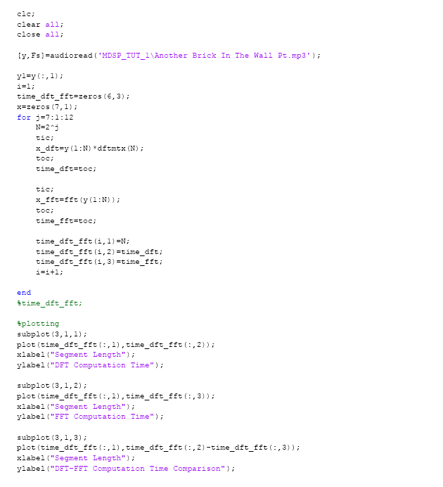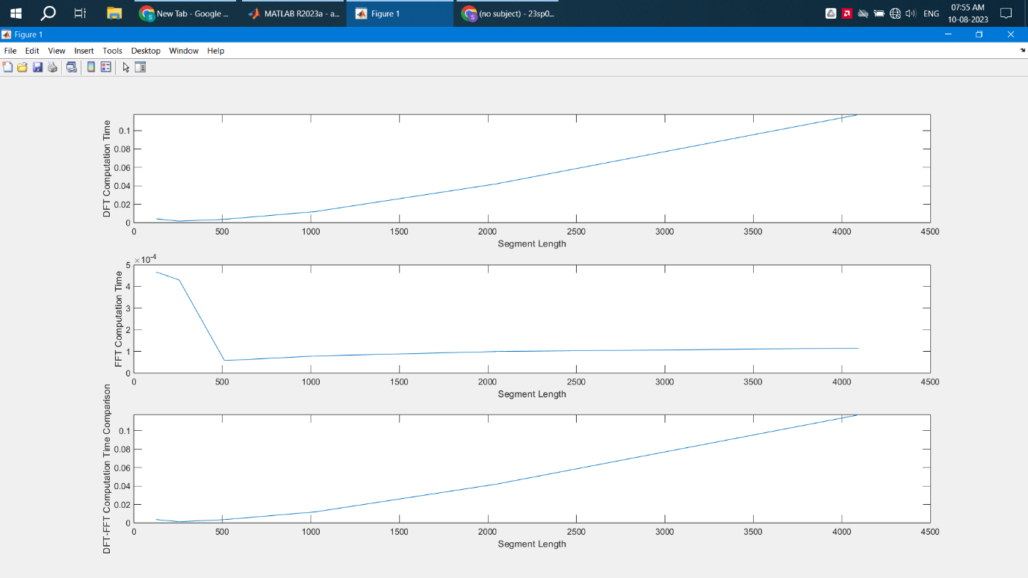

**Conclusion**: Thus, we have performed N-point DFT and FFT using MATLAB. For our tutorial we have taken N=128, 256, 512….4096. We have also sketched the graphs for timing analysis of DFT and FFT.

We found that as segment length(N) increases, the computation time for DFT increases, almost linearly but for FFT we see that the computation time remains almost the same.