# ASHTABULA LIZARD WRESTLING

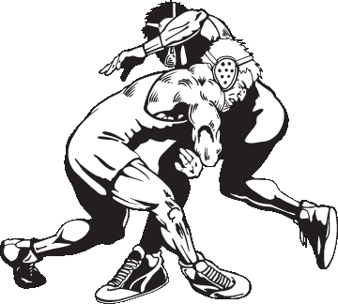

**WHO ARE WE?** ASHTABULA COUNTY’S LARGEST YOUTH WRESTLING TEAM, AND A MEMBER OF THE OHIO YOUTH WRESTLING ASSOCIATION, IN THE NORTH COAST DIVISION.

**WHO’S ELIGIBLE?** ASHTABULA COUNTY BOYS AND GIRLS AGES 5-12, WHO ARE IN KINDERGARTEN THROUGH 6TH GRADE.

**WHAT DO WE TEACH?** THE SPORT OF WRESTLING AND THE IMPORTANCE OF GOOD SPORTSMANSHIP AND RESPECT, IN A FUN AND SAFE ENVIRONMENT.

**EQUIPMENT NEEDED:** WRESTLING SHOES AND HEADGEAR.

**COST:** $70 PER PARTICIPANT, AND INCLUDES AAU MEMBERSHIP.

**WE INVITE YOU TO JOIN US!** COME CHECK OUT WHO WE ARE AND WHAT WE DO! OPEN MATS START OCTOBER 5TH 5:30-7:30, AND WILL BE HELD EVERY THURSDAY AT EDGEWOOD HIGH SCHOOL. OPEN MATS ARE FREE OF CHARGE AND OPEN TO ANYONE FROM ANY TEAM OR SCHOOL AGES 5-17. (WAIVER WILL NEED TO BE SIGNED)

**OFFICIAL SIGN UPS** ONLINE @ [WWW.LIZARDWRESTLING.COM](http://www.lizardwrestling.com) OR EACH THURSDAY AT OPEN MATS 5:30-7:30 @ EDGEWOOD HIGH SCHOOL WRESTLING ROOM. REFER TO WEB PAGE FOR DIRECTIONS.

CHECK US OUT ON FACEBOOK: LIZARD WRESTLING www.facebook.com/lizardwrestling

FOR MORE INFORMATION, MESSAGE US ON FACEBOOK OR CALL TEAM MOM PRISCILLA FRASURE (440)858-7546