THE END OF THE WORLD (1/10)
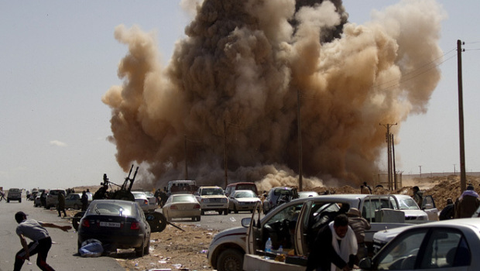
Morselli, Enrio Dysmorphophobia and taphephobia- two hitherto undescribed forms of Insanity with fixed ideas Journal of the American Psychoanalytic AssociationHistory of Psychiatry 2001 Pg 108
Damien McElroy, Ziltan7:03PM BST 09 Aug 2011 Libyan officials claim 85 dead in Nato airstrike http://www.telegraph.co.uk/news/worldnews/africaandindianocean/libya/8691801/Libyan-officials-claim-85-dead-in-Nato-airstrike.html

McDonnell, Patrick J. Libya: Nato admits civilian deaths as Gaddafi regime claims propaganda coup
June 19, 2011 Los Angeles Times http://articles.latimes.com/2011/jun/20/world/la-fg-libya-nato-20110620

McDonnell, Patrick J. Libya: Nato admits civilian deaths as Gaddafi regime claims propaganda coup
June 19, 2011 Los Angeles Times http://articles.latimes.com/2011/jun/20/world/la-fg-libya-nato-20110620

OIL! (2/10)
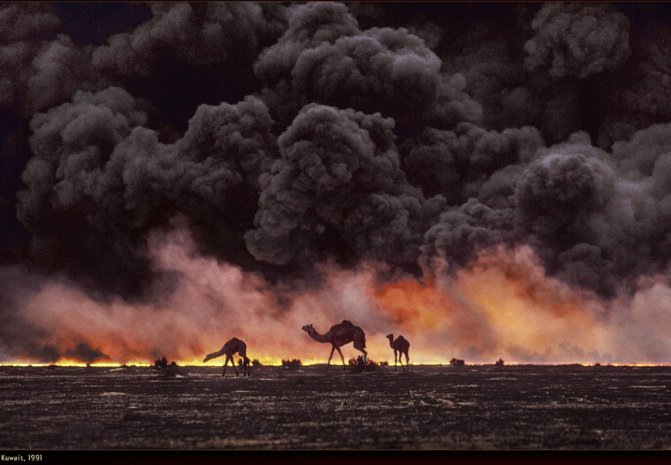
As the world’s oil supplies rapidly diminish, US officials were encouraged to install a new regime to profit oil corporations (Oasis Group, Conoco Phillips, and Marathon Oil) and private security contractors, conditioning Libya to be subject to ‘efficient exploitation,’ a euphemism for invasion, pillage and plunder, conquer, poverty, and open elections! Protecting Libyans was the pretext for invasion, not the purpose.
Secret US Embassy documents from 2007 argue
“requires extensive foreign investment... demonstrating the clear downsides to the GOL.”
A NEW WORLD ORDER (3/10)

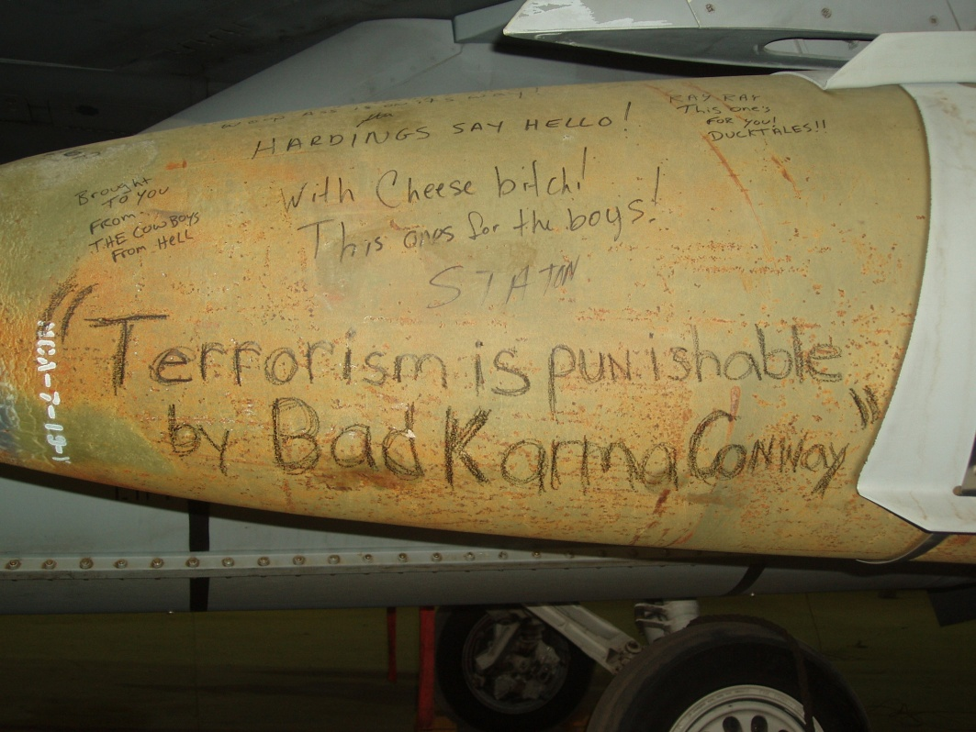
The NATO invasion was not about defending democracy, but was a civilizing mission to coerces Libyans into the globalized market economy administered by the transnational elite.

John Sargis 11

“ war against Libya being carried out by … but around the world.[2]
NOW LETS BE CIVIL (4/10)

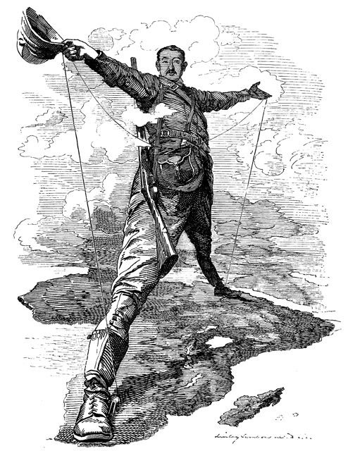

Democracy is forsaken in the name of defending, expanding, and ruling the US empire as the par excellence of human civilization. Once the hegemony of civilization becomes the apriori condition for democratic deliberation, then people in Libya can only practice democracy as long as it is in the US’s interest.
David Palumbo-Liu 02
“conditions for a participatory democracy are worsening …the other side of civilization can remain only …"
NATURE DOESN’T DO BAILOUTS! (6/10)
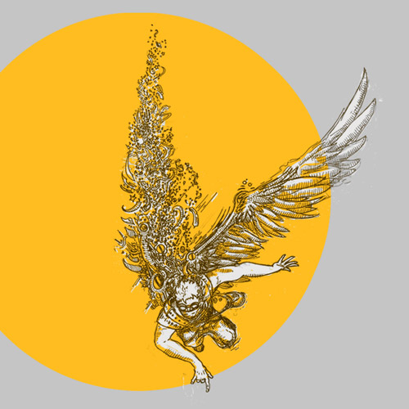
The maintenance of this order is premised on the civilized/uncivilized dichotomy, where those deemed civilized receive the privileges and power over democracy while the uncivilized are deemed outside our ethical responsibility. The Libyans who died before the National Transition Council’s establishment are erased from the history of ‘human progress’, as their deaths are considered “NECESSARY” for the expansion of Libya’s integration into civilization. The seemingly isolated slaughter of people in Libya and exploitation of oil resources threatens our ethical responsibility to all others and the ecosystem.
Rebecca Garcia Lucas Rose 06,
The denial of human-nonhuman …from the perception of human-nonhuman hyper separation.
A JOURNEY ACROSS SPACE AND TIME (5/10)

If we were to sit in this room and imagine the last few centuries pass by us, the story of the US in Libya resembles the directions on a Head and Shoulders shampoo bottle:
1.Wet hair 2. Massage onto scalp 3. Rinse 4. Repeat if desired

[ Head and Shoulders, pyrinthione zinc. Dry Scalp Care with Almond Oil
PATRICIA M. MUHAMMAD, J.D. University of Baltimore School of Law, 2004 (American University International Law Review, “The Trans-Atlantic Slave Trade: A Forgotten Crime Against Humanity as Defined by International Law”, 19 Am. U. Int'l L. Rev. 883
Historical Boy’s Clothing Ending the Atlantic African Slave Trade 8/10/2005 http://histclo.com/act/work/slave/ast/ast-atle.html
Herold, Marc. W A Dossier on Civilian Victims of United States' Aerial Bombing of Afghanistan: A Comprehensive Accounting Ph.D., M.B.A., B.Sc. Departments of Economics and Women's Studies Whittemore School of Business & Economics 2002
Churchill, Ward, and Jim V. Wall. Agents of Repression: the FBI's Secret Wars against the Black Panther Party and the American Indian Movement. South End, 1988.]
Rinse, repeat, rinse, repeat. Going forward, not backwards, upwards not forwards, and always twirling twirling TWIRLING towards freedom.
ADVOCACY (7/10)
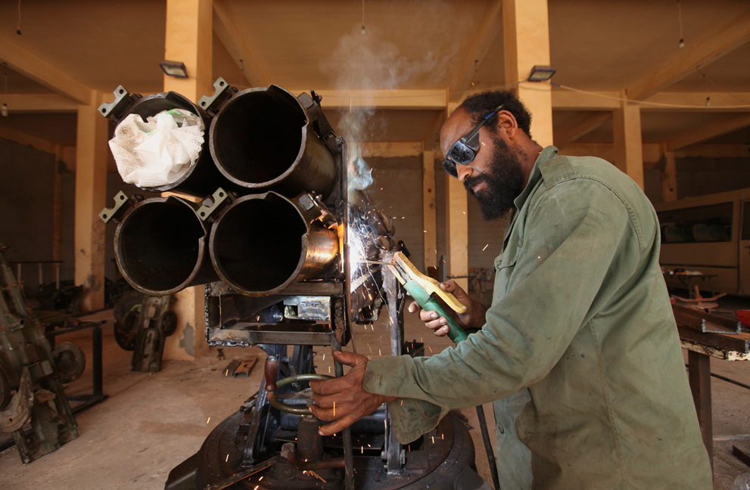
The questions posed by the Libyans who lived through the NATO bombings are as unanswerable as the past atrocities of the US, as unanswerable as the questions posed by the topic. Though one may read the topic as a call for USFG action, we find that there exists an overlooked paradox within US democracy assistance: What is democracy if the US protects democracy by forswearing democracy?
The question evokes a labyrinth: self-referential, devoid of meaning, everything and nothing.
It is within the surreality of this endless maze that…
LEE AND I AFFIRM DEMOCRACY SHOULD BE DISASSEMBLED.

The NATO invasion of Libya was based on a singular notion of democracy that presupposes US interest as apriori condition for democracy. To disassemble democracy is to affirm a space in which people can self-determine for themselves what democracy is without the imperial imposition of the US.
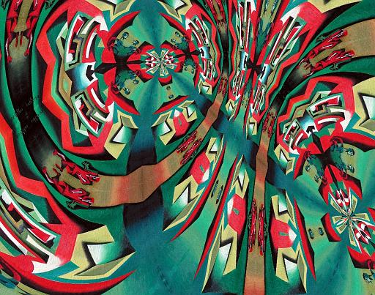 (8/10)
In order to discuss what democracy is, the term must be lighter than air, taking leave of the earth to become only half real, as free as it is insignificant. We must reinvent the fiction of democracy into the surreal, to exist within the void of its own utterance so that it can be self-interrogated. It must be nothing in order to be everywhere.

Hans Varghese Matthews 03,

the de-realization of democracy …unworthy of the democratic process.
THIRD-EYE VISION, FIVE-SIDE DIMENSION (9/10)
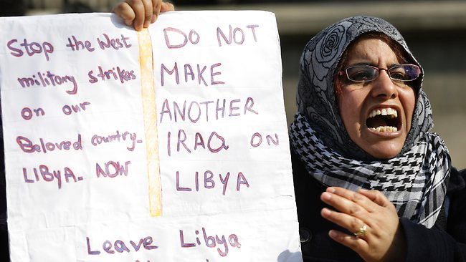
Mokhefi, 11 Gaddafi's regimein relation to Libyan tribes Mansouria Mokhefi March 2011 Thursday 17 http://amec.org.za/index.php?option=com_content&view=article&id=218:gaddafis-regime-in-relation-to-libyan-tribes&catid=69:north-africa&Itemid=90

Karon Tony In Post-Gaddafi Libya, Freedom is Messy- and Getting Messier January 4, 2012 http://globalspin.blogs.time.com/2012/01/04/in-post-gaddafi-libya-freedom-is-messy-and-getting-messier/

This is the imposition of the sovereign, where democracy is defended to foreswear democracy. Our response through our advocacy is to give up our own sovereign authorship over the terms that have been imposed on Libyans, as an affirmation of an affective communality.

Matthews 11
The Derridian Performative & the Foundation of the Interim Transitional National Committee for Libya Author: Daniel Matthews Critical Legal Thinking Law & the Political Posted on October 10, 2011.
http://www.criticallegalthinking.com/?p=4408

response to the situation in Libya is guided by … declarative voice by the National Transition Council’s”

??? (10/10)

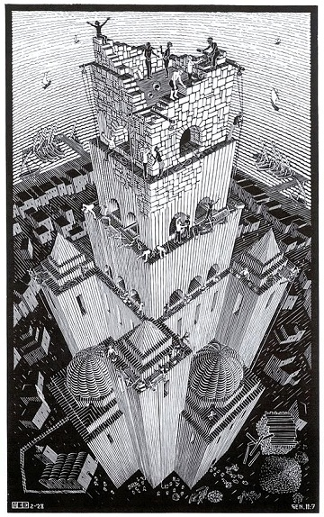

De-realizing the term democracy prompts confusion over what democracy means, which challenges the sovereign control over democracy. We abandon any rigid or static conception of what democracy is or can be. It is to affirm the death of our authorship, an unconditional gift, so that people in Libya can claim their own conception of democracy.

Ian Almond 04,

Sufism and Deconstruction: A Comparative Study of Derrida and Ibn ‘Arabi. By Ian Almond. . London: Routledge, 2004.
http://www.seekeraftertruth.com/sufism-and-deconstruction-the-honesty-of-the-perplexed/

desire to ‘universalise their idiom’…impose a single, reductive image onto the Other

Sturgis, Sue U.S. oil companies, security contractors look to Libya http://southernstudies.org/2011/10/us-oil-companies-security-contractors-look-to-libya.html Mon, 10/24/2011 Institute for Southern Studies
Security Contracting Network The New Libya; What It Means To You October 22, 2011 https://securitycontracting.net/network/2011/10/libya-means/
US Embassy, Wikileaks Subject: Scenesetter for Secretary Rice’s Visit to Libya Classified: Secret 2008-08-29 US Embassy, Tripoli http://wikileaks.org/cable/2008/08/08TRIPOLI680.html#
JOHN SARGIS The Obama doctrine, the transnational elite and the NATO attack on Libya The International Journal of INCLUSIVE DEMOCRACY, Vol. 7, No. 1 (Winter-Spring 2011)
Palumbo-Liu, David 02 (Multiculturalism Now: Civilization, National Identity, and Difference Before and After September 11th David Palumbo-Liu boundary 2 29.2 (2002) 109-127
Garcia Lucas Rose 06 Human Rights: An Earth-based Ethics Rebecca Garcia Lucas Rose 146-147 COLLOQUY text theory critique 12 (2006). © Monash University. www.colloquy.monash.edu.au/issue12/rose.pdf
Head and Shoulders, pyrinthione zinc. Dry Scalp Care with Almond Oil
Farred, Grant Disorderly Democracy: An Axiomatic Politics CR: The New Centennial Review Volume 8, Number 2 Fall 2008 muse.jhu.edu/journals/ncr/summary/v008/8.2.farred.html
Hans Varghese Mathews 2003 The Frontline: Subaltern Man Pg 4-5

