Chapter 1 – Try to Stand Out, We Bludgeon Ya Feet

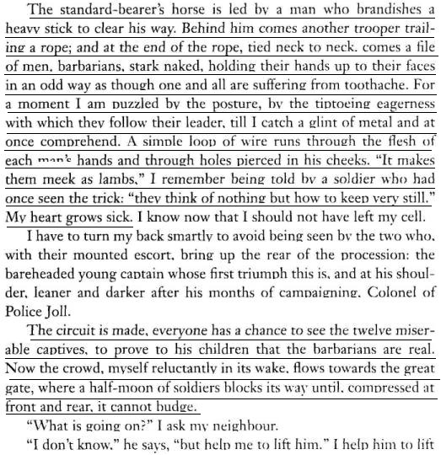
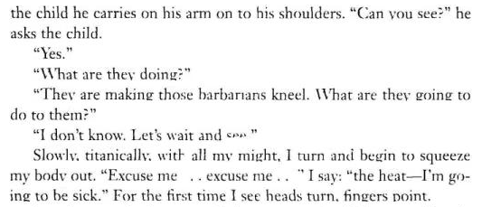

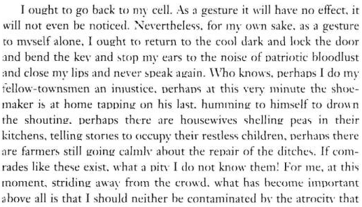
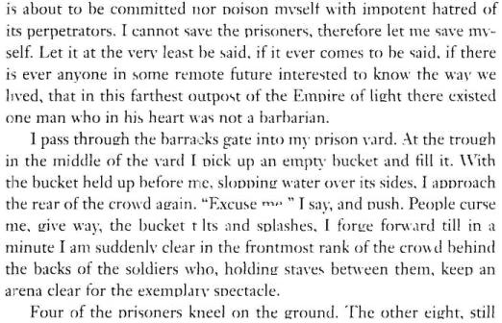
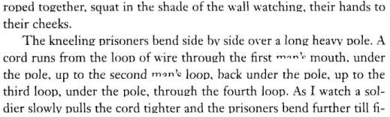
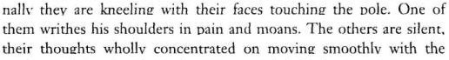
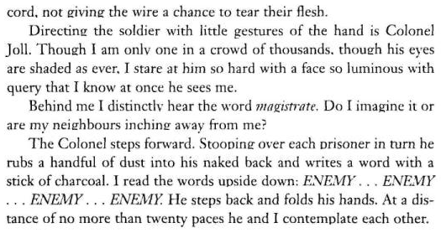
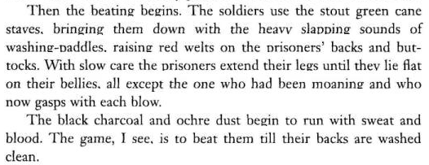
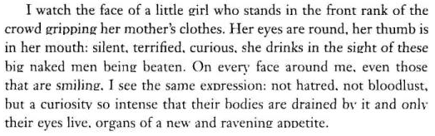
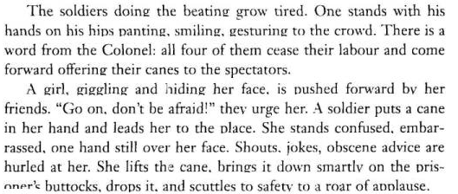
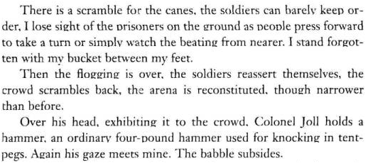
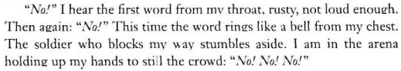

While written in 1980 in apartheid South Africa, J. M. Coetzee’s Waiting for the Barbarians is an apt allegory for the relationship America maintains today with the “terrorist threat”. Far from an unambiguous military project waged against clearly designated enemies, the War on Terror exists as a frantic attempt to seek out, expose and eradicate the elusive, freedom-hating enemy that lurks behind every corner and poses the absolute threat to our ordered, civilized way of life. President George W. Bush could not have put it in clearer terms when on September 11th of this year he asserted “This struggle has been called a clash of civilizations. In truth, it is a struggle for civilization. We are fighting to maintain the way of life enjoyed by free nations. And we're fighting for the possibility that good and decent people across the Middle East can raise up societies based on freedom and tolerance and personal dignity.” Thus we too are waiting for the barbarians, impatiently molding out the contours of an enemy identity that will draw a distinct line between good Muslim and bad Muslim, civilized and savage, democracy and violence. Integral to our mission of civilization, then, is the quest to absolutely Know and thus destroy the difference that throws our imperial demarcations into crisis.

Exemplary of this drive to Know is the United States’ Supreme Court decision in Ex Parte Quirin to designate all enemy belligerents in war who lack uniform as “unlawful combatants”. This illegalization of the uniformless belligerent speaks to our frenetic obsession with making difference transparent and subsumable into our absolute understanding of the world at large. Without a uniform, the designating marker of sovereignty and legitimacy, this project is thrown into disarray. Thus it is no coincidence that Ex Parte Quirin is the legal precedent used by the Bush administration to detain and torture those captured in the War on Terror. Torture exists as the move to make others transparent, to reduce them to and thus render truth from the physical site of their bodies. As colonel Joll notes in the beginning of the novel on the process of torture, “First I get lies, you see – this is what happens – first lies, then pressure, then more lies, then more pressure, then the break, then more pressure, then the truth. That is how you get the truth. Pain is truth; all else is subject to doubt.”

In this way, Ex Parte Quirin exists as a site of production for uniformity. Because in the absence of a homogeneous sovereign signifier, Ex Parte Quirin, much like the charcoal stick and cane staves in the novel inscribes uniformity onto and extracts it from the body of the transgressors through torture and punishment.

This spectacle of pain and truth, civilization and barbarity finds its corollary in Bush’s recent statement that “The terrorists fear freedom as much as they do our firepower.” What is made clear here is that behind the punishment and eradication of the barbarian enemy is an empire of freedom and our passive cooperation in its representational and structural assembly is integral to its accomplishment. In this way we have been rendered onlookers in the crowded theatre of American politics, taking perverse pleasure in the obscene underside of security.

Chapter 2 – An Abolition Democracy Speaks to Another Justice

But is this figure of the terrorist so foreign? Is this spectacle of insecurity that we foist on real people relegated to exotic lands that uniquely house supposed “agents of unfreedom”? Far from an abberation of democracy or response to external events, the War on Terror is an international extension of our domestic carceral system, of America’s War on Crime. The figure of the terrorist is really only the figure of the criminal, the original barbarian who must be brutally punished in the hell of the penitentiary. As Angela Davis notes:

We tend to think about torture as an aberrant event. Torture is extraordinary and can be clearly distinguished from other regimes of punishment. But if we consider the various forms of violence linked to the practice of imprisonment—circuits of violence linked to one another—then we begin to see that the extraordinary has some connection to the ordinary. Within the radical movement in defense of women prisoners’ rights, the routine strip and cavity search is recognized as a form of sexual assault. As activists like Debbie Kilroy of Sisters Inside have pointed out, if uniforms are replaced with civilian clothes—the guard’s and the prisoner’s—then the act of strip searching would look exactly like the sexual violence that is experienced by the prisoner who is ordered to remove her clothing, stoop, and spread her buttocks. In the case of vaginal and rectal searches, routinely performed on women prisoners in the U.S., this continuum of sexual violence is even more obvious.
To break free of this blackmail, as you put it, to move beyond the permissible terms, it might be helpful to consider the connections between everyday prison violence and torture. Of course, we know that some of the military personnel involved in the Abu Ghraib scandal had previously served as prison guards in domestic prisons. This points to a deeper connection between the situation at Abu Ghraib and domestic imprisonment practices. It is not a coincidence that Charles Garner, recently tried and convicted for his role in the tortures, had been employed as prison guard at SCI-Greene, the facility where death row prisoners—including Mumia Abu Jamal—are housed in Pennsylvania. As a matter of fact there were at least two lawsuits filed against him for abuse within that prison. Of course I don’t want to suggest that Garner’s previous history as a prison guard is a sufficient explanation for the tortures at Abu Ghraib, especially if such an argument is used to absolve the military hierarchy and the Bush government of responsibility. Rather I am attempting to highlight the links between the institution of the military prison and that of the domestic prison. What is routinely accepted as necessary conduct by prison guards can easily turn into the kind of torture that violates international standards, especially under the impact of racism. Fanon once made the point that violence is always there on the horizon of racism. Rather than rely on a taxonomy of those acts that are defined as torture and those that are not, it may be more revealing to examine how one set of institutionalized practices actually enables the other.

[She Continues 6 Pages Later]

The prison-industrial-complex embraces a vast set of institutions from the obvious ones, such as the prisons and the various places of incarceration such as jails, “jails in Indian country,” immigrant detention centers, and military prisons to corporations that profit from prison labor or from the sale of products that enable imprisonment, media, other government agencies, etc. Ideologies play a central role in consolidating the prison-industrial-complex—for example the marketing of the idea that prisons are necessary to democracy and that they are a major component of the solution of social problems. Throughout the world, racism has become embedded in imprisonment practices: whether in the U.S., Australia, or Europe, you will discover a disproportionate number of people of color and people from the Global South incarcerated in jails and prisons. The everyday tortures experienced by the inhabitants of domestic prisons in the U.S. have enabled the justification of the treatment meted out to prisoners in Abu Ghraib and Guantánamo. As I said earlier, it was hardly accidental that a U.S. prison guard like Charles Garner was recruited to work in Abu Ghraib. He was already familiar with the many ways prison objectifies and dehumanizes its inhabitants.

Thus we can advocate to overrule Ex Parte Quirin not as a finite call to end some sort of violence we can only witness in exotic settings like Cuba and Iraq, but as a more radical advocacy of justice that exists as a demand for no more prisons, for an ethics that leaves us unendingly open and responsible for others without a narcissistic obsession for our own security.

