Acorn Prodigey and J-O

Cross Eyed 1ac
Current space policies aren’t conducive to a common heritage approach
Peterson 05
Speaks about how the conceptualization of space beyond the mesosphere currently doesn’t acknowledge the idea of the commons and don’t have the approach of the commons they just approach however one pleases and Gendreau 2 speaks about how people think space is used as the Commons but how that thought is just an illusion and when more people gain access to that space beyond the mesosphere it will be imperialistically attacked with the major countries as the beneficiaries and other countries at the bottom of the food chain.
Milun 10 space policy is based on the epistemology of enclosure. The United states administrations argued that outer space should be considered “empty space” so when debaters advocate the use of the usfg they are advocating the idea of empty space and Siddiqi History Prof 2010 says that this view/narrative of outer-space as empty space produces an American space policy dedicated to national conquest, dominance, and technological control. Let this not be the mindset to shape the discussions of policy debate. LET THIS NOT BE THE MINDSET ROOTED IN OUR DEBATE ROUNDS. LET US NOT AIM FOR THE CAPATILIST INTEREST BUT RATHER FOR THE BENEFITS THAT HELP BODIES THAT ARE NOT PRIVALEGED. The counter idea that Milun 10 speaks about involves respecting “outer space” as the Common heritage because that causes equal distribution of common resources.
Working to recognize the global commons is the only way to solve for environmental degradation Falk 00 The international cooperation between countries works together to stop environmental degradation which not only benefits the humans but plants and animals as well.
The idea of the Commons leads to co-op between countries decreasing the chance of war and increasing the time people will have to solve the problems within countries this is from the Center for New American Security 2010
Zizek 08 has this idea that modern racism is no longer based on the ideologies of cultural or natural superiority but economic egotism and that is the root of modern racism so by disarming this weapon of economic egotism we destroy this ideas racism
Giroux proves that our speech act is significant and our solvency is inevitable by proving the debate space is a political pipeline to the outside world

What is the Commons?

How the commons should look like -
Shackelford, Scott ( J.D. Candidate (2009) at Stanford Law School and a Ph.D Candidate in International Relations at the University of Cambridge.) ’08 “The Tragedy of the Common Heritage of Mankind” February 2008 http://works.bepress.com/scott_shackelford/1
Although no universally agreed upon definition of the CHM principle has been reached by legal scholars or policymakers, a working definition would likely comprise five elements. First, there can be no private or public appropriation; no one legally owns common heritage spaces.70 Second, representatives from all nations must manage resources since a commons area is considered to belong to everyone. The role of governments then is relegated to being a representative of the people. As popular management is practically unfeasible, a special agency to coordinate shared management must administer commons spaces in the name of all mankind.71 Third, all nations must actively share with each other the benefits from the commons heritage region. Private entities seeking profits would have to perform a service that benefited all of mankind. Equitable distribution is intrinsic to the principle, but the application is ambiguous necessitating a balance between economic benefit-sharing and environmental protection. Fourth, there can be no weaponry or military installations established in commons areas. Armed conflict is unlawful since every nation has a stake in maintaining the peace. Finally, the commons should be preserved for the benefit of future generations, and to avoid a “Tragedy of the Commons” scenario.72

NEXT
Space beyond the mesosphere is not the only thing not viewed as common. The debate space is viewed as space that privileges different people making debate unequal and racist. Viewing the debate space as common space or common ground not only challenges these ideas of white supremacy, all these forms of oppression and privileged space, it makes the debate space more inclusive.
Niraj Warikoo 10 highlights that residents are trying to find common ground and it is about recognizing that we share common ground and building that foundation to achieve a greater understanding of each other. THIS IS SO IMPORTANT we need to build that foundation now!
Then Vizier backs this claim and says connecting with people is a basic human need. One of the ways of forming this connection is to find common ground. No matter how different and unique people are, there is bound to be common ground is you make the effort to look for it. With common ground comes common understanding. The debate space should be this place for common ground and understanding as a way to create better policy making. My partner and I highlight this idea by using our Hip Hop narrative. A solid foundation needs time and effort to build.
Advocacy
Thus Tyler and I advocate to view space as the common heritage of humankind in the same way that there should be common debate space accessible not just to a privileged few but to also those whose voices, needs, and cultures are frequently marginalized socially, economically and politically. Simultaneously defending the metaphorical and literal interpretation of space is key to theoretical and concrete education and challenging exploitive, exclusionary and unjust mentalities and policies beyond the mesosphere and in our debate spaces. We do this through our methodology of recognizing our personal power and agency as youth, as debaters, and as hip hop practitioners (or artists), to pull our voices out of the margins to educate and influence others to create significant change rooted in social justice and equality. The development of our knowledge is informed by the three-tiered process which values the intellect, wisdom, experiences and visions from our personal lives, organic intellectuals, and academic intellectuals. Shout out to Quiroz Martinez, Hip-Hop Pioneers, and Dr. Shanara Reid-Brinkley for continuously droppin science.

Role of the ballot/Power of the ballad
Judge, your ballot empowers you not only become a tester of the competition of policy but also become a critical intellectual/activist. Your ballot functions as a mechanism to affirm to our personal power thereby increasing it. It also highlights the good work being done to break down structural racism and oppression and it affirms the importance of the metaphorical and literal interpretation of space to our education about the topic and to the importance of our own cultures, remembering and honoring who we are, where we came from, and what we can become as long as we are allowed to grow within debate without checking our cultures at the door. This affirmation educates and opens the doors for all those who may not see themselves in the debate space because your ballot says that they belong here too, with you, with our opponents, with us, within the debate community.

Thus the framework for the round is who best moves away from this unidimentional state centric analysis, allows for a regaining of personal power, creates the most liberation for the oppressed voices in the debate round, and best challenges this imperialist and capitalist mindset created by the context of the resolution
This state centric analysis the resolution creates feeds into this apocalyptic discourse that is not directed at preserving life but instead preserving the dominant position of government officials and an insecure middle class…making us lose our personal agency and silence oppressed voices
Smith ‘7 (Anna Marie, Prof. Gov’t @ Cornell U, “Welfare Reform and Sexual Regulation,” Cambridge University Press, p. 15) vp

Framework is an argument about the way that we debate and how a debate should be viewed for educational purposes. We will argue that personal agency, which is my own power as an individual to make change, is the most important element for the framework of this debate. This means education is the most important thing in this debate, because the debate becomes about the individuals in the room. The resolution is a point of departure for the individuals in the room because it makes the state the only actor for change not us as people. Debate is a great activity that gives students the tools
to use the living word to defend themselves and to speak their voice to the World.

We advocate hip-hop as a form of alternative knowledge production within the debate round we argue that we must perform our route to personal agency and liberation
Traditional knowledge production within the debate community privileges those with institutional and economic power while excluding other forms of knowledge production. Our usage of the hip-hop/rap makes alternative forms of knowledge production legitimate and checks these functions of 'expert' discourse.
reid-brinkley 2008 [Dr. Shanara Reid-Brinkley, "THE HARSH REALITIES OF “ACTING BLACK”: HOW AFRICAN-AMERICAN POLICY DEBATERS NEGOTIATE REPRESENTATION THROUGH RACIAL PERFORMANCE AND STYLE" pages 81-83]
The process of signifyin’ engaged in by the Louisville debaters is not simply designed to critique the use of traditional evidence; their goal is to “challenge the relationship between social power and knowledge.” In other words, those with social power within the debate community are able to produce and determine “legitimate” knowledge. These legitimating practices usually function to maintain the dominance of normative knowledge-making practices, while crowding out or directly excluding alternative knowledge-making practices. The Louisville “framework looks to the people who are oppressed by current constructions of power.” Jones and Green offer an alternative framework for drawing claims in debate speeches, they refer to it as a three-tier process: A way in which you can validate our claims, is through the three-tier process. And we talk about personal experience, organic intellectuals, and academic intellectuals. Let me give you an analogy. If you place an elephant in the room and send in three blind folded people into the room, and each of them are touching a different part of the elephant. And they come back outside and you ask each different person they gone have a different idea about what they was talking about. But, if you let those people converse and bring those three different people together then you can achieve a greater truth.” Jones argues that without the three tier processdebate claims are based on singular perspectives that privilege those with institutional and economic power. The Louisville debaters do not reject traditional evidence per se, instead they seek to augment or supplement what counts as evidence with other forms of knowledge produced outside of academia. As Green notes in the double-octo-finals at CEDA Nationals, “Knowledge surrounds me in the streets,through my peers, through personal experiences, and everyday wars that I fight with my mind.” The thee-tier process: personal experience, organic intellectuals, and traditional evidence, provides a method of argumentation that taps into diverse forms of knowledge-making practices. With the Louisville method, personal experience and organic intellectuals are placed on par with traditional forms of evidence. While the Louisville debaters see the benefit of academic research, they are also critically aware of the normative practices that exclude racial and ethnic minorities from policy-oriented discussions because of their lack of training and expertise. Such exclusions prevent radical solutions to racism, classism, sexism, and homophobia from being more permanently addressed. According to Green: bell hooks talks about how when we rely solely on one perspective to make our claims, radical liberatory theory becomes rootless. That’s the reason why we use a three-tiered process. That’s why we use alternative forms of discourse such as hip hop. That’s also how we use traditional evidence and our personal narratives so you don’t get just one perspective claiming to be the right way. Because it becomes a more meaningful and educational view as far as how we achieve our education.The use of hip hop and personal experience function as a check against the homogenizingfunction of academic and expert discourse. Note the reference to bell hooks, Green argues that without alternative perspectives, “radical libratory theory becomes rootless.” The term rootless seems to refer to a lack of grounded-ness in the material circumstances that academics or experts study. In other words, academics and experts by definition represent an intellectual population with a level of objective distance from that which they study. For the Louisville debaters, this distance is problematic as it prevents the development of a social politic that is rooted in the community of those most greatly affected by the status of oppression.

POWER POLITICS COUNTERADVOCACY Negative Positioning
OVERVIEW FOR THE BLOCK

Our speech act and cultural work become a powerful statement. Since a movement’s collective identity is continually emerging and reforming between groups, the debate round becomes a place for expression. The movement ‘s strength is contingent on its creation. We become the starting point when we value our expression and place those values in words. Our advocacy stands as a cultural work being used for good means. Quiroz-Martinez highlets the elements that hold racial justice together, art, music, spoken word which we use.
Quiroz-Martinez 10{Julie- Senior Fellow, Movement Strategy Center, former Akonadi Senior Program Consultant FROM THE ROOTS: Building the Power of Communities of Color to Challenge Structural Racism January 2010 akonadi.org/document/download/607}

Picture a crowd of people. Now picture a crowd of people holding colorful hand-made signs, wearing powerful words and images on their t-shirts, and collectively belting out songs and chants.
The difference between these two pictures, asserts Melanie Cervantes, Akonadi Foundation Program Officer, is that the second picture reflects cohesive cultural elements – art, music, spoken word – “that are the glue that holds racial justice movement building together.” Moreover, says Cervantes, the difference is not just in that moment, “but in what it took to create that moment.” Maintaining that “glue” and creating those moments are crucial to shaping and reshaping the world. Cervantes, herself a dedicated artist, has helped inform Akonadi’s thinking and actions around culture and its relationship to structural racism. “Akonadi has always supported cultural work like community jazz festivals and indigenous language preservation programs,” explains Cervantes. “But as we thought more about structural racism, we wanted to think about culture as centrally embedded in building power and changing policy.” Guided by their strategic plan, Akonadi took some important steps to turn their thinking into grant making. “First we had to say, ‘This is something we value.’ Then we had to put that value into action.” Akonadi began by identifying key cultural organizations they were funding and increasing their grants and making them multi-year. “We needed to put excellent cultural organizations on par with excellent base building organizations,” observes Cervantes. Cervantes is quick to point out that cultural work often takes place outside of organizations with a core art or cultural mission. She offers the example of an organizing/service group that developed a poster to capture how immigrant community members describe the experience and feelings of hearing a knock upon their door. “They went through a process of asking questions of community members, which was important for identifying issues and leaders,” explains Cervantes. “But, the cultural work was interwoven with the base building, so the door-knocking image became an expression of collective power through a cultural medium.” “By naming culture as an explicit value,” says Cervantes, “we’re learning more about how organizing is being integrated with cultural work and how that relates to change

The debate round peoples the place to exert our power..our hip hop…our influence…

When individuals employ their own personal power we can engage within everyday modes of resistance such as speaking without being tide down, singing or other forms of expressing ourselves

Bleiker 1999 (Roland, Professor at the School of Political Science, University of Queensland Brisbane, article
" Discourse and Human Agencv" Contemporary Political Theory2 003,2,( 2547) page_34_)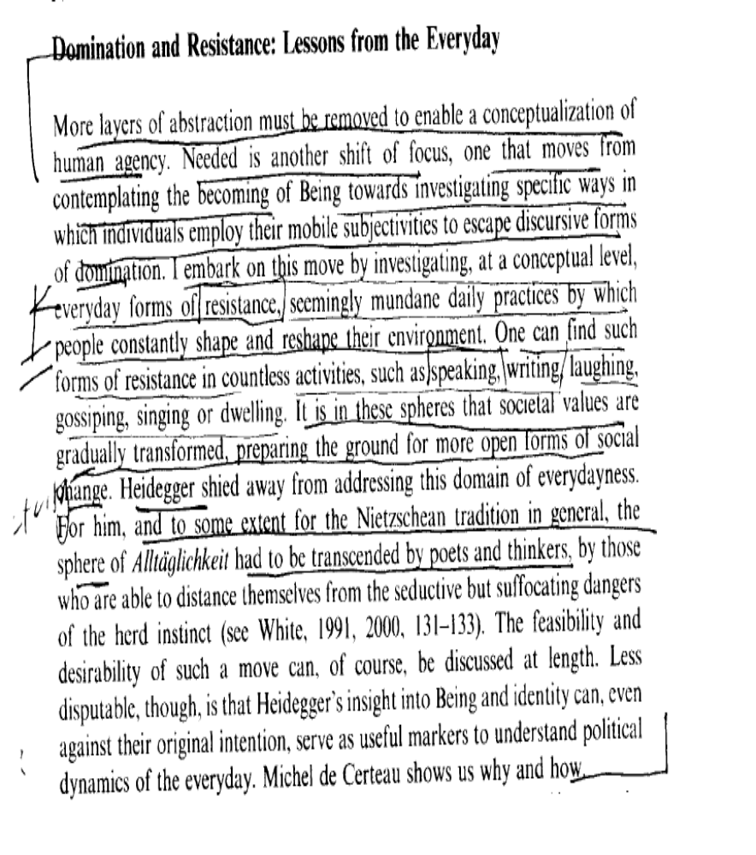

A procedural method of policymaking debate posits an ‘ideal speech’ which necessarily excludes other forms of discourse, making any definition of participation that is limited exclusively to regulated political discourse inevitably exclusionary, racist and sexist.
Kulynych, 97 (Jessica, Winthrop U Prof of Polysci, “Performing Politics: Foucault, Habermas, and Postmodern Participation, Polity, Vol. 30, No. 2 (Winter, 1997), 315-346, accessed Jstor)
Certainly, one might suggest that the above cases are really just failures of speech, and, therefore, not a critique of ideal speech as it is formulated by Habermas. Indeed Seyla Benhabib reformulates Habermas's speech act perspective to make it sensitive to the above critique. She argues that feminists concerned with the discourse model of democracy have often confused the historically biased practices of deliberative assemblies with the normative ideal of rational deliberation.26 She suggests that feminists concerned with inequities and imbalances in communication can actually benefit from the Habermasian requirement that all positions and issues be made " 'public' in the sense of making [them] accessible to debate, reflection, action and moral-political transformation."27 The "radical proceduralism" of the discourse model makes it ideally suited to identify inequities in communication because it precludes our accepting unexamined and unjustified positions.28 Even such a sophisticated and sensitive approach to ideal speech as Benhabib's cannot cleanse communicative action of its exclusivity. It is not only that acquiring language is a process of mastering a symbolic heritage that is systematically gendered, but the entire attempt to set conditions for "ideal speech" is inevitably exclusive. The model of an ideal speech situation establishes a norm of rational interaction that is defined by the very types of interaction it excludes. The norm of rational debate favors critical argument and reasoned debate over other forms of communication.29 Defining ideal speech inevitably entails defining unacceptable speech. What has been defined as unacceptable in Habermas's formulation is any speech that is not intended to convey an idea. Speech evocative of identity, culture, or emotion has no necessary place in the ideal speech situation, and hence persons whose speech is richly colored with rhetoric, gesture, humor, spirit, or affectation could be defined as deviant or immature communicators. Therefore, a definition of citizenship based on participation in an ideal form of interaction can easily become a tool for the exclusion of deviant communicators from the category of citizens. This sort of normalization creates citizens as subjects of rational debate. Correlatively, as Fraser explains, because the communicative action approach is procedural it is particularly unsuited to address issues of speech content.30 Therefore, by definition, it misses the relationship between procedure and content that is at the core of feminist and deconstructive critiques of language. A procedural approach can require that we accommodate all utterances and that we not marginalize speaking subjects. It cannot require that we take seriously or be convinced by the statements of such interlocutors. In other words, a procedural approach does not address the cultural context that makes some statements convincing and others not.

Being forced to act as the State or an advocate for the status quo totally invalidates a debater's agency, never able to speak from their own perspective or invoke change
Mitchell 98 (Gordon R., Associate Professor of Communication and Director of the William Pitt Debating Union at the University of Pittsburgh. “Pedagogical possibilities for argumentative agency in academic debate”. Argumentation and Advocacy, Volume 35, Issue 2. Fall 1998. http://findarticles.com/p/articles/mi_hb6699/is_2_35/ai_n28720712/) SLS
In the process of explaining their teaching approach, argumentation scholars sometimes invoke a bifurcation that separates academic study of argumentation from applied practice in public argument. This explanation typically begins with an elucidation of the democratic and emancipatory potential of debate as a process of decisionmaking, and then proceeds to an explanation of academic study as an essential preparatory step on the way to achievement of such emancipatory potential. This route of explanation is consistent with the American Forensic Association Credo, which declares that the purpose of forensic education is to "prepare students through classrooms, forums, and competition for participation in their world through the power of expression" (qtd. in Freeley 1996, p. 122). Writing from this posture to defend the value of National Debate Tournament (NDT) policy competition, Edward Panetta posits that NDT debate "will prepare students to be societal leaders ..." (1990, p. 76, emphasis added). Similarly, Austin Freeley suggests that academic debate "provides preparation for effective participation in a democratic society" and "offers preparation for leadership" (1997, p. 21, emphasis added). What are the entailments of such a preparatory framework for argumentation pedagogy, and how do such entailments manifest themselves in teaching practice? On the surface, the rhetoric of preparation seems innocuous and consistent with other unremarkable idioms employed to describe education (college prep courses and prep school spring to mind). However, by framing argumentation pedagogy as preparation for student empowerment, educators may actually constrain the emancipatory potential of the debate enterprise. In this vein, approaches that are purely oriented toward preparation place students and teachers squarely in the proverbial pedagogical bullpen, a peripheral space marked off from the field of social action. In what follows, I pursue this tentative hypothesis by interrogating the framework of preparatory pedagogy on three levels, considering how it can position sites of academic inquiry vis-a-vis broader public spheres of deliberation, how it can flatten and defer consideration of complex issues of argumentative engagement and how it can invite unwitting co-option of argumentative skills.

Micro political movements started in the debate round are the key to organizing change outside this round.

Kulynych, Assistant Professor of Political Science at Winthrop University, in 1997 [Jessica, “Performing Politics,” winter, Vol. 30, No. 2, Page 336]
A performative concept of participation as resistance explodes the distinction between public and private, between the political and the apolitical. As Foucault explains, what was formerly considered apolitical, or social rather than political, is revealed as the foundation of technologies of state control. Contests over identity and everyday social life are not merely additions to the realm of the political, but actually create the very character of those things traditionally considered political. The state itself is “super structural in relation to a whole series of power networks that invest the body, sexuality, the family, kinship, knowledge, technology and so forth. Thus it is contestations at the micro-level, over the intricacies of everyday life, that provide the raw material for global domination, and the key to disrupting global strategies of domination. Therefore, the location of political participation extends way beyond the formal apparatus of government, or the formal organization of the workplace, to the intimacy of daily actions and iterations.

In June of this year, the College Board released a report that noted how nearly half of young men of color age 15 to 24 who graduate from high school in the U.S. will end up unemployed, incarcerated or dead. College Board President, Gaston Caperton further explains: “At a time when our nation is committed to reclaiming its place as the world leader in higher education, we can no longer afford to ignore the plight of our young men of color...As long as educational opportunities are limited for some, we all suffer” (College Board 2011).

