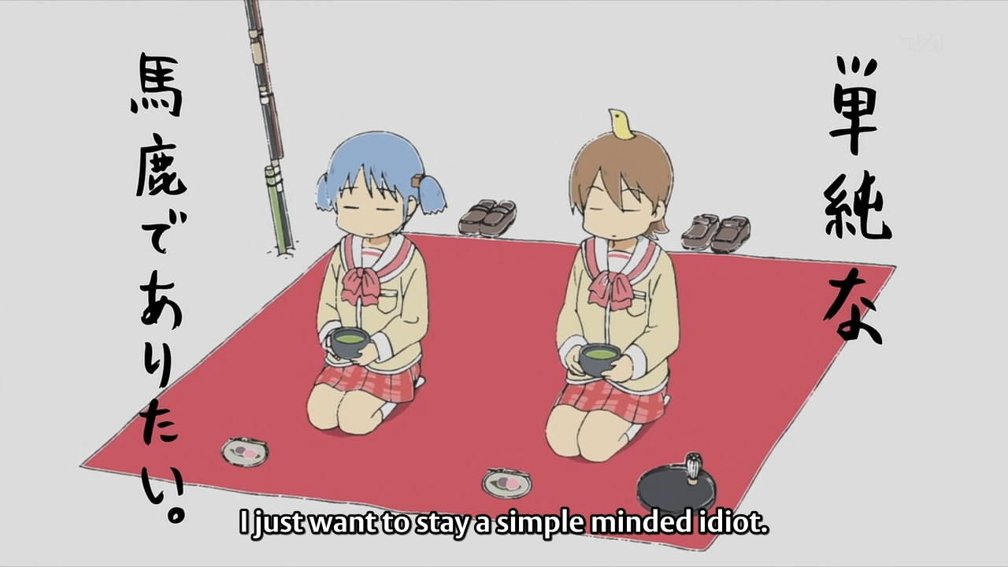

**Resolved: The United States ought to guarantee Universal Healthcare for its citizens**

**Definitions:**

Guarantee: A formal promise or assurance

(Oxford Dictionary, http://oxforddictionaries.com/definition/english/guarantee?q=guarantee)

Ought:

**Ralph Wedgwood**  **Professor of Ethics at Oxford in 2006 explains that there is a**

(Ralph Wedgewood, Professor of Ethics at Oxford University, *The meaning of ‘ought’*, 2006 Oxford Press, www-bcf.usc.edu/~wedgwood/meaningofought.htm)

I have already cited the **distinction between the practical ‘ought’ and what Sidgwick called the “political ‘ought’”. The most striking difference between these two kinds of ‘ought’, as I have suggested, seems to be this: the practical ‘ought’ is clearly indexed to a particular agent and time, and it is a constraint on what “ought” to be the case, in this sense, that it should be realizable by what the agent thinks or does at that time; the political ‘ought’, on the other hand, is not indexed to any particular agent and time in this way.** **I might say, ‘The British constitution ought to be radically reformed’**, **without having any particular agent *x* in mind (either individual or collective) such that I mean to say that *x* ought to bring it about that the British constitution is radically reformed. In that case, as I argued earlier, my statement does not contain any implicit reference to any particular agent**. **My acceptance of this statement hardly commits me to *planning* on the radical reform of the British constitution; at most it commits me to *favouring the goal* of such radical reform**.‘Ought’ exhibits other sorts of contextual variation as well. For example, on some occasions, **therefore ‘ought’ seems to be relative to a particular goal or purpose.**

The term United States does not refer to an actor because the United States works through a system of federalism. Actual implementation would be used across 50 different State governments and sometimes broken up even further into local county governments. Thus there is no actor when you refer to the United States because you cannot point to one institution that “is” the government because they are inevitably checked by another different institution. Thus evaluating the “practical ought” with an indefinite and infinite actor would be impossible and we are forced to look at this situation not through the context of practicality, but rather whether the goal or purpose of the system is desirable through the political ought.

Universal Healthcare:

**The World Health Organization defines Universal Healthcare as**

(World Health Organization, *World Health Report 2010*, 2010, www.who.int/healthsystems/topics/financing/healthreport/TBCHINo6.pdf)

Universal Healthcareis **a healthcare system which provides health care and financial protection** through some apparatus **to all of its citizens with the end goal of providing financial risk protection, improved health services, and improved health outcomes.**

Observation #1: Due to nature of ought, the burden of the affirmative is to prove that the United States should commit to furthering the goals of Universal Healthcare.

Observation #2: The Preamble to the constitution states that “We the People of the United States,

(Constitution of the United States, www.archives.gov/exhibits/charters/consitution_transcript.html)

in Order to form a more perfect Union, establish Justice, insure domestic Tranquility, provide for the common defense, promote general welfare, and secure the Blessings of Liberty to ourselves and our Posterity, do ordain and establish the Constitution of the United States.” This has three implications.

1. The preamble’s notion of “We the People” indicates that the United States government is a collective of citizens and not some random flying monster in the sky. This means that any action of the government must be done in a way which a majority those people could commonly agree upon.
2. The preamble also makes the notion that the citizens of the United States make decisions in order to insure not only rights of the citizens, but specific privileges such as welfare, defense, and tranquility as well.
3. People are their own benefactor in the sense that if people are the government AND receive the benefits of government. Thus when the United States makes an action it is really the citizens acting in a way to help their own self.

Value: Societal Welfare, because of the agent of action meaning to express a desired goal and because the actor of the resolved is the United States, the value of this round has to be what best emulates the goal of a government run by citizens for citizens. The only reason we submit ourselves to the decisions of a collective in hope that in protecting the welfare of others that we can protect our own welfare.

Value Criterion: Contractarianism

**David Gautheir** **Professor at the University of Pittsburg in 1986 explains**

(David Gautheir, Professor @ University of Pittsburg, *Morals by Agreement*, Oxford University Press, 1986, philosophyfaculty.ucsd.edu/faculty/rarneson/Courses/GauthierChapter1.pdf)

A useful vantage point for appreciating the rationale of constraint results from juxtaposing two ideas formulated by John Rawls. **A contractarian views society as 'a cooperative venture for mutual advantage' among persons 'conceived as not taking an interest in one another's interests'** .18 The contractarian does not claim that all actual societies are co-operative ventures; he need not claim that all afford the expectation of mutual advantage. Rather**, she supposes that it is in general possible for a society, analysed as a set of institutions, practices, and relationships, to afford each person greater benefit than she could expect in a 'state of nature',** and that only such a society could command the willing allegiance of every rational individual. The contractarian need not claim that actual persons take no interest in their fellows; indeed, we suppose that some degree of sociability is characteristic of human beings. But the contractarian sees sociability as enriching human life; for him, it becomes a source of exploitation if it induces persons to acquiesce in institutions and practices that but for their fellow-feelings would be costly to them. Feminist thought has surely made this, perhaps the core form of human exploitation, clear to us. However **the contractarian insists that a society could not command the willing allegiance of a rational person if, without appealing to her feelings for others, it afforded her no expectation of net benefit**. **If social institutions and practices can benefit all, then some set of social arrangements should be acceptable to all as a co-operative venture. Each person's concern to fulfill her own interests should ensure her willingness to join her fellows in a venture assuring her an expectation of increased fulfilment**.

**Contractarianism isn’t a physical contract, but rather a general principle upon which a majority of Americans use for an “ought” decision. This isn’t a debate over practicality, but rather principles. Through contractarianism we must look at how Universal Healthcare would function to obtain societal goals in order to evaluate the political ought. Contarianism argues that people have an intrinsic need to treat everyone with similar value in society, in order to guarantee their own benefit. This is why we don’t have a privatized policy force or fire department, because Americans don’t believe your level of safety should be determined by your economic status. The same state run fire department will come to my house as would go to Bill Gates. Any policy attempting to break down that mutual cooperation leads to a breakdown of those societal goals.**

Contention #1: The United States is the only advanced democratic society to not employ these benefits yet.

Around the world there are 4 basic systems of healthcare coverage

1. The Beveridge Model: A model in which healthcare is paid for and provided by the government through taxes similar to how the United States pays for the police force and High schools. An example of this system would be the UK
2. The Bismark Model: A system similar to the United States healthcare plan of having insurance companies control the healthcare industries, however, these industries have to cover everyone in the country and the rest of the check is picked up by tax dollars. An example of this system would be Germany
3. The National Health Insurance Model: A model that uses private-sector medical providers but is funded by the national government through a model of taxation similar to how the United States pays for its Postal Service. An example of this system would be Canada
4. Out of Pocket System: A system used by countries too poor and disorganized to create any model of health insurance. The basic rules of these countries are that the rich get medical care; and the poor stay sick or die. Examples of countries like these would be African nations, Poor Latin American countries, etc.

**Reid 2010** **explains that**

(Thomas Roy Reid III, American Reporter and Member of the Board at the University of Colorado Medical School, *The Healing of America: A Global Conquest for Better, Cheaper, and Fairer Healthcare*, August 2010, www.pbs.org/wgbh/pages/frontline/sickaroundtheworld/countries/models.html)

**These four models should be fairly easy for Americans to understand because we have elements of all of them in our fragmented national health care apparatus**. **When it comes to treating veterans, we’re British. For Americans over the age of 65 on Medicare, we’re Canadian. For working Americans who get insurance on the job, we’re German. For the 15 percent of the population who have no health insurance, the United States is Cambodia or Burkina Faso or rural India, with access to a doctor available if you can pay the bill out-of-pocket at the time of treatment or if you’re sick enough to be admitted to the emergency ward at the public hospital. The United States unlike every other country because it maintains so many separate systems for separate classes of people. All other countries have settled on one model for everybody. This is much simpler than the U.S. system; it’s fairer and cheaper, too.**

Contention #2: The United States currently treats healthcare as a commodity rather than a necessity.

Marcia **Angell** M.D. **’00 explains:**

(Marcia Angell, Executive Editor and Chief at the New England Journal of Medicine, “Are we in a healthcare crisis, February 2000, www.pbs.org/healthcarecrisis/Exprts_intrvw/m_angell.htm)

**What has lead us to reevaluate Healthcare in the United States? It's a cowboy country. It's always been a cowboy country, and health care, as I said, has been seen as just one more commodity and the genius of the marketplace will take care of it. People don't think, "Well, how will that play out? Suppose you're poor and you're sick, what will the marketplace do for you," because if you want a VCR, for example, and you're poor, you don't get it. So you do without a VCR. Are you really going to say that to someone that has a brain tumor? So you do without your brain surgery. And also what markets do is they put out a lot of goods. The consumer pays out of pocket. He or she looks around, looks for a bargain, decides maybe he can't afford a VCR this year, he'll get one next year. Well, imagine you have a brain tumor. You're gonna shop for a bargain? You're gonna say, "Well, I don't want an excellent brain surgeon. I want a mediocre brain surgeon. I want a cheap piece of brain surgery." No. And you can't say, "And I'll wait until next year," either. This is a life and death thing and we ought to treat it that way. We ought to treat it the same way we treat education. You don't personally buy education insurance or your employer doesn't buy you education insurance. It's something that a decent society supplies to everyone.**

The way we treated healthcare in the past was not only hypocritical, but also fundamentally flawed. In order to obtain contractarianism, we must be able to treat everyone in society to basic needs and not pick and choose which basic needs are essential. Things necessary for survival by a general principle should be treated as equal for all instead of insisting that separate but equal healthcare really is “equal”. As a general goal we should strive to treat healthcare as a necessity rather than as a commodity.