# 2AC

## 2AC T – Democracy Assistance

### Counter-interpretation –

(b) Sense of Congress regarding mechanisms for delivering assistance

(1) Findings

Congress finds the following:

(A) Democracy assistance has many different

AND

auditing functions, and advance security sector reform.

(B) There is a need for

AND

and delivery mechanisms for United States democracy assistance.

US Code, ’10 (“§ 8262. UNITED STATES DEMOCRACY ASSISTANCE PROGRAMS” Title 22, Chapter 89, Subchapter VI,

http://www.law.cornell.edu/uscode/usc_sec_22_00008262----000-.html)

### We meet – IMET civil-military programming is democracy assistance

Carothers, Director of Democracy at Carnegie, ’99 (Thomas, “Aiding Democracy Abroad: the Learning Curve” p 196-197)

An additional area of democracy aid that merits

AND

involved in human rights abuses and military dictatorships.

### Prefer our interpretation –

### Grounded literature – Carothers is the most qualified source on the topic

Brookings, ‘4 (“REVIEW: Critical Mission: Essays on Democracy Promotion” http://www.brookings.edu/press/Books/2004/criticalmission.aspx)

Demand for practical knowledge and lessons about how

AND

-date, comprehensive bibliography on democracy promotion.

ABOUT THE AUTHOR Thomas Carothers Thomas Carothers is

AND

expert on U.S. foreign policy.

SELECTED REVIEWS "Carothers's examinations have helped us

AND

Robert Kagan, author, of PARADISE AND POWER

### Core of the topic – excluding military democracy assistance is arbitrary – turns limits and predictability

Phillips, Director of National Committee on American Foreign Policy, and Mitchell, International Politics Prof at Columbia, ‘8 (David and Lincoln, May, “Enhancing Democracy Assistance” American Foreign Policy Interests, Vol 30 Issue 3, p 156-175, InformaWorld)

Decades of successful democracy assistance as well as

AND

lest the opportunity to shape outcomes be lost.

### Aff flexibility –limited number of affs about democracy assistance – expanding the definition to include the military causes more explicit solvency advocates which causes less contrived and vague affirmatives

### Aid is not just one thing – even if IMET does security assistance that doesn’t mean it’s not democracy assistance

Tarnoff and Nowels, Specialists of Foreign Affairs and National Defense at CRS, ‘4 (Curt and Larry, April 15, “Foreign Aid: An Introductory Overview of U.S. Programs and Policy” http://www.au.af.mil/au/awc/awcgate/crs/98-916.pdf)

Arguably, from the end of World War

AND

of good governance and free market economic reform.

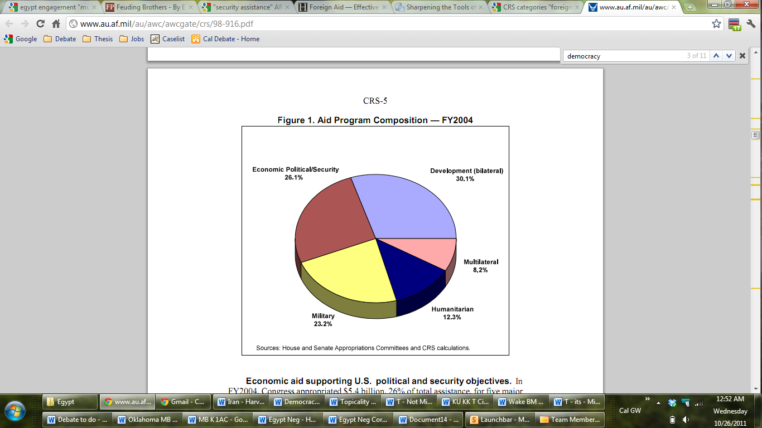

## 2AC No Indo-Pak War

### Pakistan collapse causes nuclear terrorism

Brookes, Heritage, ‘9 (Peter, November 9, “Why We Can’t Walk Away” http://www.heritage.org/Research/Commentary/2009/11/Why-We-Cant-Walk-Away)

But while the war in Afghanistan is often

AND

likelihood of a positive result across the border.

### Extinction

Morgan, Professor Foreign Studies Hankuk University, ‘9 (Dennis Ray, December, “World on fire: two scenarios of the destruction of human civilization and possible extinction of the human race” Futures, Vol 41 Issue 10, p 683-693, ScienceDirect)

In a remarkable website on nuclear war,

AND

upon the environment and fragile ecosphere as well.

## 2AC Turkey CP

### Only the US can has enough influence to restrain Egypt’s military – previous relationship gives us unique influence

Ash, Historian, political writer and Guardian columnist, 11

(5/18, Obama can now define the third great project of Euro-Atlantic partnership, www.guardian.co.uk/commentisfree/2011/may/18/obama-define-great-euro-atlantic-project)

I do not say this for the sake of … two events have already opened the new chapter.

### Counterplan is worse than the status quo – Turkey will lead SCAF towards greater confrontation and violence

Cook, Senior Fellow - Middle Eastern Studies - CFR, 11

(8/1, Istanbul on the Nile, http://globalpublicsquare.blogs.cnn.com/2011/08/01/istanbul-on-the-nile/)

In the weeks and months …, the Egyptian officers should not even bother trying.

### Can’t overcome alt causes to Turkey’s soft power

Zalewski, 11 --- correspondent for Polityka, Poland’s best-selling news magazine, an editor at European Stability Initiative and a contributor to a number of English-language publications including The National, Insight Turkey and Turkish Policy Quarterly (Winter 2010/2011, Piotr Zalewski, World Policy Journal, “The Self-Appointed Superpower: Turkey Goes it Alone,” <http://www.worldpolicy.org/sites/default/files/uploaded/image/WPJ-Winter2010-11-Zalewski-Turkey.pdf>, JMP)

A Cold War Turn If anything, therefore

AND

danger of being perceived as its greatest liability.

## Kritik

### Perm – do the plan as a leap to global empathetic consciousness

BILGIN 2004 – PROF IR BIKENT U WHOSE MIDDLE EAST, INTERNATIONAL RELATIONS, VOL 18 NO 25

From a Critical Security Studies perspective, …, not at their expense.**46**

### Middle East experts get it right – especially about democracy

Heydemann, Director –Social Science Research Council, 02  
(“Defending the Discipline,” Former Prof Poli Sci – Columbia, Journal of Democracy Vol. 13, No. 3)

Crisis is the handmaiden of introspection, so

AND

Middle East during the course of the 1990s.

### Foreign policy should be guided by a mix of moral and self-interested motivations – alt can’t solve the aff or US hegemony

George Friedman - founder, chief intelligence officer, and CEO of Stratfor – 12/6/11, Egypt and the Idealist-Realist Debate in U.S. Foreign Policy, http://www.stratfor.com/weekly/20111205-egypt-and-idealist-realist-debate-us-foreign-policy?utm_source=freelist-f&utm_medium=email&utm_campaign=20111206&utm_term=gweekly&utm_content=readmore&elq=88a5097c3a284763b9202918890c5a91

Western countries, following the principles of the

AND

and I think you can see the predicament.

### Studies prove conflicts have been decreasing – primacy is THE reason.

Drezner, 2005 [Daniel, Gregg Easterbrook, Associate Professor of International Politics at the Fletcher School of Law and Diplomacy at Tufts University, “War, and the dangers of extrapolation,” may 25]

Daily explosions in Iraq, massacres in Sudan

AND

.S. intervention would be equally daunting.

### Blaming the US is collusion with the Egyptian military – saying we should take our hands off mean those in power in the region take control

Halliday, Professor – IR – London School of Economics, 93 (Orientalism and its Critics, British Journal of Middle Eastern Studies 20 (2) p. 159-16)

This brings me to the fourth, and

AND

one social, cultural or even ethnic group.

### Floating pik bad

### No mindless intervention

Mandelbaum 11 (Michael Mandelbaum, A. Herter Professor of American Foreign Policy, the Paul H. Nitze School of Advanced International Studies, Johns Hopkins University, Washington DC; and Director, Project on East-West Relations, Council on Foreign Relations, “CFR 90th Anniversary Series on Renewing America: American Power and Profligacy,” Jan 2011)

MANDELBAUM:  I think it is, Richard

AND

And that unit has come to an end.

### Stability prerequisite to the alternative – security approach is best

Hinnebusch, Professor IR and Middle East at St Andrew’s, ‘2 (Raymond- Director Centre for Syrian Studies, “The Foreign Policies of Middle East States” p 21-22)

Order and power politics. To the degree

AND

realist rules of Middle East international politics.48

## 2AC Payroll (Complete)

### Egyptian instability kills the economy

El-Erian, ’11 [Mohamed A. El-Erian, Pimco chief executive officer and co-chief investment officer, Faculty @ Harvard Business School, “Egypt's Improbable Path Traces Four Points: Mohamed A. El-Erian,” Jan 31st 2011, http://www.bloomberg.com/news/2011-01-31/egypt-s-improbable-path-traces-four-points-mohamed-a-el-erian.html]

How Egypt evolves in the next few days

AND

a secular movement could be hijacked by theocrats.

### Payroll won’t save the economy

Bartlett, 8/30 --- held senior policy roles in the Reagan and George H.W. Bush administrations (Bruce, 8/30/2011, “The Case Against a Payroll Tax Cut,” economix.blogs.nytimes.com/2011/08/30/the-case-against-a-payroll-tax-cut/)

It’s rare for Republicans to find a tax

AND

nothing to increase aggregate demand or economic output.

### Economic decline doesn’t cause war

Barnett, Senior Managing Director Enterra Solutions LLC, ‘9 (Thomas, August 24, “The New Rules: Security Remains Stable Amid Financial Crisis” World Politics Review, http://www.worldpoliticsreview.com/articles/4213/the-new-rules-security-remains-stable-amid-financial-crisis)

When the global financial crisis struck roughly a

AND

apace. That's what the Internet is for.

### Obama won’t push the plan –

### First – He’ll circumvent Congress to get his agenda

Nicholas, 1/1 (Peter, 1/1/2012, LA Times, “Obama's resolution? To limit dealings with Congress,” <http://www.latimes.com/news/nationworld/nation/la-na-obama-plans-20120101,0,2595075.story>)

Reporting from Honolulu— Heading into the new

AND

a solution for the nation's high jobless rate.

### Second, plan implemented by the DOD and funded by the DOS

Moskowitz, Policy Planning Office at Office of Undersecretary of Defense for Policy, ‘8 (Elisa, December, “The creation of Expanded International Military Education and Training (E-IMET)” DISAM Journal)

Funding for IMET (and other Security Assistance

AND

.S.-origin equipment. (3)

### Plan is not new funding – IMET internal reprogramming

K. AISTON – State Department – Aug 2000, C ONFIDENTIAL STATE 017117 (Memo), http://www.state.gov/documents/organization/165657.pdf

WHEN AF AND DRL MET IN 1994 TO

AND

ALL OTHER (NON-PARIAH) STATES.

### Won’t pass – Republican backlash over nomination

Clarke & Spetalnick, 1-5

[Dave Clarke and Matt Spetalnick, Reporters for Reuters, “Stymied by Congress, Obama to boldly seat nominees,” January 5th 2012, http://www.reuters.com/article/2012/01/05/us-financial-regulation-cordray-idUSTRE80312J20120105]

A defiant President Barack Obama on Wednesday … for 160 million Americans.

### E-IMET not controversial

Moskowitz, Policy Planning Office at Office of Undersecretary of Defense for Policy, ‘8 (Elisa, December, “The creation of Expanded International Military Education and Training (E-IMET)” DISAM Journal)

The catalyst for the initiative was the Foreign

AND

met the intent of Congress. (12)

### Political capital not key – empirically proven

Edwards 3 (George C. Edwards, Distinguished Professor of Political Science at Texas A&M, former Director of the Center for Presidential Studies, Riding High in the Polls: George W. Bush and Public Opinion, <http://www-polisci.tamu.edu/MyDocuments/web/Edwards/Papers%20PDF/work_papers/SP01LegislativeImpact.pdf>)

One of the perennial questions about presidential-

AND

deference to a widely supported chief executive.44

### Obama won’t negotiate with Congress

Nakamura, 1/1 (David, 1/1/2012, Washington Post, “Obama taking fight to Congress,” Factiva)

HONOLULU - President Obama has a New Year's

AND

doing everything he can to improve the economy.

# 1AR

## MENA Aid Now

### Syria aid now

Daily Star, 12-29-’11 (“U.S. quietly preparing to support Syria opposition: report” http://www.dailystar.com.lb/News/Middle-East/2011/Dec-29/158282-us-quietly-preparing-to-support-syria-opposition-report.ashx#axzz1hycu7uJu)

White House officials are quietly preparing options to

AND

engaging more with the external and internal opposition.

## Say No

### SCAF is pissed at Turkey and doesn’t want to encourage anti-Israel stances – only the US has leverage

RANIA ABOUZEID – TIME – 9/13/11, Why Turkey's Erdogan Is Greeted like a Rock Star in Egypt, http://www.time.com/time/world/article/0,8599,2093090,00.html

Turkish Prime Minister Recep Tayyip Erdogan — a

AND

he indicated that he is likely to deliver.

## Case

### Egyptian military rejects the counterplan – assistance not threats key to solve

Cook, Senior Fellow at CFR, 09 (Political Instability in Egypt)

The United States will have few options should

AND

should also explain to the Egyptian officers that there

## Compartmentalization

### Empirical studies prove

Dickinson, 09 – professor of political science at Middlebury College and taught previously at Harvard University where he worked under the supervision of presidential scholar Richard Neustadt (5/26/09, Matthew, Presidential Power: A NonPartisan Analysis of Presidential Politics, “Sotomayor, Obama and Presidential Power,” http://blogs.middlebury.edu/presidentialpower/2009/05/26/sotamayor-obama-and-presidential-power/, JMP)

As for Sotomayor, from here the path

AND

power that cannot be measured through legislative boxscores.

## Link

### Democratic engagement with Egyptian military is a major foreign policy win

Lane, The News Tribune, 2-15-’11 (Charles, “Obama can reap political capital from revolt in Egypt” http://www.thenewstribune.com/2011/02/15/1545321/obama-can-reap-political-capital.html)

Still, even after the resignation of Hosni

AND

in Egypt over the rest of his term.