## 1NC

### First are the links:

### Sequecing – Materiality comes first – a Marxist epistemology is not only valid, but challenges the radical right’s deployment of constructivism.

Dana L. Cloud, Steve Macek, and James Arnt Aune, ‘6 (Department of Communication Studies University of Texas, Austin Department of Speech Communication North Central College, Department of Communication Texas A&M “The Limbo of Ethical Simulacra”: A Reply to Ron Greene,” Philosophy and Rhetoric, Vol. 39, No. 1)-mikee

Greene and other … and human suffering.

### b. Epistemological focus – Fixating on epistemological questions eliminates all productive potential – accepting truth claims, even if they are not perfect, is necessary for politically instrumental action

Cloud, Professor of Communication Studies at Texas, 2006

December, Communication and Critical/Cultural Studies

Of necessity, attention … structuralism and relativism.

### c. Focus on discourse – more dangerous battleground, structural antagonism

Cloud, prof of Communication @ UTexas, 05 [Dana, Management Communication Quarterly, “Fighting Words: Labor and the Limits of Communication at Staley, 1993 to 1996”]

Like managers and … and other benefits (p. 189).

### d. Their postmodern project insulates capitalism from criticism, blunts attempts to analyses market ideology, and allows the worst forms of capitalism to spread

Reconsidering Marx in Post-Marxist Times: A Requiem for Postmodernism?

Author(s): Peter **McLaren** and Ramin Farahmandpur

Source: Educational Researcher, Vol. 29, No. 3 (Apr., **2000**), pp. 25-33

Published by: [American Educational Research Association](http://www.jstor.org/action/showPublisher?publisherCode=aera)

Stable URL: [http://www.jstor.org/staMi 11 n"il](http://www.jstor.org/stable/1176914?origin=JSTOR-pdf)^^^M

Accessed: 11/09/2011 23:35

Despite its successes, … most troublesome determinations.

### Its try or die for the negative—capitalism makes multiple scenarios for extinction an inevitability.

Theory & Praxis 2009

<http://one-dimensional.blogspot.com/>

In a little …**to smash it.**

**The impact—capitalism pathologically prioritizes short-term profit over long term viability of the system—this form of rationalistic logic guarantees the inevitable deployment of every scenario for global destruction including nuclear war, ecological damage, space militarization, and many other scenarios—extinction is inevitable in their framework—alternative is the only hope because humanity survives on a thin margin generated by the dissidence against capitalism in imperial states—its try or die**

**Marko 2003**—5/14, https://www2.indymedia.org.uk/en/2003/05/68173.html

Bertrand Russell throughout … of its time.

### Alt: Vote negative as an act of solidarity.

### Struggles matter – Solidarity transcends nationality and makes resistance to institutions possible. It’s about embracing actions, not revealing.

Cloud, Professor of Communication Studies @ Texas, ‘6 (Dana, Communication and Critical/Cultural Studies Vol. 3, No. 4, December, pp. 329􏰜354, “The Matrix and Critical Theory’s Desertion of the Real.”)-mikee

Aimed at producing … anti-sweatshop movement.119

## 1NR

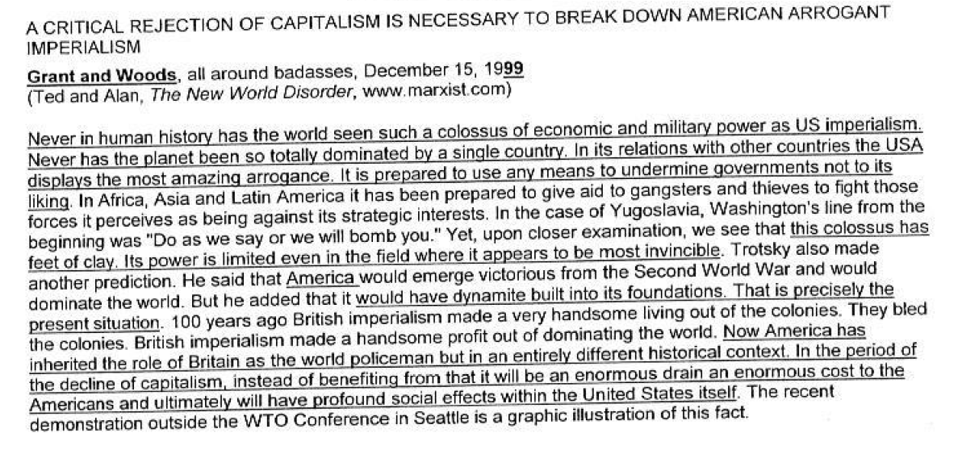

### And, Iraq proves that capitalism still needs physical forces – only voting negative offers an emancipatory politics based on solidarity with countless movements challenging capitalism.

Dana L. Cloud, Steve Macek, and James Arnt Aune, ‘6 (Department of Communication Studies University of Texas, Austin Department of Speech Communication North Central College, Department of Communication Texas A&M “The Limbo of Ethical Simulacra”: A Reply to Ron Greene,” Philosophy and Rhetoric, Vol. 39, No. 1)-mikee

On this point, … stage of history.

### They posit stories of change as more important than Marxist change – cultural changes distract us from proper material ways to deal with capitalist exploitation of labor

Stephen Tumino, English—Pitt, 2002

“Contesting the Empire-al Imaginary: The Truth of Democracy as Class,” http://www.redcritique.org/MayJune02/contestingtheempirealimaginary.htm

Against the totally … now in the US.

### Recognition of capitalism is not enough – their understanding of capitalism through an epistemological lens makes deciding between competing representations impossible, ignoring the ontological effect unequal distributions of wealth have on power relationships

Kapoor, 2008 (Ilan, Associate Professor at the Faculty of Environmental Studies, York University, “The Postcolonial Politics of Development,” p. 15-16)

The problem is that … types of situations.