**The lives of animals on factory farms:**

<http://www.animal-rights-action.com/factory-farming.html>

“Factory Farming: A Life of Animal Abuse”

Factory Farming:

Hundreds Of Chickens In Cages Far Too Small For Them. They spend their whole lives in these cages, only getting out to be slaughtered.

Factory Farming Chickens In Small Cages

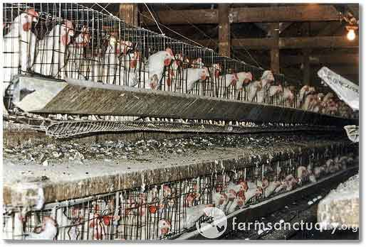

It is not just hens and chickens that suffer. Millions upon millions of other animals are farmed in this way across the world. 2 out of 3 farm animals across the world are factory farmed.

I find factory farming statistics such as these, and how factory farmed animals are treated, very upsetting. This web page will inform you about the perils of intensive farming to both the animals and humans.

We will also look at some of the real stories that barely scratch the surface of what goes on through factory farms across the world. The practice must be stopped NOW.

TABLE OF CONTENTS

What is Intensive Farming?

Animal Abuse and Intensive Farming Stories

What is Live Export?

Testimonies Of Factory Farm Workers

Intensive Farming Campaigns

What is Intensive Farming?

What is Factory Farming? This barbaric practice began in the 1920's. Animals are abused throughout their life, right and through the slaughter house.

The more meat, milk, eggs and other animal products that can be produced, the more money factory farmers make. This is the essence of the process.

Farming machinery and techniques developed to the point where the animals 'didn't need to be raised outside'. No sunlight or exercise required. They could be kept inside; in a smaller space - a cost saver.

The perpetrators soon found disease spread amongst the animals. No problem. Large amounts of antibiotics could be sprayed all over the animals. Problem solved.

The development of steroids meant that animals could be grown faster and bigger - increased productivity means increased profit.

Pigs In Small Cages Feeding

Notice The Blood On Their Snouts From Rubbing Against The Bars

Factory Farming Pigs

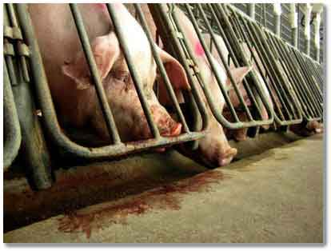

Animals such as Cows, Calves, Pigs, Turkeys and Rabbits are often clamped in small, cramped cages or small enclosures where they are unable to move. Imagine the stress this puts the animals under!

They never get the chance to go outside and exercise. Their lives are purely for the production of eggs, milk, or their flesh for human consumption.

Make no mistake, these cages and confined spaces are disgusting. They often have low lighting, or no lighting at all. The animal waste is rarely cleared away, triggering disease.

Steroids, other drugs and genetic changes make the animals fatter, faster. They produce more milk and lay more eggs than they would normally.

These drugs half the time it takes for a calf to reach maturity, with untold stresses on the calf's body. The animals are also fed high carbohydrate diets what are not natural to them - increasing the animals weight and body stress.

The overcrowding spreads disease. A quick way to remedy this is to spray them with pesticides and feed them antibiotics. These drugs remain in the bodies of the animals humans consume - a potential health hazard.

It is due to these disgusting conditions, and disgusting treatment, that the animals become agitated and start fighting amongst themselves. This leads to more abhorrent treatment of the animals, such as beak searing and castration.

A Poor Chicken Enduring The Painful Beak Searing Process

Factory Farming Debeaking

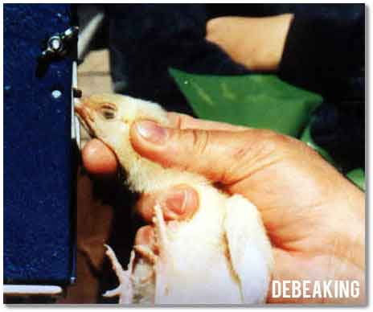

These unfortunate animals are not thought of as living, breathing individuals. They are food producing robots.

Return to the Table of Contents

Animal Abuse and

Intensive Farming Stories

The horror stories documented below are just the tip of the iceberg of what goes on throughout intensive farming, and what this Industry does not want you to know. Animal abuse and factory farming go hand in hand!

The brutality dished out by abusive workers and the Corporate Businesses are both shocking and upsetting. If you are unaware of what goes on to put beef, eggs and pork on your plate, read on.

If you are against factory farming, remind yourself why you are vegetarian or vegan. Your actions help combat the atrocities that goes on every single day.

When austerity bites it is not just people that suffer. In 2010, 400 000 newborn Chickens were murdered by the bankrupt Krasnaya Polyana Chicken Farm is Russia.

The farm was owned by a Russian member of parliament, Alexander Chetverikov, and the chicks were killed in the most horrendous ways:

Drowned in rusty barrels of water

Leaving them outside to freeze to death

Starved to death because the Company could not afford to feed them

The adult chickens were thrown into a pit and buried alive

Workers from the Krasnaya Polyana Chicken Farm

Tipping baby chickens into oil cans for drowning or freezing to death

Workers from the Krasnaya Polyana Chicken Farm tipping baby chickens into oil cans for drowning or freezing to death

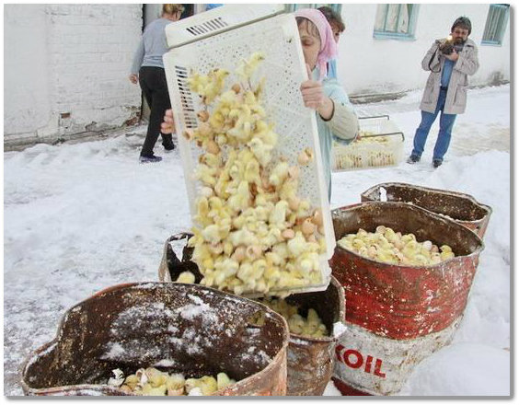

The savagery of the owners also resulted in similar deaths of another 3 000 000 chicks! 3 Million!!

Shockingly, barbaric action such as this IS NOT ILLEGAL!. These living, breathing animals have the capacity to suffer just like you! And this sort of thing is happening all over the world, everyday.

Even if these chicks survived, they would be destined for a life inside a battery cage, or even ground to death if they turned out to be male.

In Israel, Anonymous for Animal Rights (Opens New Window) put a hidden camera inside a battery cage of an egg facility.

Broadcast 24 hours a day, it showed in real-time the dreadful lives of 3 battery caged hens. They are locked in a cage 40cm long, 33cm wide and 45cm high. To put this into context, each hen lives in a space less than a sheet of A4 paper!

They can't stretch their wings. They stand on wire mesh, not solid ground, and obviously can't run, fly, dust-bath and all their other natural behaviours that makes them happy.

Watch the video below for recorded footage from this initiative:

Recorded footage of Battery Hen life in Israel

To truly understand the lives of factory farming battery hens, you need to walk a mile in their shoes, as the saying goes. Animal Visuals enables you to do this by turning you into a battery hen, with 6 other's in a ramped cage.

You have a 360 degree view of what it must be like for millions of them all over the world. Take a look for yourself. The animation is provided below. Are you now thinking twice about how your eggs and chicken came from?

The animated world of the Battery Hen

Mercy for Animals (Opens New Window) published their findings from an undercover investigation at Hy-Line Hatchery in Iowa. 150,000 male chicks are killed in a grinder every single day!.

Factory Farming Male Chickens

Being Ground To Death-While Alive

Factory Farming Male Chickens Being Ground To Death-While Alive

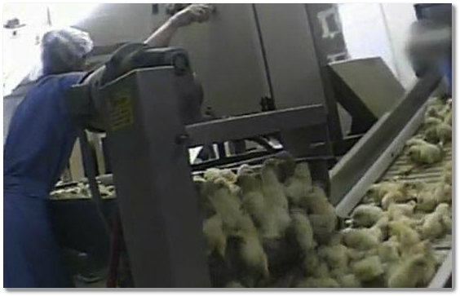

They are thrown into a spinning auger before being tripped to pieces whilst still alive by a high-pressure macerator.

Male chicks are seen as useless because they don't lay eggs, and they do not grow quickly enough to be a meat bird. What is the human race doing here? How can this gruesome end even be considered when you find out they become trapped in or behind the machinery, suffering unimaginable pain before dying!!!

Watch the video below to see for yourself. These animals are thrown away like rubbish and dropped without any consideration to their welfare.

They are ripped away from the comfort of their mothers and thrown onto a loud, churning conveyor belt before meeting their end. Can you imagine how terrifying this is for them?!

Undercover Footage of Factory Farming Activity

As well as being ground up alive in grinding and mincing machines, live male chicks are also used as a packaging filler by the poultry industry, knowing they are going to suffer and die either in transit, or shortly after arrival. They are used as 'padding' in packaging, which is acceptable industry practice in the poultry industry.

Pigs are also victims of Factory farming. The Humane Society of the United States (HSUS) (Opens New Window) documented shocking footage and information about the treatment of pigs by the worlds largest pork producer, Smithfield foods.

Their evidence shows female pigs crammed into gestation or sow crates which are far too small for them to move around in.,/p.

This leads to the pigs biting the metal crates in frustration, cutting their mouths and increasing their risk of infection.

The never-ending cycle of suffering is compounded by the fact that the piglets are born on hard concrete or metal floors. Stressful for the pig, she is cannot nurture her young properly. Often she watches her young fall though the metal slats and drown in the manure pits below.

This leads to behavioural problems resulting in aggression and injury. With the intelligence of a 3 year old, this reaction is understandable, but leads to more intense cruelty to deal with it!

Surgical procedures such as cutting out their teeth, slicing off their tails and male castration, all without any pain relief, is common place.

If the suffering of Pig Factory Farming isn't enough, it is compounded by their treatment at the hands of the workers. HSUS found a “basketball-sized abscess” on the back of one of the pigs. This was cut open with an unsterilised razor, without anaesthetic or a vet present.

Another pig was shot in the head but was still alive when thrown into the bin. As with chicks, piglets were tossed into carts without any consideration to their welfare.

The following undercover video was taken from the Smithfield exposure. It is heartbreaking!

Smithfield Investigation Footage

Below is life on a factory farm, looking from a factory farmed pig's point of view.

Life of a factory farmed pig

Factory Farming Life of a Factory Farmed Pig Conditions If I Could Speak

113

Dairy cows also suffer at the hands of Factory farming. After 9 months of forced pregnancy, their calf's are taken away from their mothers after only a day or two. The cows cry out in pain all the time for their young, stolen from them to be slaughtered for veal meat.

The milk to nurture the calf's are then bottled and put in your supermarkets or on your doorstep by the milk man. The forced pregnancies must make living in their bodies unbearable. Their udders often swell with the disease mastitis, which is difficult to cure in these circumstances.

Thousands of male Calf's are shot or murdered in other ways as they are useless to the dairy Industry. They will not produce enough beef to be profitable, even if they are drugged to abnormally increase their growth rate, causing heat disease and other pains, like cows bred for meat are.

Factory Farming Slaughtered Newborn Male Calf

Factory Farming Slaughtered Newborn Male Calf

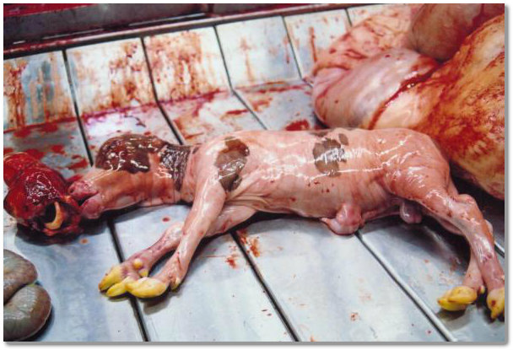

In the UK, veal calves that survive are often crammed into lorries and transported to the continent when they spend their lives indoors, in a small pen, without any daylight or natural stimulation. These calves spend their short lives being fattened up before being slaughtered.

See the From Farm To Slaughter web page for more details.

End Intensive Farming (Opens New Window) gives an introduction to cow factory farming. NYC Animal Rights (Opens New Window) shows on graphic detail cow factory farming photos.

Below is a four minute video to pay respect to the many, many animals forced to suffer and die due to human meat eaters:

Return to the Table of Contents

What is Live Export?

Live export is where animals are transported for many hours, or days on end across countries and continents. They suffer in searing heat with no water or food, squashed together in a cramped space.

Just like humans, sheep spread their legs and take small steps back and forth in order to balance, but when they do not have the space to do this, fall, crush and trample injuries occur more often. There is no room for the animals to lie down and rest so the animals suffer pain.

Stress hormones like cortisol rise steeply in sheep during transportation, and ewes may skip or delay their estrus (heat) cycle. The immune systems of pigs become weaker. Chickens overheat and die, even on cold days. The animals are often handled in a way that causes them pain and injury when being loaded and unloaded.

Studies have shown that the vibration and noise of a lorry can feel uncomfortable and frightening to animals. In the European Union, animals can be transported for two 14 hour blocks in a row, with just one hour rest in between for water.

Below: This is how tightly sheep are packed in to lorries to be taken on journeys over counties and continents, with just a short break for water. This does not allow space for animals to spread their legs and take small steps to help them balance, or to lie down when tired. This results in injuries and pain. Studies have shown that when given more room, the animals suffered fewer injuries and less pain.

factory farming how sheep are transported in lorries eu regulations very stressed

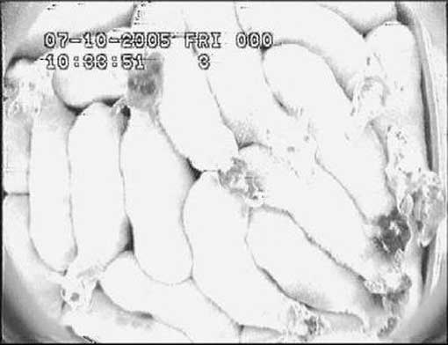

**Every day, each and every one of us participates in a war which consists of endless genocide of the non-human. Every year, billions of animals are slaughtered by humans. Animals are captured, detained, tortured and killed for the sake of consumption. This violence is rendered invisible by a normative understanding of war that excuses the violence against the non-human as legitimate.**

**Kochi 9** - Sussex Law School, University of Sussex, Brighton, UK (Tarik, “Species War: Law, Violence and Animals,” SAGE Journals)

7. The idea that war and violence sits at the foundation of law and operates creatively has been expressed in differing ways by Heraclitus, Machiavelli, Hegel, Freud and Walter Benjamin. Here, I am merely taking this insight and developing it by reflecting upon the primary role played by human violence carried out against non-human animals. the protagonist Elizabeth Costello draws a comparison between the everyday slaughter of non-human animals and the genocide of the Jews of Europe during the twentieth century. “In addressing you on the subject of animals,” she continues, “I will pay you the honour of skipping a recital of the horrors of their lives and deaths. Though I have no reason to believe that you have at the forefront of your minds what is being done to animals at this moment in production facilities (I hesitate to call them farms any longer), in abattoirs, in trawlers, in laboratories, all over the world, I will take it that you concede me the rhetorical power to evoke these horrors and bring them home to you with adequate force, and leave it at that, reminding you only that the horrors I here omit are nevertheless at the center of this lecture.” 9

A little while later she states: “Let me say it openly: we are surrounded by an enterprise of degradation, cruelty, and killing which rivals anything that the Third Reich was capable of, indeed dwarfs it, in that ours is an enterprise without end, self-regenerating, bringing rabbits, rats, poultry, livestock ceaselessly into the world for the purpose of killing them.” “And to split hairs, to claim that there is no comparison, that Treblinka was so to speak a metaphysical enterprise dedicated to nothing but death and annihilation while the meat industry is ultimately devoted to life (once its victims are dead, after all, it does not burn them to ash or bury them but on the contrary cuts them up and refrigerates and packs them so that they can be consumed in the comfort of our own homes) is as little consolation to those victims as it would have been – pardon the tastelessness of the following – to ask the dead of Treblinka to excuse their killers because their body fat was needed to make soap and their hair to stuff mattresses with.” Similar comparisons have been made before. Yer, when most of us think about the term “war” very seldom do we bother to think about non-human. A great deal of the contemporary discussion about the moral standing of animals and their treatment is owed to the work of Peter Singer. The purpose of my article is not to directly contribute to this debate. Rather, my focus is upon attempting to re-think some of the conceptual foundations of the Law of war by drawing the status of animal slaughter back into our legal categoryies. For this reason I will not attempt to discuss or survey the many arguments about the moral standing of non-human animals but will keep to a more historical, and perhaps sociological, discussion of the Law of war.

The term war commonly evokes images of states, armies, grand weapons, battle lines, tactical stand-offs, and maybe even sometimes guerrilla or partisan violence. Surely the keeping of cattle behind barbed wire fences and butchering them in abattoirs does not count as war? Surely not? Why not? What can be seen to be at stake within Elizabeth Costello’s act of posing the modern project of highly efficient breeding and factory slaughtering of non-human animals beside the Holocaust is a concern with the way in which we order or arrange conceptually and socially the legitimacy of violence and killing. In a “Western” philosophical tradition stretching at least from Augustine and Aquinas, through to Descartes and Kant, the ordering of the relationship between violence and legitimacy is such that, predominantly, non-human animals are considered to be without souls, without reason and without a value that is typically ascribed to humans. For example, for Augustine, animals, together with plants, are exempted from the religious injunction “Thou shalt not kill.” When considering the question of what forms of killing and violence are legitimate, Augustine placed the killing of non-human animals well inside the framework of religious and moral legitimacy. 12

Of relevance is the practice by which the question of legitimate violence is ordered – that is, the manner in which it is organised by philosophical, moral and cultural justifications in a way that sets out how particular acts of violence are to be understood within social-material life. Within a Western tradition the killing of animals is typically not considered a form of war because violence against animals is placed far within the accepted framework of legitimate killing. 12. Augustine, City of God against the Pagans, Dyson, R.W. tr. ed. (Cambridge: Cambridge University Press, 1998), p. 33, I, 21. This account expresses a particular religious-cultural form of valuing the lives of non-human animals in which non-human animals are placed below humans on a Judeo-Christian and Islamic cosmic hierarchy of creation. While there are other differing cosmic conceptions, such as those found within Hinduism and Buddhism and within various indigenous cosmologies within North America and Australia and within radical utilitarian conceptions expressed by Bentham and Peter Singer focused upon “suffering,” the model of a Judeo-Christian and Islamic hierarchy of creation remains dominant within “Western” (or North Atlantic) culture and its conceptions of law. Such a hierarchy of value is further backed in the West, in differing ways, by the secular cosmology of the theory of evolution, and scientific claims about the higher mental capacities of humans over the bulk of non-human animals. Owing to these hierarchies, for Western legal systems “animal rights” still stand far below and have not been extended from human rights and while the notion of human dignity takes centre stage, notions of “animal dignity” stand at the periphery. On various approaches to the extension of moral standing to non-human animals see: Bentham, J. Introduction to the Principles of Morals and Legislation, Burns, J.H. and Hart, H.L.A. eds. ( London: Methuen, 1982); Singer, P. Animal Liberation (New York: Random House, 1975); Regan, T. “The Case for Animal Rights” in Singer, P. ed. In Defence of Animals (Oxford: Basil Blackwell, 1985); Clarke, S.R.L. The Moral Standing of Animals (Oxford: Oxford University Press, 1977); Hursthouse, R. Ethics, Humans and Other Animals ( London: Routledge, 2000).

**This Western conception of ‘war’ is grounded upon a hierarchy of values which regards nonhuman life as ‘raw material’ for the preservation of human life.**

**Kochi 9** - Sussex Law School, University of Sussex, Brighton, UK (Tarik, “Species War: Law, Violence and Animals,” SAGE Journals)

The response of the lawyer, international lawyer, politician or philosopher to the account so far might be to say that this is all very interesting but that it still has little to do with “war.” Such figures might still argue that the term “war” refers to something carried out by states and governed by “national interest,” or guided by moral ideals like freedom and human rights, or by international law. This response, however, overlooks the way in which the typical and everyday use of the term war is itself conceptually and  historically ordered in a practice that differentially values forms of life. In what follows I look more closely at how arguments about legitimate violence within two contemporary conceptions or discourses of the law of war are ordered and of how this ordering is related to the foundational moment of species war. The dominant Western conceptions of the law of war rest upon two major conceptual and historical “foundations.” The first involves the way in which the monopoly upon the legitimacy of violence is vested in the sovereignty of the state and grounded upon the principles of preservation of life, domestic peace and security from external threat. This form which sometimes expresses a reason of state or national interest approach to questions of war is often called the Westphalian system of international relations and is ambiguously historically linked to the Peace of Westphalia (1648). The second dominant narrative or form of thinking about the laws of war is represented by contemporary international humanitarian law. This approach grounds the legitimacy of war upon the maintenance of peace and  security between nations bound together with the concern for the protection of human rights and the prevention of human rights abuses, war crimes and genocide via the establishment of the United Nations (1945). While this mode of thinking about war inherits much from the Westphalian system, it is historically grounded upon an international response to “world war” and the genocide of European Jews. The natural law theories of Hugo Grotius and Thomas Hobbes are often viewed as laying down the theoretical justifications for the  modern secular state, the legitimacy of sovereign violence, and the Westphalian international order. Within the context of bloody intra-state civil wars such as the Thirty Years War (1618–48) and moments of domestic chaos such as the English Civil War (1642–51) thinkers such as Grotius and Hobbes reacted to widespread social violence often motivated by actors party to differing Christian confessions all claiming adherence to a universal  religious, moral or political truth. Grotius and Hobbes, albeit in different ways, responded by producing a de-sacralized natural law that was grounded not upon  theological conceptions of right and justice but upon more earthly, “secular,” concepts of the preservation of human life and survival. For these thinkers the chaos of civil war and intra-state civil war could be nullified if the criteria of what counted as legitimate violence were determined by an institution that guaranteed peace and security. Roughly, Grotius and Hobbes attempted to theoretically re-order  territory and space around the figure of sovereignty and inter-sovereign relations. The legitimacy of human violence is no longer grounded upon a universal conception of divine authority but is instead located around the figure and office of the sovereign who maintains peace and security over a particular, limited territory. Such an approach to the chaos of civil war can be termed the juridical ordering of the concept of war. This de-legitimisation of the right to private violence in the name of peace  creates what Max Weber later describes as the “state’s monopoly upon the legitimacy of violence.” Modern war, juridically ordered, takes on the definition of a form of violence waged between sovereigns, who hold a particular status. By this definition violence carried out by the state against a non-sovereign group is excluded from the language of “war proper” as is private violence (including rebellion, sabotage and terrorism) which is defined as crime.Grotius and Hobbes are sometimes described as setting out a prudential approach, or a natural law of minimal content because in contrast to Aristotelian or Thomastic legal and political theory their attempt to derive the legitimacy of the state and sovereign order relies less upon a thick conception of the good life and is more focussed upon basic human needs such as survival. In the context of a response to religious civil war such an approach made sense in that often thick moral and religious conceptions of the good life (for example, those held by competing Christian Confessions) often drove conflict and violence. Yet, it would be a mistake to assume that the categories of “survival,” “preservation of life” and “bare life” are neutral categories. Rather survival, preservation of life and bare life as expressed by the Westphalian theoretical tradition already contain distinctions of value – in particular, the specific distinction of value between human and non-human life. “Bare life” in this sense is not “bare” but contains within it a distinction of value between the worth of human life placed above and beyond the worth of non-human animal life. In this respect bare life within this tradition contains within it a hidden conception of the good life. The foundational moment of the modern juridical conception of the law of war already contains within it the operation of species war. The Westphalian tradition puts itself forward as grounding the legitimacy of violence upon the preservation of life, however its concern for life is already marked by a hierarchy of value in which non-human animal life is violently used as the “raw material” for preserving human life. Grounded upon, but concealing the human-animal distinction, the Westphalian  conception of war makes a double move: it excludes the killing of animals from its definition of “war **proper,” and**, **through rendering dominant the modern** juridical **definition of “war** proper” the tradition **is able to** further institutionalize and **normalize a particular conception** of the good life. Following from this original distinction of life-value realized through the juridical language of war were other forms of human life whose lives were considered to be of a lesser value under a European, Christian, “secular” natural law conception of the good life. Underneath this concern with the preservation of life in general stood veiled preferences over what particular forms of life (such as racial conceptions of human life) and ways of living were worthy of preservation, realization and elevation. The business contracts of early capitalism, the power of white males over women and children, and, especially in the colonial context, the sanctity of European life over non-European and Christian lives over non-Christian heathens and Muslims, were some of the dominant forms of life preferred for preservation within the early modern juridical ordering of war.

**And anthropocentrism has been the foundational model for any and every form of discrimination. Any argument which attempts to claim superiority of the human over the nonhuman rests on the same justifications used by White European males to subjugate other humans**

Best 7 – Associate Professor at the University of Texas in the Department of Humanities and Philosophy (Steven, “Eternal Treblinka: Our Treatment of Animals and the Holocaust, by Charles Patterson” *Journal for Critical Animal Studies*, <http://www.criticalanimalstudies.org/JCAS/Journal_Articles_download/Issue_7/bestpatterson.pdf>)

While a welcome advance over the anthropocentric conceit that only humans shape human actions, the environmental determinism approach typically fails to emphasize the crucial role that animals play in human history, as well as how the human exploitation of animals is a key cause of hierarchy, social conflict, and environmental breakdown. A core thesis of what I call “animal standpoint theory” is that animals have been key driving and shaping forces of human thought, psychology, moral and social life, and history overall. More specifically, animal standpoint theory argues that the oppression of human over human has deep roots in the oppression of human over animal.1

In this context, Charles Patterson’s recent book, The Eternal Treblinka: Our Treatment of Animals and the Holocaust, articulates the animal standpoint in a powerful form with revolutionary implications. The main argument of Eternal Treblinka is that the human domination of animals, such as it emerged some ten thousand years ago with the rise of agricultural society, was the first hierarchical domination and laid the groundwork for patriarchy, slavery, warfare, genocide, and other systems of violence and power. A key implication of Patterson’s theory is that human liberation is implausible if disconnected from animal liberation, and thus humanism -- a speciesist philosophy that constructs a hierarchal relationship privileging superior humans over inferior animals and reduces animals to resources for human use -- collapses under the weight of its logical contradictions.

Patterson lays out his complex holistic argument in three parts. In Part I, he demonstrates that animal exploitation and speciesism have direct and profound connections to slavery, colonialism, racism, and anti-Semitism. In Part II, he shows how these connections exist not only in the realm of ideology – as conceptual systems of justifying and underpinning domination and hierarchy – but also in systems of technology, such that the tools and techniques humans devised for the rationalized mass confinement and slaughter of animals were mobilized against human groups for the same ends. Finally, in the fascinating interviews and narratives of Part III, Patterson describes how personal experience with German Nazism prompted Jewish to take antithetical paths: whereas most retreated to an insular identity and dogmatic emphasis on the singularity of Nazi evil and its tragic experience, others recognized the profound similarities between how Nazis treated their human captives and how humanity as a whole treats other animals, an epiphany that led them to adopt vegetarianism, to become advocates for the animals, and develop a far broader and more inclusive ethic informed by universal compassion for all suffering and oppressed beings. The Origins of Hierarchy "As long as men massacre animals, they will kill each other" –Pythagoras

It is little understood that the first form of oppression, domination, and hierarchy involves human domination over animals.2 Patterson’s thesis stands in bold contrast to the Marxist theory that the domination over nature is fundamental to the domination over other humans. It differs as well from the social ecology position of Murray Bookchin that domination over humans brings about alienation from the natural world, provokes hierarchical mindsets and institutions, and is the root of the long-standing western goal to “dominate” nature.3 In the case of Marxists, anarchists, and so many others, theorists typically don’t even mention human domination of animals, let alone assign it causal primacy or significance. In Patterson’s model, however, the human subjugation of animals is the first form of hierarchy and it paves the way for all other systems of domination such as include patriarchy, racism, colonialism, anti-Semitism, and the Holocaust. As he puts it, “the exploitation of animals was the model and inspiration for the atrocities people committed against each other, slavery and the Holocaust being but two of the more dramatic examples.”4

Hierarchy emerged with the rise of agricultural society some ten thousand years ago. In the shift from nomadic hunting and gathering bands to settled agricultural practices, humans began to establish their dominance over animals through “domestication.” In animal domestication (often a euphemism disguising coercion and cruelty), humans began to exploit animals for purposes such as obtaining food, milk, clothing, plowing, and transportation. As they gained increasing control over the lives and labor power of animals, humans bred them for desired traits and controlled them in various ways, such as castrating males to make them more docile. To conquer, enslave, and claim animals as their own property, humans developed numerous technologies, such as pens, cages, collars, ropes, chains, and branding irons.

The domination of animals paved the way for the domination of humans. The sexual subjugation of women, Patterson suggests, was modeled after the domestication of animals, such that men began to control women’s reproductive capacity, to enforce repressive sexual norms, and to rape them as they forced breeding in their animals. Not coincidentally, Patterson argues, slavery emerged in the same region of the Middle East that spawned agriculture, and, in fact, developed as an extension of animal domestication practices. In areas like Sumer, slaves were managed like livestock, and males were castrated and forced to work along with females.

In the fifteenth century, when Europeans began the colonization of Africa and Spain introduced the first international slave markets, the metaphors, models, and technologies used to exploit animal slaves were applied with equal cruelty and force to human slaves. Stealing Africans from their native environment and homeland, breaking up families who scream in anguish, wrapping chains around slaves’ bodies, shipping them in cramped quarters across continents for weeks or months with no regard for their needs or suffering, branding their skin with a hot iron to mark them as property, auctioning them as servants, breeding them for service and labor, exploiting them for profit, beating them in rages of hatred and anger, and killing them in vast numbers – all these horrors and countless others inflicted on black slaves were developed and perfected centuries earlier through animal exploitation.

As the domestication of animals developed in agricultural society, humans lost the intimate connections they once had with animals. By the time of Aristotle, certainly, and with the bigoted assistance of medieval theologians such as St. Augustine and Thomas Aquinas, western humanity had developed an explicitly hierarchical worldview – that came to be known as the “Great Chain of Being” – used to position humans as the end to which all other beings were mere means.

Patterson underscores the crucial point that the domination of human over human and its exercise through slavery, warfare, and genocide typically begins with the denigration of victims. But the means and methods of dehumanization are derivative, for speciesism provided the conceptual paradigm that encouraged, sustained, and justified western brutality toward other peoples. “Throughout the history of our ascent to dominance as the master species,” Patterson writes, “our victimization of animals has served as the model and foundation for our victimization of each other. The study of human history reveals the pattern: first, humans exploit and slaughter animals; then, they treat other people like animals and do the same to them.”5 Whether the conquerors are European imperialists, American colonialists, or German Nazis, western aggressors engaged in wordplay before swordplay, vilifying their victims – Africans, Native Americans, Filipinos, Japanese, Vietnamese, Iraqis, and other unfortunates – with opprobrious terms such as “rats,” “pigs,” “swine,” “monkeys,” “beasts,” and “filthy animals.”

Once perceived as brute beasts or sub-humans occupying a lower evolutionary rung than white westerners, subjugated peoples were treated accordingly; once characterized as animals, they could be hunted down like animals.6 The first exiles from the moral community, animals provided a convenient discard bin for oppressors to dispose the oppressed. The connections are clear: “For a civilization built on the exploitation and slaughter of animals, the `lower’ and more degraded the human victims are, the easier it is to kill them.”7 Thus, colonialism, as Patterson describes, was a “natural extension of human supremacy over the animal kingdom.”8 For just as humans had subdued animals with their superior intelligence and technologies, so many Europeans believed that the white race had proven its superiority by bringing the “lower races” under its command.

There are important parallels between speciesism and sexism and racism in the elevation of white male rationality to the touchstone of moral worth. The arguments European colonialists used to legitimate exploiting Africans – that they were less than human and inferior to white Europeans in ability to reason – are the very same justifications humans use to trap, hunt, confine, and kill animals. Once western norms of rationality were defined as the essence of humanity and social normality, by first using non-human animals as the measure of alterity, it was a short step to begin viewing odd, different, exotic, and eccentric peoples and types as non- or sub-human. Thus, the same criterion created to exclude animals from humans was also used to ostracize blacks, women, and numerous other groups from “humanity.” The oppression of blacks, women, and animals alike was grounded in an argument that biological inferiority predestined them for servitude. In the major strain of western thought, alleged rational beings (i.e., elite, white, western males) pronounce that the Other (i.e., women, people of color, animals) is deficient in rationality in ways crucial to their nature and status, and therefore are deemed and treated as inferior, subhuman, or nonhuman. Whereas the racist mindset creates a hierarchy of superior/inferior on the basis of skin color, and the sexist mentality splits men and women into greater and lower classes of beings, the speciesist outlook demeans and objectifies animals by dichotomizing the biological continuum into the antipodes of humans and animals. As racism stems from a hateful white supremacism, and sexism is the product of a bigoted male supremacism, so speciesism stems from and informs a violent human supremacism -- namely, the arrogant belief that humans have a natural or God-given right to use animals for any purpose they devise or, more generously, within the moral boundaries of welfarism and stewardship, which however was Judaic moral baggage official Chistianithy left behind.

**The first step is a reorientation towards the meaning and language of war. The move to exclude specieist exploitation as war is the same move by other historical acts of genocide. Our affirmative demands recognition of this unending violence as war.**

**Kochi 9** - Sussex Law School, University of Sussex, Brighton, UK (Tarik “Species War: Law, Violence and Animals”

The meanings attached to the words we use are significant here. Many of our linguistic categories have been formulated along the distinction between human and non-human and offer different meanings based upon what object within this distinction a word denotes. Words like “killing” and “slaughter” evoke different meanings and different responseswhen applied to humans as opposed to chickens or cattle or insects. While most people would react in horror to the brutal killing of a child, they accept the daily slaughter of thousands of calves. Although there exists a bureaucratic language of regulation governing issues of efficiency, property rights, hygiene and cruelty, the breeding of animals for killing is widely accepted as a legitimate act. Such that, the killing of one animal is not considered murder and the killing of a geographical group of animals is not considered an act of genocide or species war. Yet, this ordering of the legitimacy of violence is not in anyway natural and eternal. Rather, it is contingent and both historically and cosmically temperamental. Consider a hypothetical situation where a group of “aliens” emerged from deep space with forms of technology that far surpassed our own and possessed levels of intelligence that humans could not imagine. These aliens considered humans to be without souls, they considered humans to be so devoid of reason that they made no effort to communicate with us. Our behaviour and language appeared to them just as the movements of ants, the song of birds, and the efforts of chimpanzees appear to us. Further, these aliens cared little for human suffering. If these aliens decided to enslave and breed humans for food, would this be an act of species war? Even if humans rallied together, Hollywood style, (or, like a swarm of bees protecting their hive) and called this an act of “war,” might not the aliens simply laugh, or grumble about how their new animals struggle and go on to devise new methods of capture and killing so that we humans might not bruise our flesh.13

While such an example appears at first bizarre, it is not out of the range of future possibility. Further, the example draws upon an already present heritage of anthropological, racial and colonial forms of thinking belonging to many Western traditions in which acts of violence were legitimised historically by those in positions of power and often never officially called “war.” Aspects of this historical comparison are made by Elizabeth Costello – the Nazi portrayal of Jews as “animals” playing a role in both 13. Similar hypothetical situations have been imagined within numerous science fiction stories in popular culture, most notably: Wells, H.G. The War of the Worlds (London: Heinemann, 1973). Wells makes the link between war, colonialism and the destruction of non-human animal life. At p. 4 he states:

And before we judge them too harshly, we must remember what ruthless and utter destruction our own species has wrought, not only upon animals, such as the vanished bison and the dodo, but upon its own inferior races. The Tasmanians, in spite of their human likeness, were entirely swept out of existence in a war of extermination waged by European immigrants in the space of fifty years. Are we such apostles of mercy as to complain if the Martians warred in the same spirit.

“ ‘They went like sheep to the slaughter.’ ‘They died like animals.’ ‘The Nazi butchers killed them.’ Denunciation of the camps reverberates so fully with the language of the stockyard and slaughterhouse that it is barely necessary for me to prepare the ground for the comparison I am about to make. The crime of the Third Reich, says the voice of accusation, was to treat people like animals.” 14

**Marc and I thus advocate for restrictions on the species war powers authority of the President of the United States over targeted killing, indefinite detention, and the introduction of Armed Forces into hostilities.**

**Voting affirmative acknowledges the existence of species war. The affirmative is a claim upon the state to make this recognition. We must reject the hierarchy of species and reject the notion of legitimate violence against the nonhuman.**

**Kochi 9** - Sussex Law School, University of Sussex, Brighton, UK (Tarik, “Species War: Law, Violence and Animals,” SAGE Journals)

Although species war remains largely hidden because it is not seen as war or even violence at all it continues to affect the ways in which juridical mechanisms order the legitimacy of violence. While species war may not be a Western monopoly, in this account I will only examine a Western variant. This variant, however, is one that may well have been imposed upon the rest of the world through colonization and globalization. In what will follow I offer a sketch of species war and show how the juridical mechanisms for determining what constitutes legitimate violence fall back upon the hidden foundation of species war. I try to do this by showing that the various modern juridical mechanisms for determining what counts as legitimate violence are dependent upon a practice of judging the value of forms of life. I argue that contemporary claims about the legitimacy of war are based upon judgements about differential life-value and that these judgements are an extension of an original practice in which the legitimacy of killing is grounded upon the valuation of the human above the non-human. Further, by giving an overview of the ways in which our understanding of the legitimacy of war has changed, I attempt to show how the notion of species war has been continually excluded from the Law of war and of how contemporary historical movements might open a space for its possible re-inclusion. In this sense, the argument I develop here about species war offers a particular way of reflecting upon the nature of law more generally. In a Western juridical tradition, two functions of law are often thought to be: the establishment of order (in the context of the preservation of life, or survival); and, the realization of justice (a thick conception of the “good”). Reflecting upon these in light of the notion of species war helps us to consider that at the heart of both of these functions of law resides a practice of making judgements about the life-value of particular “objects.” These objects are, amongst other things: human individuals, groups of humans, non-human animals, plants, transcendent entities and ideas (the “state,” “community,” etc.). For the law, the practice of making judgements about the relative life- value of objects is intimately bound-up with the making of decisions about what objects can be killed. Within our Western conception of the law it is difficult to separate the moment of judgement over life-value from the decision over what constitutes “legitimate violence.” Species war sits within this blurred middle-ground between judgement and decision – it points to a moment at the heart of the law where distinctions of value and acts of violence operate as fundamental to the founding or positing of law. The primary violence of species war then takes place not as something after the establishment of a regime of law (i.e., after the establishment of the city, the state, or international law). Rather, the violence of species war occurs at the beginning of law, at its moment of foundation, as a generator, as a motor. 7

**Our affirmative is an act of assuming a traitorous identity. The dynamics of different forms of privilege posits us all as in positions of both the oppressor and oppressed. In the species war, we are all human oppressors that are complicit in a cycle of tortuous violence. The only feasible solution for the nonhuman is to work against the structures of your own culture. This does not mean we deny our identities or claim unity with the oppressed, but it does mean that we adopt an ethic that attempts to end our own domination.**

**Plumwood 2 –** (Val, “Environmental Ethics”, p.205-6)

There are, I have suggested, multiple bases for critical solidarity with nature. One important critical basis can be understanding that certain human societies position humans as oppressors of non-human nature, treating humans as a privileged group which defines the non-human nature, in terms of roles that closely parallel our own roles as recipients of oppression within human dominance orders. Our grasp of these parallels may be based upon imaginative or narrative transpositions into locations paralleling that of the oppressed non-human other: artistic representation has an important place in helping us make such transpositions. Literature has often played such a transposing role historically, especially in the nineteenth and early twentieth century, in relation to the class system, slavery, women’s oppression, and animal oppression. In recent decades science fiction narrative that imaginatively position humans as colonized or exploited reductively as food by alien invaders have provided very powerful vehicles for such imaginative transpositions into a place that parallels that of the non-human food animal. So have those cartoonists whose ‘absurd’ humour depends upon exploiting parallels in the condition of the human and non-human oppressed. A chicken coming from a human house carrying a baby passes a women coming from a chicken coop carrying a basket of eggs, for example. A Larson elephant is outraged when he notices the ivory notes on a piano keyboard at an interspecies party and makes the connection to the fate of his own kind. The leap of recognition that is often described and explained in terms of an unanalysed and capricious emotion of ‘empathy’ or ‘sympathy’ is often better understood in terms of a concept of solidarity that is based on an intellectual and emotional grasp of the parallels in the logic of the One and the Other. Since most people suffer from some form of oppression within some dominance order or other, there is a widespread basis for the recognition that we are positioned multiply as oppressors or colonizers just as we are positioned multiply as oppressed and colonized. This recognition that one is an oppressor as well as an oppressed can be developed in certain cirvumstances to become the basis for the critical ‘traitorous identity’ which analyses, opposes and actively works against those structures of one’s own culture or group that keep the Other in an oppressed position. Traitorous kinds of human identity involve a revised conception of the self and its relation to the non-human other, opposition to oppressive practices, and the abandonment and critique of cultural allegiances to the dominance of the human species and its bonding against non-humans, in the same way that male feminism requires abandonment and critique of male bonding as the kind of male solidarity that defines itself in opposition to the feminine or to women, and of the ideology of male supremacy. These ‘traitorous identities’ that enable some men to be male feminists in active opposition to androcentric culture, some whites to be actively in opposition to white supremacism and ethnocentric culture, also enable some humans to be critical of ‘human supremacism’ and in active opposition to anthropocentric culture. “Traitorous’ identities do not appear by chance, but are usually considerable political and personal achievements in integrating reason and emotion; they speak of the traitor’s own painful self-reflection as well as efforts of understanding that have not flinched away from contact with the pain of oppressed others. What makes such traitorous identities possible is precisely the fact that the relationship between the oppressed and the ‘traitor’ is not one of identity, that the traitor is critical of his or her own ‘oppressor’ group as someone from within that group who has some knowledge of its workings and its effects on the life of the oppressed group. It depends on the traitor being someone with a view from both sides, able to adopt multiple perspectives and locations that enable an understanding how he or she is situated in the relationship with the other from the perspective of both kinds of lives, the life of the One and the live of the Other. Being a human who takes responsibility for their interspecies location in this way requires avoiding both the arrogance of reading in your own location and perspective as that of the other, and the arrogance of assuming that you can ‘read as the Other’ know their lives as they do, and in that sense speak or see as the other. Such a concept of solidarity as involving multiple positioning and perspectives can exploit the logic of the gap between contradictory positions and narratives standpoint theory applies to. The traitorous identity implies a certain kind of ethics of support relations which is quite **distinct from the ethics involved in claiming unity**. It stresses a number of counter-hegemonic virtues, ethical stances with can help to minimize the influence of the oppressive ideologies of domination and self-imposition that have formed our conceptions of both the other and ourselves. As we have seen, important among these virtues are listening and attentiveness to the other, a stance which can help counter the backgrounding which obscures and denies what the non-human other contributes to our lives and collaborative ventures. They also include philosophical strategies and methodologies that maximize our sensitivity to other members of our ecological communities and openness to them as ethically considered beings in their own right, rather than ones that minimize ethical recognition or that adopt a dualistic stance of ethical closure that insists on sharp moral boundaries and denies the continuity of planetary life. Openness and attentiveness are among the communicative virtues we have already discussed; more specifically, they mean giving the other’s needs and agency attention, being open to unanticipated possibilities and aspects of the other, reconceiving and re-encountering the other as a potentially communicative and agentic being, as well as ‘an independent creature of value and originator of projects that demand my respect’. A closely allied stance, as Anthony Weston points out, is that of invitation, which risks an offering of relationship to the other in a more or less open-ended way.