AI-POWERED EARLY SEPSIS RISK DETECTION USING PROMPT ENGINEERING
ASHTAVARTHANI S | V JAYA PRADHA
Dept. of Artificial Intelligence and Machine Learning
Panimalar Engineering College, Chennai, Tamil Nadu, India
Email: [ashtavarthani29@gmail.com]
I. ABSTRACT
Sepsis is a time-critical clinical condition in which delayed recognition can contribute to rapid deterioration and organ dysfunction. Conventional bedside screening depends on structured physiological measurements and clinical judgement, while many machine-learning systems rely primarily on structured electronic health record (EHR) variables and may not fully exploit contextual information contained in clinical notes. This paper proposes an AI-powered early sepsis risk detection framework based on prompt engineering, designed as a clinician-support prototype rather than an autonomous diagnostic system. The proposed approach converts selected patient observations, vital signs, laboratory values, and relevant clinical context into a standardized prompt representation and evaluates multiple prompting strategies, including zero-shot, few-shot, and structured reasoning prompts. Clinical indicators such as suspected infection, respiratory rate, systolic blood pressure, mental status, lactate, and organ-dysfunction-related variables are incorporated with reference to established sepsis definitions and screening guidance. The system produces a risk category, supporting evidence, missing-information flags, and a concise explanation intended for human review. Performance is planned to be evaluated using sensitivity, specificity, precision, recall, F1-score, AUROC, false-alert rate, calibration-related measures, and lead time before clinically defined sepsis onset. The framework aims to investigate whether careful prompt design can improve consistency and transparency when large language models are used for early sepsis risk assessment while preserving human oversight and reducing unsupported clinical recommendations.
Keywords: Sepsis, Early Risk Detection, Prompt Engineering, Large Language Models, Clinical Decision Support, Electronic Health Records, qSOFA, SOFA, Explainable AI.
II. INTRODUCTION
Sepsis is a life-threatening condition associated with a dysregulated response to infection and organ dysfunction. The Sepsis-3 consensus defines sepsis around life-threatening organ dysfunction caused by a dysregulated host response to infection and describes septic shock as a more severe state associated with substantially increased mortality. Because deterioration may occur rapidly, early recognition and timely clinical assessment are important components of sepsis care.
Current clinical workflows use combinations of patient history, physical examination, vital signs, laboratory measurements, organ-function indicators, and established screening frameworks. The qSOFA score uses altered mentation, systolic blood pressure of 100 mmHg or less, and respiratory rate of 22/min or greater as bedside indicators associated with poor outcomes in patients with suspected infection. However, current guidance emphasizes that sepsis should not be ruled in or ruled out using a single score, biomarker, or diagnostic test.
Artificial intelligence has increasingly been investigated for early sepsis prediction using EHR data. Prior machine-learning studies have demonstrated the value of longitudinal clinical data, but published systems differ substantially in datasets, outcome definitions, variables, validation methods, and reporting standards. Unstructured clinical notes can also contain contextual information that is difficult to represent using conventional tabular models.
Large language models (LLMs) provide a different mechanism for processing mixed clinical context through natural-language prompts. Prompt engineering refers to the deliberate construction of instructions, context, examples, constraints, and output formats to guide model behavior. Clinical NLP research has shown that zero-shot and few-shot prompting strategies can be systematically evaluated, while recent work has explored LLM-based systems for early sepsis prediction.
This paper proposes a prompt-engineered early sepsis risk detection framework that combines structured clinical features with controlled natural-language context. The objective is not to replace clinical diagnosis or treatment, but to investigate whether prompt design can provide a reproducible, explainable preliminary risk assessment that helps clinicians identify cases requiring closer evaluation.
The key contributions are threefold: (i) a standardized prompt architecture for early sepsis risk assessment; (ii) a comparison of zero-shot, few-shot, and structured reasoning prompting strategies; and (iii) an evaluation protocol emphasizing clinically meaningful detection metrics, lead time, robustness, and explanation quality rather than relying on accuracy alone.
III. RELATED WORKS
A. Clinical Sepsis Definitions and Screening
The Sepsis-3 consensus established organ dysfunction as a central component of the modern sepsis definition and introduced qSOFA as a bedside score for identifying patients with suspected infection who are at increased risk of poor outcomes. More recent Surviving Sepsis Campaign guidance recommends that hospitalized adults be screened using validated approaches such as NEWS/NEWS2, MEWS, or SIRS rather than relying on qSOFA alone. These recommendations motivate a multi-factor AI framework in which established clinical indicators are treated as supporting evidence rather than as a standalone diagnostic rule.
B. Machine Learning for Early Sepsis Prediction
Machine-learning and deep-learning approaches have been widely studied for sepsis prediction from EHR data. Systematic reviews report substantial variation in study design, datasets, sepsis definitions, feature sets, and validation procedures. Longitudinal vital signs and laboratory measurements can provide useful temporal information, but model performance may be affected by missing data, class imbalance, dataset shift, and differences in clinical workflow.
C. Large Language Models in Clinical NLPD.
LLM-Based Sepsis Prediction
Recent research has investigated LLM-assisted early sepsis prediction by integrating language models with established predictive systems. Such work suggests that unstructured clinical notes may provide contextual information that complements structured EHR variables. The proposed study focuses more specifically on prompt engineering: the same clinical input is evaluated under controlled prompt variants so that the effect of prompt structure can be measured.
D. Explainability, Safety, and Human Oversight
In clinical decision support, high predictive performance alone is insufficient. A useful system should expose the evidence supporting its output, identify missing information, avoid fabricating clinical facts, and allow clinicians to override or disregard the model. The proposed framework therefore treats explanation, uncertainty communication, and human review as design requirements rather than optional features.
Ref. | Approach | Limitation / Gap Addressed
[1] | Sepsis-3 clinical definition | Provides clinical foundation; not an AI prediction method.
[2] | Clinical sepsis screening guidance | A single screening score should not be treated as a diagnostic system.
[3] | ML/DL EHR sepsis prediction review | Variation in datasets, features and validation.
[4] | Sepsis prediction model evaluation review | Need for standardized and clinically meaningful evaluation.
[5] | Clinical prompt-engineering study | Shows that prompt strategy can affect clinical NLP performance.
[6] | LLM-based early sepsis prediction | Motivates combining LLM context with predictive modeling.
[7] | LLM clinical workflow review | Highlights validation, monitoring and implementation challenges.

IV. PROPOSED METHODOLOGY
The proposed architecture contains six stages: clinical data preparation, feature normalization, prompt construction, multi-strategy prompting, risk interpretation, and evaluation. The framework is intended for research validation and does not provide autonomous diagnosis, medication selection, or treatment instructions.
A. System Overview
The system accepts de-identified clinical observations such as age group, suspected infection status, temperature, heart rate, respiratory rate, blood pressure, oxygen saturation, mental status, lactate, white blood cell count, platelet count, creatinine, bilirubin, and other available organ-function indicators. Where clinical notes are available, relevant contextual statements are extracted or supplied as controlled text. The data are then placed into a fixed prompt schema so that each patient is represented consistently.
B. Clinical Feature Preparation
Numerical variables are checked for units, missing values, physiologically implausible entries, and temporal ordering. Missing values are explicitly marked as unavailable rather than replaced with invented values. Derived indicators such as qSOFA components and, where sufficient variables are available, SOFA-related organ dysfunction information may be calculated using validated definitions. The model is instructed to distinguish observed information from assumptions.
C. Prompt Engineering Strategy
Three prompt configurations are compared. In the zero-shot prompt, the model receives a role definition, the patient context, a risk-assessment task, and a fixed output format without examples. In the few-shot prompt, a small set of carefully selected, de-identified examples demonstrates how clinical evidence should map to the requested output categories. In the structured-reasoning prompt, the model is instructed to organize the assessment into evidence for infection, organ dysfunction indicators, risk factors, missing data, and final risk category. The study evaluates these strategies without treating generated reasoning as independently verified clinical truth.
D. Risk Output Design
The output is constrained to a small number of interpretable categories such as Low, Intermediate, or High risk, together with: (1) observed evidence supporting the category; (2) missing or uncertain information; (3) relevant clinical indicators; and (4) a statement that clinician review is required. The system is explicitly instructed not to invent laboratory values, diagnoses, treatment orders, or patient history.
E. Algorithm 1: Prompt-Based Risk Assessment
Input: de-identified patient observations X. Output: risk category R and evidence summary E. Step 1: validate and normalize X. Step 2: identify available infection and organ-dysfunction indicators. Step 3: construct the standardized prompt P. Step 4: execute the selected prompting strategy. Step 5: parse the constrained response into R and E. Step 6: flag missing or conflicting information. Step 7: compare R with the reference outcome and store evaluation metrics. Step 8: return the result for research review.
Stage | Input | Output
1. Data preparation | EHR/vital/lab/note data | Clean, de-identified record
2. Feature mapping | Clinical variables | Standardized clinical context
3. Prompt construction | Context + task + constraints | Prompt template
4. LLM inference | Prompt | Risk category + evidence
5. Validation | Prediction + reference outcome | Performance metrics
6. Human review | Model output | Safety/utility assessment

F. Safety and Guardrails
Guardrails are incorporated to reduce unsafe outputs. The prompt instructs the model to use only supplied information, explicitly identify missing variables, avoid unsupported certainty, and avoid treatment recommendations. Any high-risk output is framed as a signal for further clinical assessment rather than a diagnosis. Evaluation should be conducted only on appropriately governed, de-identified data with institutional approval where required.
V. IMPLEMENTATION
The prototype can be implemented in Python using pandas and NumPy for data preparation, scikit-learn for baseline metrics and conventional comparison models, and an LLM API or locally hosted language model for prompt-based inference. A lightweight Streamlit interface may be used to demonstrate the workflow with synthetic or approved de-identified records. The implementation should keep prompts, model version, temperature or generation settings, timestamps, and output parsing rules fixed during each experimental run so that results are reproducible.
Component | Tool / Technology | Purpose
Data processing | Python / pandas / NumPy | Cleaning, validation and feature preparation
Clinical scoring | Python implementation of validated definitions | qSOFA/SOFA-related supporting indicators
Baseline models | scikit-learn | Reference comparison
LLM inference | Approved LLM API / local model | Prompt-based risk assessment
Prompt templates | Python / JSON | Zero-shot, few-shot and structured prompts
Evaluation | scikit-learn / pandas | Sensitivity, specificity, F1, AUROC, etc.
Interface | Streamlit | Research prototype demonstration

A. Prompt Template Structure
ROLE: You are a clinical decision-support research assistant. CONTEXT: Use only the patient information supplied below. TASK: Assess early sepsis risk using the specified evidence categories. CONSTRAINTS: Do not invent missing data; do not provide treatment orders; identify uncertainty. OUTPUT: Risk category, evidence, missing information, and human-review notice. This structure separates role, clinical context, task, constraints, and output requirements, allowing prompt variants to be compared systematically.
VI. EXPERIMENTAL EVALUATION
The study should report experimental results only after testing on a predefined, appropriately labeled dataset. Illustrative values must not be presented as measured clinical performance. The primary comparison is between zero-shot, few-shot, and structured prompt configurations, with conventional risk scores or machine-learning baselines included where feasible.
A. Evaluation Protocol
The dataset is divided into development and held-out test partitions without patient-level leakage. Where temporal data are used, observations occurring before the prediction time are separated from information that becomes available afterward. The reference outcome should be defined in advance using an appropriate clinical definition and documented time window. Thresholds and prompt examples should be fixed before final test evaluation.
Metric | Definition / Use
Sensitivity | Proportion of reference-positive cases correctly identified.
Specificity | Proportion of reference-negative cases correctly identified.
Precision | Proportion of predicted positive/high-risk cases that are reference positive.
Recall | Same concept as sensitivity; useful for class-specific reporting.
F1-score | Harmonic mean of precision and recall.
AUROC | Discrimination across classification thresholds.
Lead time | Time between first qualifying alert and reference sepsis onset.
False-alert rate | Frequency of alerts among non-reference cases or monitored encounters.
Prompt consistency | Agreement across repeated equivalent prompt presentations.

B. Sample Output Format
Case | Zero-Shot | Few-Shot | Structured Prompt | Reference
Case 01 | High / evidence | High / evidence | High / evidence | Positive
Case 02 | Intermediate | Low | Intermediate | Negative
Case 03 | Low | Intermediate | Intermediate | Positive

The rows above are illustrative placeholders only and must be replaced by actual results after experimentation. Reporting should include confidence intervals where appropriate, subgroup analyses where sample size permits, and a qualitative review of false-positive and false-negative cases.
C. Planned Robustness Analysis
Robustness should be assessed by varying non-clinical wording while preserving the same patient facts, testing missing-value patterns, and comparing outputs across prompt templates. Additional analysis can examine whether performance changes across age groups, sex, care settings, or other relevant subgroups, subject to adequate sample size and ethical governance.
D. Threats to Validity
Important threats include dataset shift, label ambiguity, missing clinical variables, class imbalance, documentation differences, temporal leakage, prompt sensitivity, model updates, and hallucinated information. Because an LLM may produce fluent language even when uncertain, textual confidence should not be interpreted as calibrated probability. Prospective multi-site validation and clinician review are required before any real-world clinical deployment.
VII. CONCLUSION
This paper proposed an AI-powered early sepsis risk detection framework based on prompt engineering and structured clinical context. The framework combines established sepsis-related indicators with controlled zero-shot, few-shot, and structured prompting strategies to investigate whether LLMs can support earlier and more interpretable risk assessment. Unlike a system that treats a single score or generated response as a diagnosis, the proposed design explicitly separates observed evidence, missing information, model output, and human review.
The principal limitation is that prompt-based performance can vary with data quality, prompt wording, model version, and clinical setting. The proposed system therefore requires rigorous retrospective evaluation, external validation, prospective testing, safety monitoring, and clinician oversight before any clinical use.
Future work will focus on temporal patient trajectories, retrieval-augmented clinical evidence, calibration of risk outputs, multimodal clinical data, fairness analysis, prospective evaluation, and integration with clinician workflows. The long-term objective is to develop a transparent research framework that can complement established sepsis screening practices while maintaining patient safety and human responsibility for clinical decisions.
The proposed approach focuses on providing a risk category, supporting evidence, and missing clinical information rather than making an autonomous medical diagnosis. Safety constraints are incorporated to prevent the model from generating unsupported clinical information or treatment recommendations. Performance can be evaluated using sensitivity, specificity, precision, recall, F1-score, AUROC, false-alert rate, and lead time
Error analysis can help identify false positives, false negatives, missing-data errors, prompt instability, and unsupported statements.
Future work can involve testing the approach on larger and clinically validated datasets and comparing multiple language models.
Further improvements can focus on prompt optimization, explainability, calibration, robustness, and real-time clinical data processing.
Clinical validation and appropriate human oversight will be essential before considering any real-world deployment.
The framework can potentially improve the consistency and interpretability of LLM-based clinical decision-support systems.
Explicit handling of missing information can reduce the possibility of the model generating unsupported clinical values.
Performance evaluation using sensitivity, specificity, precision, recall, F1-score, AUROC, false-alert rate, and lead time can provide a comprehensive assessment of the system.
The proposed approach focuses on providing a risk category, supporting evidence, and missing clinical information rather than making an autonomous medical diagnosis.
Safety constraints are incorporated to prevent the model from generating unsupported clinical information or treatment recommendations.
Performance can be evaluated using sensitivity, specificity, precision, recall, F1-score, AUROC, false-alert rate, and lead time

Overall, prompt engineering provides a flexible framework for applying language models to clinical decision-support research.
Future work can focus on testing the system with larger validated clinical datasets, improving prompt robustness, comparing different language models, and integrating explainable and clinically validated prediction methods.

The final system should be used only as a decision-support tool with appropriate human clinical review.

VISUAL SYSTEM DESIGN AND EVALUATION FIGURES
The following figures summarize the proposed architecture, prompt-engineering workflow, and planned evaluation dimensions. They are included to improve the technical readability of the paper and to provide a clear visual representation of the proposed research framework.
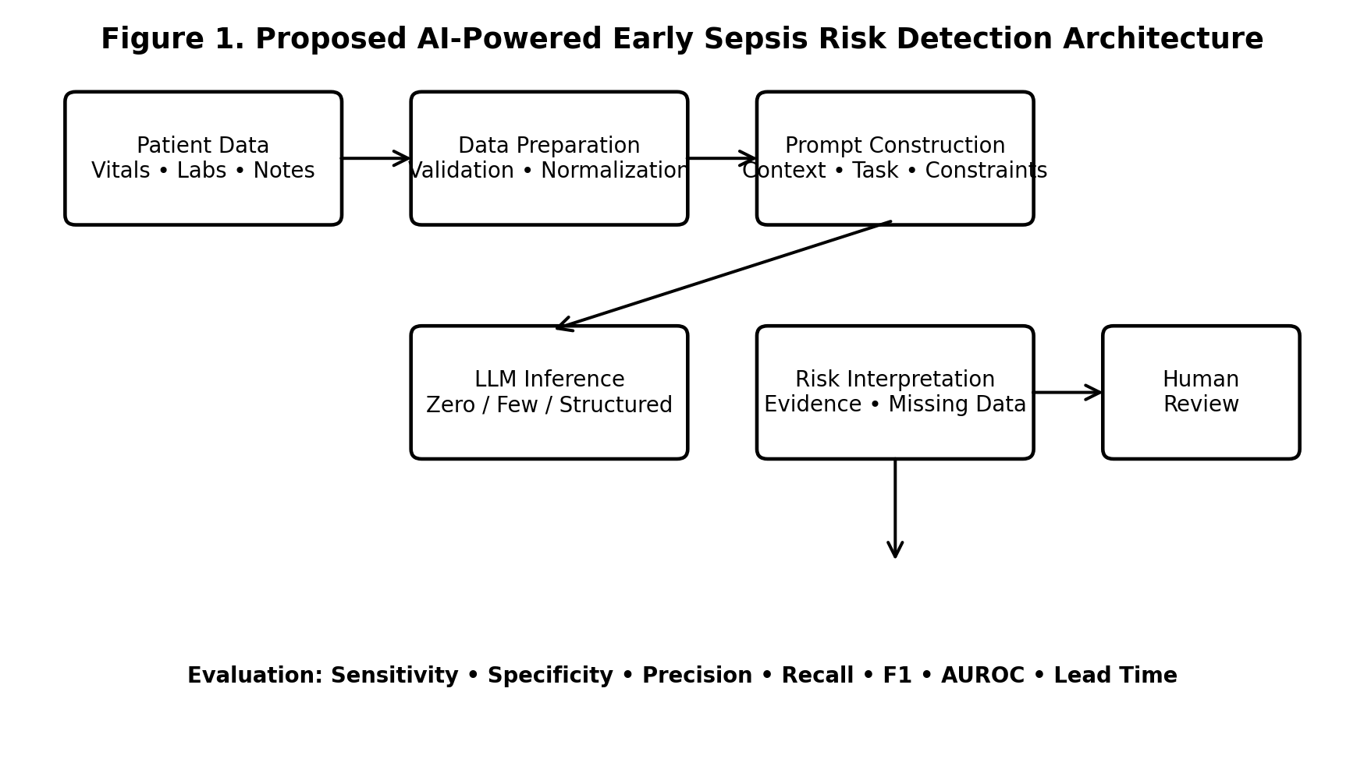
Fig. 1. Proposed System Architecture: clinical data are prepared, converted into a controlled prompt, evaluated by an LLM, interpreted into a risk output, and reviewed by a human.
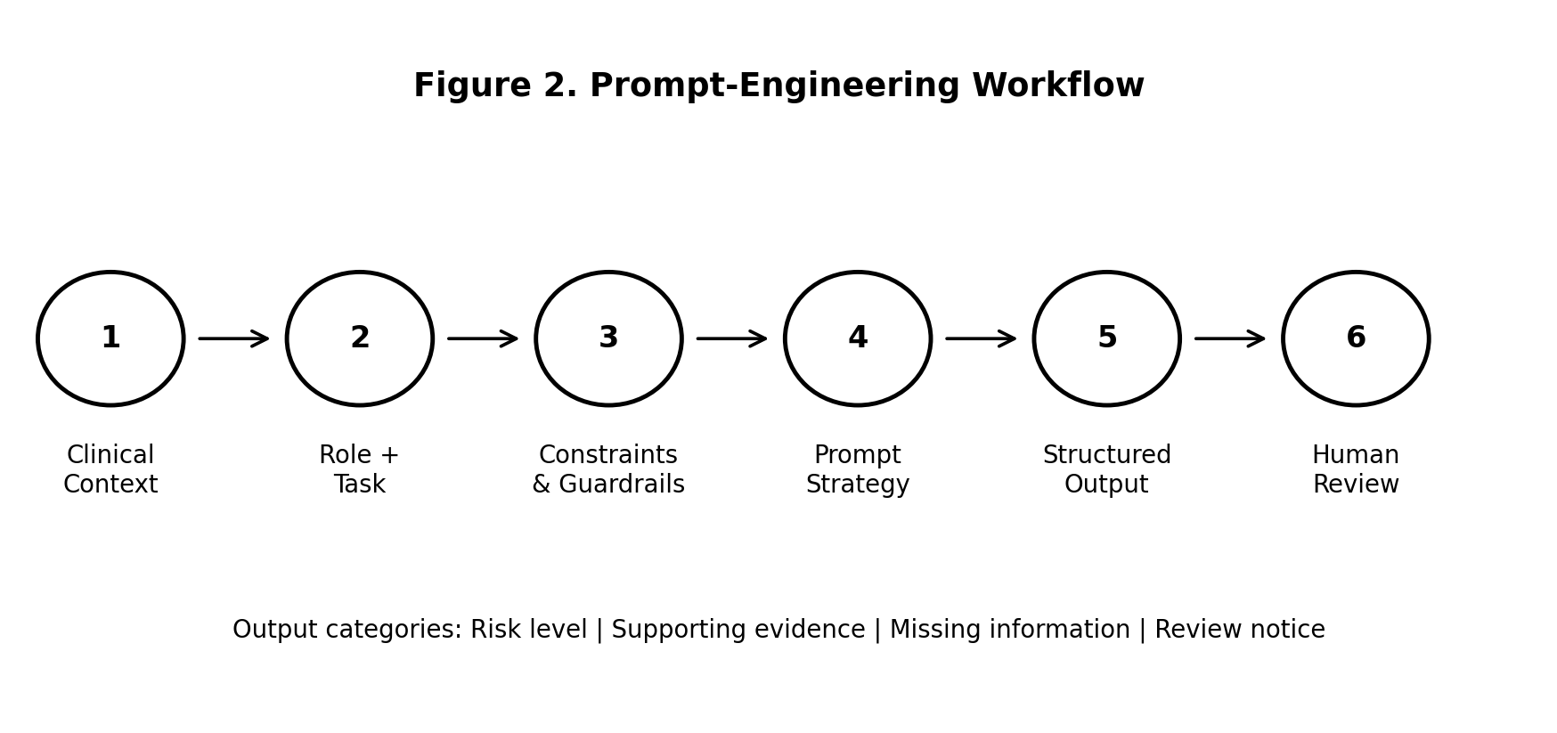
Fig. 2. Prompt-Engineering Workflow: the same clinical context is evaluated using controlled prompt components and a structured output format.
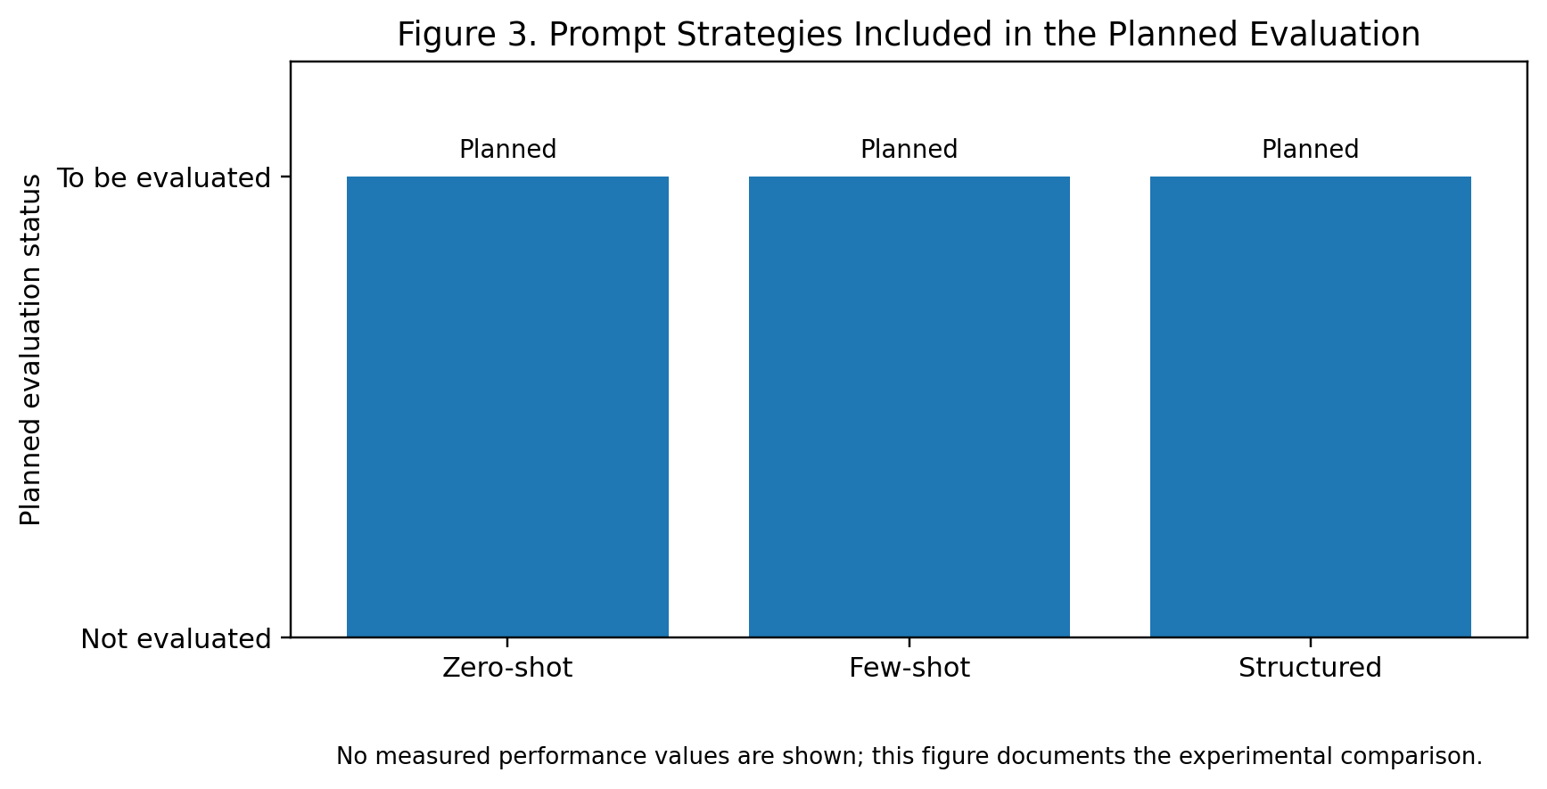
Fig. 3. Planned Prompt-Strategy Comparison. This is a study-design figure, not an experimental performance result.
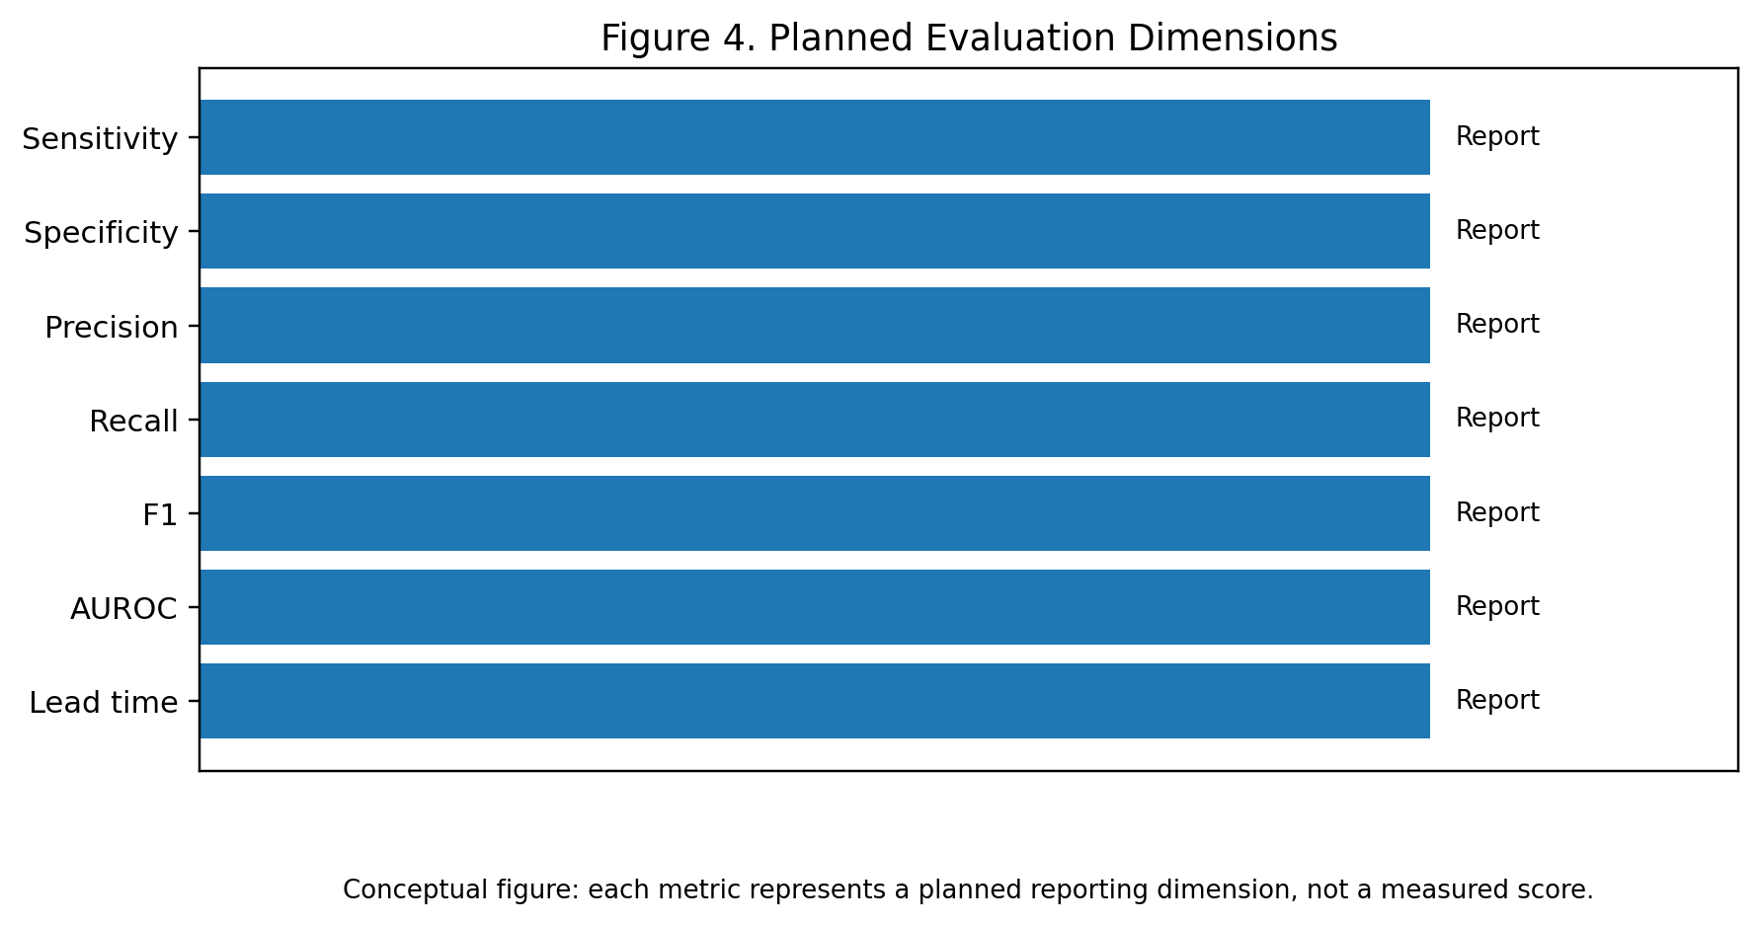
Fig. 4. Planned Evaluation Dimensions. Actual metric values must be inserted after testing on the approved dataset.

TABLE VII. STANDARDIZED PROMPT COMPONENTS
Component | Purpose | Example
Role | Defines the task boundary | Clinical decision-support research assistant
Context | Supplies patient observations | Vitals, laboratory values, notes
Task | Defines requested assessment | Estimate early sepsis risk
Constraints | Reduces unsupported outputs | Do not invent missing data
Output | Standardizes response | Risk + evidence + missing data + review

DATA-READY RESULTS SECTION
• The current figures intentionally avoid presenting invented medical performance. Once the prototype is tested, replace the conceptual figures with measured sensitivity, specificity, F1-score, AUROC, calibration, and lead-time results.
• For final submission, include the dataset name, number of patient encounters, positive/negative outcome counts, train/validation/test split, prediction horizon, model version, prompt version, and confidence intervals where appropriate.
• Do not label illustrative values as actual results. Any clinical performance claim should be supported by the completed experiment and the approved reference outcome definition.

Metric | Zero-shot | Few-shot | Structured
Sensitivity | [Value] | [Value] | [Value]
Specificity | [Value] | [Value] | [Value]
Precision | [Value] | [Value] | [Value]
Recall | [Value] | [Value] | [Value]
F1-score | [Value] | [Value] | [Value]
AUROC | [Value] | [Value] | [Value]

Replace [Value] with actual experimental results after testing.
D. Risk Classification Analysis
- The system classifies patient records according to the defined risk categories.
- The predicted risk category is compared with the reference outcome.
- Correct predictions, false positives, and false negatives are analyzed to understand system performance.
E. Confusion Matrix Analysis
• A confusion matrix is used to visualize correct and incorrect classifications.
• True Positive (TP): Correctly identified risk cases.
• True Negative (TN): Correctly identified non-risk cases.
• False Positive (FP): Non-risk case incorrectly identified as high risk.
• False Negative (FN): Risk case incorrectly classified as low risk.
F. Prompt Consistency Analysis
- Similar clinical inputs are tested using different prompt formulations.
- The consistency of risk categories and supporting evidence is analyzed.
- Prompt instability and unsupported statements are recorded as part of the error analysis.
G. Lead-Time Analysis
- The system's ability to identify potential risk before a reference clinical event can be measured.
- Lead time can be reported in minutes or hours depending on the dataset's timestamps.
- A higher useful lead time may indicate earlier identification of potential deterioration.
H. Result Visualization
The experimental results can be presented using:
- Bar graph for Sensitivity, Specificity, Precision and F1-score
- ROC curve for AUROC comparison
- Confusion matrix
- Prompt-strategy comparison chart
- Lead-time distribution graph
- Error-analysis chart

VIII. REFERENCES
[1] M. Singer et al., “The Third International Consensus Definitions for Sepsis and Septic Shock (Sepsis-3),” JAMA, vol. 315, no. 8, pp. 801–810, 2016, doi: 10.1001/jama.2016.0287.
[2] C. W. Seymour et al., “Assessment of Clinical Criteria for Sepsis: For the Third International Consensus Definitions for Sepsis and Septic Shock (Sepsis-3),” JAMA, vol. 315, no. 8, pp. 762–774, 2016, doi: 10.1001/jama.2016.0288.
[3] L. Evans et al., “Surviving Sepsis Campaign: International Guidelines for Management of Sepsis and Septic Shock 2021,” Critical Care Medicine, vol. 49, no. 11, pp. e1063–e1143, 2021.
[4] H. C. Prescott, M. Antonelli, A. Alhazzani et al., “Surviving Sepsis Campaign: International Guidelines for Management of Sepsis and Septic Shock 2026,” Critical Care Medicine, 2026.
[5] A. Desautels et al., “Prediction of Sepsis in the Intensive Care Unit With Minimal Electronic Health Record Data: A Machine Learning Approach,” JMIR Medical Informatics, vol. 8, no. 1, 2020.
[6] M. Islam et al., “Machine Learning-Based Early Prediction of Sepsis Using Electronic Health Records: A Systematic Review,” Journal of Clinical Medicine, vol. 12, no. 17, 2023.
[7] Y. Zhang et al., “Evaluating Machine Learning Models for Sepsis Prediction: A Systematic Review of Methodologies,” iScience, vol. 25, 2022.
[8] S. Sivarajkumar et al., “An Empirical Evaluation of Prompting Strategies for Large Language Models in Zero-Shot Clinical Natural Language Processing,” arXiv:2309.08008, 2023.
[9] S. Sandeep Nachane et al., “Few Shot Chain-of-Thought Driven Reasoning to Prompt LLMs for Open Ended Medical Question Answering,” arXiv:2403.04890, 2024.
[10] J. A. K. et al., “Development and Prospective Implementation of a Large Language Model Based System for Early Sepsis Prediction,” 2025, doi: 10.1101/2025.03.07.25323589.
[11] “Effective Prompt Design for Large Language Models in Clinical Practice,” European Journal of Internal Medicine, 2026, doi: 10.1080/17843286.2026.2613903.
[12] “Large Language Models in Real-World Clinical Workflows: A Systematic Review of Applications and Implementation,” Frontiers in Digital Health, 2025, doi: 10.3389/fdgth.2025.1659134.

