**ASSESSMENT COVER PAGE**

* **STUDENT DETAILS / DECLARATION:**

|  |  |  |  |
| --- | --- | --- | --- |
| Course Name: | Advanced Diploma of Civil Construction Design | | |
| Unit / Subject Name: | **RIICWD601E Manage civil works design processes** | | |
| Trainer’s Name: | **Muhammad** | Assessment No: | **Assignment 1 & 2** |
| **I declare that:** | * I fully understand the context and purpose of this assessment. * I am fully aware of the competency standard/criteria against which I will be assessed. * I have been given fair notice of the date, time and venue for the assessment. * I am aware of the resources I need and how the assessment will be conducted. * I have had the appeals process and confidentiality explained to me. * I agree that I am ready to be assessed and that all written work is my own.   This assessment is my:  o First submission o Re-submission (Attempt ) | | |
| Student Name: | **Sheikh Abdullah** | Student ID: | **SBDI** **1829** |
| Student’s Signature: |  | Submission Date: | 12 May 2024 |

**ASSESSOR USE ONLY:**

|  |  |  |  |  |
| --- | --- | --- | --- | --- |
| **Result:** | Assignment 1 | o Satisfactory o Not Satisfactory | | |
| Assignment 2 | o Satisfactory o Not Satisfactory | | |
|  | o Satisfactory o Not Satisfactory | | |
| *Final Assessment Result for this unit* | C / NYC | | |
| **Feedback:** | *Feedback is given to the student on each*  *Assessment task & final outcome of the unit* | Yes / No | | |
| Assessor’s  Feedback: |  | | | |
| Assessor’s  Signature: |  | | Date: |  |

**ASSESSMENT FIRST SUBMISSION/RE-SUBMISSION RECEIPT:**

It is student’s responsibility to keep the assessment submission receipt as a proof of submission of assessment tasks

|  |  |  |  |
| --- | --- | --- | --- |
| Student Name: | **Sheikh Abdullah** | Student ID: | **SBDI** **1829** |
| Unit / Subject Code: | **RIICWD601E Manage civil works design processes** | Assessment No: |  |
| Trainer Name: | Muhammad | Date: | 12 May 2024 |
| Signature: |  | | |

This page left blank intentionally.

**ASSIGNMENT 1:**

**KNOWLEDGE ASSESSMENT**

**RIICWD601E Manage civil works design processes**

|  |  |
| --- | --- |
| **Student Name** | **Sheikh Abdullah** |
| **Student ID** | **SBDI 1829** |
| **Unit commenced (Date)** |  |
| **Unit Completed (Date)** |  |
| I hereby certify that I have undertaken these assessment tasks utilising my own work without assistance from any other parties. I have not knowingly plagiarised any work in completing these assessment activities.  **Student Signature** |  |

TyPES of evidence

The RTO ensures that assessment is carried out in accordance with the requirements of the unit and the standards and will implement an assessment process which identifies the evidence required for each unit of competency. They will identify the type of evidence and the assessment methods used.

Types of evidence include:

Direct Evidence – things that the assessor, observes first-hand, e.g., observation or work samples

Indirect Evidence – things that someone else has observed and reported to us, e.g., third party reports

Supplementary Evidence – other things that can indicate performance, such as training records, questions, written work, portfolios

Assessment methods may include but are not limited to:

Written Activity

Case Study

Observation/Demonstration

Practical Activity

Questions

Third Party Report

Assessment must comply with the assessment methods of the training package and be conducted in accordance with the Principles of Assessment and assessment conditions. This means the assessment must be fair, flexible, reliable and valid.

ASSESSMENT INFORMATION for students

Throughout your training we are committed to your learning by providing a training and assessment framework that ensures the knowledge gained through training is translated into practical on the job improvements.

You are going to be assessed for:

Your skills and knowledge using written and observation activities that apply to the workplace.

Your ability to apply your learning.

Your ability to recognize common principles and actively use these on the job.

All of your assessment and training is provided as a positive learning tool. Your assessor will guide your learning and provide feedback on your responses to the assessment materials until you have been deemed competent in this unit.

HOW YOU WILL BE ASSESSED

The process we follow is known as competency-based assessment. This means that evidence of your current skills and knowledge will be measured against national standards of best practice, not against the learning you have undertaken either recently or in the past. Some of the assessment will be concerned with how you apply your skills and knowledge in the workplace, and some in the training room as required by each unit.

The assessment tasks have been designed to enable you to demonstrate the required skills and knowledge and produce the critical evidence to successfully demonstrate competency at the required standard.

Your assessor will ensure that you are ready for assessment and will explain the assessment process. Your assessment tasks will outline the evidence to be collected and how it will be collected, for example, a written activity, case study, or demonstration and observation.

The assessor will also have determined if you have any special needs to be considered during assessment. Changes can be made to the way assessment is undertaken to account for special needs and this is called making Reasonable Adjustment.

**What happens if your result is ‘Not Yet Competent’ for one or more assessment tasks?**

Our assessment process is designed to answer the question “has the desired learning outcome been achieved yet?” If the answer is “Not yet”, then we work with you to see how we can get there.

In the case that one or more of your assessments has been marked ‘NYC’, your trainer will provide you with the necessary feedback and guidance, for you to resubmit your responses.

**What if you disagree on the assessment outcome?**

You can appeal against a decision made in regard to your assessment. An appeal should only be made if you have been assessed as ‘Not Yet Competent’ against a specific unit and you feel you have sufficient grounds to believe that you are entitled to be assessed as competent. You must be able to adequately demonstrate that you have the skills and experience to be able to meet the requirements of units you are appealing the assessment of.

Your trainer will outline the appeals process, which is available to the student. You can request a form to make an appeal and submit it to your trainer, the course coordinator, or the administration officer. The RTO will examine the appeal and you will be advised of the outcome within 14 days. Any additional information you wish to provide may be attached to the appeal form.

**What if I believe I am already competent before training?**

If you believe you already have the knowledge and skills to be able to demonstrate competence in this unit, speak with your trainer, as you may be able to apply for Recognition of Prior Learning (RPL).

**Assessor Responsibilities**

Assessors need to be aware of their responsibilities and carry them out appropriately. To do this they need to:

Ensure that participants are assessed fairly based on the outcome of the language, literacy and numeracy review completed at enrolment.

Ensure that all documentation is signed by the student, trainer, workplace supervisor and assessor when units and certificates are complete, to ensure that there is no follow-up required from an administration perspective.

Ensure that their own qualifications are current.

When required, request the manager or supervisor to determine that the student is ‘satisfactorily’ demonstrating the requirements for each unit. ‘Satisfactorily’ means consistently meeting the standard expected from an experienced operator.

When required, ensure supervisors and students sign off on third party assessment forms or third-party report.

Follow the recommendations from moderation and validation meetings.

**How should I format my assessments?**

Your assessments should be typed in a 11 or 12 size font for ease of reading. You must include a footer on each page with the student’s name, unit code and date. Your assessment needs to be submitted as a hardcopy or electronic copy as requested by your trainer.

**How long should my answers be?**

The length of your answers will be guided by the description in each assessment, for example:

|  |  |
| --- | --- |
| **Type of Answer** | **Answer Guidelines** |
| Short Answer | 4 typed lines = 50 words, or  5 lines of handwritten text |
| Long Answer | 8 typed lines = 100 words, or  10 lines of handwritten text = of a foolscap page |
| Brief Report | 500 words = 1 page typed report, or  50 lines of handwritten text = 1foolscap handwritten pages |
| Mid Report | 1,000 words = 2 page typed report  100 lines of handwritten text = 3 foolscap handwritten pages |
| Long Report | 2,000 words = 4 page typed report  200 lines of handwritten text = 6 foolscap handwritten pages |

**How should I reference the sources of information I use in my assessments?**

Include a reference list at the end of your work on a separate page. You should reference the sources you have used in your assessments in the Harvard Style. For example:

Website Name – Page or Document Name, Retrieved insert the date. Webpage link.

For a book: Author surname, author initial Year of publication, Title of book, Publisher, City, State

assessment guide

The following table shows you how to achieve a satisfactory result against the criteria for each type of assessment task. The following is a list of general assessment methods that can be used in assessing a unit of competency. Check your assessment tasks to identify the ones used in this unit of competency.

| **Assessment Method** | **Satisfactory Result** | **Non-Satisfactory Result** |
| --- | --- | --- |
| You will receive an overall result of Competent or Not Yet Competent for the unit. The assessment process is made up of a number of assessment methods. You are required to achieve a satisfactory result in each of these to be deemed competent overall. Your assessment may include the following assessment types. | | |
| **Questions** | All questions answered correctly | Incorrect answers for one or more questions |
| Answers address the question in full, referring to appropriate sources from your workbook and/or workplace | Answers do not address the question in full. Does not refer to appropriate or correct sources. |
| **Third Party Report** | Supervisor or manager observes work performance and confirms that you consistently meet the standards expected from an experienced operator | Could not demonstrate consistency. Could not demonstrate the ability to achieve the required standard |
| **Written Activity** | The assessor will mark the activity against the detailed guidelines/instructions | Does not follow guidelines/instructions |
| Attachments if requested are attached | Requested supplementary items are not attached |
| All requirements of the written activity are addressed/covered. | Response does not address the requirements in full; is missing a response for one or more areas. |
| Responses must refer to appropriate sources from your workbook and/or workplace | One or more of the requirements are answered incorrectly.  Does not refer to or utilise appropriate or correct sources of information |
| **Observation/Demonstration** | All elements, criteria, knowledge and performance evidence and critical aspects of evidence, are demonstrated at the appropriate AQF level | Could not demonstrate elements, criteria, knowledge and performance evidence and/or critical aspects of evidence, at the appropriate AQF level |
| **Case Study** | All comprehension questions answered correctly; demonstrating an application of knowledge of the topic case study. | Lack of demonstrated comprehension of the underpinning knowledge (remove) required to complete the case study questions correctly. One or more questions are answered incorrectly. |
| Answers address the question in full; referring to appropriate sources from your workbook and/or workplace | Answers do not address the question in full; do not refer to appropriate sources. |
| **Practical Activity** | All tasks in the practical activity must be competed and evidence of completion must be provided to your trainer/assessor.  All tasks have been completed accurately and evidence provided for each stated task. | Tasks have not been completed effectively and evidence of completion has not been provided. |
| Attachments if requested are attached | Requested supplementary items are not attached |

**Knowledge Assessment (Written Tasks)**

1. **Outline 2 ways to reduce the environmental impact of civil projects.**

The following are two ways,

1. **Green Building Design and Sustainable Materials:**

Implement green building practices that prioritize energy efficiency, water conservation, and reduced waste generation. This includes using renewable energy sources, energy-efficient lighting systems, and sustainable HVAC (heating, ventilation, and air conditioning) solutions. Reducing the use of materials with high carbon footprints can significantly lower the environmental impact of the project.

1. **Conduct Environmental Assessments:**

Prioritize thorough environmental impact assessments (EIAs) to identify potential ecological impacts. Develop mitigation strategies such as habitat restoration programs and wildlife corridors to minimize disturbance and preserve biodiversity throughout the project lifecycle.

**2. What is the advantage of incorporating demand operated ventilation in civil designs?**

The advantage of Incorporating demand-operated ventilation in civil designs is it provides energy savings by adjusting airflow based on occupancy and air quality. It ensures optimal indoor conditions while reducing energy consumption and operational costs. This approach enhances comfort, improves air quality, and promotes sustainability in buildings.

**3. In designing stair placement, what would you do to encourage use?**

Nowadays, the used of stairs are not that common as people become lazier in terms to engage minimal physical activity by using escalators or lifts, however, one way to encourage the use of the stairs in by locating motivational signs, or placing sounds for each step, making the steps with lights design. As well at the moment of design it would be better where the locations is with visible access, close to the lifts or escalators.

**4. How would you develop a sustainable procurement strategy to be implemented during construction?**

I will choose sustainable materials such as timber or bamboo, use recycled metal such as Aluminium and steel as they are versatile, cement made from recycled plastic. And have a strategic management waste where place recycle packeting and storage the extra material for use in the future projects. At the same time no extra ordering material.

**5. Where relevant to the proposed development, what engineering information at should be provided?**

The engineering information should be provided as below,

1. **Site Information:** Detailed information about the project site, including topography, soil conditions, geotechnical surveys, and environmental assessments. This information is crucial for understanding the site's suitability and potential challenges.
2. **Topographic** **maps**: It will determine the limit and the area of the land. With detailed information about nearby buildings, footpaths and so on.
3. **Architectural design:** it is a detail design of the plans and how the building it will look like, where it will include the external and internal details of it however it can be modified during the process as the civil engineering request for fixability of the project.
4. **geotechnical studies:** this information is vital for the project in develop as it will make understand the conditions of the soil, where it will determinate the design of the foundations, stability of the design, determine risk, if the soil has underwater, how the building will settle and how the weight of the design will affect the buildings in the surrounding.
5. **Structural engineering analysis**: after the architect show the drawings of the project the structural engineering will locate all the beans, columns and it will design the infrastructure of the building including calculations, load analysis, material specifications, location of the foundations. Design of drain, wastewater.
6. **Mechanical and electrical engineering:** it will design electrical systems, ventilation plumbing design.
7. **Project Timeline and cost :** A well-defined project timeline outlining the different phases of the development, from planning to completion and its cost.
8. **Risk Analysis:** Identifying potential risks and challenges associated with the project and proposing risk mitigation strategies.

**6. What does it mean to have uniquely identified requirements? Why should requirements be uniquely identified?**

To have a uniquely identified requirements which means assigning a distinct label to each requirement. This ensures clarity, avoids confusion, and aids in tracking changes throughout the project. It helps resolve conflicts, cross-reference related elements, and comply with standards. Ultimately, it enhances project management, communication, and successful delivery.

**7. What is the term used for the processes required to ensure that the project include all the work required, and only the work required, to complete the work successfully.**

(a) Project Scope Management

(b) Bill of Materials

(c) Work Breakdown Structure

(d) None of the above

**8. Project Scope Management has following processes:**

**a. Collect Requirements**

**b. Plan Scope management**

**c. Define Scope**

**d. Create WBS**

**Arrange them in the correct sequence.**

(a) a-b-c-d

(b) c-d-b-a

(c) b-a-c-d

(d) a-c-b-d

**9. How does scope creep happen?**

There is many ways that scope creep can happen, usually it is the lack of the team making small decisions that can change the time or terms of the project without following management process such as:

* Unclear initial requirements.
* Poor communication or documentation of requirements..
* Failure to enforce project scope boundaries.
* Inadequate requirement management.
* Stakeholder requests not aligned with project objectives.
* External factors such as market changes or regulatory requirements.

**10. What happens during concept design stages?**

During concept design stages,

- Initial project ideas are developed into feasible concepts.

- It involves defining project objectives, exploring design options, and generating rough sketches or diagrams.

- Preliminary assessments of technical feasibility, budget, and schedule are made to determine the project's viability before proceeding to detailed design phases.

**11. What should a completed detailed design include?**

A completed detailed design should include:

1. Comprehensive technical drawings, specifications, and plans detailing all aspects of the project.

2. Clear documentation of materials, components, and construction methods.

3. Precise measurements, dimensions, and tolerances for accuracy in implementation.

4. Integration of architectural, structural, mechanical, and electrical elements.

5. Compliance with relevant codes, regulations, and standards.

6. Detailed cost estimates, including material quantities and labor requirements.

7. Risk assessments and mitigation strategies.

8. Consideration of sustainability principles and environmental impacts.

9. Coordination with stakeholders and consultants to ensure alignment with project goals.

10. Approval by relevant authorities and stakeholders before implementation.

**12. Outline a strategy to facilitate collaboration on an engineering project.**

To facilitate collaboration on an engineering project:

- Establish clear project objectives, roles, and responsibilities.

- Implement collaborative tools such as project management software for communication and document sharing.

- Conduct regular team meetings to discuss progress, challenges, and solutions.

- Foster a culture of open communication and mutual respect among team members.

- Encourage interdisciplinary collaboration and knowledge sharing.

- Provide opportunities for skill development and training.

- Establish feedback mechanisms to address concerns and improve collaboration.

- Assign a dedicated project manager to oversee coordination and resolve conflicts.

- Celebrate milestones and achievements to boost team morale.

- Conduct post-project evaluations to identify lessons learned and areas for improvement.

**13. What is Computer Aided Design?**

Computer-Aided Design (CAD) is the use of computer software to create, modify, analyze, and optimize designs for various engineering and architectural purposes. CAD software enables precise drafting and modeling of 2D and 3D objects. An example is AutoCAD, widely used in architecture, engineering, and construction industries for drafting and design.

**14. What should happen after the design review?**

After the design review, stakeholders should address identified issues, make necessary revisions, and approve the final design. Any required changes should be incorporated, and updated documentation should be disseminated to the relevant team members. This ensures alignment with project requirements and prepares for the next phase of implementation.

**15. What does it mean to actively listen?**

Actively listening means fully concentrating, understanding, and responding to what is being said, both verbally and non-verbally. It involves giving full attention to the speaker, asking clarifying questions, and empathizing with their perspective. Active listening fosters better communication, trust, and mutual understanding in conversations.

**16. How is the client included in design concept development?**

The client is included in design concept development through regular consultations, meetings, and presentations. Their input, preferences, and feedback are actively sought and integrated into the design process. This ensures alignment with the client's vision, objectives, and expectations for the project.

**17. What is the purpose of design evaluation?**

Design evaluation serves the purpose of assessing the quality, feasibility, and effectiveness of a proposed design before implementation. It identifies flaws, verifies requirements, and optimizes performance. Additionally, it ensures safety, compliance, and cost-effectiveness, while considering user experience and sustainability. Design evaluation provides valuable feedback, enabling iteration and informed decision-making throughout the design process, leading to successful and well-executed projects.

**Assessment Outcome**

|  |  |
| --- | --- |
| **Question** | **Correct (✓)** |
| 1 |  |
| 2 |  |
| 3 |  |
| 4 |  |
| 5 |  |
| 6 |  |
| 7 |  |
| 8 |  |
| 9 |  |
| 10 |  |
| 11 |  |
| 12 |  |
| 13 |  |
| 14 |  |
| 15 |  |
| 16 |  |
| 17 |  |

**Assessed by: Assessor Signature: Date:**

**ASSIGNMENT 2:**

**Skills Assessment**

**RIICWD601E Manage civil works design processes**

|  |  |
| --- | --- |
| **Student Name** | **Sheikh abdullah** |
| **Student ID** | **SBDI 1829** |
| **Unit commenced (Date)** |  |
| **Unit Completed (Date)** |  |
| I hereby certify that I have undertaken these assessment tasks utilising my own work without assistance from any other parties. I have not knowingly plagiarised any work in completing these assessment activities.  **Student Signature** |  |

**Task 1 – Civil Works Design**

You are required to undertake a civil construction design project as outlined below. Your Assessor will take the role of the client for the purposes of this assessment task.

**Design Specifications**

1. The Problem

You are a civil designer working for the state department of transportation. You have been assigned responsibility for the design of a truss bridge to carry a two-lane highway across the river valley shown below.

1. Design Objective

Satisfy all of the specifications listed below, while keeping the total cost of the project as low as possible.

1. Bridge Configuration
   1. The bridge may cross the valley at any elevation from the high water level to 24 meters above the high water level.
   2. If the elevation of the bridge is below 24 meters, excavation of the river banks will be required to achieve the correct highway elevation.
   3. To provide clearance for overhead power lines (shown above), the highest point on the bridge may not exceed an elevation 32.5 meters above the high water level (8.5 meters above the top of the river banks).
   4. The bridge may consist of either standard (simple supports) or (arch supports). If necessary, the bridge may also use one intermediate , located near the centre of the valley. If necessary, the bridge may also use cable , located 8 meters behind one or both abutments.
   5. Each main truss can have no more than 100 and no more than 200 .
   6. The bridge will have a flat, reinforced deck. Two types of concrete are available:
      1. Medium-strength concrete requires a deck thickness of 23 centimetres (0.23 metres).
      2. High-strength concrete requires a deck thickness of 15 centimetres (0.15 meter).
   7. In either case, the deck will be supported by transverse spaced at 4 metre intervals. To accommodate these floor beams, your must have a row of joints spaced 4 meters apart at the level of the deck. These joints are created automatically when you begin a new design.
   8. The bridge deck will be 10 meters wide, such that it can accommodate two lanes of traffic.
2. Member Properties
   * Materials. Each member of the truss will be made of either carbon steel, high-strength low-alloy steel, or quenched and tempered steel.
   * . The members of the truss can be either solid bars or hollow tubes. Both types of cross-sections are square.
   * Member Size. Both cross-sections are available in a variety of standard sizes.
3. Loads

The bridge must be capable of safely carrying the following loads:

* + Weight of the deck.
  + Weight of a 5-cm thick , which might be applied at some time in the future.
  + Weight of the steel floor beams and supplemental bracing members (assumed to be 12.0 applied at each deck-level joint).
  + Weight of the main trusses.
  + Either of two possible truck loadings:
    - Weight of one standard H25 truck loading per lane, including appropriate allowance for the dynamic effects of the moving load. (Since the bridge carries two lanes of traffic, each main truss must safely carry one H25 vehicle, placed anywhere along the length of the deck.)
    - Weight of a single 480 kN Permit Loading, including appropriate allowance for the dynamic effects of the moving load. (Since the Permit Loading is assumed to be cantered laterally, each main truss must safely carry one-half of the total vehicle weight, placed anywhere along the length of the deck.)

1. Structural Safety

The bridge will comply with the structural provisions of the state specified standards, to include:

* + Material densities
  + Load combinations
  + Tensile strength of members
  + Compressive strength of members

1. Cost

The cost of the design will be calculated using the following cost factors:

* + Material Cost:
    - * Carbon steel bars - $4.50 per kilogram
      * Carbon steel tubes - $6.30 per kilogram
      * High-strength steel bars - $5.00 per kilogram
      * High-strength steel tubes - $7.00 per kilogram
      * Quenched and tempered steel bars - $5.55 per kilogram
      * Quenched and tempered steel tubes - $7.75 per kilogram
  + Connection Cost: $500.00 per joint
  + Product Cost: $1000.00 per product
  + Site Cost:
    - * Reinforced concrete deck (medium strength) - $5,150 per 4-meter panel
      * Reinforced concrete deck (high strength) - $5,300 per 4-meter panel
      * Excavation - $1.00 per cubic meter (See the Site Design Wizard for excavation volume)
      * Supports (abutments and pier) - Cost varies (See the Site Design Wizard for specific values)
        + $6,000 per anchorage

**Required:**

1. Make a detailed list of all constraints and requirements to the bridge design.

2. Prepare functional specifications

3. Present at least 2 designs to meet the design specifications. The designs are to include, as relevant:

* calculations, which may include:
* loads
* sheer forces
* bending moments
* stresses
* construction materials and services quantities
* construction cost estimates
* recommended sizing of components
* recommended materials
* recommended reinforcement sizing and location
* drawings
* risk assessment of:
* the existing conditions
* the application of the design
* maintainability of the works
* health, safety and environmental requirements
* contribution to ancillary documentation, which may include:
* design notes
* construction notes
* supplementary drawings
* input to the specifications

Note: The designs, and their development, should comply with relevant requirements including:

* legislative, organisational and site requirements and procedures
* manufacturer's guidelines and specifications
* Australian standards
* Code of practice
* Employment and workplace relations legislation
* Equal Employment Opportunity and Disability Discrimination legislation

**Proposed Truss bridge design report**

**Answer:**

1. All constraints and requirements to the bridge design.
   1. High of the bridge can not be more than 32.5 m above the high-water level.
   2. Deck 10 m wide to accommodate 2 lanes of traffic.
   3. The bridge must cross the valley at an elevation of 24 m above the water level.
   4. Deck will be reinforced with concrete.
   5. Deck will have transverse floor beams spaced at 4 m intervals.
   6. Truss can have more than 100 and no more than 20o members.
   7. Concrete available: Medium strength (23 cm thick) and high strength (15 cm thick).
   8. Members can be carbon steel, high-strength low alloy steel, or quenched and tempered steel.
   9. Bridge must have the loads of the deck, floor beams, main trusses, and future pavement load.
   10. Must accommodate the weight of H25 truck loads, consider 2 trucks at the same time in the bridge (Weight of each truck 450 KN).
   11. The bridge must comply with state-specific requirements standards.
   12. Material costs for different types of steel, concrete
2. **Functional specifications.**
   1. The bridge needs to offer a secure and long-lasting passage across the river, accommodating a two-lane highway.
   2. Bridge configuration, materials and member sizes should be chosen to achieve structural stability and low-cost material.
   3. The design should consider ease of construction and maintenance and environmental impact with sustainability aspects.
   4. The design should be complaint with relevant Australian standards and codes of practice.
3. **Design**

Concept no.1:

it will have standard supports, high-strength concrete for the deck, hollow tubes for main truss member. With alloy steel. The units system express in the software it was set up for Ton-m-c

Table 1: It is the t(Thickness), L ( Longitude), w( Wide ), concerto (specific weight)

|  |  |  |
| --- | --- | --- |
| Deck | | |
| t | 0.15 | m |
| L | 44 | m |
| w | 10 | m |
| concerto | 2400 | kg/m^3 |

Table 2: It is the t (Thickness), L (Longitude), w (Wide), concerto (specific weight)

|  |  |  |  |  |  |
| --- | --- | --- | --- | --- | --- |
| Primary beam | | | Secondary beam | | |
| t | 0.15 | m | t | 0.15 | m |
| a | 0.15 | m | a | 0.3 | m |
| b | 0.075 | m | b | 0.15 | m |
| concerto | 2400 | kg/m^3 | concerto | 2400 | kg/m^3 |

Table 3: It is the t (Thickness), L ( Longitude), w( Wide ), concerto (specific weight)

|  |  |  |  |  |  |
| --- | --- | --- | --- | --- | --- |
| Hollow tube | | | Hollow tube 2 | | |
| t | 0.1 | m | t | 0.0004 | t |
| h | 0.2 | m | h | 0.1 | h |
| b | 0.2 | m | b | 0.1 | b |
| steel | 7750 | kg/m^3 | steel | 7750 | kg/m^3 |

**Dead Loads:** Table 4: t/2 ( length of the distribution load in the section of the deck in this case it is the wide of the deck divide by two).

|  |  |  |
| --- | --- | --- |
| Deck | | |
| t/2 | 5 | m |
| A | 220 | m^2 |
| ω | 79200 | kg |

Table 5: it is principal beam that it will be in the sides of the deck.

|  |  |  |
| --- | --- | --- |
| Beam no.1 | | |
| A | 3.3 | m^2 |
| ω | 1188 | kg |

Table 6: t/2 ( it is the length of the distribution load in the section of the beam)

|  |  |  |
| --- | --- | --- |
| Beam no. 2 | | |
| t/2 | 0.075 | m |
| A | 0.75 | m^2 |
| ω | 270 | kg |

Table 7: it is the weight of the hollow tube in a distribution load for each.

|  |  |  |  |  |  |
| --- | --- | --- | --- | --- | --- |
| Hollow tube | | | Hollow tube 2 | | |
| A | 0.749 | m^2 | A | 15.3 | m^2 |
| ω | 580.475 | kg | ω | 47.43 | kg |

Calculations were made to find the dead load of the structure that is the total summitry of the weight of the deck, beam 1, beam 2 and 2 designs for the hollow tube.

|  |  |  |
| --- | --- | --- |
| Total loads | 81238.48 | kg |

Image 1: **View of the bridge**

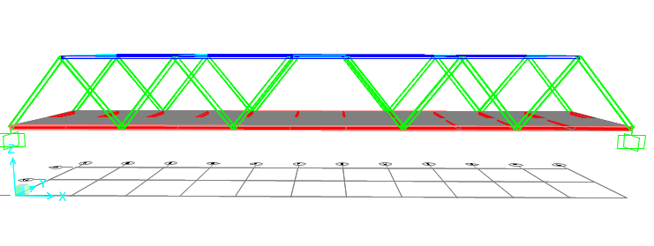

Image 2: **Sheer force calculation**

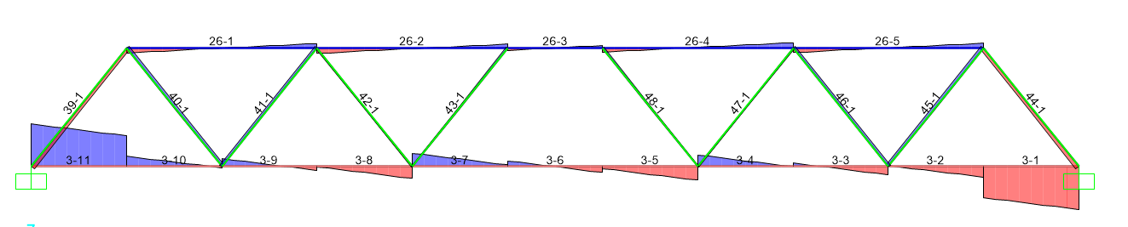

Image 3: **Bending moments**

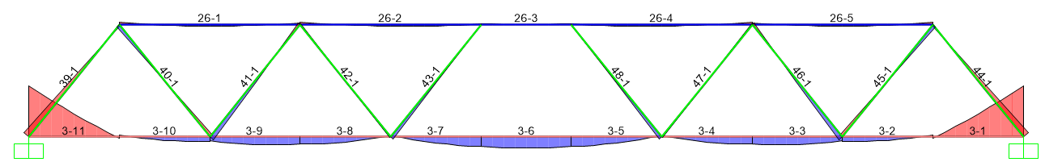

Image 4: **Stress maxima**

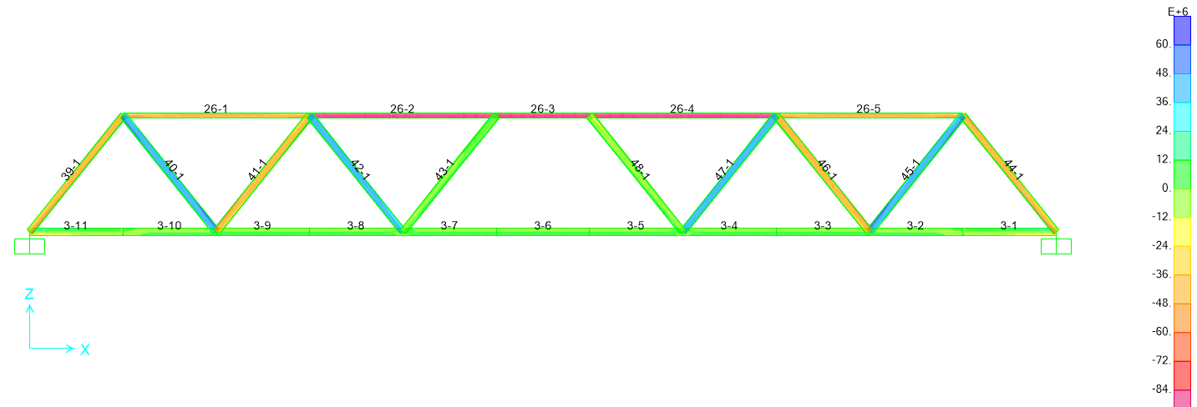

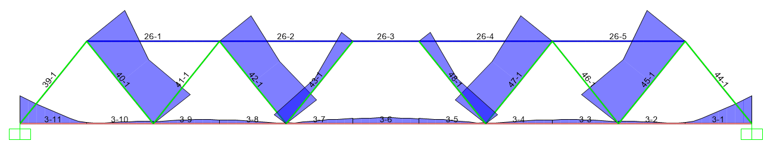

Each image must account for the presence of two trucks and an additional 5 cm thickness of concrete incorporated during the process.

##### Cost for process

|  |  |
| --- | --- |
| Cost | |
| High strength steel tubes | $ 4,395.34 |
| High strength concrete | $ 286,200.00 |
| High strength concrete | $ 127,200.00 |
| Connection per join | $ 15,000.00 |
| Total cost | $ 432,795.34 |

The total project cost amounts to $432,795.34.

Concept no.2

|  |  |  |
| --- | --- | --- |
| Deck | | |
| t | 0.25 | m |
| L | 44 | m |
| w | 10 | m |
| concerto | 2400 | kg/m^3 |

|  |  |  |  |  |  |
| --- | --- | --- | --- | --- | --- |
| Primary beam | | | Secondary beam | | |
| t | 0.25 | m | t | 0.25 | m |
| a | 0.25 | m | a | 0.25 | m |
| b | 0.5 | m | b | 0.125 | m |
| concerto | 2400 | kg/m^3 | concerto | 2400 | kg/m^3 |

|  |  |  |
| --- | --- | --- |
| Arc | | |
| d | 0.5 | m |
| R | 0.25 | m |
| A | 0.1963 | m^2 |
| steel | 7750 | kg/m^3 |

|  |  |  |
| --- | --- | --- |
| Deck | | |
| t/2 | 5 | m |
| A | 220 | m^2 |
| ω | 132000 | kg |
| Total loads | 145950 | kg |

|  |  |  |  |  |  |
| --- | --- | --- | --- | --- | --- |
| Beam no.1 | | | Beam no.2 | | |
| A | 22 | m^2 | t/2 | 0.125 | m |
| ω | 13200 | kg | A | 1.25 | m^2 |
|  |  |  | ω | 750 | kg |

|  |  |  |
| --- | --- | --- |
| Arc | | |
| a | 0.1963 | m^2 |
| L | 1 | m |
| ω | 1521.325 | kg |

##### Design for concept 2

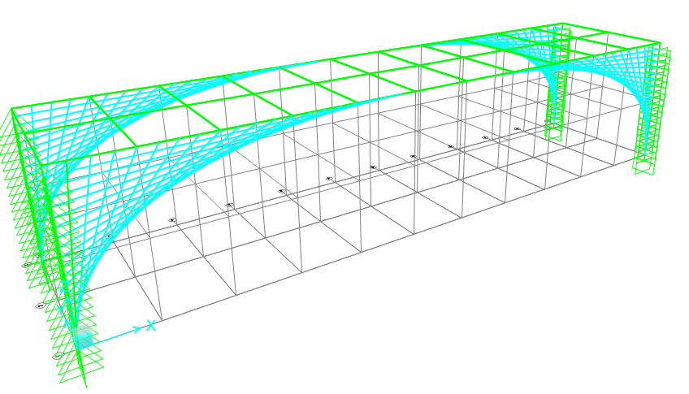

##### Bending moment

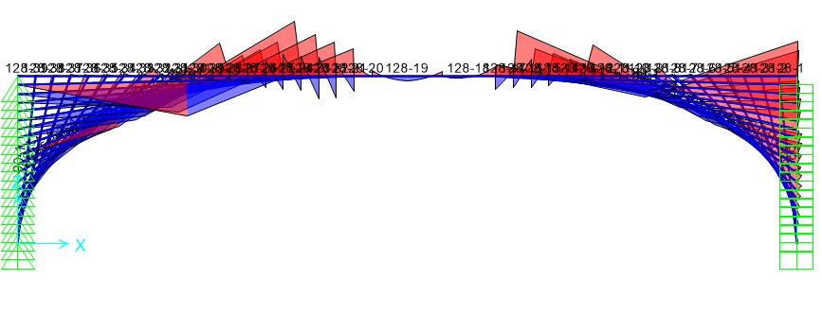

##### Sheers force

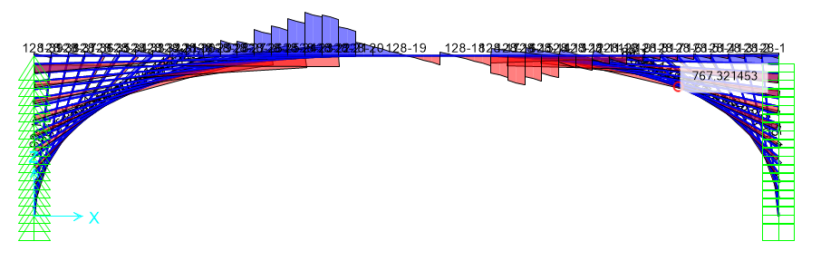

##### Stress maximum

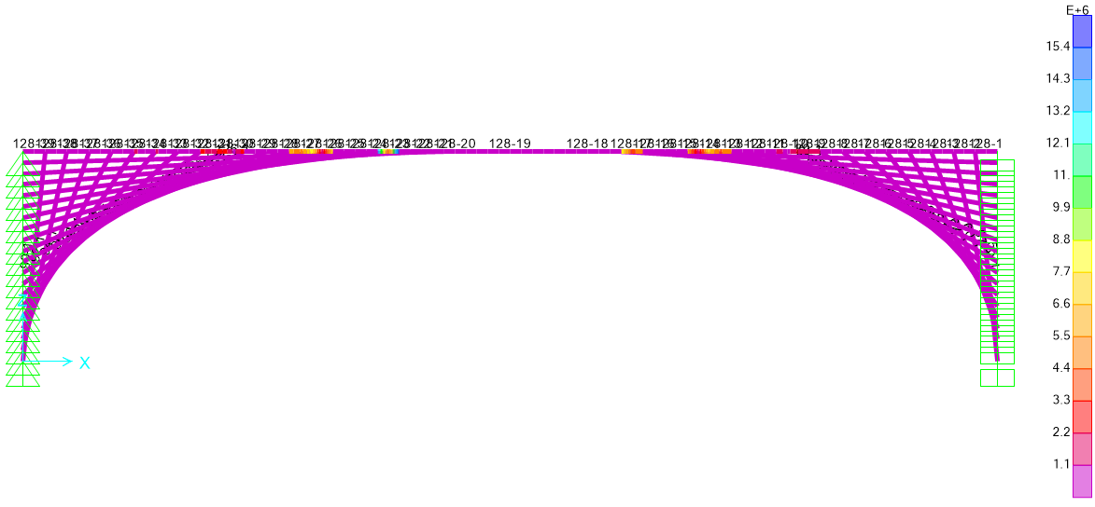

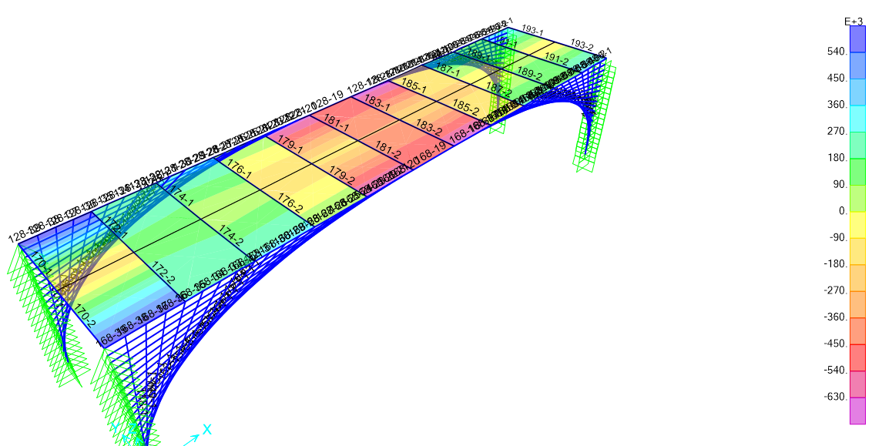

|  |  |  |
| --- | --- | --- |
| Cost | |  |
| Medium strength steel tubes | $ 380,331.25 |  |
| Medium strength concrete | $ 154,500.00 | Deck |
| Medium strength concrete | $ 123,600.00 | Beam 2 |
| Connection per join | $ 25,000.00 | 50 |
| Total cost | $ 683,431.25 |  |

For the both above concept it was regulated by,

- MRTS04 General earthworks

- MRTS71 Reinforcing steel

- MRTS51 Environmental management

- MRTS62 Bridge Substructure

- MRTS22 Supply of Cover Aggregate

- MRTS77 Bridge Deck Transport and Main Roads Specifications

- MRTS82 Bridge bearings, Bridge deck expansion joint

- MRTS03 Drainage, resurfacing structures, and protective treatments

- MRTS50 Specific quality system requirements

**Observation Checklist (To be completed by Assessor)**

| **Observation Criteria** | **S** | **NS** |
| --- | --- | --- |
| Obtained, interpreted, clarified and confirmed work requirements |  |  |
| Accessed, interpreted and applied documentation required for civil works design and confirmed work activity is compliant |  |  |
| Analysed client design criteria requirements for civil works to confirm required specifications are included |  |  |
| Advised client on potential environmental impact of proposed works and provided design options that meet environmental requirements |  |  |
| Confirmed required development and implementation factors are addressed in civil works design criteria |  |  |
| Prepared functional specifications according to engineering standards and design specifications |  |  |
| Obtained and documented and client agreement on civil works design criteria |  |  |
| Identified innovative procedures for developing the design concept according to design requirements |  |  |
| Investigated and analysed potential design concepts that meet design requirements |  |  |
| Collaborated with client to improve outcomes and resolve issues associated with design concept |  |  |
| Advised client of potential impacts of proposed works on local communities |  |  |
| Analysed and selected resources, processes and systems required to develop the design |  |  |
| Coordinated design tasks to meet required outcomes and cost structure |  |  |
| Developed and check design solution against engineering specifications |  |  |
| Established documentation management process according to workplace requirements |  |  |
| Checked and confirmed supporting documentation required to implement the design meets workplace requirements |  |  |
| Checked and confirmed design is identified by design documentation and records specified by client |  |  |
| Applied documentation control process specified by client when making changes to design |  |  |
| Checked and confirmed design documentation for currency and accuracy |  |  |
| Reviewed design and confirmed it meets client requirements |  |  |
| Incorporated amendments advised by client and confirmed design meets legislative requirements |  |  |
| Reviewed design with client and obtain documented approval |  |  |
| Prepared and implemented plans that verify completed physical work meets client requirements |  |  |
| Developed periodic test schedules for monitoring performance and permitted involved personnel to implement corrective action as required |  |  |
| Sought feedback from commissioning process to facilitate corrective actions and design improvements |  |  |
| Evaluated design outcome performance according to workplace requirements |  |  |
| Evaluated community response to design outcome and document according to workplace requirements |  |  |
| Adhered to statutory compliance requirements and procedures |  |  |
| Adhered to work health and safety requirements and procedures |  |  |
| Adhered to environmental management requirements and procedures |  |  |
| Adhered to cultural and heritage requirements and procedures |  |  |
| Adhered to quality management requirements and procedures |  |  |
| Prepared functional specifications applying engineering standards and the design specifications |  |  |
| Used a range of communication techniques and equipment to convey information to others |  |  |

**Outcome**

❑ Satisfactory ❑ Unsatisfactory

Comments:

|  |
| --- |
|  |
|  |
|  |
|  |
|  |
|  |
|  |

Date ______________________

Signed _____________________________ (Assessor)

Signed ______________________________(Student)

**RIICWD601E Manage civil works design processes**

**Assessment Outcome Record**

In order to be deemed competent in this unit, the candidate must answer all written questions correctly and satisfactorily complete all practical tasks. In order to complete all practical tasks, all Observation Criteria need to be satisfied, i.e. demonstrated and marked as an 'S'. The task summary outcome must be noted as satisfactory to note the demonstration of a satisfactory outcome for each practical task requirement.

|  |  |
| --- | --- |
| Student Name |  |
| 🞎 Not Yet Competent | 🞎 Competent |
| Comments | |
|  | |
|  | |
|  | |
|  | |
|  | |

|  |  |
| --- | --- |
| Assessor (Name) | Muhammad |
| Assessor Signature |  |
| Date |  |