**DISTRIBUTED ENERGY RESOURCES**

**REPORT**

**Table of Content**

Introduction 3

An overview of the facilities and its DSM/DER activities 3

Description of the market structure facilitating DSM/DER 4

Purpose of utilization of DSM/DER 5

Explanation of alternative approaches 7

Conclusion 10

References 12

# Introduction

Distributed energy resources or ***DER*** is an alternate name given to renewable energy systems or units that are positioned at businesses, or houses to provide power. Examples of DER include thermal energy storage, smart meters, home energy management systems, and rooftop solar PV units.

# An overview of the facilities and its DSM/DER activities

In 2018, the Distributed Energy Integration Program or ***DEIP*** was set up in Australia with the collaboration of market authorities, government agencies, and consumer associations to maximize the value of consumers’ DER. Nearly $9.6 million in funding was provided to 12 research and domestic projects to manage superior levels of DER in different parts to combat commercial challenges (Arena.gov.au*,* 2024).

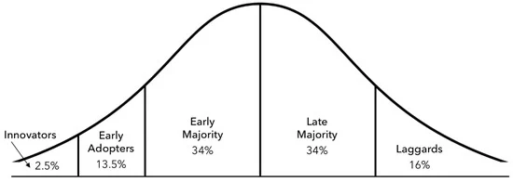

**Figure 1: Population phases of DER adoption in Australia**

(Source: Hargreaves *et al.* 2023)

Standard innovation diffusion curve with the innovator to the early adopter, and finally to the laggards is shown in Figure 1. Renewable energy sources provide nearly 22% of energy where average installation costs for a 2-megawatt wind turbine are $3 to $4 million (Gupta, 2023). Centralized energy systems concentrate all power in a single location whereas DER consists of several small-scale units installed at many locations. ***[Referred to Appendix 1]***

# Description of the market structure facilitating DSM/DER

The International Energy Agency or ***IEA*** recorded a steep rise in the electricity demand in recent years with serious consequences for consumers triggering blackouts in major economies. A 6% surge in electricity across the globe is found with a total electricity demand of 1500 TW or terawatt per hour and for China, it was 10% (Ambrose, 2022). Moreover, in the UK coal-fired plants generated 9% of electricity as gas was more expensive. Total CO2 emission may climb up to 7% as Britol proposed a decline of 55% in 2023 leading to becoming “***net zero carbon***” by 2050 (Ambrose, 2022). On the other hand, an ‘alarming slowdown’ is rife in the Australian renewable energy sector and $1.5 bn was sanctioned for new projects to run till 2027 with a target of decarbonization (Hannam, 2024). Furthermore, digitalization and net zero goals are on the way in Australia with the rising demand for electricity.

Different regulatory frameworks, market mechanisms, and technological changes have guided the construction of an Australian Energy Market designed for demand-side management (DSM) and the realities of distributed generation (Li *et al.* 2020). At the National Electricity Market (NEM), a wholesale market separating electricity trade from generation becomes a matter of mere brokerage between seller and buyer. Australian Energy Market Operator (AEMO) ensures that the supply-demand axis is always kept in balance.

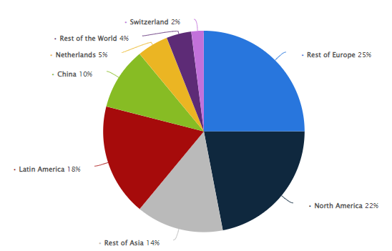

**Figure 2: Distribution of Royal DSM's sales worldwide in 2022, by destination region**

(Source: Statista, 2024)

The regulations set by such organizations as the Australian Energy Regulator (AER) and the Australian Energy Market Commission (AEMC) are aimed at facilitating the integration of demand-side management (DSM) and distributed energy resources (DER). Renewable energy targets offer both national and local bonuses for example initiatives like the Renewable Energy Target (RET) and state-specific incentives eventually result in intense pressures for investment revealing themselves as solar PVs battery storage and other DER technologies.

Programs such as demand-side system response offer one mechanism. By means of this, consumers are encouraged to make the most of their energy consumption by either reducing when the grid is most congested or shifting it to off-peak hours which is at night. This sort of offer has both a stabilizing effect on the network and brings about some circumvention of new threats to infrastructure needs. Retailers as well as aggregators play vital roles in enabling DSM. They do so through launching innovative rate plans, offering energy management services in various fashions, and so on.

Alongside pressures from the market, technological advancements such as advanced metering infrastructure ensure that we can control and monitor DER in real time. This capability supports the integration of distributed resources directly into grid ways, forming a more weather-resistant and sustainable energy system. A market structure that is created with appropriate regulation and technical innovation does make it possible to incorporate DSM and DER into the system very conveniently Steven Brown describes the inhabitants of the hillside village as being the pioneers of a sustainable energy future. The Australian market as a whole serves them well in this pursuit.

# Purpose of utilization of DSM/DER

DSM (Demand side management) basically helps people monitor their energy consumption when demand is at its peak (Akanksha *et al*. 2021). In that scenario, using renewable energy as electricity can provide several benefits to people such as reducing market prices for electricity, reducing the costs of managing the electricity grid, customers can save on their energy bills, network operators can ensure network reliability, the environment suffers less and many more. Along with that, DSM utilities help to save money. On the other hand, the establishment of DER (distributed energy resources) promotes the use of renewable energy in the form of solar panels, off-grid or grid-connected systems and more. DER provides several technical, economic and environmental benefits in the era of sustainability. Besides this, it helps to reduce electricity costs, enhancing reliability, power quality as well as efficiency (IEA, 2020). Moreover, renewable DG technologies such as solar, biomass, hydro and more help to provide faster and less expensive electricity options compared to conventional large high-voltage electricity generating stations.

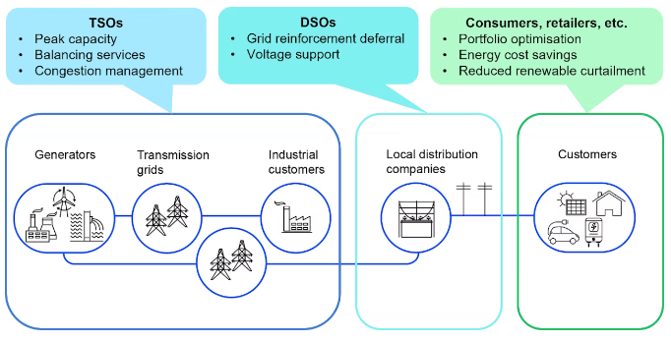

**Figure 3: Multiple Grid’s benefits of digitally enabled DERs**

(Source: IEA, 2020)

**Technical benefits**

Using DER provides several technical advantages to people in the era of technological advancement as it has a huge potential to produce low-price energy. Most importantly, it helps to enhance energy efficiency which has a huge impact on reducing energy consumption. Along with that, DER improved power quality and reduced system losses. Besides this, it has a huge influence in enhancing people's reliability on renewable energy resources.

**Economic benefits**

As per the economic aspect of DERs, it has a huge contribution in reducing the cost of electricity. Along with that, it helps to reduce transmission and operation costs compared with the conventional energy system. Most importantly, it has a huge impact on saving fuel (Liu *et al*. 2024). Due to this, people become able to use sufficient energy at a very low cost but with efficacy and efficiency. Moreover, reduction in fossil fuel consumption, greenhouse gas emissions, in Electricity Tariffs becomes possible due to the use of DERs which help to save a lot of energy.

**Environmental benefits**

Using DERs reduces the need to establish centralized power plants which help to reduce pollution caused by electricity generation. Most importantly, DER helps to reduce line losses during transmission by using local RESs (Cornejo Müller *et al*. 2020). Using cost-effective DG technologies, DER can help to exploit the waste energy produced during electricity generation. Hence, the use of DER has a huge impact on operating independently of the electric power grid in the era of digital transformation.

# Explanation of alternative approaches

There are several alternative approaches to DER which help people to get quality and reliable power systems in the era of the industrial revolution. Those alternative approaches are listed below with evidence support.

**Solar photovoltaic (PV) systems**

Among all the available energy resources sunlight is the most freely available energy source. That is why the solar PV system is the most used DG system. Solar PV panels convert sunlight into electricity which helps people to get quality and reliable sources of electricity in the era of technological advancement (Mustafa *et al.* 2020). Moreover, it helps people to fulfil their smaller relative needs for electricity. Along with that, it is environmentally friendly and does not produce any harmful gasses.

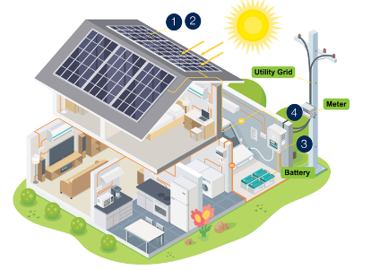

**Figure 4: Solar photovoltaic (PV) systems**

**Wind Turbines**

Wind turbines use blades to gather the wind's kinetic energy and then convert it into electricity (Bošnjaković *et al.* 2022). Moreover, it takes minimal space to set up and the source is totally economical for people. Along with that, wind is present everywhere and that is why in remote areas using wind turbines provides efficient energy resources with ultimate quality. Besides this, individual buildings or communities can use this DG system to get environmentally friendly energy resources at a minimal cost.

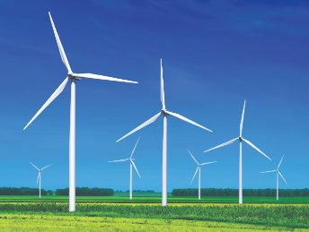

**Figure 5: Wind Turbines**

**Hydroelectric power plants**

In the case of a Hydroelectric power plant, the water flows through a pipe which helps to turn blades in a turbine then the generator produces electricity through spinning (Alvarez *et al.* 2020). In that scenario, it can be seen that the whole process is very clean and does not produce any waste as well as harmful gasses. That is why using hydroelectric power plants for generating electricity not only saves energy but also saves the environment from fatal damage in the era of digitalisation. Hence, it helps to reduce fossil fuel consumption, air pollution and more which has a huge impact in mitigating climate change.

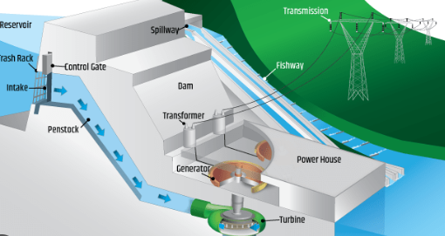

**Figure 6: Hydroelectric power plants**

**Diesel and Gasoline Generators**

Diesel and gasoline generators use biomass to produce electricity (Mobarra *et al.* 2022). Due to this, it does not produce any harmful wastes which can ruin environmental sustainability. Along with that, it has a huge impact on providing quality energy. Moreover, it requires low maintenance and provides a long operational life which helps people to reduce their energy costs. Besides this, it uses very little fuel for generating electricity due to its high compression ratio.

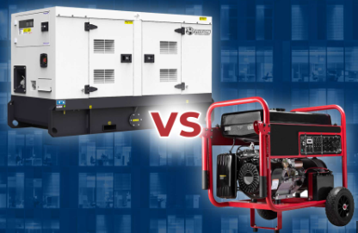

**Figure 7: Diesel and Gasoline Generators**

**Combined heat and power systems (CHP)**

In the CHP system electricity and thermal energy are produced from the same fuel. Hence, it has a huge impact on saving fuels or natural resources of energy. Along with that, it uses hot and chilled water in commercial as well as institutional and residential buildings for generating heat through renewable energies. Therefore, CHP systems produce energy as well as heat which can be used for several purposes for enhancing people's lifestyle.

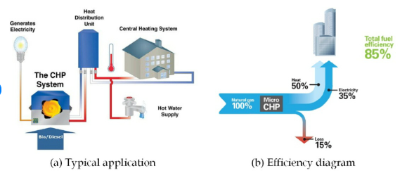

**Figure 8: Combined heat and power systems (CHP)**

# Conclusion

From the above-mentioned analysis, it can be concluded that DERs have a huge impact on saving energy resources in the present era of climate change. Along with that, it helps people to reduce their electricity bills by establishing a DG system on their rooftops. Most importantly, using DERs helps people to get efficient and quality electricity with consistency. However, some challenges regarding infrastructure, technology disruption and more can be faced during implementation of the DER system. Those changes can be solved by skilled and technical experts. In that scenario, individual buildings and industries can adopt DERs to protect the planet as well as society from huge air pollution as well as carbon emissions caused by generating electricity through conventional electricity plants. Moreover, using DG technologies helps people to reduce the need of setting a backup plan for electricity as well as it helps to protect the system from losses. Along with that, it helps network providers to provide consistent signals which help people to accomplish their work with more efficiency. Therefore, organizations as well as buildings need to set a DER system for saving energy for future generations in the era of sustainable development.

# References

Ambrose, J., 2022. *Global rise in electricity use may bring three years of price volatility.* Available at: https://www.theguardian.com/business/2022/jan/14/global-surge-in-electricity-use-could-bring-three-more-years-of-price-rises [Accessed on 24 April, 2024]

Arena.gov.au*,* 2024*. Distributed energy resources.* Available at: https://arena.gov.au/renewable-energy/distributed-energy-resources/ [Accessed on 24 April, 2024]

Gupta, A., 2023. *A Clean Energy Future Starts With An Efficient Grid.* Available at: https://www.forbes.com/sites/forbestechcouncil/2023/05/02/a-clean-energy-future-starts-with-an-efficient-grid/?sh=5f69d24b75e1/ [Accessed on 24 April, 2024]

Hannam, P., 2024. *Australian renewable sector recorded ‘alarming’ slowdown in 2023, energy body finds.* Available at: https://www.theguardian.com/environment/2024/mar/13/australian-renewable-sector-recorded-alarming-slowdown-in-2023-energy-body-finds [Accessed on 24 April, 2024]

Hargroves, K., James, B., Lane, J. and Newman, P., 2023. The role of distributed energy resources and associated business models in the decentralised energy transition: a review. Energies, 16(10), p.4231.

Li, H.X., Edwards, D.J., Hosseini, M.R. and Costin, G.P., 2020. A review on renewable energy transition in Australia: An updated depiction. *Journal of cleaner production*, *242*, p.118475.

Akanksha Sharma, ... Naqui Anwer, 2021 Integration of distributed energy resources in power systems: Issues, challenges, technology options, and the need for resilience Available at:<https://www.sciencedirect.com/topics/engineering/distributed-energy-resource> [Accessed on 26 April 2024]

IEA(2020)Distributed energy resources are creating new power system opportunities, and also challengesAvailable at:<https://www.iea.org/reports/unlocking-the-potential-of-distributed-energy-resources/executive-summary> [Accessed on 26 April 2024]

Liu, M., Teng, F., Zhang, Z., Ge, P., Sun, M., Deng, R., Cheng, P. and Chen, J., 2024. Enhancing Cyber-Resiliency of DER-Based Smart Grid: A Survey. *IEEE Transactions on Smart Grid*.<https://arxiv.org/pdf/2305.05338>

Cornejo Müller, A., Wachtler, B. and Lampert, T., 2020. Digital divide—Social inequalities in the utilisation of digital healthcare. *Bundesgesundheitsblatt-Gesundheitsforschung-Gesundheitsschutz*, *63*, pp.185-191.<https://link.springer.com/content/pdf/10.1007/s00103-019-03081-y.pdf>

Mustafa, R.J., Gomaa, M.R., Al-Dhaifallah, M. and Rezk, H., 2020. Environmental impacts on the performance of solar photovoltaic systems. *Sustainability*, *12*(2), p.608.<https://www.mdpi.com/2071-1050/12/2/608/pdf>

Bošnjaković, M., Katinić, M., Santa, R. and Marić, D., 2022. Wind turbine technology trends. *Applied Sciences*, *12*(17), p.8653.<https://www.mdpi.com/2076-3417/12/17/8653/pdf>

Alvarez, X., Valero, E., Torre-Rodríguez, N.D.L. and Acuna-Alonso, C., 2020. Influence of small hydroelectric power stations on river water quality. *Water*, *12*(2), p.312.<https://www.mdpi.com/2073-4441/12/2/312/pdf>

Mobarra, M., Rezkallah, M. and Ilinca, A., 2022. Variable speed diesel generators: Performance and characteristic comparison. *Energies*, *15*(2), p.592.<https://www.mdpi.com/1996-1073/15/2/592/pdf>

Statista(2024)Distribution of Royal DSM's sales worldwide in 2022, by destination regionAvailable at:<https://www.statista.com/statistics/670298/royal-dsm-sales-by-region/>[Accessed 23 May 2024]

**Appendices**

**Appendix 1: DER and centrally located energy storage**

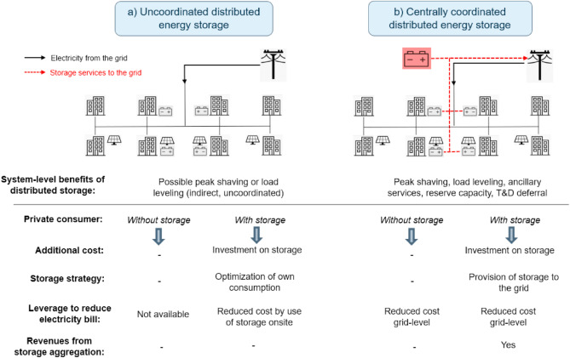

(https://www.sciencedirect.com/science/article/pii/S0360544221016911)