EMPOWERMENT TECHNOLOGIES | PERFORMANCE TASK
GAMECRAFT: Create, Design, Play!
GAME DOCUMENTATION
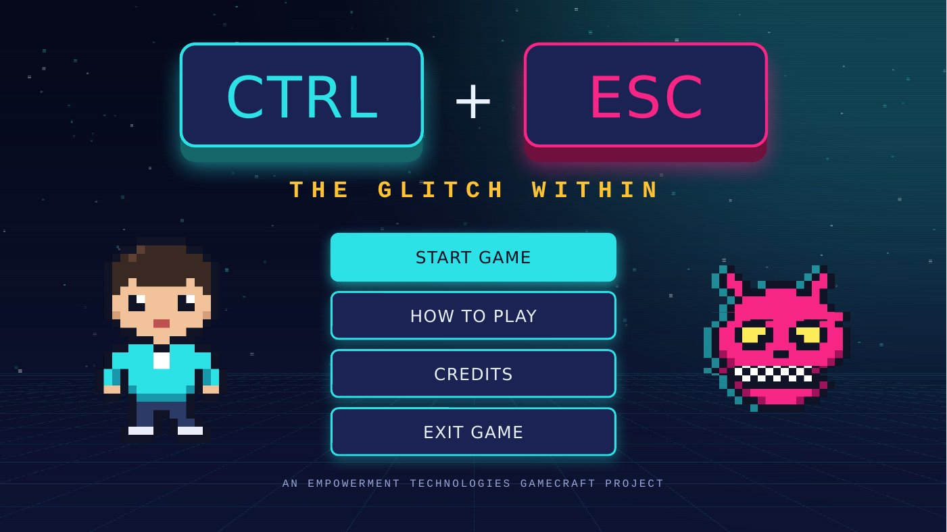
CTRL + ESCAPE: The Glitch Within
An escape room, story adventure, and quiz game made in Microsoft PowerPoint
Group Name | [Group Name]
Members | [Member Name] - Game Designer  [Member Name] - Story / Content Designer  [Member Name] - PowerPoint Developer  [Member Name] - Tester / Documentation Lead
Grade & Section | [Grade & Section]
Subject Teacher | [Teacher's Name]
Date Submitted | [Date]
Table of Contents

If the table of contents looks empty, right-click it and choose Update Field.

1. Game Overview
CTRL + ESCAPE: The Glitch Within is an original escape-room adventure built entirely in Microsoft PowerPoint. The player becomes Kai, a Senior High School student who gets pulled inside an infected computer after clicking a fake "You won a FREE phone!" pop-up. To escape, Kai must cross four computer sectors, answer general-knowledge challenges about science, history, everyday life, and geography, protect three shields, and collect four Code Fragments that unlock the ESC Gate guarded by a virus named NULL.
Play the game: CTRL-ESCAPE_Game.pptx (keep this document and the game in the same folder)
Item | Details
Game Title | CTRL + ESCAPE: The Glitch Within
Genre | Escape Room + Story-Based Adventure + Quiz (Digital Escape Challenge)
Platform | Microsoft PowerPoint in Slide Show mode (Windows or Mac). Saved as a normal .pptx, so no macros are needed.
Players | 1 player, or a small group deciding answers together
Target Audience | Senior High School students and anyone who enjoys trivia. No special knowledge is needed: the questions cover things most people learn in school and everyday life.
Playing Time | About 10 to 15 minutes per run
Game Content | General knowledge: science and nature, Philippine history, everyday life (food, sports, and money), and geography
Game Size | 133 slides, 548 hyperlinks, 5 game areas, 14 challenges, 3 endings (win with 1, 2, or 3 stars) plus Game Over
Project Files | CTRL-ESCAPE_Game.pptx (the playable game) and CTRL-ESCAPE_Game_Documentation.docx (this document)

1.1 Objective of the Game
Escape the computer by clearing all four sectors, collecting the four Code Fragments, answering NULL's final question, and entering the correct ESC Gate code before losing all three shields.

1.2 What Makes It Original
- An original story, setting, and cast: Kai (the player), BYTE (the antivirus guide), and NULL (the virus villain).
- All pixel art, sound effects, dialogue, and questions are original to this project.
- It mixes three genres: a story adventure, a quiz, and an escape-room code puzzle.
- A full lives system (shields) built with nothing but hyperlinks, with no macros.
- A final twist: NULL scrambles the ESC Gate, so players must enter their fragments in reverse order.
- The story teaches its own lesson: the whole adventure starts because Kai clicked a scam pop-up.

2. The Team: Members and Roles
Each member led one part of the project, but everyone helped plan, build, test, and present the game.
Role | Member | Responsibilities | Main Outputs
Game Designer | [Member Name] | Created the game concept, the shield and fragment mechanics, rules, scoring, and game flow | Game flowchart, rules, mechanics
Story / Content Designer | [Member Name] | Wrote the backstory, characters, dialogue, questions, hints, and explanations | Story slides, question bank
PowerPoint Developer | [Member Name] | Built the slides, hyperlinks, action buttons, slide masters, transitions, and sounds | The playable game file (.pptx)
Tester / Documentation Lead | [Member Name] | Planned and ran playtests, recorded results, and put together this Word document | Testing log, this documentation
[Add a row for each additional group member.]

3. Story and Characters

3.1 Backstory
It is 11:47 PM, the night before the Empowerment Technologies deadline. Kai is finishing the group's PowerPoint game when a flashing pop-up appears: "CONGRATULATIONS! You are our 1,000,000th visitor! You WON a FREE PHONE!" Without thinking twice, Kai clicks CLAIM NOW.
ZZZAP! The pop-up was a trap set by NULL, a computer virus that pulls Kai inside the computer. NULL now controls the system and plans to keep Kai, and the group's files, forever.
Luckily, BYTE, the computer's last working antivirus program, finds Kai. BYTE explains the only way out: cross the four sectors of the computer, collect the four Code Fragments, and unlock the ESC Gate at NULL's Core. Every wrong answer lets NULL break one of Kai's three shields. If all of them break, the system crashes.
When Kai finally escapes, Kai wakes up at the desk. The project is saved, the virus is gone, and a sticky note on the monitor says: THINK BEFORE YOU CLICK.

3.2 Characters
 | Character | Description
 | Kai  The Player | A Senior High School student and the hero of the game. Kai is curious and creative but a little too quick to click. Over the adventure, Kai learns to think before clicking.
 | BYTE  The Guide | The computer's last working antivirus program: a friendly robot with a monitor for a head. BYTE introduces each sector, explains every correct answer, and gives hints after mistakes.
 | NULL  The Villain | A glitchy virus that got in through the fake pop-up. NULL taunts the player after wrong answers, asks the final question, and scrambles the ESC Gate code.

3.3 Setting
The game takes place inside Kai's computer, shown as a glowing digital world with a neon grid floor. Each area has its own color so players always know where they are: cyan for the Science Lab, orange for the Time Vault, violet for the Fun Zone, green for the World Map, and magenta for NULL's Core.
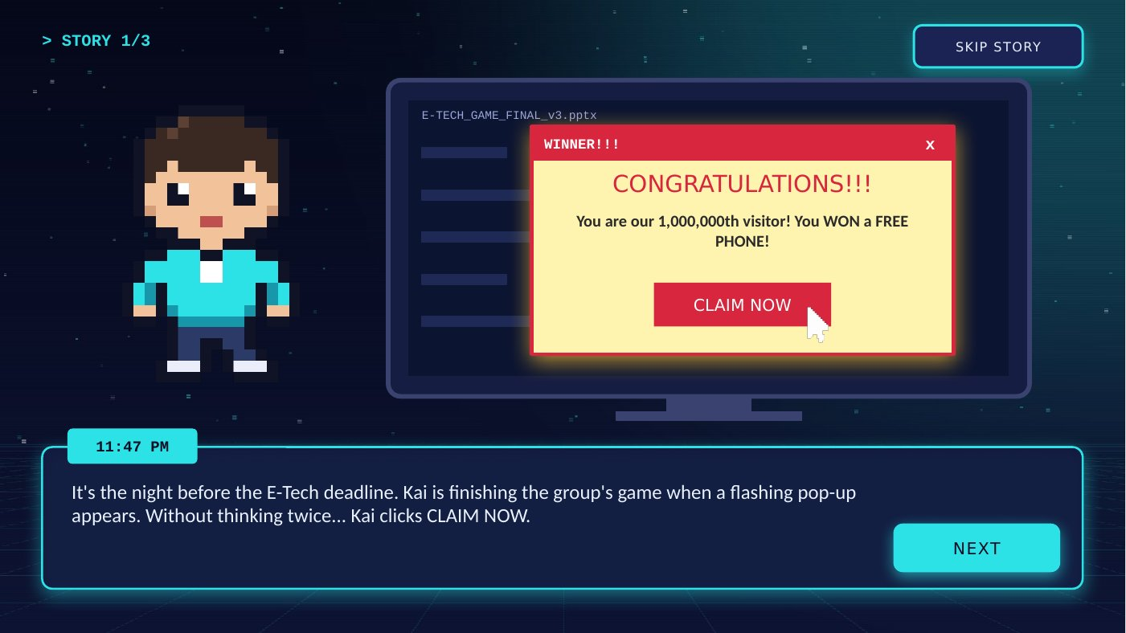
Figure 1. Story slide 1: Kai clicks the fake "You won a FREE phone!" pop-up.

4. Game World: The Five Areas
The adventure is divided into four sectors and a final area. Each one covers a different general-knowledge topic and ends with a reward. The questions were chosen so that any student can play, not just ICT experts.
Area | Topic | Challenges | Reward
Sector 1: The Science Lab | Science and Nature | 2 multiple-choice questions + 1 Fact or Myth | Code Fragment 3
Sector 2: The Time Vault | Philippine History | 2 multiple-choice questions + 1 Fact or Myth | Code Fragment 8
Sector 3: The Fun Zone | Everyday Life: Food, Sports, and Money | 2 multiple-choice questions + 1 sari-sari store receipt puzzle | Code Fragment 1
Sector 4: The World Map | Geography of the Philippines and the World | 1 choose-a-door puzzle + 2 multiple-choice questions | Code Fragment 6
NULL's Core | Final challenge: think before you click | Boss question + 4-digit ESC Gate code lock | Escape + star rank
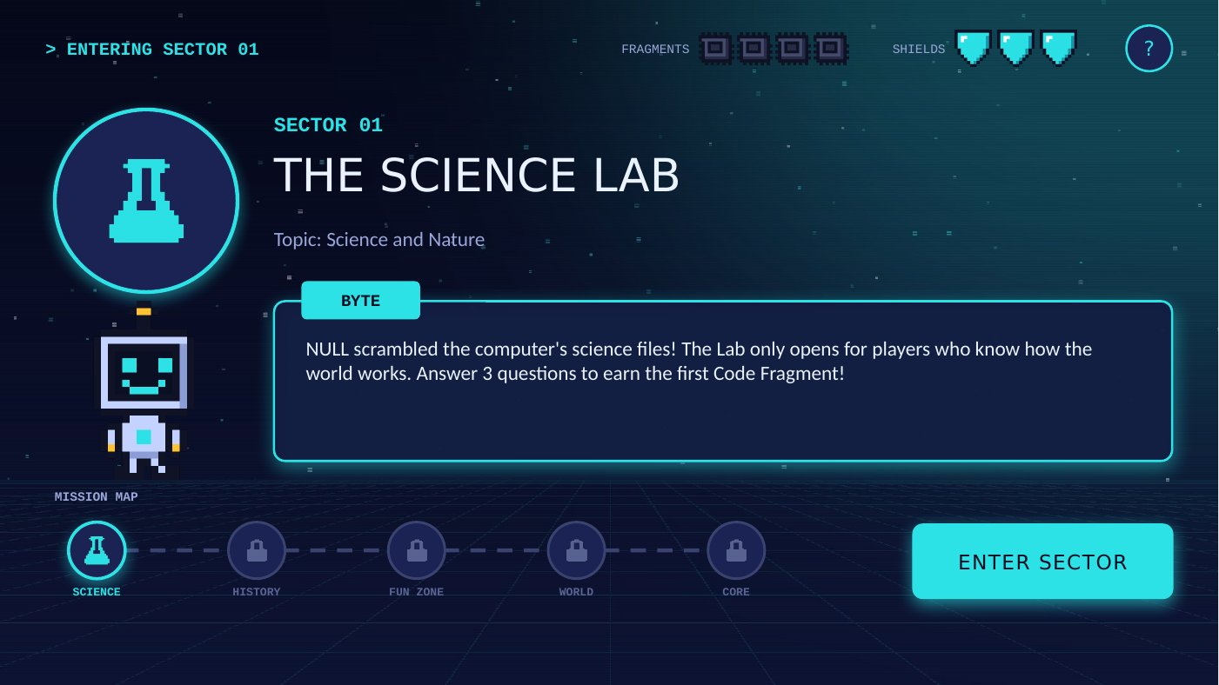
Figure 2. A sector entrance. BYTE gives a briefing and the mission map shows progress.

5. Game Mechanics

5.1 Core Gameplay Loop
- Read the situation or question.
- Choose an answer by clicking a button, a door, or a code.
- Get feedback: ACCESS GRANTED for a correct answer, GLITCH DETECTED for a wrong one.
- Continue to the next challenge, or try again with one less shield.
- Clear the sector to collect its Code Fragment, then move to the next sector.

5.2 Shields (Lives)
The player starts with 3 shields, shown in the top-right corner of every game slide. A wrong answer breaks one shield and shows a hint, and the player retries the same question. Losing the third shield crashes the system (Game Over). Shields never refill, so every answer matters from Sector 1 all the way to NULL's Core.

5.3 Code Fragments and the ESC Gate
Clearing a sector awards a Code Fragment: a single digit shown on that sector's last ACCESS GRANTED slide. The fragments are 3, 8, 1, and 6. The FRAGMENTS meter in the top bar shows how many have been collected, but not their values, so players must write the digits down. At the ESC Gate, NULL reveals a twist: the code must be entered in reverse order, which makes the answer 6-1-8-3.

5.4 Challenge Types
Type | How It Works | Where
Multiple Choice | Four answer buttons (A to D). Click the best answer. | All areas
Fact or Myth? | Read a statement from a corrupted file, then decide if it is a FACT or a MYTH. | Sectors 1 and 2
Receipt Puzzle | Read a sari-sari store receipt and work out the total. | Sector 3
Door Maze | Four doors, each labeled with a city. Open the one that leads the right way. | Sector 4
Code Lock | Pick the correct 4-digit code made from the collected fragments. | NULL's Core

5.5 Feedback and Hints
ACCESS GRANTED slides confirm the right answer, and BYTE explains why it is correct, so players learn even when they guess. GLITCH DETECTED slides show NULL's taunt, the shield that was lost, and a hint from BYTE that points toward the answer without giving it away.

5.6 Scoring and Ranks
The score is the number of shields kept at the end of the game.
Shields Kept | Stars | Rank | Victory Message
3 of 3 | 3 stars | CYBER GUARDIAN | A flawless escape. NULL never stood a chance!
2 of 3 | 2 stars | GLITCH BUSTER | A strong escape with only one broken shield!
1 of 3 | 1 star | LUCKY ESCAPER | You made it out... with just one shield left!
0 | none | SYSTEM CRASH | Game Over. Retry the mission from Sector 1.

5.7 Win and Lose Conditions
- Win: answer NULL's final question and unlock the ESC Gate with the correct code while at least one shield is left.
- Lose: lose all three shields at any point in the game. The player can retry from Sector 1 or return to the main menu.

6. Rules of the Game
- Play in Slide Show mode and use only the mouse. Click the buttons on the slides; do not use the arrow keys, space bar, or scroll wheel to change slides.
- You begin with 3 shields. They do not refill during the game.
- Every question has exactly one correct answer.
- A wrong answer breaks 1 shield, and you must retry the same question until you get it right.
- If all 3 shields break, the system crashes and the mission restarts from Sector 1 with 3 shields.
- Clear every question in a sector to receive its Code Fragment. Write every fragment down.
- You may click the ? button at any time to read the rules. It does not cost a shield.
- To win, answer NULL's final question and unlock the ESC Gate with the correct code.
- Your rank depends on how many shields you keep.
- No peeking at the answer key in this document while playing!

7. How to Play

7.1 Getting Started
- Keep CTRL-ESCAPE_Game.pptx and this Word document in the same folder.
- Open the game in Microsoft PowerPoint. If a yellow Protected View bar appears, click Enable Editing.
- Turn on your speakers for the sound effects.
- Press F5 (or click Slide Show > From Beginning) to start.
- On the title screen, click START GAME. First-time players should click HOW TO PLAY first.

7.2 Playing the Game
- Read the three story slides and click NEXT, or click SKIP STORY.
- At each sector entrance, read BYTE's briefing and click ENTER SECTOR.
- Read each question and click the answer you think is correct.
- If you see ACCESS GRANTED, read BYTE's explanation and click CONTINUE.
- If you see GLITCH DETECTED, read the hint and click TRY AGAIN.
- When a Code Fragment appears, write it down.
- At NULL's Core, answer the final question, then enter the code to unlock the ESC Gate.
- On the ending slide, click PLAY AGAIN or EXIT GAME.

7.3 Buttons and Controls
Button | Where It Appears | What It Does
START GAME | Title screen | Begins the story
HOW TO PLAY / ? | Title screen, every game slide | Opens the rules. BACK returns you to the exact slide you came from.
CREDITS | Title screen | Shows the team and can open this Word document
NEXT / SKIP STORY | Story slides | Moves through the story, or jumps straight to Sector 1
ENTER SECTOR / FACE NULL | Sector entrances | Starts the first question of the area
A, B, C, D (and doors) | Question slides | Chooses an answer
CONTINUE | ACCESS GRANTED slides | Goes to the next challenge
TRY AGAIN | GLITCH DETECTED slides | Retries the same question with one less shield
RETRY MISSION / MAIN MENU | Game Over slide | Restarts Sector 1 with 3 shields, or returns to the title
PLAY AGAIN / EXIT GAME | Ending slide | Returns to the title, or ends the slide show

Tip for presenting the game
For a classroom demo, you can lock the game to button clicks only: Slide Show > Set Up Slide Show > Browsed at a kiosk (full screen). In kiosk mode the keyboard cannot skip slides, but PowerPoint restarts the show after 5 minutes with no clicks, so use it only while someone is playing.

8. Game Flow and Structure

8.1 Overall Game Flow
The flowchart below shows every path through the game, from the title screen to the ending, including the help screen, credits, and Game Over.
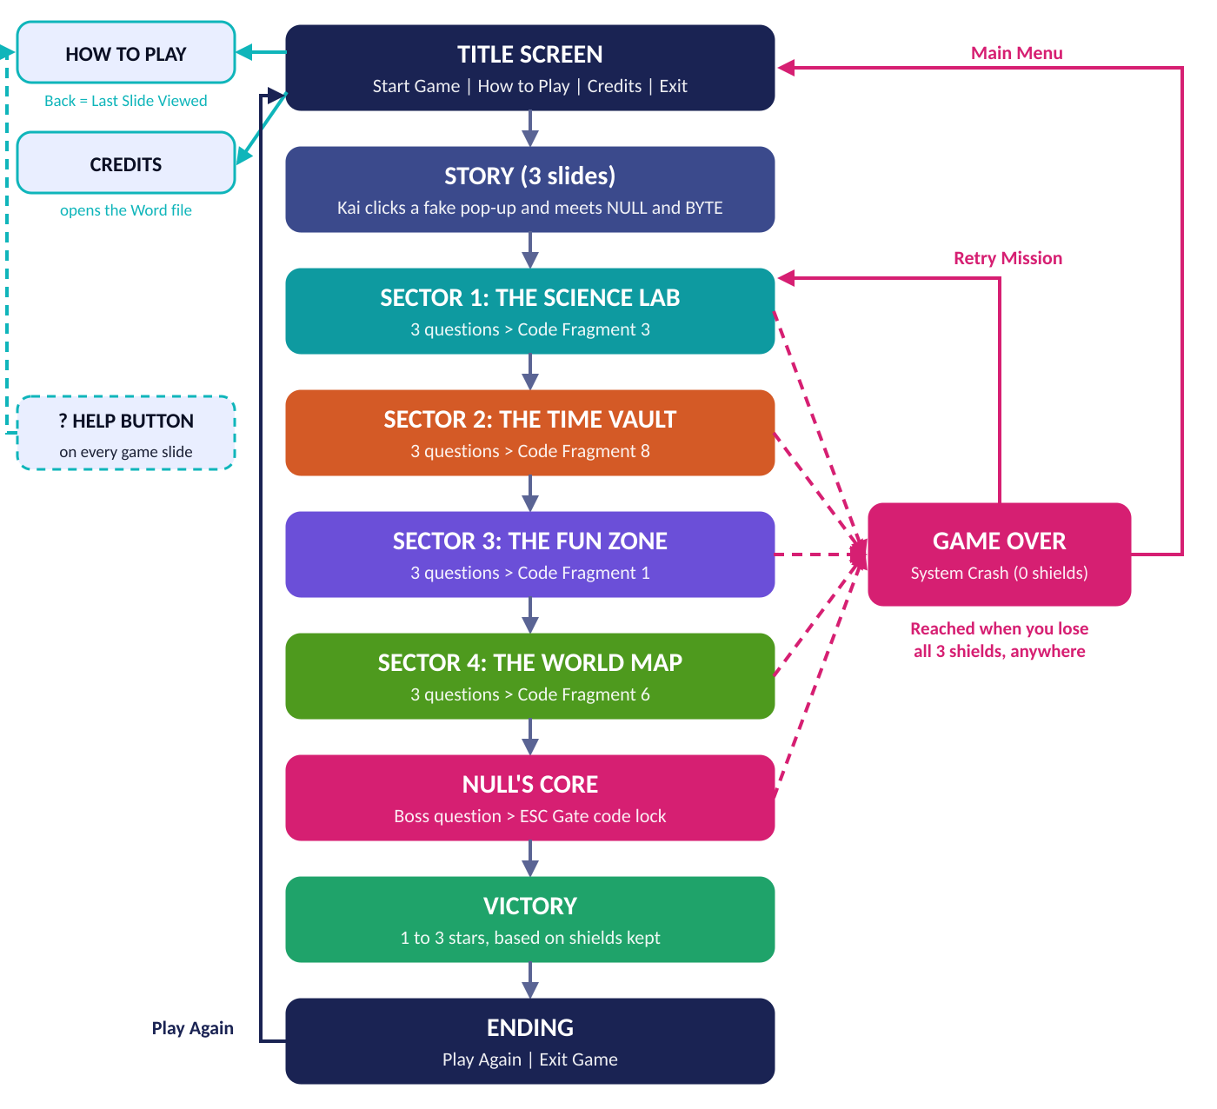
Figure 3. Overall game flow of CTRL + ESCAPE.

8.2 The Question Loop
Every challenge in the game follows the same loop. The answer buttons are hyperlinks: the correct one leads to an ACCESS GRANTED slide, and the wrong ones lead to a GLITCH DETECTED slide.
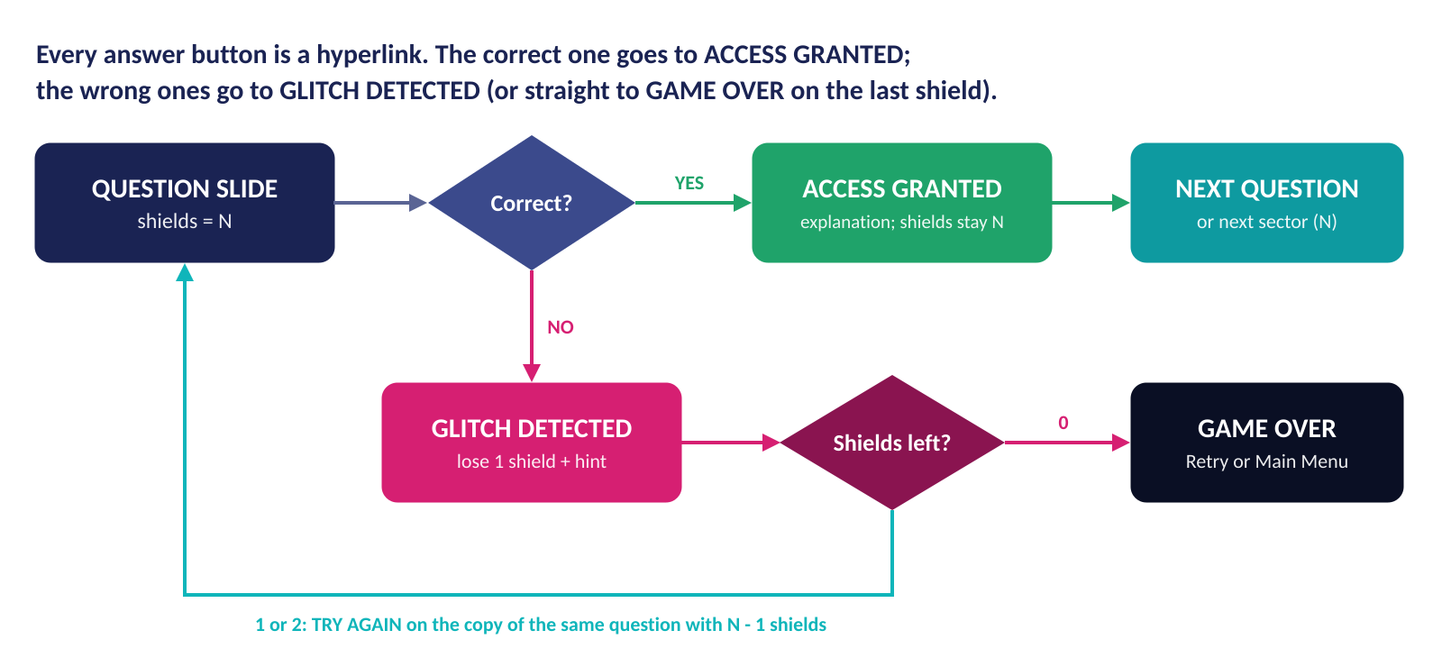
Figure 4. What happens after the player clicks an answer.

8.3 How Shields Are Tracked Without Macros
PowerPoint cannot remember a number such as "shields left" unless you use VBA macros, which need a macro-enabled file and are often blocked on school computers. We solved this with slide copies: every question slide exists in three versions, one for each shield level (3, 2, or 1). Each version shows the correct number of shields, and its hyperlinks lead to the matching versions of the next slides.
- A correct answer moves to the next question at the same shield level.
- A wrong answer moves to the copy of the same question with one less shield.
- A wrong answer with only one shield left goes straight to Game Over.
Each challenge therefore needs 8 slides: 3 question copies, 3 ACCESS GRANTED slides, and 2 GLITCH DETECTED slides. This is why the game has 133 slides even though it has 14 challenges.
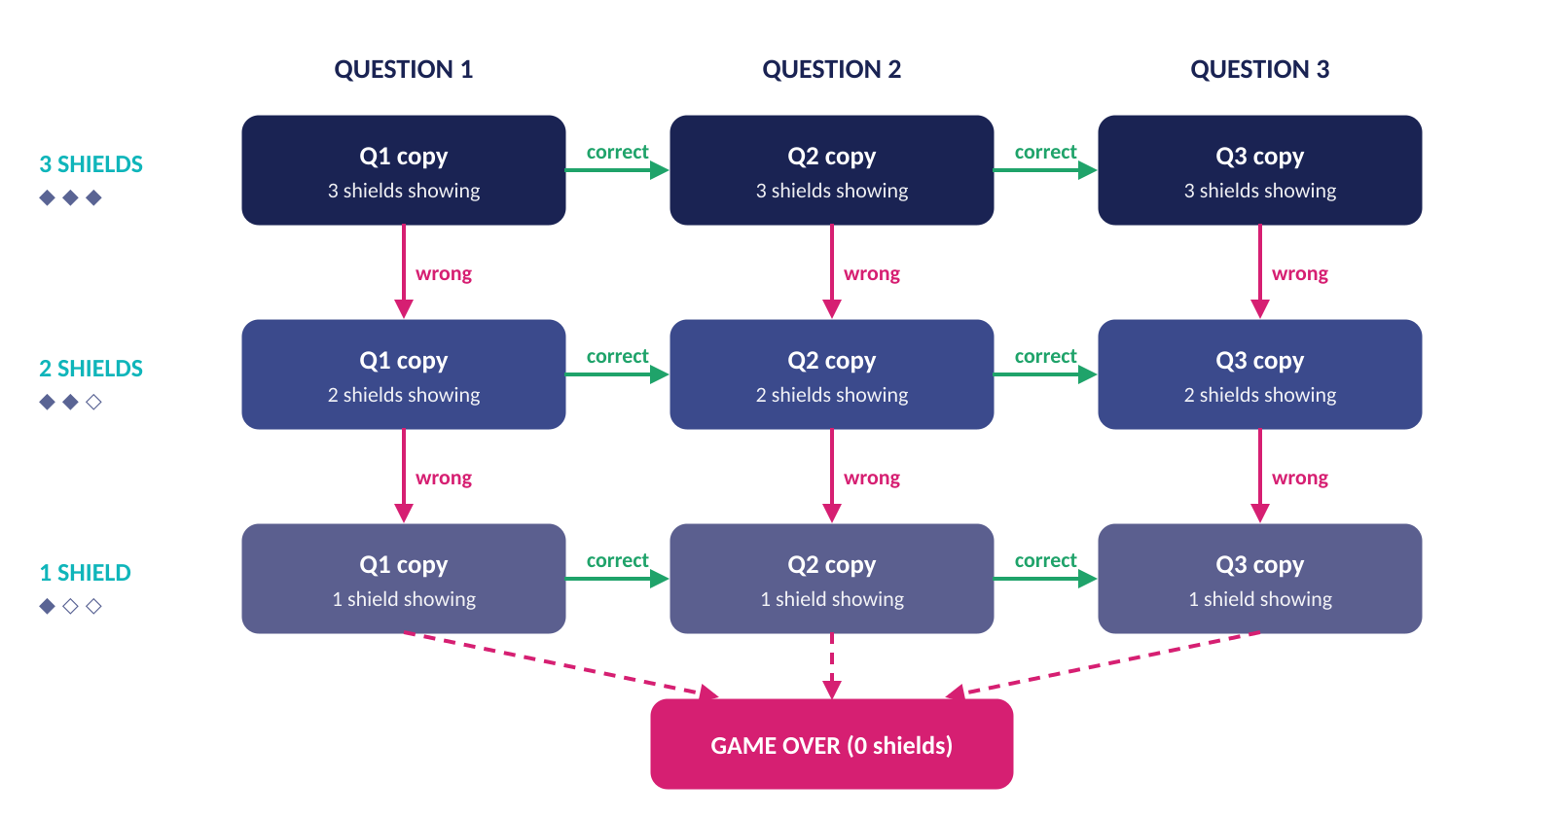
Figure 5. The slide-copy system that tracks shields.

8.4 Slide Map
The slides are organized into PowerPoint sections. Open View > Slide Sorter in PowerPoint to see them grouped this way.
Section | Slides | Count | Contents
Main Menu | 1 to 3 | 3 | Title screen, How to Play, Credits
Story | 4 to 6 | 3 | Three story slides
Sector 1 - Science Lab | 7 to 31 | 25 | Entrances, 3 questions, and their feedback slides
Sector 2 - Time Vault | 32 to 58 | 27 | Entrances, 3 questions, and their feedback slides
Sector 3 - Fun Zone | 59 to 85 | 27 | Entrances, 3 questions, and their feedback slides
Sector 4 - World Map | 86 to 112 | 27 | Entrances, 3 questions, and their feedback slides
NULL's Core (Final) | 113 to 131 | 19 | Entrances, boss question, code lock, and 3 victory slides (one per star rank)
Endings | 132 to 133 | 2 | Game Over (System Crash) and the ending slide

9. Game Content: Question Bank and Answer Key
Teacher's copy: spoilers ahead!
This section lists every challenge, its correct answer, BYTE's explanation, and the hint shown after a wrong answer.

Sector 1: The Science Lab
Topic: Science and Nature | Reward: Code Fragment 3
No. | Question and Choices | Answer | Explanation and Hint
1 | Which planet is known as the 'Red Planet'?  A. Venus  B. Mars  C. Jupiter  D. Saturn | B. Mars | Why: Mars looks red because its soil is full of iron oxide, the same stuff that makes rust. Venus is the hottest planet, while Jupiter and Saturn are giant gas planets.  Hint: It's the fourth planet from the Sun, and robot rovers drive around on it.
2 | BYTE found this claim in a corrupted science file. Is it a FACT or a MYTH?  Statement: "Lightning never strikes the same place twice."  A. FACT  B. MYTH | B. MYTH | Why: It's a myth! Lightning can strike the same place again and again, especially tall buildings, towers, and trees. Some skyscrapers are hit by lightning many times every year.  Hint: Think about what happens to very tall buildings during big thunderstorms.
3 | Plants make their own food using sunlight. Which gas do they take in from the air to do it?  A. Oxygen  B. Nitrogen  C. Carbon dioxide  D. Helium | C. Carbon dioxide | Why: In photosynthesis, plants use sunlight, water, and carbon dioxide to make sugar for food. They release oxygen, the gas we need to breathe.  Hint: It's the same gas that we breathe OUT.

Sector 2: The Time Vault
Topic: Philippine History | Reward: Code Fragment 8
No. | Question and Choices | Answer | Explanation and Hint
4 | Which Filipino hero wrote the famous novels Noli Me Tangere and El Filibusterismo?  A. Andres Bonifacio  B. Emilio Aguinaldo  C. Apolinario Mabini  D. Jose Rizal | D. Jose Rizal | Why: Dr. Jose Rizal wrote Noli Me Tangere (1887) and El Filibusterismo (1891). His novels showed the abuses of Spanish rule and inspired Filipinos to fight for change.  Hint: His monument stands in Rizal Park (Luneta) in Manila.
5 | This history file might be corrupted. Is the statement below a FACT or a MYTH?  Statement: "Ferdinand Magellan was killed in the Battle of Mactan in 1521."  A. FACT  B. MYTH | A. FACT | Why: It's a fact! On April 27, 1521, Magellan was killed in the Battle of Mactan by the warriors of Lapulapu, who is honored as one of the first Filipinos to resist foreign rule.  Hint: Remember Lapulapu, the brave chieftain of Mactan.
6 | On what date does the Philippines celebrate its Independence Day?  A. December 30  B. June 12  C. August 21  D. November 30 | B. June 12 | Why: On June 12, 1898, Emilio Aguinaldo declared the independence of the Philippines from Spain in Kawit, Cavite. December 30 is Rizal Day and November 30 is Bonifacio Day.  Hint: It's in the month when the rainy season usually begins.

Sector 3: The Fun Zone
Topic: Everyday Life: Food, Sports, and Money | Reward: Code Fragment 1
No. | Question and Choices | Answer | Explanation and Hint
7 | In basketball, how many players from ONE team are on the court at the same time?  A. 5  B. 6  C. 7  D. 11 | A. 5 | Why: Each basketball team has 5 players on the court: usually 2 guards, 2 forwards, and a center. Volleyball has 6 players per team, and football (soccer) has 11.  Hint: Count the fingers on one hand.
8 | Kai buys merienda at the sari-sari store. The vault opens with the TOTAL. How much is it?  Receipt: Pandesal (10 pcs) 50, Banana cue 25, Softdrink 20, Chips 15, Candy 5  A. PHP 105  B. PHP 120  C. PHP 115  D. PHP 125 | C. PHP 115 | Why: 50 + 25 + 20 + 15 + 5 = 115, so the total is PHP 115. Tip: add the big numbers first (50 + 25 = 75), then add the rest (75 + 20 + 15 + 5 = 115).  Hint: Add the prices two at a time, then double-check your answer.
9 | What ingredient is most commonly used to give the Filipino dish sinigang its sour taste?  A. Coconut milk  B. Soy sauce  C. Sugar  D. Tamarind (sampalok) | D. Tamarind (sampalok) | Why: Sinigang gets its famous sour taste from tamarind (sampalok). Some versions use guava, kamias, or green mango instead. Coconut milk is used in dishes like ginataan.  Hint: It grows in brown, curved pods, and kids love it as candy too!

Sector 4: The World Map
Topic: Geography of the Philippines and the World | Reward: Code Fragment 6
No. | Question and Choices | Answer | Explanation and Hint
10 | Kai must travel to the capital city of Japan. Which door leads there?  A. Kyoto  B. Tokyo  C. Osaka  D. Seoul | B. Tokyo | Why: Tokyo is the capital of Japan and one of the biggest cities in the world. Kyoto is Japan's old capital, Osaka is another big Japanese city, and Seoul is the capital of South Korea.  Hint: This city hosted the 2020 Summer Olympics.
11 | What is the largest ocean on Earth?  A. Pacific Ocean  B. Atlantic Ocean  C. Indian Ocean  D. Arctic Ocean | A. Pacific Ocean | Why: The Pacific Ocean is the largest and deepest ocean, covering about one-third of Earth's surface. The Philippines sits on its western side.  Hint: It's the ocean right next to the Philippines.
12 | Which is the highest mountain in the Philippines?  A. Mount Mayon  B. Mount Pulag  C. Mount Apo  D. Mount Pinatubo | C. Mount Apo | Why: Mount Apo in Mindanao is the highest peak in the Philippines, at about 2,950 meters above sea level. Mount Pulag is the highest in Luzon, and Mayon is famous for its perfect cone shape.  Hint: It's on the island of Mindanao, near Davao City.

NULL's Core (Final)
Topic: Final Challenge: Think Before You Click
No. | Question and Choices | Answer | Explanation and Hint
13 | NULL: "Before you leave, answer THIS! When my 'FREE PHONE' pop-up appeared, what SHOULD you have done?"  A. Click it fast before it disappears  B. Share it so your friends can win too  C. Close it without clicking and run an antivirus scan  D. Type your name and address to claim it | C. Close it without clicking and run an antivirus scan | Why: Never click suspicious pop-ups or 'You won!' offers. Close them safely, never enter personal information, and scan your device. THINK before you click!  Hint: What would BYTE, the antivirus, tell you to do?
14 | NULL: "Fine! But I SCRAMBLED the ESC Gate! The code is your 4 fragments in REVERSE order. Hehehe!"  A. 3816  B. 6183  C. 1638  D. 8361 | B. 6183 | Why: Your fragments were 3 - 8 - 1 - 6. Read backwards, the code is 6 - 1 - 8 - 3. The ESC Gate is open!  Hint: Write your fragments from Sector 1 to Sector 4, then read them from right to left.

10. Visual and Audio Design

10.1 Art Style
The game uses retro pixel art (8-bit style) set in a dark "inside the computer" world with neon grid floors, glowing buttons, and a terminal-style top bar. The characters, shields, fragments, and doors were drawn pixel by pixel on a grid and then enlarged, so every pixel stays sharp on a projector.
Every game slide shares the same layout, so players always know where to look: area name at the top-left, fragments and shields at the top-right, the question in the center, and the answers below.

10.2 Color Palette
 | Color | Hex Code | Used For
 | Deep Navy | #0A0F24 | Background of every slide
 | Panel Blue | #1A2353 | Buttons, panels, and dialog boxes
 | Cyber Cyan | #2DE2E6 | BYTE, Sector 1: The Science Lab, and main buttons
 | Glitch Magenta | #F72585 | NULL, wrong answers, and NULL's Core
 | Access Mint | #4BF0A0 | Correct answers and victory
 | Fragment Amber | #FFC233 | Code Fragments, hints, and stars
 | Vault Orange | #FF7A45 | Sector 2: The Time Vault
 | Fun Zone Violet | #A98BFF | Sector 3: The Fun Zone
 | Map Lime | #9BE564 | Sector 4: The World Map

10.3 Typography
Font | Used For | Why
Arial Black | Titles and buttons | Thick, bold letters that read like a game logo
Calibri | Questions, story text, and explanations | Clean and easy to read on a screen
Courier New | Top bar, labels, receipts, door signs, and codes | Looks like computer code and fits the "inside the computer" theme

10.4 Sound Effects
All sounds are original 8-bit square-wave tones made for this project. They are attached to the slides as transition sounds, so they play automatically.
Sound | When It Plays
Start-up chime | When the title screen appears
Success jingle | On every ACCESS GRANTED slide
Error buzz | On every GLITCH DETECTED slide and when NULL first appears
Victory fanfare | When the ESC Gate unlocks
Crash tune | On the Game Over (System Crash) slide

10.5 Screen Designs
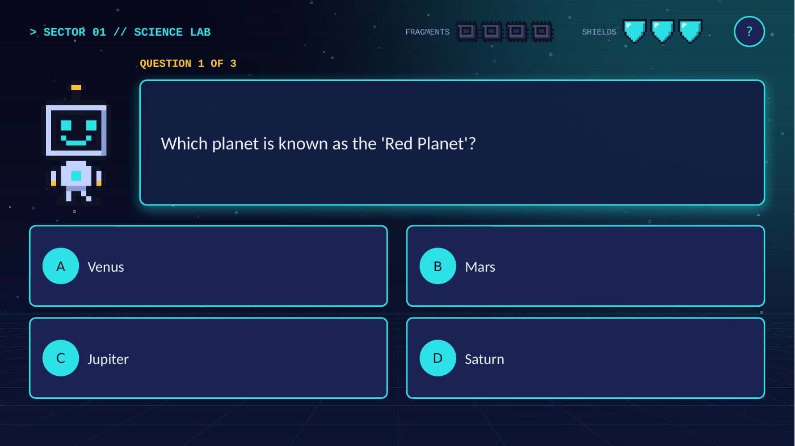  Figure 6. A question slide with four answer buttons. | 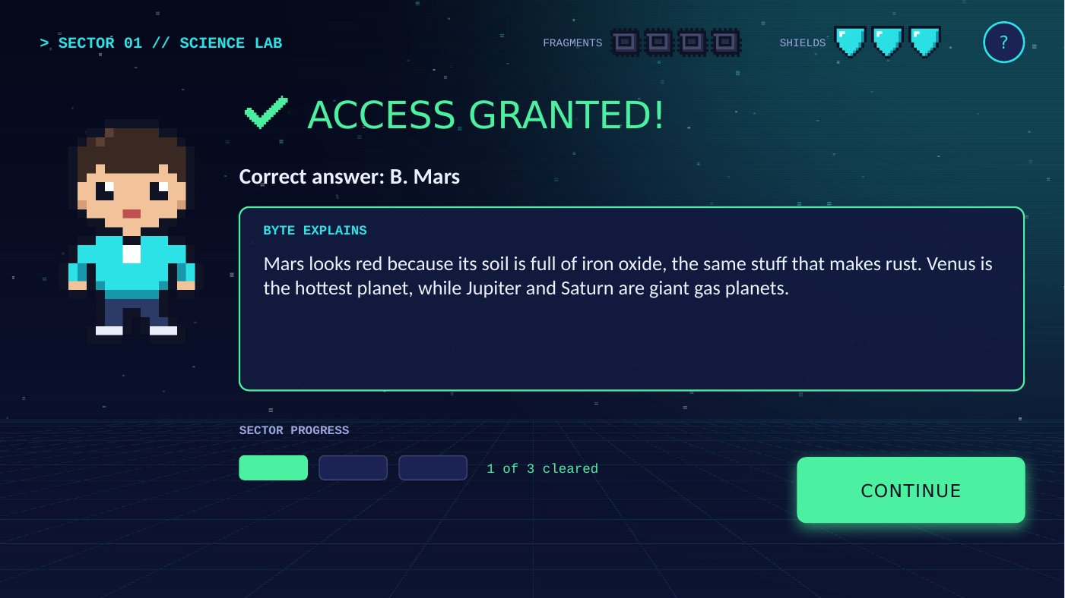  Figure 7. ACCESS GRANTED: BYTE explains the answer.
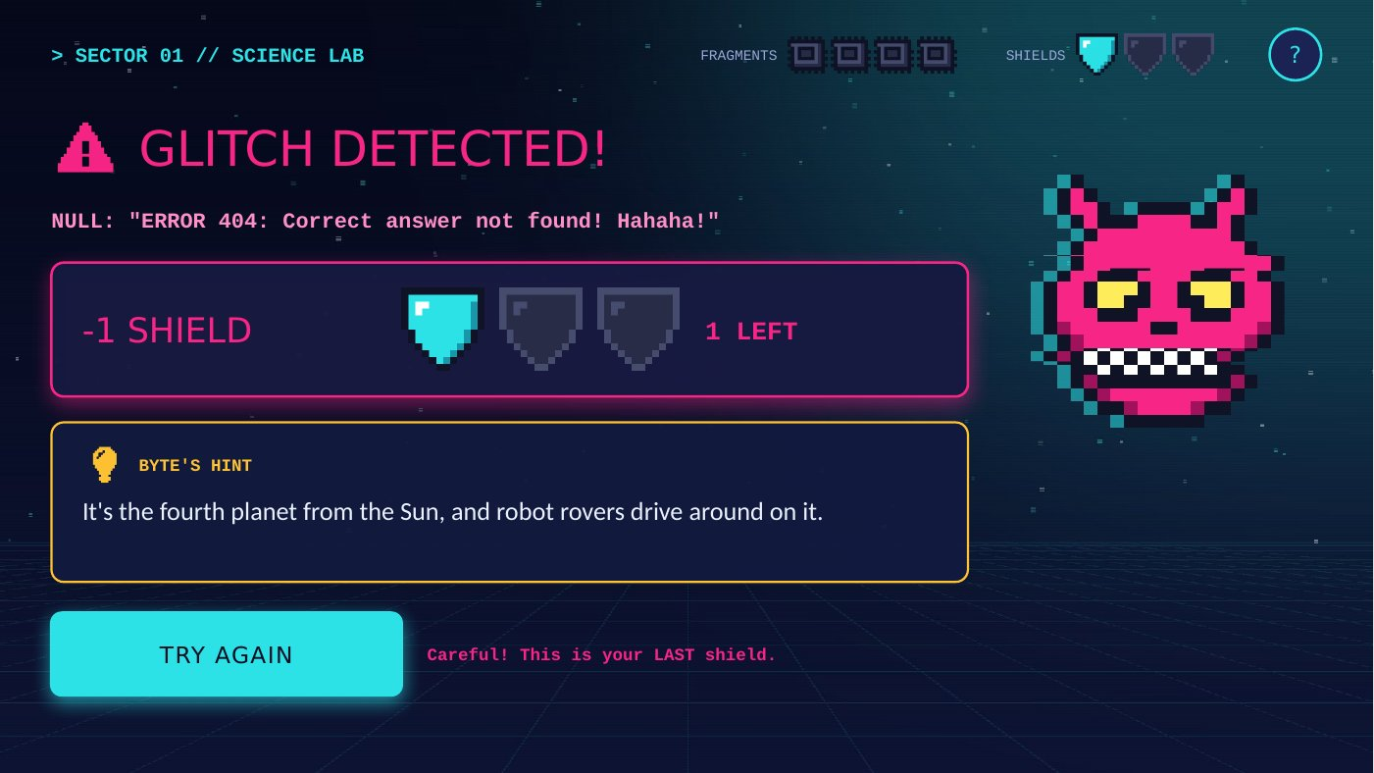  Figure 8. GLITCH DETECTED: a shield breaks and BYTE gives a hint. | 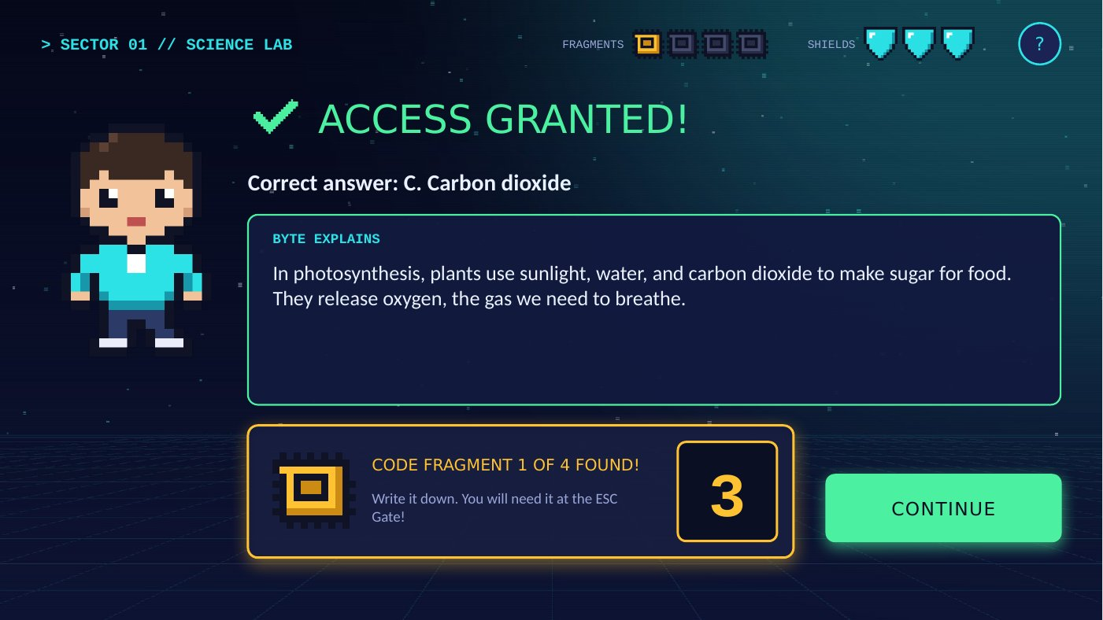  Figure 9. Clearing a sector reveals a Code Fragment.

11. How We Used Microsoft Productivity Tools
This project used Microsoft Word and Microsoft PowerPoint for different jobs: Word to plan, organize, and document the game, and PowerPoint to build the playable game itself.

11.1 Microsoft PowerPoint Features
Feature | How We Used It in the Game
Hyperlinks and Action Settings (Insert > Action > Hyperlink to: Slide) | 548 links connect every answer, button, and door to the correct slide.
"Last Slide Viewed" action | The BACK button on How to Play returns players to whatever slide they came from.
"End Show" action | The EXIT GAME buttons close the slide show.
Hyperlink to another file | The Credits slide opens this Word document.
Slide Masters (View > Slide Master) | Six masters hold the background art for the menu, each sector, and NULL's Core, so all 133 slides stay consistent.
Sections | Slides are grouped into sections (Main Menu, Story, Sector 1, and so on) for easy editing in Slide Sorter.
Transitions with sound | Every slide fades in; feedback, victory, and game-over slides play sound effects.
Turning off "On Mouse Click" (Transitions > Advance Slide) | Clicking an empty part of a slide never skips a question.
Shapes, Pictures, and Tables | Buttons, dialog boxes, the Fact or Myth cards, the receipt table, and pixel-art characters.
Speaker Notes | Each slide's notes describe its purpose, shield level, and correct answer for the developer and teacher.

11.2 Microsoft Word Features
Feature | How We Used It in This Document
Styles and Headings | Consistent headings that also power the table of contents and the Navigation Pane
Table of Contents | An automatic, clickable table of contents
Cover Page and Page Breaks | A title page and a new page for each major section
Headers and Footers | The game title in the header and page numbers (Page X of Y) in the footer
Tables with Shading | Overview, roles, mechanics, question bank, color palette, and test logs
Pictures and Captions | Screenshots, character art, and flowcharts with automatically numbered captions
Bulleted and Numbered Lists | Rules, instructions, and step-by-step procedures
Hyperlink to a File | A link in Section 1 opens the game file

11.3 From Plan to Finished Game
Stage | Tool Used | What We Did
Plan | Word | Brainstormed the concept, wrote the story, rules, and question bank, and drew the game flow.
Create | PowerPoint | Built the slide masters, slides, buttons, and links, then added pixel art and sounds.
Organize | PowerPoint sections, Word styles | Grouped 133 slides into sections and organized this document with headings and a table of contents.
Test | PowerPoint Slide Show | Played every path, checked every link, recorded bugs, and fixed them.
Evaluate | Word | Recorded playtest feedback, compared the game with the objectives, and wrote reflections.

11.4 Work Plan
Phase | Tasks | Lead | Target Date
1. Concept | Choose the genre, theme, and title; write the game idea | Game Designer | [Date]
2. Story and Content | Write the story, characters, 14 challenges, hints, and explanations | Story / Content Designer | [Date]
3. Design | Plan the game flow, shield system, layouts, colors, and pixel art | Game Designer | [Date]
4. Development | Build the slides, masters, hyperlinks, transitions, and sounds | PowerPoint Developer | [Date]
5. Testing | Test every path, run playtests, and fix problems | Tester / Documentation Lead | [Date]
6. Documentation | Finish this Word document, add screenshots, and write reflections | Tester / Documentation Lead | [Date]
7. Presentation | Rehearse and present the game to the class | Whole group | [Date]

12. Testing and Evaluation

12.1 Technical Checks
These checks were completed by scanning every slide and link in the game file.
What Was Checked | Result
Every hyperlink leads to a slide that exists (548 links) | Passed
Every slide can be reached from the title screen (133 of 133) | Passed
Each of the 42 question slides has exactly one correct answer; the other answers remove one shield | Passed
TRY AGAIN keeps the lower shield count; CONTINUE keeps the current count | Passed
A wrong answer on the last shield leads to Game Over | Passed
"On Mouse Click" advancing is turned off on every slide | Passed
The file opens without repair errors (Office file format validation) | Passed

12.2 Playtest Checklist
Complete this checklist while playing the game in Slide Show mode.
Check | Result (Yes / No) | Notes
Sound effects play on the title, feedback, victory, and Game Over slides
How to Play > BACK returns to the previous slide
EXIT GAME ends the slide show
OPEN GAME DOCUMENTATION opens this Word file
All text fits inside its buttons and boxes
A full winning run takes about 10 to 15 minutes
Three wrong answers lead to Game Over

12.3 Playtest Record
Ask classmates to play the game, then record what happened and what you changed.
Tester | Date | Win / Lose | Shields Kept | Feedback | Changes Made

12.4 Evaluation Against the Learning Objectives
Learning Objective | How Our Project Meets It
Apply appropriate features of MS Word and MS PowerPoint in creating a digital product | PowerPoint: hyperlinks, actions, slide masters, sections, transitions, and sounds. Word: styles, a table of contents, captions, tables, and headers and footers (Section 11).
Design an original game with clear objectives, mechanics, rules, and instructions | An original story and characters, a clear objective (Section 1), mechanics (Section 5), rules (Section 6), and instructions (Section 7).
Use PowerPoint's interactive features to create a playable digital game | A fully playable game with 548 links, five challenge types, shields, fragments, a code lock, and three victory ranks.
Demonstrate creativity, collaboration, problem-solving, and digital productivity skills | Creativity: pixel art, story, and the reverse-code twist. Collaboration: clear roles. Problem-solving: tracking shields without macros. Productivity: planning, testing, and documenting with Office tools.

12.5 Known Limitations and Future Improvements
- Keyboard keys (arrows, space bar) can still change slides in normal Slide Show mode. Players should use the mouse, or the teacher can use kiosk mode (see the tip in Section 7).
- Because shields are tracked with slide copies, adding one new question means adding 8 new slides.
- Future ideas: a timer challenge, new sectors about music, movies, and animals, shuffled questions for replay value, and a two-player mode.

13. Reflection
Each member answers these questions in 3 to 5 sentences:
- What did you contribute to the game?
- What was the hardest part, and how did you solve it?
- What did you learn about using Word and PowerPoint as productivity tools?

[Member Name], Game Designer
[Write your reflection here.]

[Member Name], Story / Content Designer
[Write your reflection here.]

[Member Name], PowerPoint Developer
[Write your reflection here.]

[Member Name], Tester / Documentation Lead
[Write your reflection here.]

Group Reflection
[Write what your group learned from creating CTRL + ESCAPE together.]

14. References and Credits
- Game content: common general knowledge in science, Philippine history, everyday life, and geography. Every fact used in the questions can be checked in an encyclopedia or a school textbook.
- Software: Microsoft PowerPoint (game) and Microsoft Word (documentation).
- Original assets: the story, characters, questions, pixel art, and sound effects are original to this project. No copyrighted images or music were used.
- Fictional examples: the "You WON a FREE PHONE" pop-up, the sari-sari store receipt, and all characters in the game are made up for this story.

Appendix: Screen Gallery
More screens from the finished game.
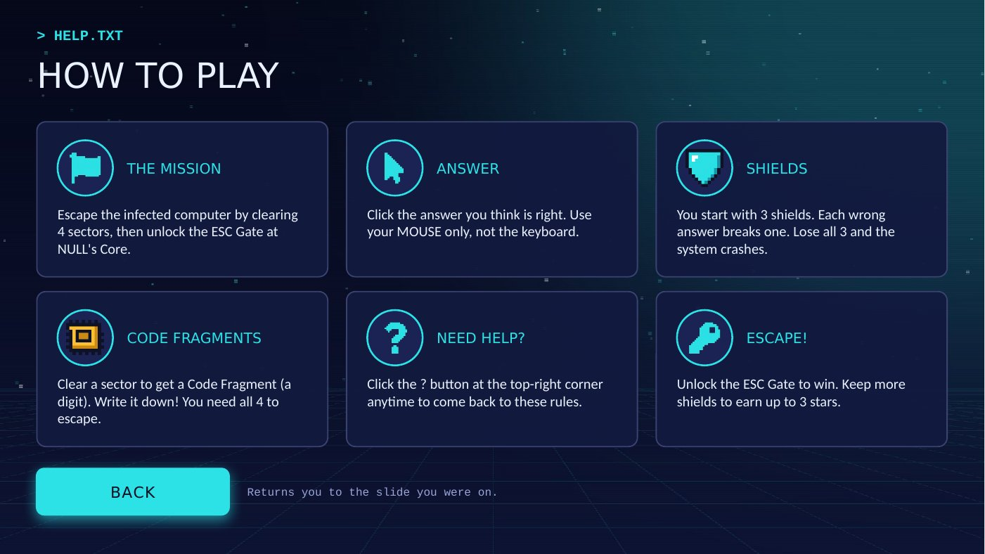  Figure 10. How to Play screen with the BACK button. | 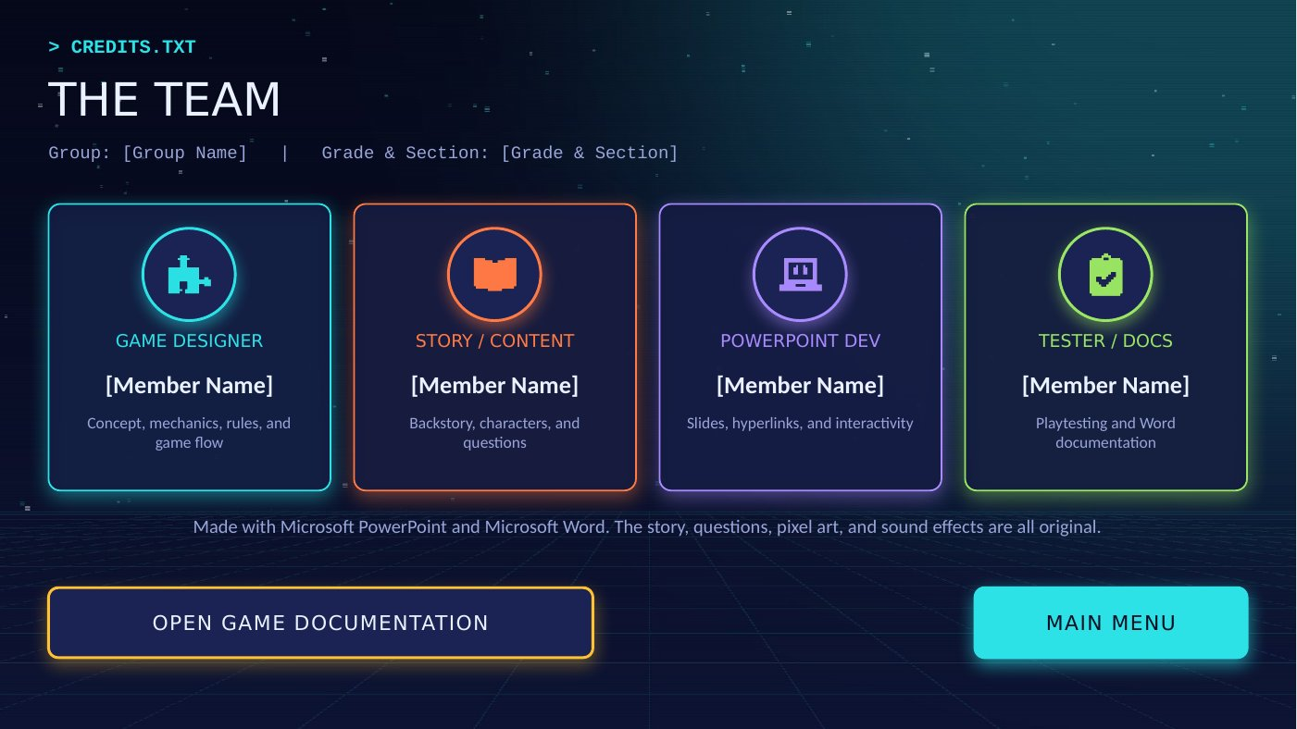  Figure 11. Credits screen with the link to this document.
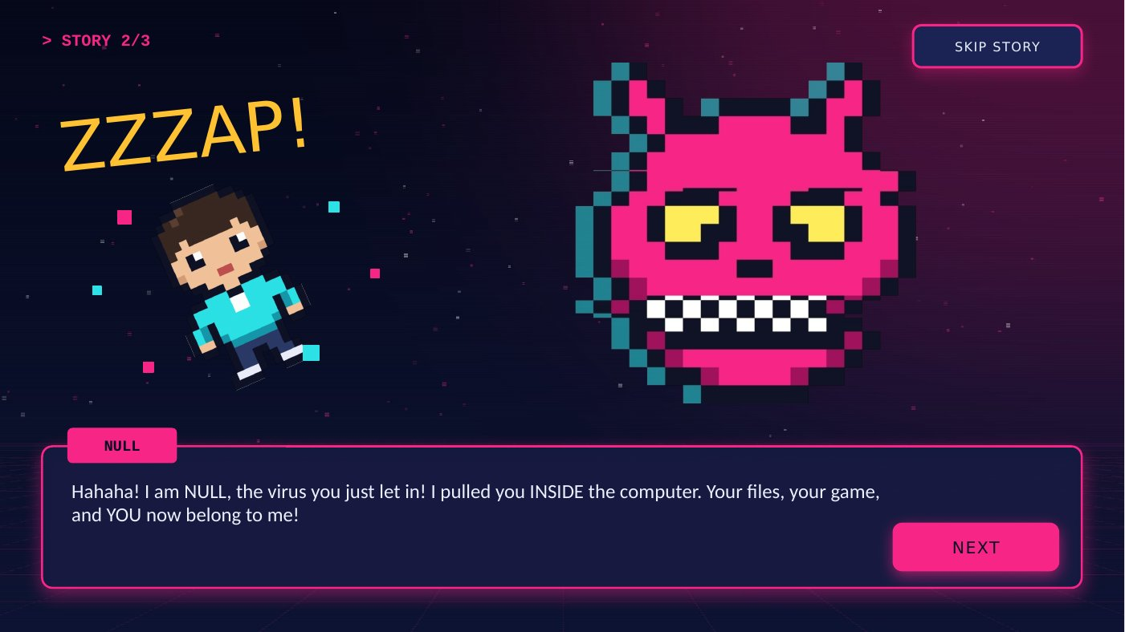  Figure 12. Story slide 2: NULL appears. | 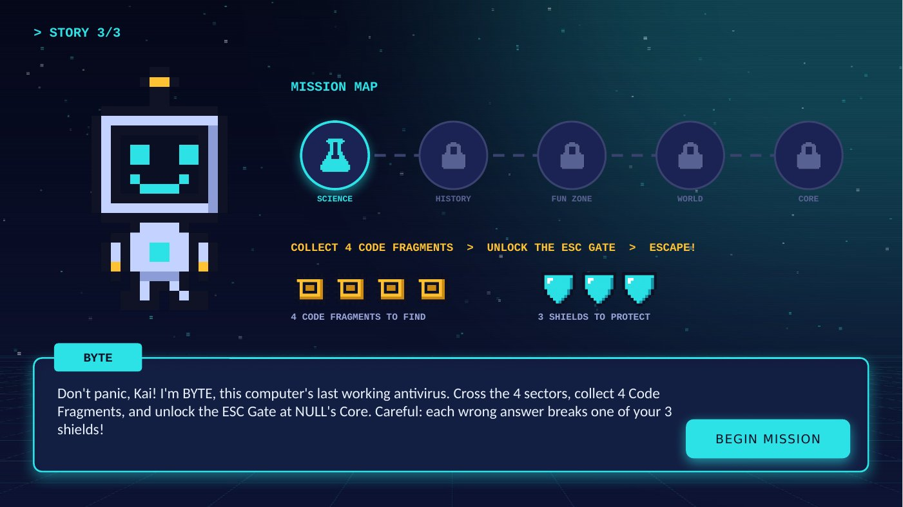  Figure 13. Story slide 3: BYTE explains the mission.
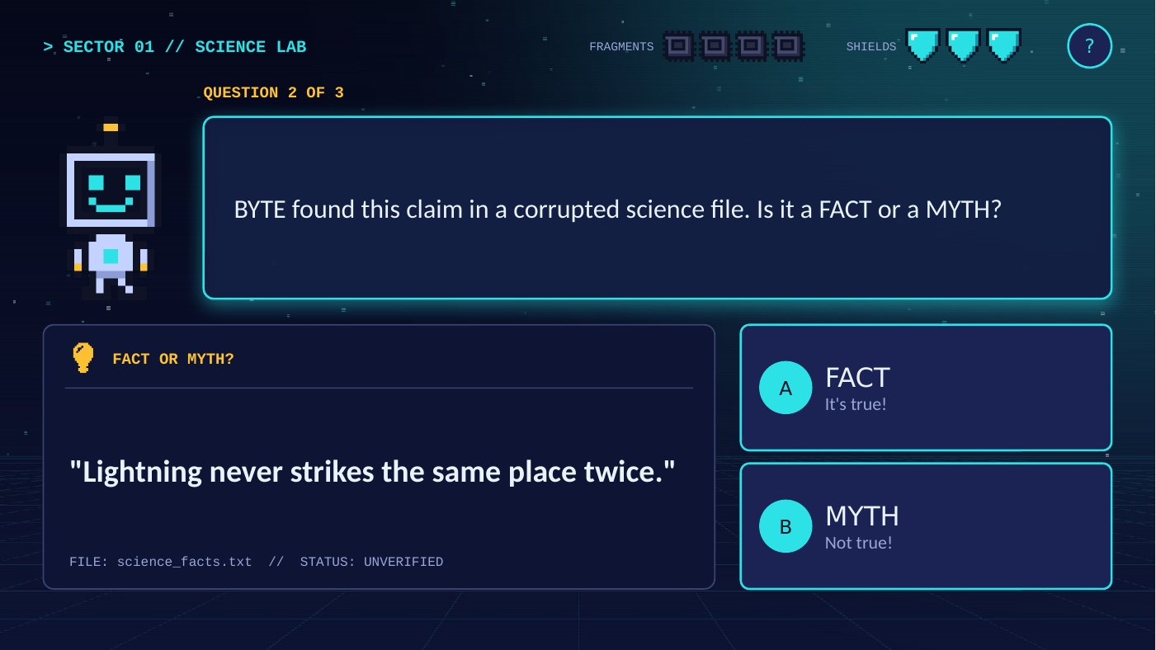  Figure 14. Sector 1: Fact or Myth? | 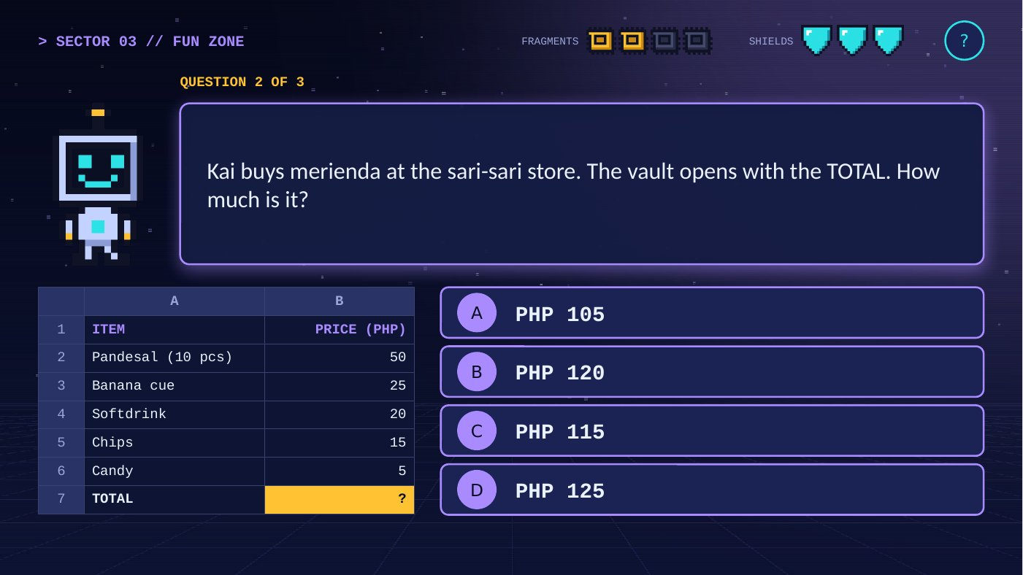  Figure 15. Sector 3: the sari-sari store receipt puzzle.
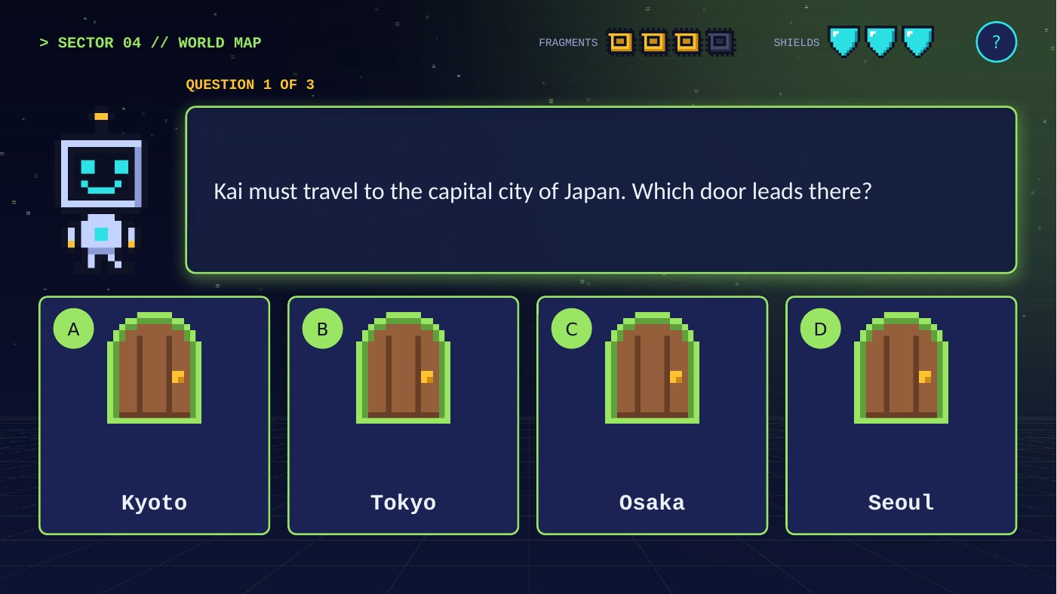  Figure 16. Sector 4: the door maze. | 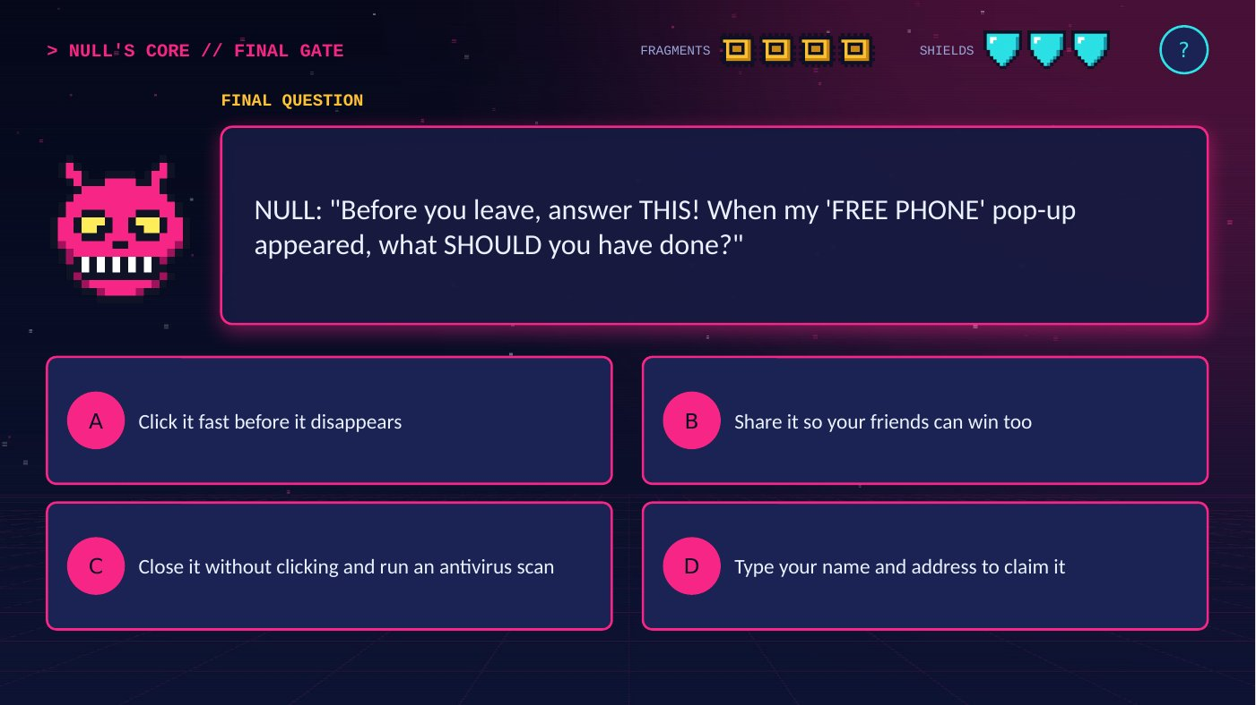  Figure 17. NULL's Core: the final question.
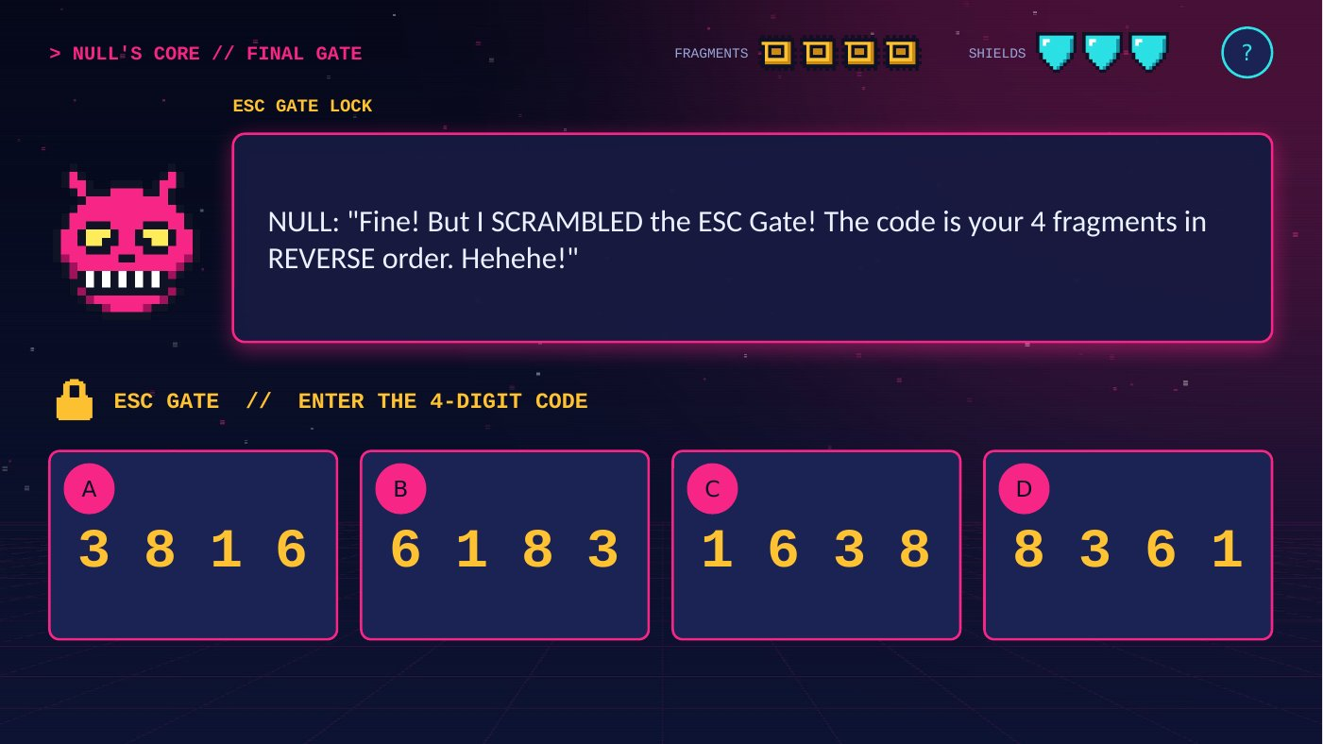  Figure 18. The ESC Gate code lock. | 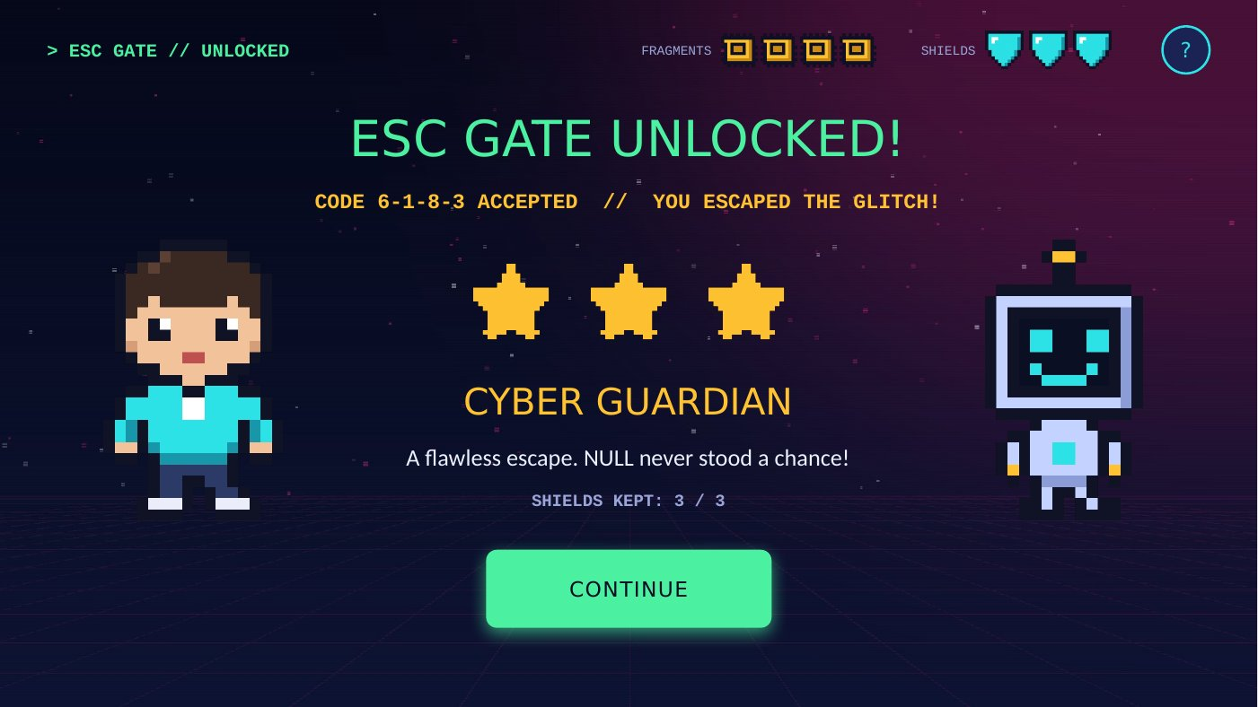  Figure 19. Victory with 3 stars: Cyber Guardian.
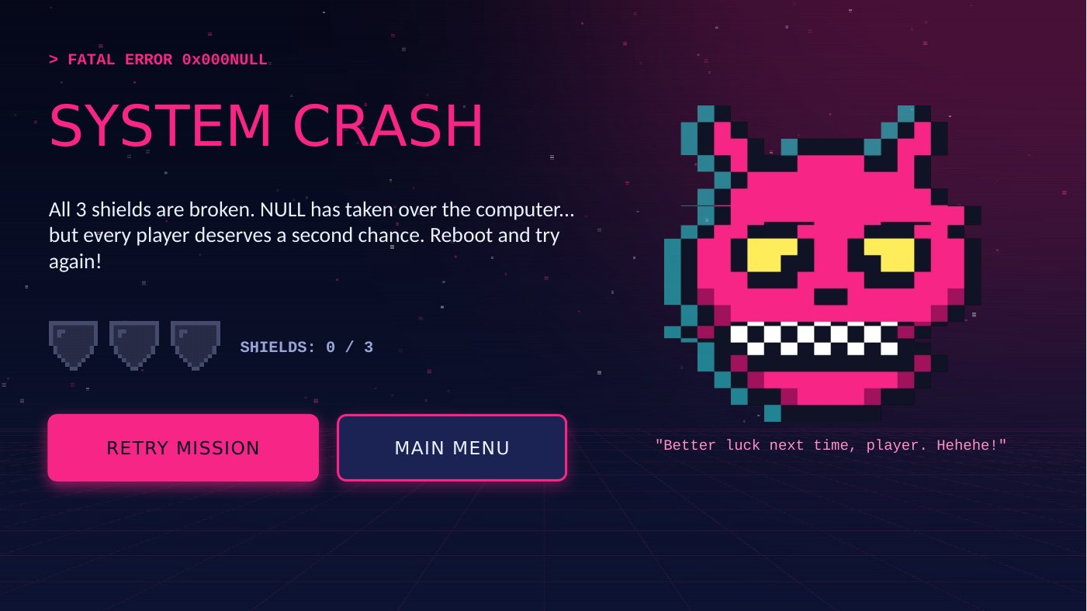  Figure 20. Game Over: System Crash. | 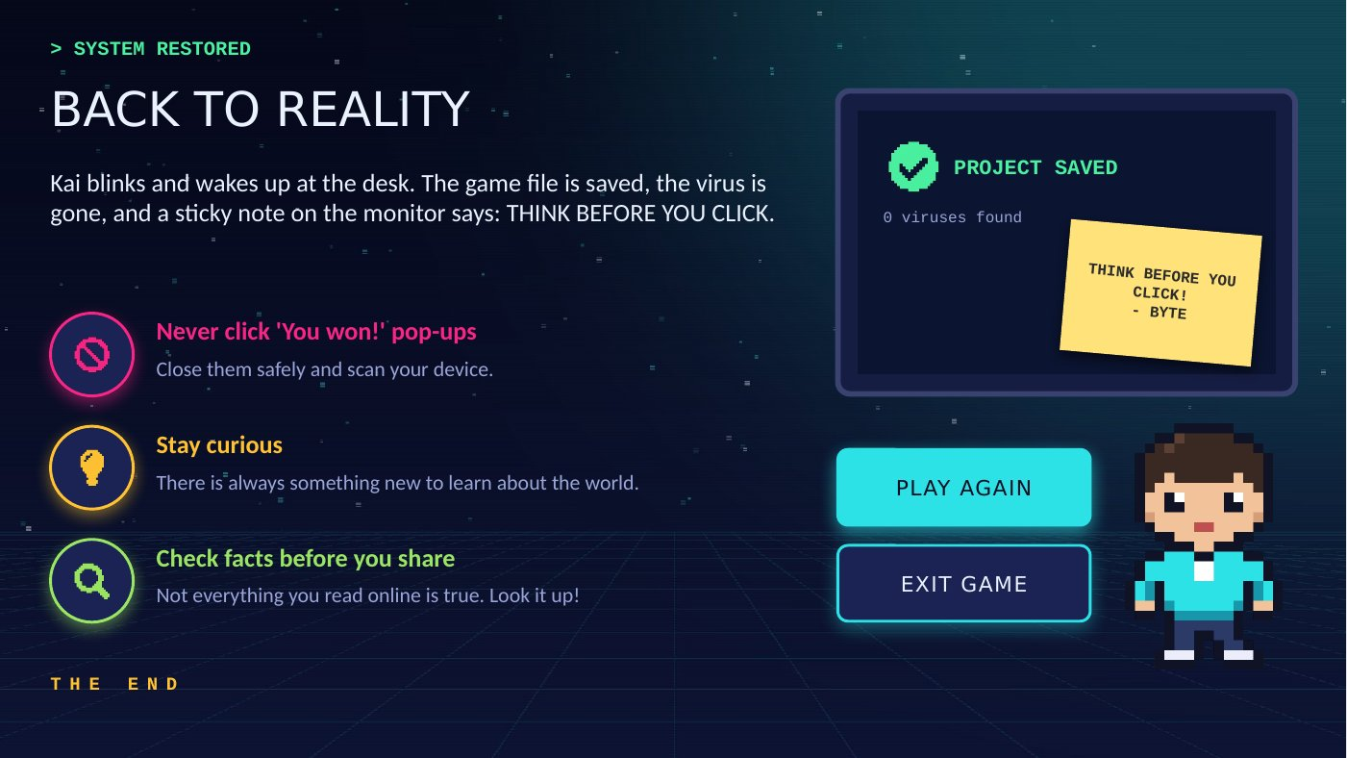  Figure 21. The ending slide.

