Plan of Operations

January 2025 – December 2026

Table of Contents

* Executive Summary
* Company Overview
* Products and Services
* Market Analysis
* Marketing and Sales Strategy
* Operations Plan
* Financial Plan and Projections
* Milestones and Timeline
* Appendix

Executive Summary

Mission

To empower individuals and businesses to effortlessly create and share web content in an instant, transforming ideas into interactive web experiences with just a prompt. Div-idy strives to make digital expression accessible to everyone, fostering creativity and connection in a fast-paced, ever-evolving online world.

Vision

To become the world’s leading platform for instant web creation, inspiring a global community of creators to share their stories, ideas, and innovations seamlessly. By 2030, Div-idy envisions a world where anyone can build and publish online content effortlessly, enabling connectivity and digital expression on a massive scale.

Goal

To establish Div-idy as a Fortune 500 company by 2030, achieving $35 billion in annual revenue through innovative, user-centered solutions that make webpage creation simple, accessible, and engaging for a global audience.

Core Business Idea

Div-idy is an AI-powered platform that enables users to instantly create and publish webpages with a simple prompt. Designed for speed and simplicity, Div-idy allows users to generate complete webpages in seconds, share them via a unique QR code or direct link, and explore others' creations. It’s a free, accessible tool that makes webpage creation and sharing easy and effortless for everyone.

Company Overview

Ashton Kirtley - Founder & Operator

Ashton Kirtley is a dedicated UX strategist with a strong passion for AI and its potential to transform digital experiences. With a background in understanding user needs and behavior, Ashton combines expertise in user experience with an enthusiasm for learning and implementing AI, aiming to create intuitive, innovative tools that make technology accessible to all.

Business Concept

Div-idy is an AI-powered platform that allows users to instantly create and publish webpages with just a prompt. It simplifies the process of webpage creation, making it fast, accessible, and user-friendly. Revenue is generated through third-party ads (Google AdSense), first-party sponsored content (sponsored Divs), and a premium version of dev tools offering advanced features for users seeking more customization and functionality.

Value Proposition:

Div-idy offers an unmatched value proposition by making webpage creation fast, easy, and accessible for everyone. With just a simple prompt, users can generate fully functional webpages in seconds, without needing any technical expertise. The platform’s intuitive interface ensures a seamless experience, while its instant publishing and sharing features—via unique QR codes or direct links—make it effortless to showcase work. Whether for personal projects, business use, or creative expression, Div-idy empowers users to bring their ideas to life quickly and share them with the world, all at no cost.

Products and Services

Primary Product

The primary product of Div-idy is its AI-powered instant webpage creation tool, which allows users to effortlessly generate fully functional webpages with just a quick prompt. This product enables users, whether individuals or businesses, to bring their ideas to life in seconds, eliminating the need for coding or complex design skills. In addition to creating pages, Div-idy also serves as a platform for discovering, viewing, and sharing others' work, fostering a community where users can gain inspiration, showcase their creations, and collaborate. This combination of easy creation and sharing makes Div-idy an all-in-one platform for digital expression.

Potential Revenue Outlets

Div-idy generates revenue through multiple channels. Third-party ads, such as Google AdSense, are displayed on the platform to earn income from user engagement. First-party sponsored Divs provide an opportunity for brands to advertise directly within the platform, creating additional revenue. Div-idy can offer a premium version of its dev tools, giving users access to advanced features, customization options, and an enhanced AI model for those who want more control over their webpages. These revenue outlets support the platform’s growth and sustainability while providing value to both users and advertisers.

Market Analysis

o Identify target markets, such as small businesses, individual creators, and entrepreneurs.

o Discuss any competitor insights or trends in AI-based webpage creation.

<https://explodingtopics.com/blog/creator-economy-market-size>

Year Market Valuation Calculated Based on Forecasted CAGR

2023 $127.65 billion

2024 $156.37 billion

2025 $191.55 billion

2026 $234.65 billion

2027 $287.45 billion

2028 $352.13 billion

2029 $431.36 billion

2030 $528.39 billion

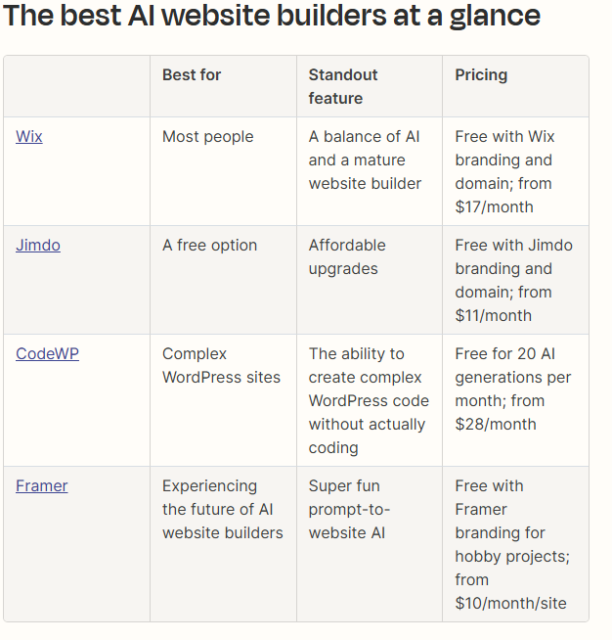

Marketing and Sales Strategy

Include Immediate Actions for January–March 2025.

Outline Short-Term strategies, like community building and freemium models.

Highlight Mid-Term and Long-Term actions for social media growth, content marketing, corporate solutions, and international expansion.

Operations Plan

Outline immediate goals to optimize user experience and the platform’s functionality.

Describe plans for building and managing the user community and user support system.

Financial Plan and Projections

Summarize expected revenue sources and potential cost structures.

Project growth targets and expenses for milestones (2025, 2026, and by 2030).

Milestones & Timeline

List the actions you’ve organized as immediate, short-term, mid-term, and long-term.

Include your goals to secure funding and scale operations in the later stages.

Ashton Kirtley

Founder & Operator

Goals

Make the fortune 500 list by 2030

Have annual revenue of $35 Billion by 2030

What is Div-idy?

Div-idy is a free, instant webpage creator powered by AI.

With just a quick prompt, you can generate a complete webpage in seconds.

Publish it with a single click.

Share it easily via a unique QR code or direct link.

A platform for viewing others work

Making webpage creation and sharing fast and effortless.

Revenue Outlets

Third Party Ads (Google Ad Scene)

First Party Ads (Sponsored Divs)

Premium Version of Dev Tools (More advanced AI model)

Immediate Actions (January 1 2025 - March 31st 2025)

1. Optimize User Experience

Ensure the platform is intuitive and bug-free.

Test the prompt-based page creation flow to ensure it's simple and satisfying for users.

2. Launch Marketing Campaigns

Use low-cost digital marketing methods:

Focus on SEO for organic traffic

Start social media accounts

Create content that highlights the ease and value of div-idy’s instant webpage creation.

3. Leverage Influencers and Partnerships

Reach out to micro-influencers, tech bloggers, and YouTubers in relevant niches (e.g., startups, small businesses, digital marketing) to showcase div-idy.

4. Offer Incentives and Referral Program

Offer early adopters special incentives (e.g., free advertising on the platform, to promote sponsor div) and start a referral program to encourage users to spread the word.

5. Gather and Analyze User Feedback

Engage early users and ask for their feedback to refine the user experience. Understand what additional features might be valuable to them.

6. Optimize for Virality

Add branding elements (e.g., subtle watermarks, “Created with div-idy” messages) on free pages to encourage organic sharing and drive traffic back to the site.

Short-Term Actions (April 1st - June 30th)

7. Develop Community Engagement Channels

Launch a forum, Discord channel, or subreddit where users can share their pages, ask questions, and give feedback. This builds a community and creates advocates for the platform.

8. Introduce a Freemium Subscription Model

Keep a free tier for basic usage, but introduce premium plans with exclusive features for users who want more customization and functionality. (Maybe a more advanced AI model)

9. Enhance AI Capabilities

Gradually improve the AI’s ability to create various page types and add simple customization options to appeal to a wider range of users. (Work on promote engenerring and ai models)

10. Begin Data-Driven Optimization

Use analytics to track which pages get the most engagement, where users drop off, and what features are popular. This will help guide product improvements and marketing strategies.

Mid-Term Actions (July 2025 - December 2025)

11. Create Case Studies and Success Stories

Showcase how early users have benefited from using div-idy. Use these stories for marketing and to build credibility.

12. Expand Social Media Presence and Start Content Marketing

Ramp up efforts on social media and start a blog or YouTube channel to provide helpful content, tutorials, and case studies.

13. Add Advanced Analytics for Users

Allow users to view page insights (e.g., traffic, engagement) to see the value they’re getting from div-idy. This will add credibility and encourage retention.

14. Begin Mobile Optimization and Development

Start working on mobile-responsive designs and consider a mobile app to attract more users who prefer on-the-go webpage creation.

Long-Term Actions ( January 2026 - December 2026)

15. Scale Up Marketing and Consider Paid Ads

When there’s a solid user base, scale up marketing with paid ads targeting specific demographics (e.g., small businesses, creators, etc.).

16. Develop Corporate Packages and Enterprise Solutions

As the user base grows, introduce advanced packages with branding options, team collaboration features, and custom support for larger clients.

17. Secure Funding for Expansion

As you achieve significant traction and revenue, seek funding to expand the team, infrastructure, and marketing efforts.

18. International Expansion and Localization

Translate and localize the platform for other regions. Begin by targeting high-potential markets to broaden div-idy’s reach.

19. Build a Strong Customer Support System

Develop a dedicated customer support team to handle increasing demand as the user base scales.

20. Introduce APIs and Further Product Expansion

Offer an API for external platforms and expand beyond simple webpages to cater to diverse use cases like landing pages, e-commerce, and portfolios.