Development Log for Software Design: "Power Quality Waveform Analyser”
Project Title: Power Quality Waveform Analyser
Date Started: Sunday March 29, 2026
Development Period: X Weeks.
Author: Ashton Crane

1. Structure Chart
A structure chart is created to visually represent the different modules in the system. Below is a simple structure chart of the system.
Insert Structure Chart Here

2. Program Design (Pseudocode/Flowcharts)

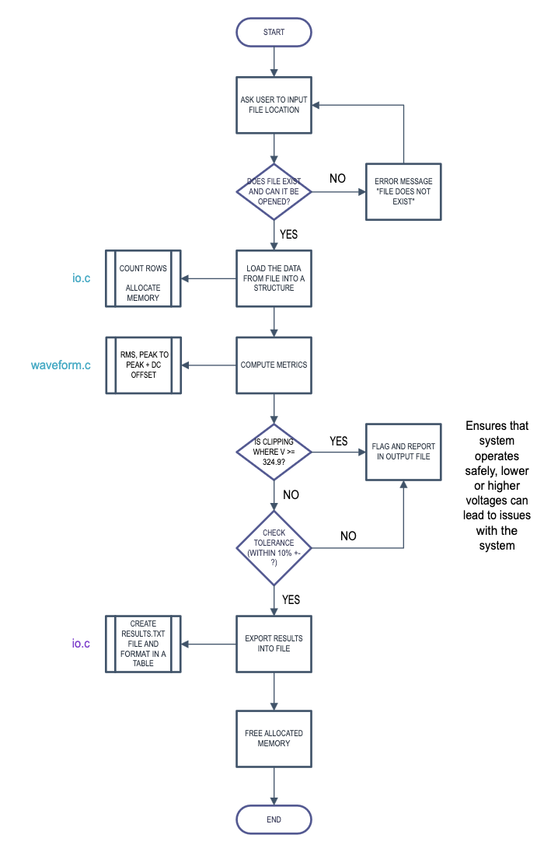
Overall Flow of The Program Main.c

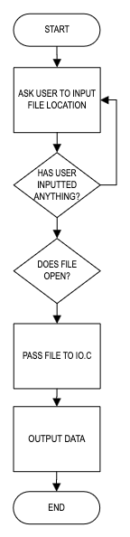

Waveform.c IO.c
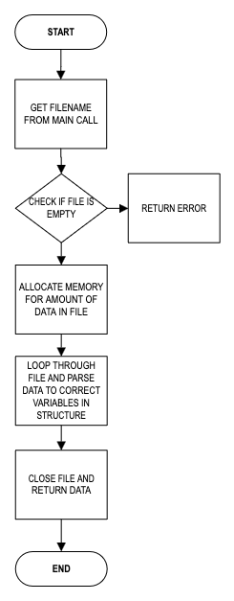
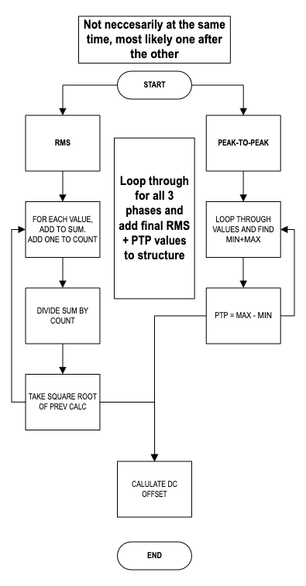

3. Function Description
Each function in the system is described below:
- Example Function, version x.x
  - Description: The function does….
  - Input Parameters: List acceptable data types and ranges here and order.
  - Returns: What the output returns, and where applicable, what it means.
4. Evidence of Unit Testing
Unit Testing Function Name Version X.X:
- Test Case 1:
  - Input: data types and numbers
  - Expected Output: 80.0
  - Result: Passed
- Test Case n: (repeat as needed)
Unit Test Results Summary:
- General description, any issues remaining?
- Edge cases, such as X, were tested (not) successfully.
- List any things needing resolving in future versions
5. Evidence of Integration Testing
Integration Test:
- Blocks/Functions tested together: Function name1 x.x and function name2 x.x
  - Test Steps:
    - List these here
  - Expected Outcome:
    - Program should X.
    - Functions should Y.
  - Result: Passed
Integration Test Results Summary:
- The system correctly integrates Function name1 x.x and Function name2 x.x.
- The following still needs to be resolved/implemented….
5. Evidence of Scenario Testing
Software/project version X.x
Testing scenario: Tests a series of events to test larger functionality – describe here
Steps:
    - Input thing
    - Validate input (successful).
    - Receive next input
    - Do something else here
4.1 multiple variations can be tested here
4.1.1 event – Passed
4.1.2 event – Passed
4.2 event - Failed.
6. Evidence of Version Control
The project was managed using Git for version control. Below are the key Git commands used in the development process:
- Initial Commit:
bash
Copy code
git init
etc
- Bug Fixes:
bash
Copy code
git checkout -b fix-input-validation-bug
GitHub Repository:
- GitHub Repository Link
7. Full Code (in Zip File) uploaded externally to Blackboard on 01/06/25
- Student_submission_name.zip
Note: The zip file contains:
- Source Code (.c files)
- Unit Test Scripts (.py for Python unit tests)
- Integration Test Logs (test_logs.txt)
8. References
- C Programming Language or specific instance such as….:
  - Kernighan, B.W., & Ritchie, D.M. (1988). The C Programming Language (2nd ed.). Prentice Hall.
- Git Documentation:
  - Chacon, S., & Straub, B. (2014). Pro Git. Apress.
  - Git Documentation
- Software Testing:
  - Kaner, C., Falk, J., & Nguyen, H. (1999). Testing Computer Software (2nd ed.). Wiley.

