Authors: Servando Balderas, Ashtyn Aldrete, and Connor McMullen
Course: BANA 4373 – Advanced Business Analytics
Date: May 6, 2026

Executive Summary:
This report investigates the impact of Hurricane Katrina on the population of New Orleans, Louisiana. We compared it against Birmingham, Alabama and used Jefferson County, AL to represent the city's observations. The time periods analyzed for this report span from 1995 to 2015. This is to sort the two cities into an equal measurement of ten years before and after the event. The methods used for this report include a difference in differences and an OLS regression.
Key Findings:
In our analysis of the population of Orleans Parish, LA, the area hasn’t been able to fully recover from the impacts of Hurricane Katrina. The population dropped by 54.13% between 2005 through 2006. A decade after the event occurred, the county has only seen about 86.76% of the share that it had in 2005. Our control variable has kept a steady growth over the same period with no noticeable increases caused by evacuations from the storm. The difference in difference effect from the storm has seen the loss of one hundred and thirty-four thousand more residents after Katrina than Jefferson County, AL.
The main limitation in the study is found with Orleans Parish declining in population before the event occurred. This affects the accuracy on the impact as our control variable differs in pre-Katrina trends. The hurricane caused a large number of residents to leave the location in 2005, but it does not explain the downward trend that was occurring before. Our analysis is limited to only population changes, and further variables are recommended to be considered such as income, education, and modes of travel. All of which could factor into the rates of displacement in the population of New Orleans, Louisiana.

Research Question and Motivation:
In the august of 2005, Hurricane Katrina made landfall over New Orleans, Louisiana. This storm led to a devasting impact over the southern region which has caused a shift in the population. The trends of the area were at a decline before the event and has seen a steady growth after. There are multiple factors that could explain why this outcome came to be and this study will focus on how Hurricane Katrina affected the population overall. We will analyze how the trends were before and after for both locations. Then we will use the difference in difference method to measure how the Hurricane affected New Orleans. These will help answer our question in how much Katrina impacted the location.
The motivation for this research for us is to see how the population has been affected by Hurricane Katrina. The relevance of this topic should be considered for all who live near a maritime tropical airmass. The warm waters of the gulf intensify tropical storms rapidly and there is always a potential of a once in a hundred-year storm to occur. When it does happen, emergency management has to consider which regions should citizens evacuate to and anticipate which areas are at most risk. The large movement of the evacuations should be considered by neighboring cities and states as we saw after this event. Those who have been displaced have reached cities such as Houston and San Antonio, Texas with federal assistance.
When considering the motivation of this study for Houstonians, events such as Hurricane Harvey that has resulted in severe flooding all over the area. What has impacted New Orleans can a potential risk for Houston, Texas as there are reports of the ground level lowering as the usage of groundwater increases in the region. This would increase the likelihood of more flood zones which can be amplified from a Hurricane making landfall. The study in figuring out how it impacts the population of New Orleans can aid in how city development and planning in Houston can mitigate impacts in the future.

Data:
Variable | FRED Series | Description
Resident Population in Orleans Parish, LA | LAORLE0POP | Annual estimates of the resident population. Thousands of Persons, Not Seasonally Adjusted.
Resident Population in Jefferson County, AL | ALJEFF5POP | Annual estimates of the resident population. Thousands of Persons, Not Seasonally Adjusted.

Reasoning for Jefferson County, AL:

We chose Jefferson County, AL to represent the city of Birmingham as our control group. The Hurricane did not hit Birmingham directly and has not seen a sizeable amount of evacuates such as Houston, Texas. The two cities contain urban populations in the southern region with county equivalent population sizes. However, due note that the trends for Orleans Parish has been going lower before the event as opposed to Jefferson County.

Sample Period:
The sample period chosen for this study spans from 1995 to 2015. This is to show the time series trends that occurred before and after the event by ten years. The year 2005 is the year of the event and divides these decades into two groups. We went with year averages for 10 years to capture the long-term trends of both groups more accurately with limited observation rates.
Cleaning Decisions:
The FRED data is clean as is with all observation years present from both locations. All the values from the summary statistics are sound and went on with merging into a two-location panel. The data for both groups were sorted into treated and control groups and also marking for before and after the event.

Summary Statistics:
The count for both data sets is twenty-one as it includes the ten-year observation groups and the year of the event. The average population of Jefferson County in the time frame surpasses Orleans Parish by nearly two-hundred and forty-eight thousand. No negative values to report in the summary, all observations are available.
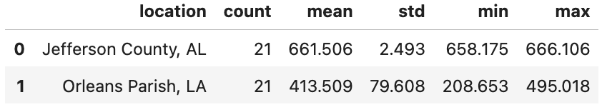

3. Methodology:
3.1 Difference-in-Differences Design
To study how Hurricane Katrina affected the population of New Orleans, we used a difference-in-differences (DiD) approach. The treated group in this study is Orleans Parish, Louisiana, and the control group is Jefferson County, Alabama, which we used to represent Birmingham. Jefferson County was chosen because it is a Southern urban area that was not directly struck by Hurricane Katrina. It is also a better comparison than Houston, since Houston received many evacuees after the storm and would not work as a clean control group.
The purpose of the DiD method is to compare how Orleans Parish changed after Katrina relative to how the control group changed over the same period. By doing this, we can better isolate the impact of Hurricane Katrina instead of only looking at New Orleans by itself.
3.2 Data and Sample Period
The data for this analysis came directly from the Federal Reserve Economic Data (FRED) public CSV endpoint. The notebook used annual population data for Orleans Parish (LAORLE0POP) and Jefferson County, Alabama (ALJEFF5POP). After downloading the data, both series were cleaned and merged into one panel dataset.
The sample period used in this study is 1995 through 2015. This gives ten years before Katrina and ten years after, with 2005 acting as the event year. Since Katrina made landfall in late August 2005, the year 2005 is treated as the last pre-Katrina year, while 2006 and later are treated as post-Katrina observations.
3.3 Model Setup
To build the DiD model, the notebook created two main indicator variables. The first variable, treated, equals 1 for Orleans Parish and 0 for Jefferson County. The second variable, post_katrina, equals 1 for 2006 and later and 0 for the years before that. The main regression includes these two variables along with their interaction term.
The interaction term is the most important part of the model because it measures how much more Orleans Parish’s population changed after Katrina relative to the control group. A negative interaction coefficient would mean that New Orleans experienced a larger drop in population after the storm than Jefferson County did over the same period.
3.4 Regression Specifications and Visual Analysis
The notebook estimated the model in two forms. The first used population in thousands, which makes the results easier to interpret in terms of the number of residents. The second used the log of population, which allows the effect to be interpreted in percentage terms. Both models were estimated using OLS with HC1 robust standard errors.
Along with the regression analysis, the notebook also included several visual tools. These included a population levels graph, an indexed population graph using 2005 as the base year, and an event-study-style graph that tracks how the gap between Orleans Parish and Jefferson County changed after Katrina. These visuals help show both the immediate drop and the longer-term recovery pattern.

4. Results
4.1 Exploratory Findings
The graphs show a clear break in Orleans Parish population after Hurricane Katrina. In the population levels figure, Jefferson County remains relatively stable over the sample period, while Orleans Parish drops sharply after 2005. This suggests that New Orleans experienced a major population shock that was not seen in the control group.
The indexed population graph supports this result. When both locations are set equal to their 2005 population level, Orleans Parish falls sharply after Katrina and stays below its pre-storm level for the rest of the sample. Jefferson County does not show the same type of decline. This suggests that the Orleans Parish drop was not just part of a wider regional pattern.
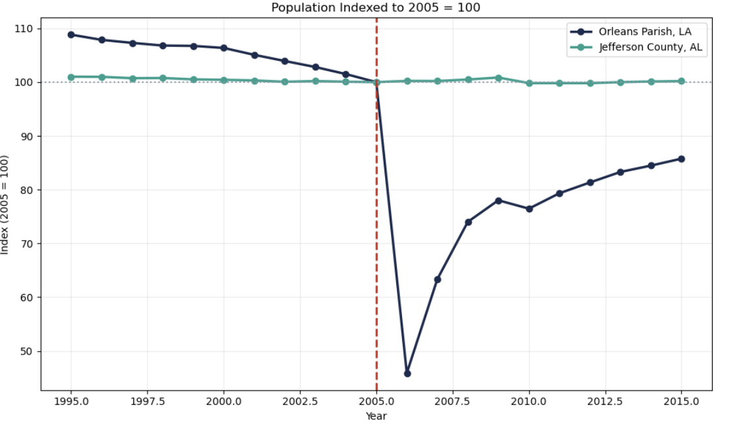
The event-study-style graph shows a similar pattern. Once the Orleans-minus-control gap is re-centered to zero in 2005, the years after Katrina become much more negative and remain below the baseline through 2015. This shows that the impact of Katrina was not only immediate, but also long-lasting.
4.2 Difference-in-Differences Results
The DiD table gives a direct estimate of the change. For Jefferson County, Alabama, the average population was 662.483 thousand before Katrina and 660.432 thousand after Katrina, which is a decline of about 2.051 thousand. For Orleans Parish, Louisiana, the average population was 478.513 thousand before Katrina and 342.004 thousand after Katrina, a decline of about 136.510 thousand.
After subtracting the control-group change from the Orleans Parish change, the difference-in-differences estimate is -134.458 thousand. This means that Orleans Parish lost about 134,458 more residents after Katrina than would be expected based on the trend in Jefferson County alone.
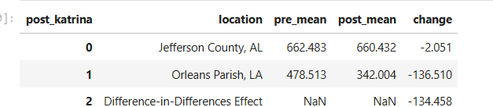
4.3 Regression Results
The regression output confirms the same finding. In the levels model, the interaction term between treated and post Katrina is -134.458, and the estimate is statistically significant. This means the Orleans Parish experienced an additional post-Katrina population decline of about 134.5 thousand residents relative to the control group. The model also has an R² of 0.962, which means the model explains a large share of the variation in the data.
In the log model, the interaction coefficient is -0.347, which means the post-Katrina population in Orleans Parish was about 29.32% lower relative to the control group. This result is also statistically significant, and the model has an R² of 0.905. Since both the levels model and the log model show the same conclusion, the findings are consistent across both specifications.
4.4 Recovery and Long-Term Impact
The notebook also shows how severe the immediate drop was. The Orleans Parish population went from 454.845 thousand in 2005 to 208.653 thousand in 2006, which is a one-year decline of 54.13%. Although the population began to recover after that, it still did not return to its pre-Katrina level by the end of the sample.
By 2015, the Orleans Parish population had recovered to 390.094 thousand, which is only 85.76% of its 2005 level. This shows that Katrina caused not only a short-term displacement shock, but also a lasting effect on the population of New Orleans.
Overall, the graphs, DiD table, and regression results all point to the same conclusion: Hurricane Katrina had a large and persistent negative effect on the population of Orleans Parish relative to the Birmingham-area control group.

Limitations:
There are several limitations to consider in this study. The most significant being the concerns we face with violations of the parallel trend’s assumption. For the difference in difference methods to produce estimates, we can redeem reliable; both the treated group and the control group should follow similar trends before the event occurs. In the data we provided through FRED, Orleans Parish was already experiencing levels of decline in population before Hurricane Katrina, while the Jefferson County population level sustained its population throughout the event. The divergence being pre-existing means a portion of the post Katrina population decline may have occurred regardless of the hurricane which inflates our estimate.
Another limitation is that this study only uses one control group. Jefferson County, Alabama was selected due to its similar urban area that was not directly hit by the storm and did not receive a substantial portion of refugees. However, relying on a single control group makes the result sensitive to unique trends that may have been active in Jefferson County at the time. Using multiple control groups or a synthetic control method could ground our findings.
In addition, this analysis is limited to population counts as the sole outcome variable. Population change alone does not capture the full scope of the hurricanes' impact. Factors such as household income, employment rates, housing availability, education level, and demographic composition all shifted after Katrina and are not accounted for in this study. Future research should include these additional variables to provide a more complete picture of the disaster’s long-term effects on the community.
Finally, our annual frequency of FRED population data limits our abilities to observe short-term dynamics. Monthly or quarterly data would allow for a more precise analysis of the timing and pace of both displacement and recovery.
Implications for Practitioners:
The findings of this study carry important implications for emergency management professionals, urban planners, and policy makers in hurricane-prone regions. The fact that Orleans Parish lost approximately 134,458 more residents than expected relative to the control group demonstrates that a single catastrophic event can fundamentally reshape the city’s population trajectory for over a decade.
For emergency managers, these results emphasize the importance of pre-distortion planning that goes beyond immediate evacuation logistics. Evacuations plans should be paired with long-term recovery strategies that address housing, infrastructure, and economic opportunity so that displaced residents have a viable path to return. The data shows that even ten years after Katrina, New Orleans has only recovered to about 86% of its pre-event population, suggesting that recovery without targeted intervention is slow and incomplete.
For cities like Houston, Texas, which faced similar risks from hurricanes and flooding, this study provides a cautionary example. Reports on ground subsidence due to ground water erosion increased Houston’s vulnerability to major flood events. City planners should use studies like this to justify investments in flood mitigation infrastructure, zoning reforms, and resilience programs that reduce the likelihood of mass displacement. Factors like sea level, ground water absorption rates, and urban sprawl all create conditions that can lead to similar events such as Katrina.
Neighboring cities and states should also prepare for the strain that comes from receiving large numbers of evacuees. After Katrina, cities such as Houston and San Antonio absorbed significant displaced populations, which placed pressure on housing, schools, healthcare systems, and social services, regional coordination plans that anticipate these spillover effects help receiving communities manage the impact more effectively. When displacement is not accounted for, housing prices, strain on infrastructure, and standard of living can shift dramatically in surrounding areas.

Conclusion:
This study examined the impact of Hurricane Katrina on the population of Orleans Parish, Louisiana, using Jefferson County, Alabama as a control group and a difference in difference research design. The analysis covered the period from 1995 to 2015, providing ten years of data on either side of the event.
The results show that Hurricane Katrina has a large and lasting negative effect on the population of New Orleans. Orleans Parish experienced a year of population decline of 54.13% between 2005 and 2006. The difference in differences estimate indicates that Orleans Parish lost approximately 134,458 more residents after Katrina than would be expected based on the trend observed in Jefferson County. Both the levels of regression and the log regression confirmed this finding with statistical significance and a strong fit model. Although the population began to recover in the years following the hurricane, it had only reached approximately 86% of its 2005 by 2015. This persistent gap highlights that natural disasters of this magnitude do not simply cause temporary displacement. They can permanently alter the size and composition of the city’s population. Future research should expand this analysis by incorporating additional outcome variables and multiple control groups to further isolate the casual effects of the hurricane.
AI Disclosure:
Google Gemini was used to debug a syntax error during the implementation of the Jupiter Notebook code.

References:
Federal Reserve Bank of St. Louis. (n.d.). Resident Population in Orleans Parish, LA [LAORLE0POP]. FRED Economic Data. Retrieved May 2026, from https://fred.stlouisfed.org/series/LAORLE0POP
Federal Reserve Bank of St. Louis. (n.d.). Resident Population in Jefferson County, AL [ALJEFF5POP]. FRED Economic Data. Retrieved May 2026, from https://fred.stlouisfed.org/series/ALJEFF5POP
Sayers, D. (2025). Is Houston sinking? Study claims Space City among 28 cities in U.S. seeing significant rates. ABC13 Houston. https://abc13.com/post/is-houston-sinking-study-claims-space-city-among-28-cities-us-seeing-significant-rates/16393579/

