**Name:- Baviskar Chhaya Suresh Roll No:12**

**Practical 1:**

**Set up a GitHub account and send an email message to friend telling to your friend about the account.**

**Create a GitHub account**

If you don't already have a GitHub account, here's how to create one.

1. Open [https://github.com](https://github.com/) in a web browser, and then select **Sign up**.

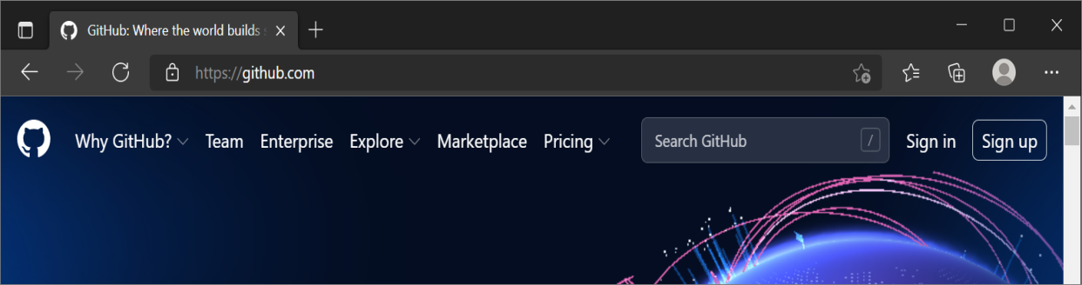

1. **Enter your email** address.

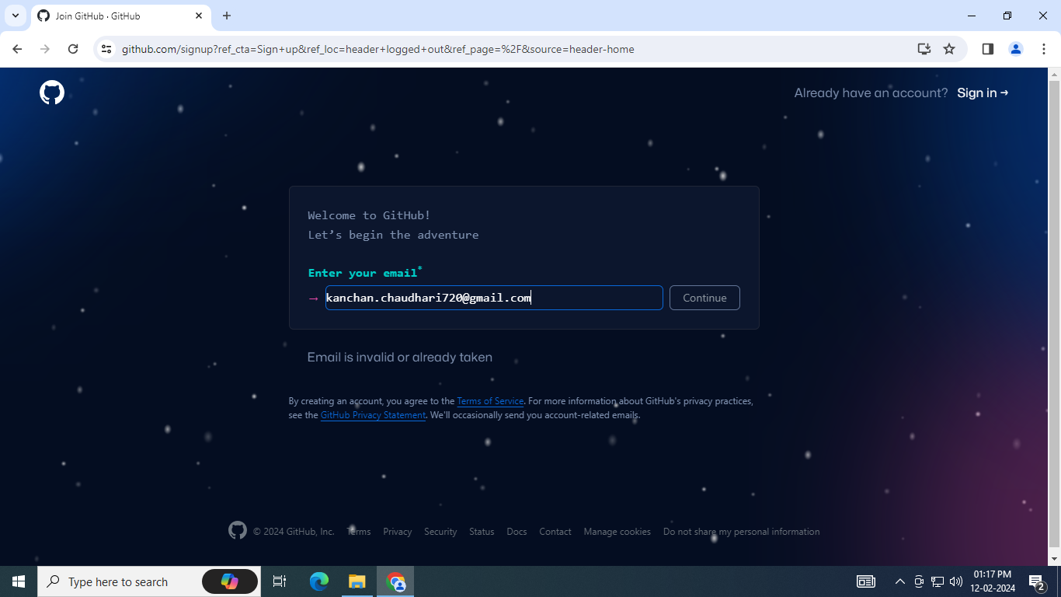

1. **Create a password** for your new GitHub account, and **Enter a username**, too. Next, choose whether you want to receive updates and announcements via email, and then select **Continue**.

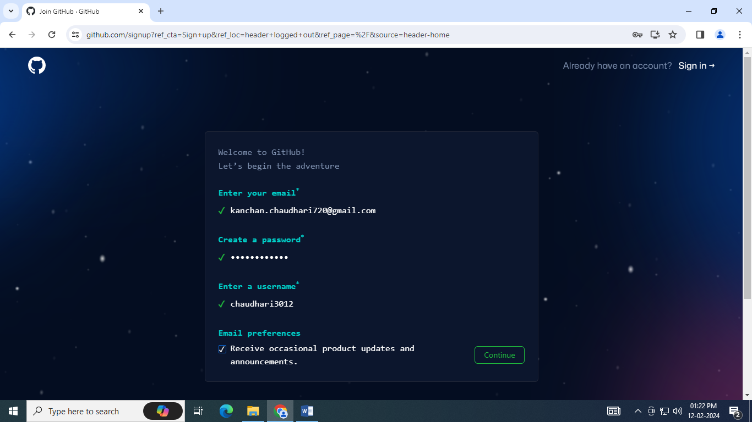

1. **Verify your account** by solving a puzzle. Select the **Start Puzzle** button to do so, and then follow the prompts.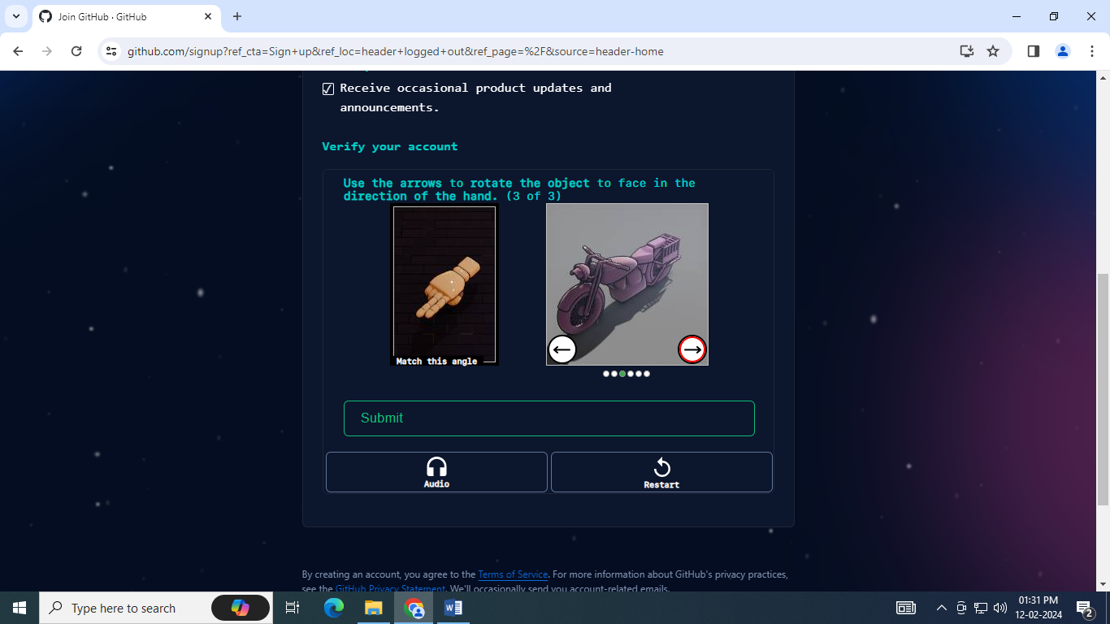
2. After you verify your account, select the **Create account** button.
3. Next, GitHub sends a launch code to your email address. Type that launch code in the **Enter code** dialog, and then press **Enter**.

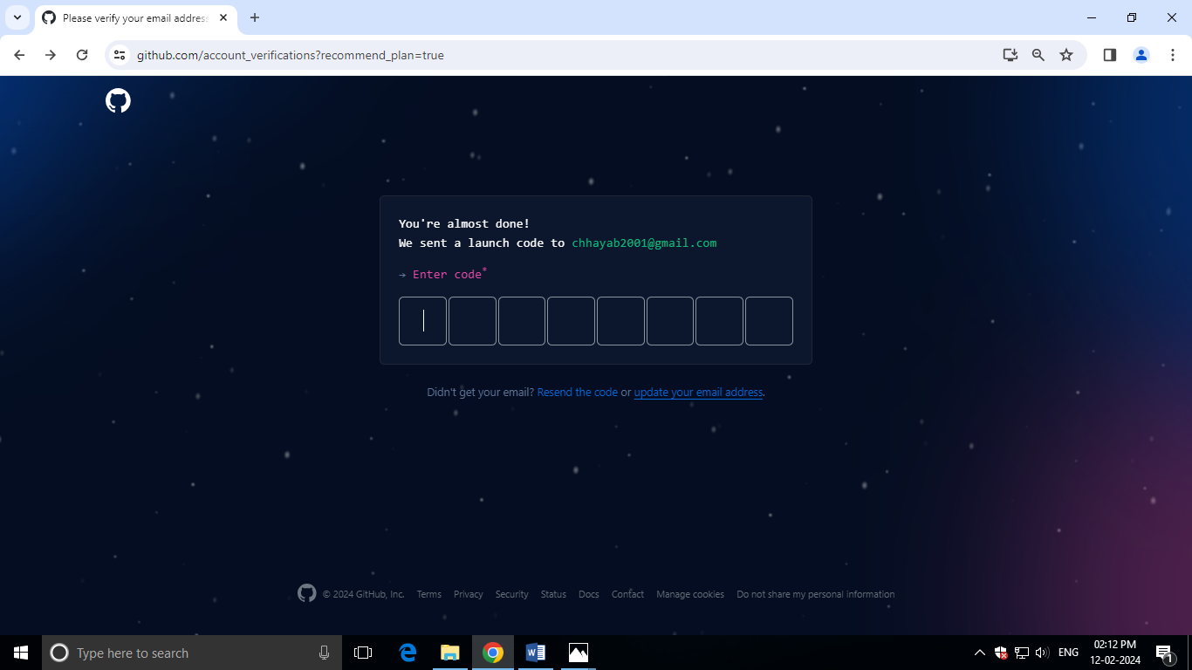

1. GitHub asks you some questions to help tailor your experience. Choose the answers that apply to you in the following dialogs:
   * **How many team members will be working with you?**
   * **What specific features are you interested in using?**
2. On the **Where teams collaborate and ship** screen, you can choose whether you want to use the Free account or the Team account. To choose the **Free** account, select the **Skip personalization** button.

GitHub opens a personalized page in your browser.

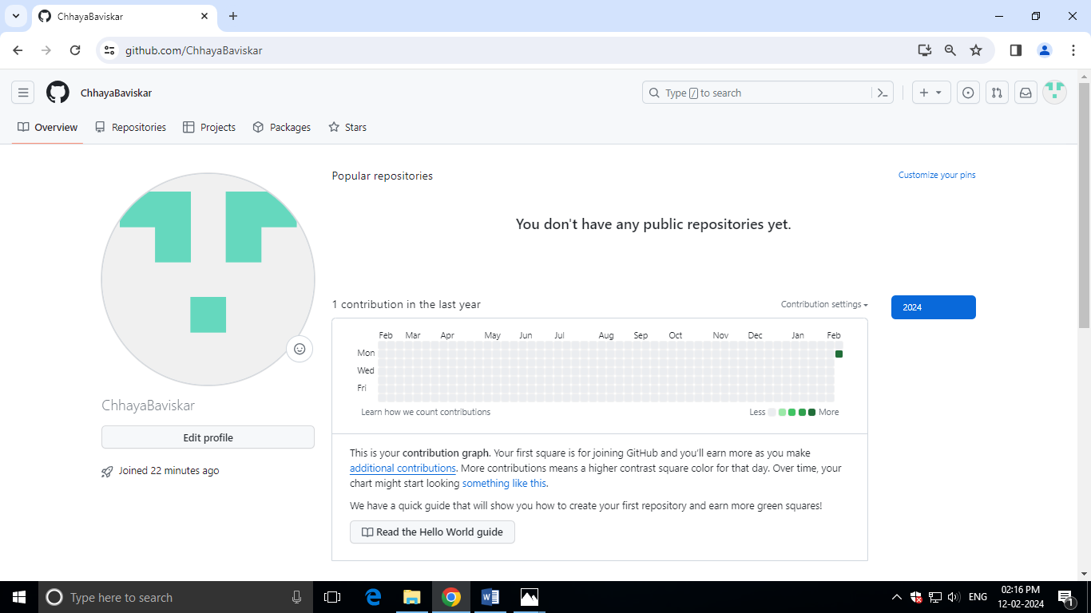

Congratulations! You've successfully created your GitHub account.

**Paste the screen shots of email which you had sended to your friend through Github**

Step1: Go to Github account and login.

Step2: After login, click on any created remote repository.

Step3: Go to settings of that particular remote repository and click on Email notifications and add the email id of your friend which you had to send the mail.

Step4: Make changes on your remote repository by editing any existing file or you can create any new file also.

Step5: Now, tell your friend to check his/her mail id by login.

**Paste your sended mail screenshot here**

