

**SHOGEKIJO WEBSITE REPORT**

**A PROJECT REPORT**

***Submitted by***

**Ashutosh Sahu (201500168)**

**Aayush Garg (201500006)**

**Saloni Shukla(201500611)**

**Tanu Gola(201500740)**

***in partial fulfilment for the award of the degree of***

#### BACHELOR OF ENGINEERING

**IN**

##### Computer Engineering and Applications

**GLA University, Mathura**

#### BONAFIDE CERTIFICATE

Certified that this project report **SHOGEKIJO WEBSITE** is the bonafide work of **Aayush Garg, Ashutosh Sahu, Saloni Shukla, Tanu Gola** who carried out the project work under my supervision.

|  |  |  |
| --- | --- | --- |
|  | |  |
| <<Signature of the Supervisor>>  **SIGNATURE**    Mr. Akash Choudhary  **SUPERVISOR**  Technical Trainer |

**INTERNAL EXAMINER EXTERNAL EXAMINER**

**DECLARATION**

We hereby declare that work which is being presented in the MINI Project “**SHOGEKIJO Website”** in partial fulfillment of the requirements for MINI Project, is an authentic record of our own work carried by the team members under the supervision of our mentor Mr. Akash Kumar Choudhary.

Group Members:

Ashutosh Sahu (201500168)

Aayush Garg (201500006)

Saloni Shukla(201500611)

Tanu Gola(201500740**)**

Course: B. Tech (Computer Science and Engineering)

Year: 3rd

Semester: 6th

Supervised By:

Mr. Akash Kumar Choudhary, Technical Trainer

Department of Training and Development, GLA University

**ACKNOWLEDGEMENT**

We would like to express our profound gratitude and deep regards to our mentor Mr. Akash Kumar Choudhary for his exemplary guidance, monitoring and constant encouragement throughout the course of this project. We are profoundly grateful towards the unmatched services rendered by him.

**CONTENT**

|  |  |
| --- | --- |
| **S.No.** | **TITLE** |
| **1.** | Introduction |
| **2.** | About Project |
| **3.** | Advantages |
| **4.** | Problems faced |
| **5.** | Inspiration |
| **6.** | Report |

**ABSTRACT**

The website typically has a user-friendly interface and is designed to cater to the needs of anime fans. Users can browse through a vast collection of anime shows,read reviews and get recommendations based on their interests. They can create a personal account to keep track of their favourite shows, share their own reviews, and interact with other users on the platform. The website may also offer merchandise and other related products for purchase, such as DVDs, Blu-rays, and other collectibles.

**INTRODUCTION**

Shogekijo is a streaming service that offers a wide variety of award-winning Anime, shows and more on thousands of internet-connected devices. You can watch as much as you want, whenever you want without a single commercial – all for one low monthly price. There's always something new to discover and new TV shows and movies are added every week!.

**About Project**

An anime website is an online platform dedicated to the distribution, streaming, and discussion of Japanese animated series, movies, and other related content. These websites offer a vast collection of anime titles, covering various genres, including action, adventure, romance, comedy, sci-fi, fantasy, and many more.

**Primary reason to choose this Project**

It’s main purpose of course is to entertain the viewer. The second purpose is to faithfully adapt and bring life to the source material. Manga is a far more efficient medium for story telling. You can simply get through the story faster. Now unless the anime tells a better story there is no reason to watch it. Now the Demon Slayer anime, and the Demon Slayer manga tell pretty much the same story.

**The Main Objective of the Project**

The objective of ANIME is to create a model that can adapt and learn from data in real-time, enabling it to make accurate predictions and decisions even in rapidly changing environments. The ultimate goal of ANIME is to provide a powerful tool for understanding and controlling complex systems in a wide range of fields, including finance, energy, transportation, and more.

**Scope of the Project**

The scope of anime websites in the future is likely to continue expanding as the popularity of anime and related content grows worldwide. With the increasing demand for anime content, anime websites will continue to serve as a hub for fans to access their favourite shows and discover new titles .

1.More Exclusive Content

2.Virtual Reality (VR) and Augmented Reality (AR) Integration

3.Global Expansion

4.Social Features.

**Working Methodology of the Project**

The working methodology of an anime website may vary depending on the specific site and its features. However, here are some common steps involved in the working of an anime website: Content Organization: Once the content is acquired, it is organized and categorized based on factors such as genre, popularity, release date, and more. Streaming: Anime websites typically stream the content directly to users' devices using video streaming technology. User Accounts: Most anime websites require users to create an account to access their content.

**ADVANTAGES**

**A few benefits of SHOGEKIJO Website are**

* SHOGEKIJO is so simple to use. You do not have to set up anything. Open the app, log in, and you are ready to go. You can browse by genre or by name. It is all very easy.
* There is nothing more annoying than commercials interrupting the movie or TV show you are watching. SHOGEKIJO is commercial-free. This means that when you find a film or a show you want to watch and click Play, you will watch it without being interrupted by ads. Don’t worry, this goes for the free trial as well.
* SHOGEKIJO allows users to download the content and watch it offline. This is a great option, especially if you plan to go on a road trip with friends or on vacation. Perhaps you won’t have a great internet connection, so you won’t be able to stream shows and movies. SHOGEKIJO makes sure that you get to enjoy yourself no matter where you are.
* Another advantage of SHOGEKIJO is that you can choose a membership plan that is ideal for you. You can downgrade or upgrade anytime you want. There are three available plans: basic, standard, and premium. Each plan comes with different options. For instance, Ultra HD is only available with the Premium membership plan. The first month is free for all the plans, and you can cancel the membership whenever you want.

**PROBLEMS FACED**

**A few problem we faced while working on projects are**

* Implementation of Login and SignUp page with authentication
* Implementation of Viewpost query to show all post in home page
* Faced problem while making navbar.
* Creating profile info side bar in profile page and uploading updated data

**DATA FLOW DIAGRAM**

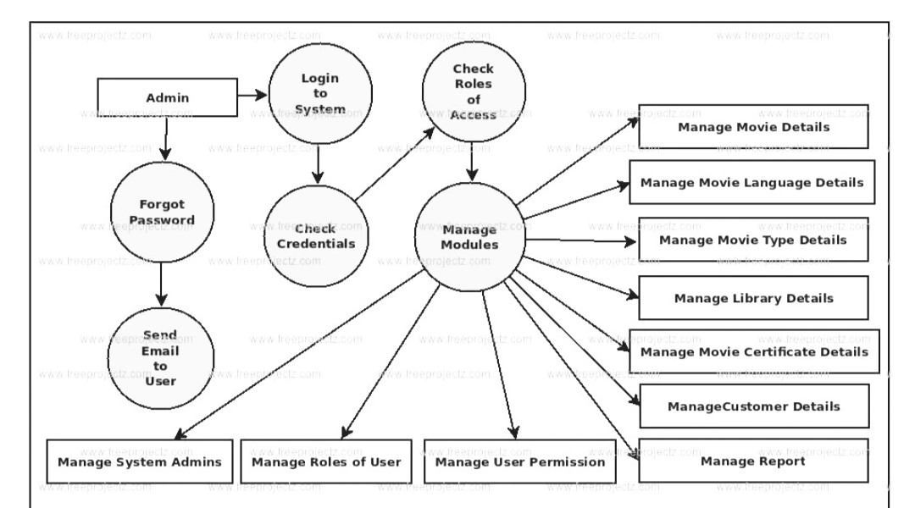

**INSPIRATION**

Inspiration for creating this project comes while visiting some popular online TV Shows websites like Amazon prime ,hotstar, Netflix ,zoro.tv.

These Websites documentaries are not only entertaining but also inspirational that feature wonderful messages to lift your spirits and add positivity to your life**.**

As an entrepreneur, you might not have much time to watch TV series, but you’re always looking for ways to keep your creativity flowing. A TV series might be one source of inspiration, as it can be watched in succinct short episodes and get your creativity flowing for a longer period of time than just a movie.

**REPORT**

* **Current Build include:-  
  Login and registration authentication  
  Watching anime**

**Trending anime available**

**New arrival anime section to select**

**Logout functionality**

#### USER MANUAL

* **Install Xampp in the system**
* **Run apache and mysql server from xampp**
* **Import database in phpMyAdmin in the cloned file**
* **Run index.html from localhost server**

**Details About the Hardware and the Software**

**System Requirements: -**

Supported Operating Systems: - Windows 7, 8, 10

Software Required:

* Web Browser like Google Chrome, Microsoft Edge, etc.
* IDE like Visual Studio Code.

**Hardware Requirements: -**

* Minimum 4GB Ram
* Minimum Intel i3 processor or Ryzen-3
* Graphics Card