-- Q1 Average number of items per order - daily, monthly, weekly, state, city, pincode

Select

EXTRACT(DAY from order_received_timestamp) AS daily,

EXTRACT(MONTH from order_received_timestamp) AS monthly,

EXTRACT(WEEK from order_received_timestamp) AS weekly,

a.state AS state,

a.city AS city,

f.pincode AS pincode,

avg(item_count) as avg_items

From `fractalb.star_schema.fact_daily_orders` f

left join `fractalb.star_schema.dim_customer` c

on f.customerid = c.customerid

left join `fractalb.star_schema.dim_address` a

on c.address_id = a.address_id

group by

daily,

monthly,

weekly,

state,

city,

pincode

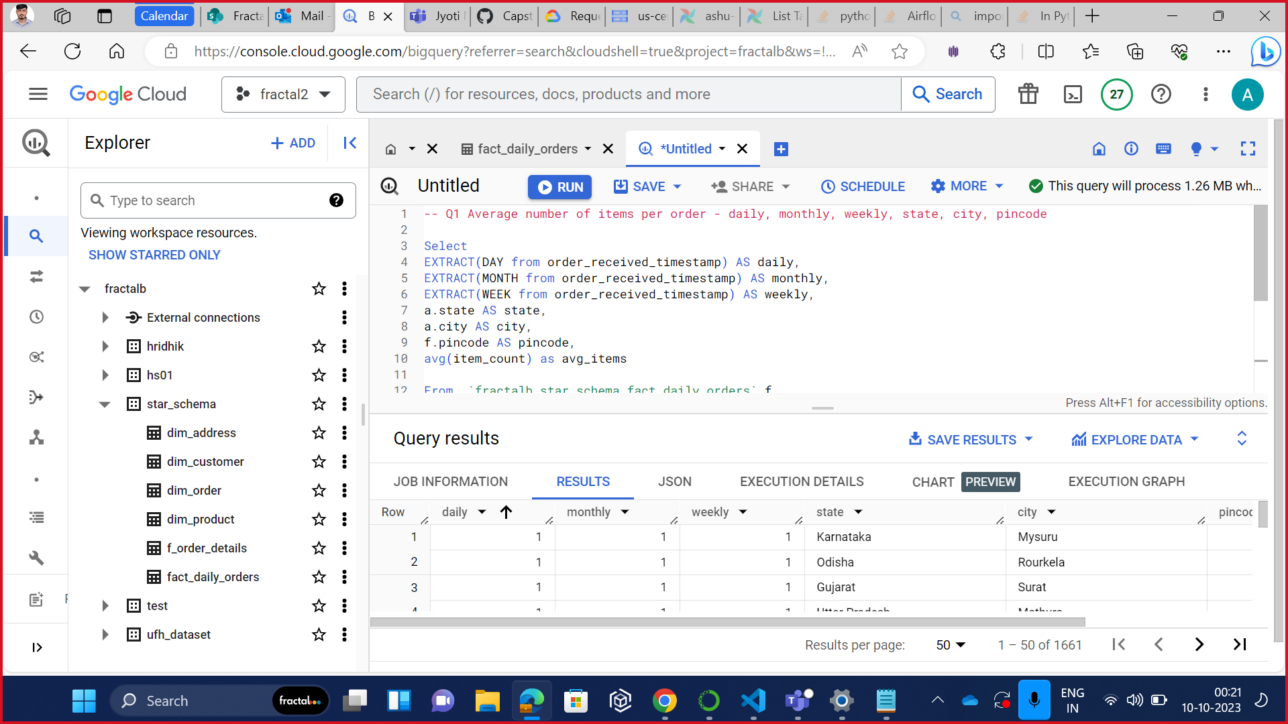

-- Q2 Average amount of sales per order - daily, monthly, weekly, state, city, pincode

Select

EXTRACT(DAY from f.order_received_timestamp) AS daily,

EXTRACT(MONTH from f.order_received_timestamp) AS monthly,

EXTRACT(WEEK from f.order_received_timestamp) AS weekly,

a.state AS state,

a.city AS city,

f.pincode AS pincode,

avg(order_amount) as avg_sales

From `fractalb.star_schema.fact_daily_orders` f

left join `fractalb.star_schema.dim_customer` c

on f.customerid = c.customerid

left join `fractalb.star_schema.dim_address` a

on c.address_id = a.address_id

group by

daily,

monthly,

weekly,

sTATE,

city,

pincode

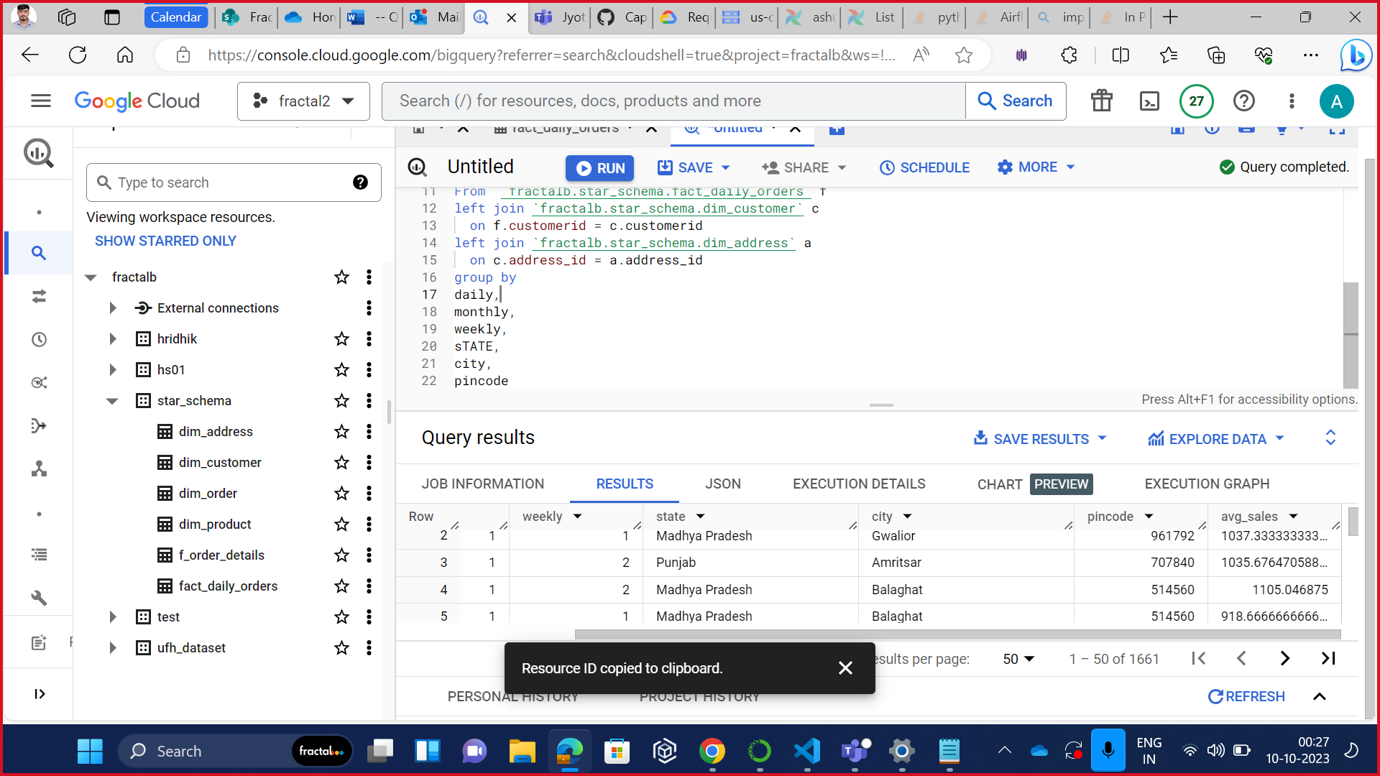

-- Q3 total number of units sold per day of a product SKU and its monthly trend

select

p.productname,p.sku,

EXTRACT(DAY from f.order_delivery_timestamp) as day,

EXTRACT(MONTH from f.order_delivery_timestamp) as month,

sum(quantity) as units_sold

From `fractalb.star_schema.dim_product` p

join `fractalb.star_schema.f_order_details` f

on p.productid = f.productid

group by productname,

sku,

day,

month

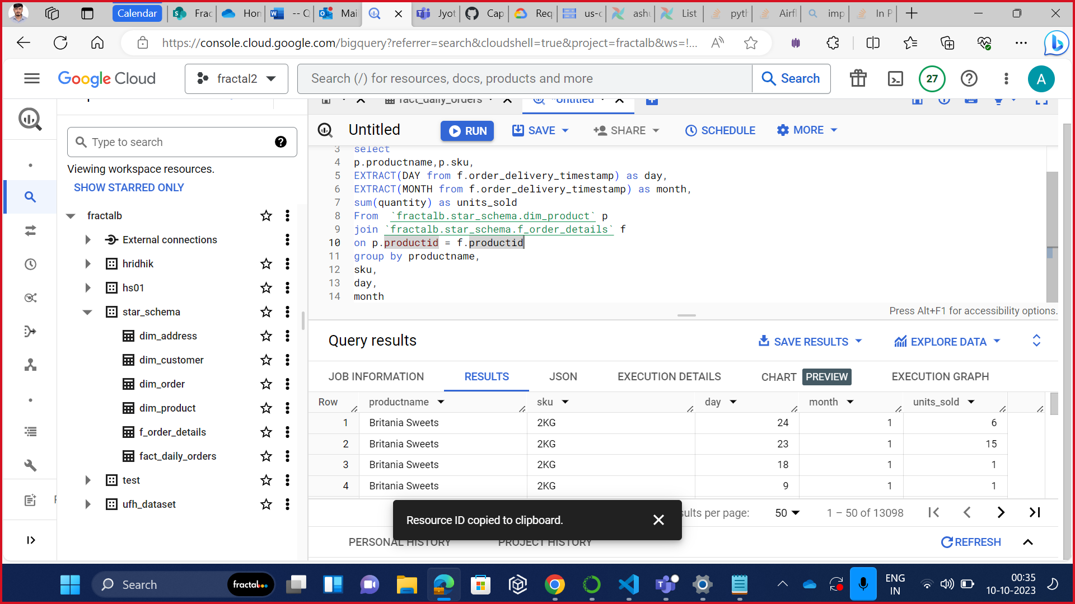

-- 4 Total Order Amount on daily basis, also to be able to split by product and geography

select

EXTRACT(DATE from f.order_received_timestamp) AS daily,

o.productid,

a.city,

sum(order_amount) total_sales

from `fractalb.star_schema.fact_daily_orders` f

join `fractalb.star_schema.f_order_details` o on f.orderid = o.orderid

join `fractalb.star_schema.dim_customer` c on f.customerid = c.customerid

join `fractalb.star_schema.dim_address` a on c.address_id = a.address_id

group by

daily,

productid,

city

order by daily

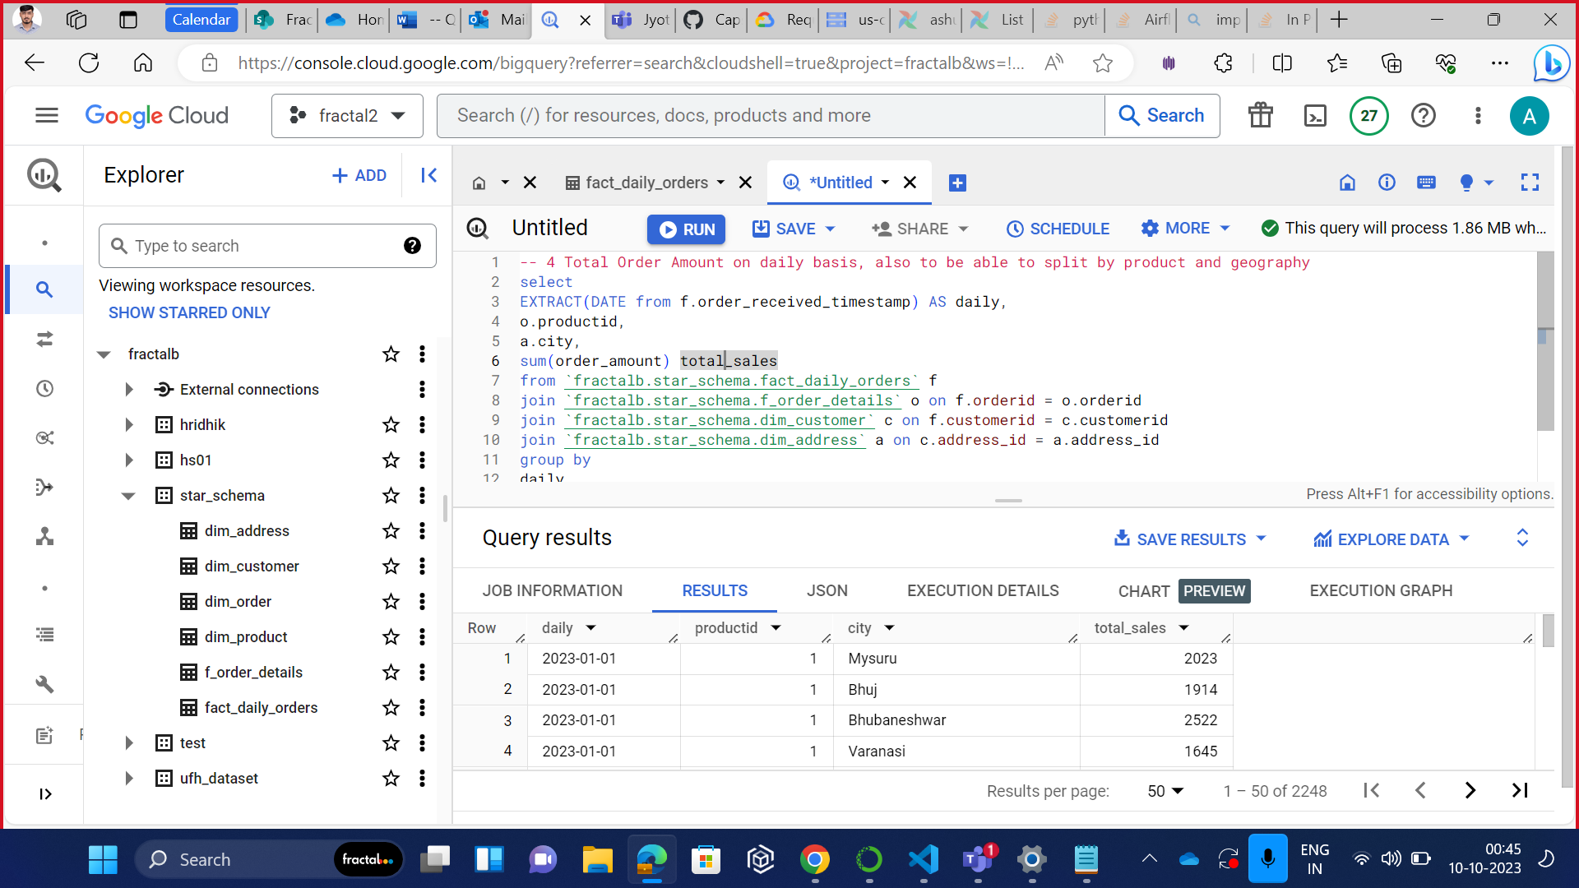

-- Q5 Distribution of orders according to area ( state, city, pincode etc)

select

a.state,

a.city,

count(distinct f.orderid) NumberOfOrders

from `fractalb.star_schema.fact_daily_orders` f

join `fractalb.star_schema.dim_customer` c on f.customerid = c.customerid

join `fractalb.star_schema.dim_address` a on c.address_id = a.address_id

group by

state,city

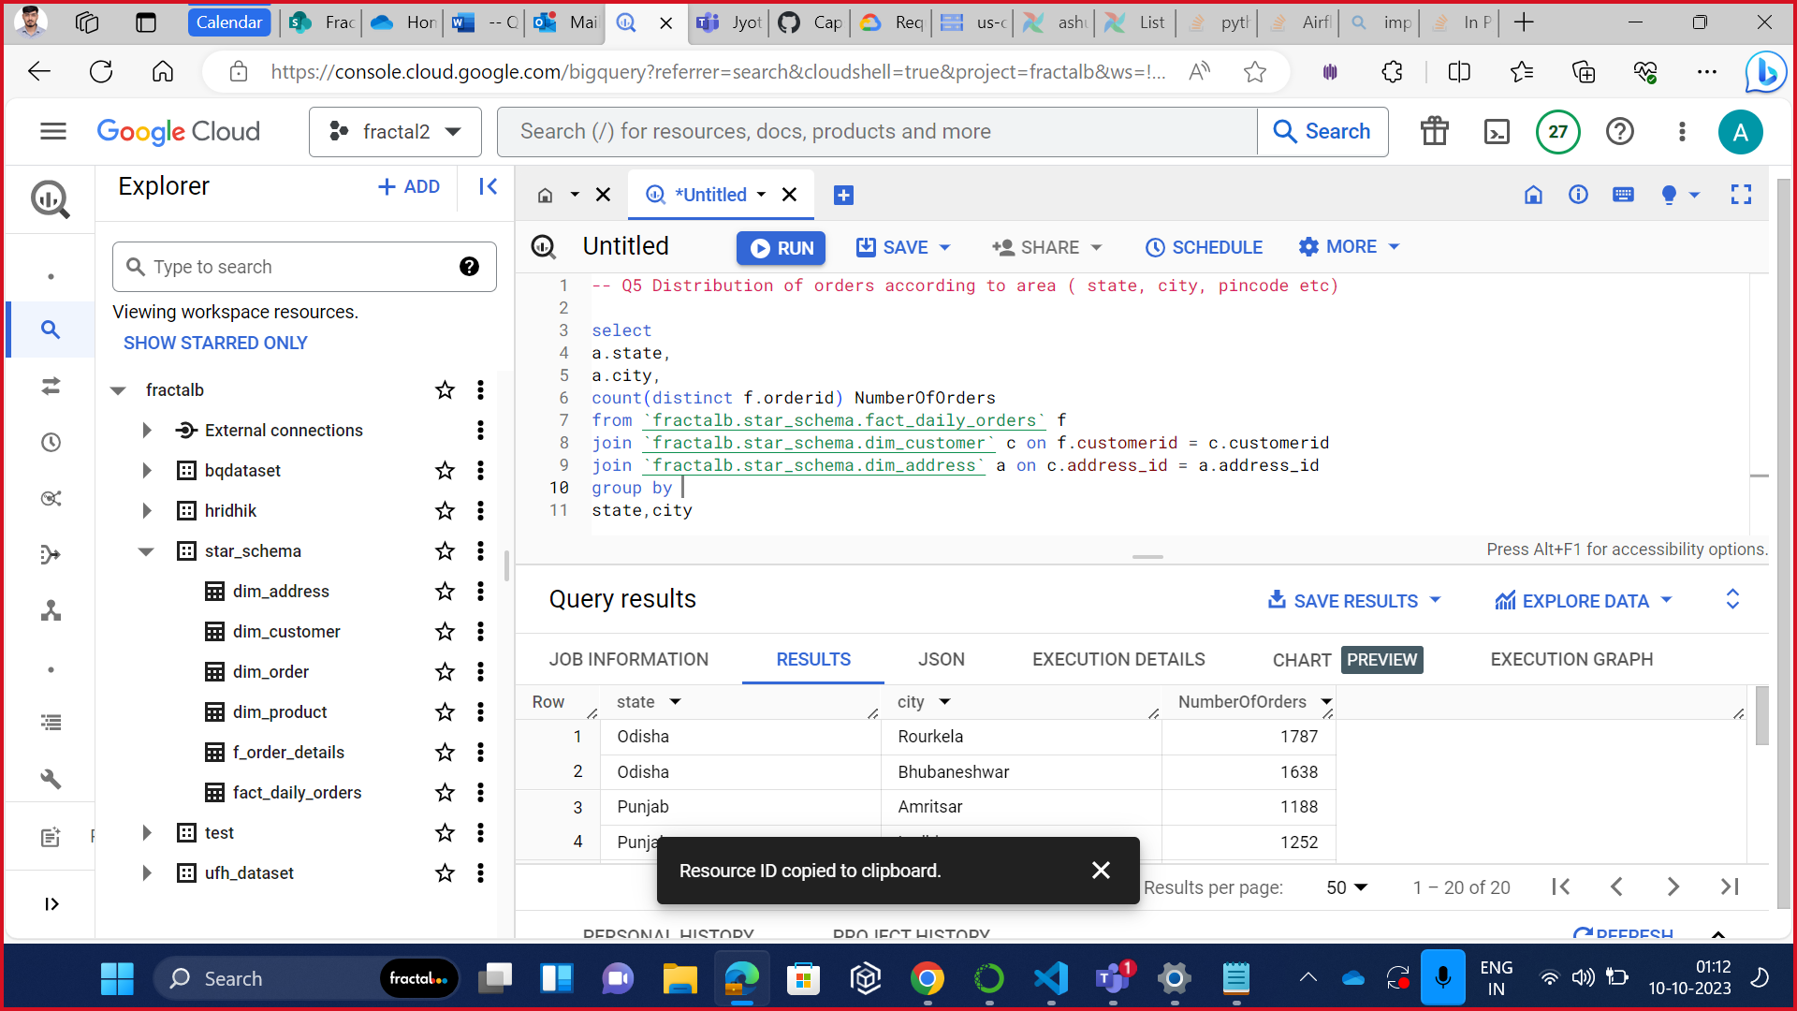

-- Q6 Average order amount per customer on daily basis

select

c.customerid AS id,

c.name AS name,

EXTRACT(DATE from order_received_timestamp) date,

round(avg(order_amount),2) AS OrderAmount

from `fractalb.star_schema.fact_daily_orders` f

left join `fractalb.star_schema.dim_customer` c

on f.customerid = c.customerid

group by

id, date, name

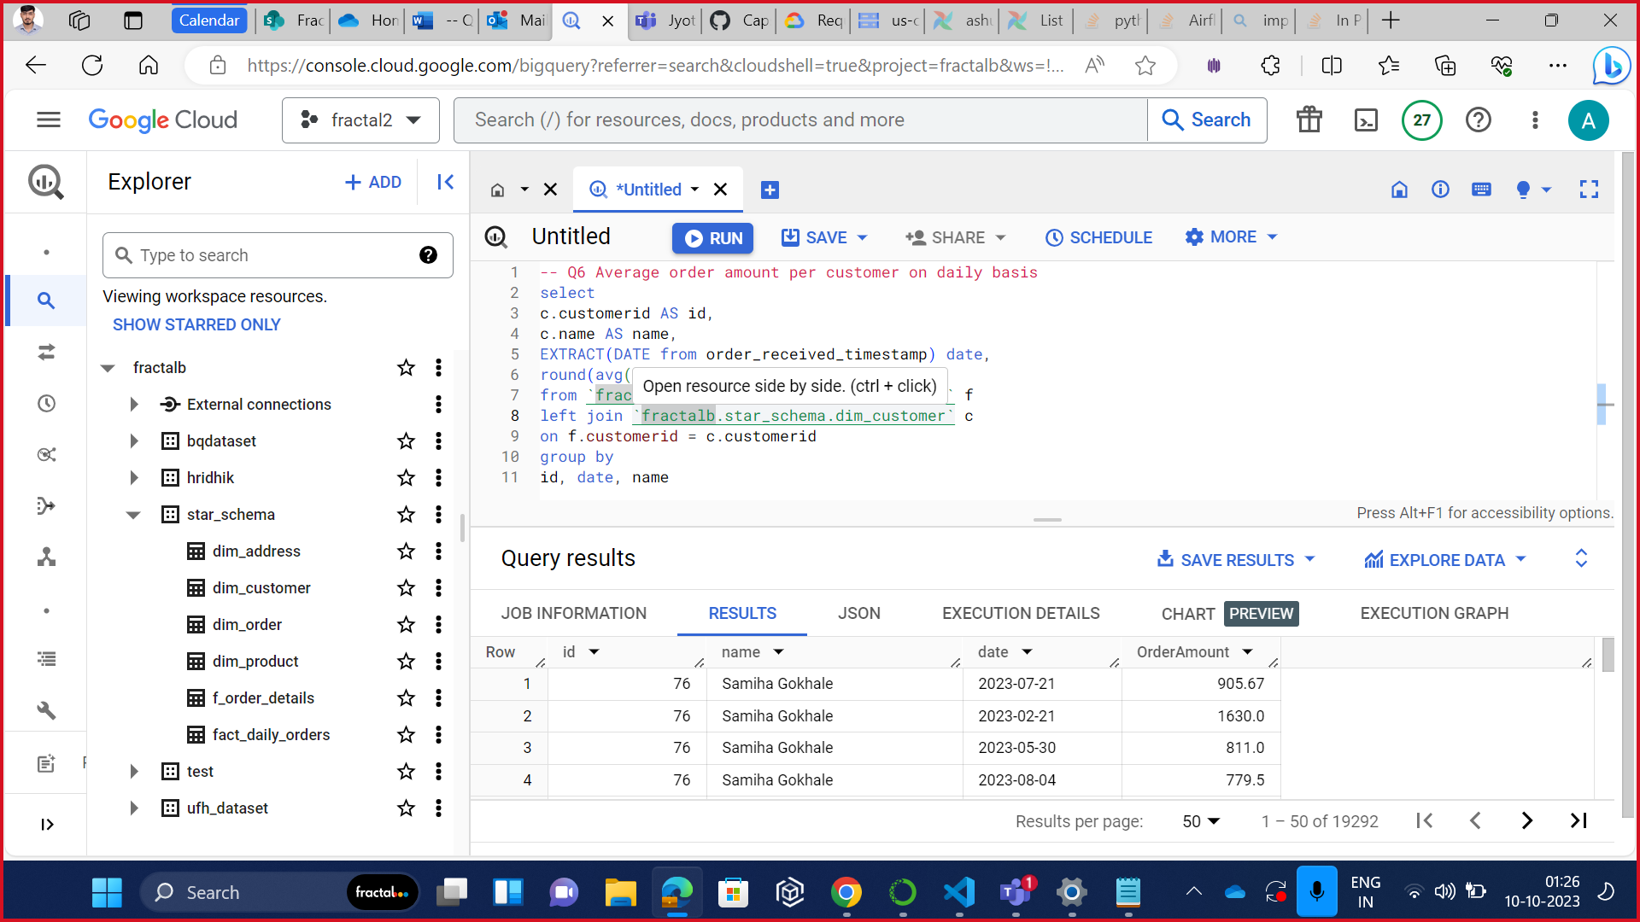

-- Q7 New Customers on daily basis

select

START_DATE,

count(customerid) NewCustomers

from `fractalb.star_schema.dim_customer`

where customerid in (select customerid from `fractalb.star_schema.dim_customer`

group by customerid having count(*)=1)

group by START_DATE

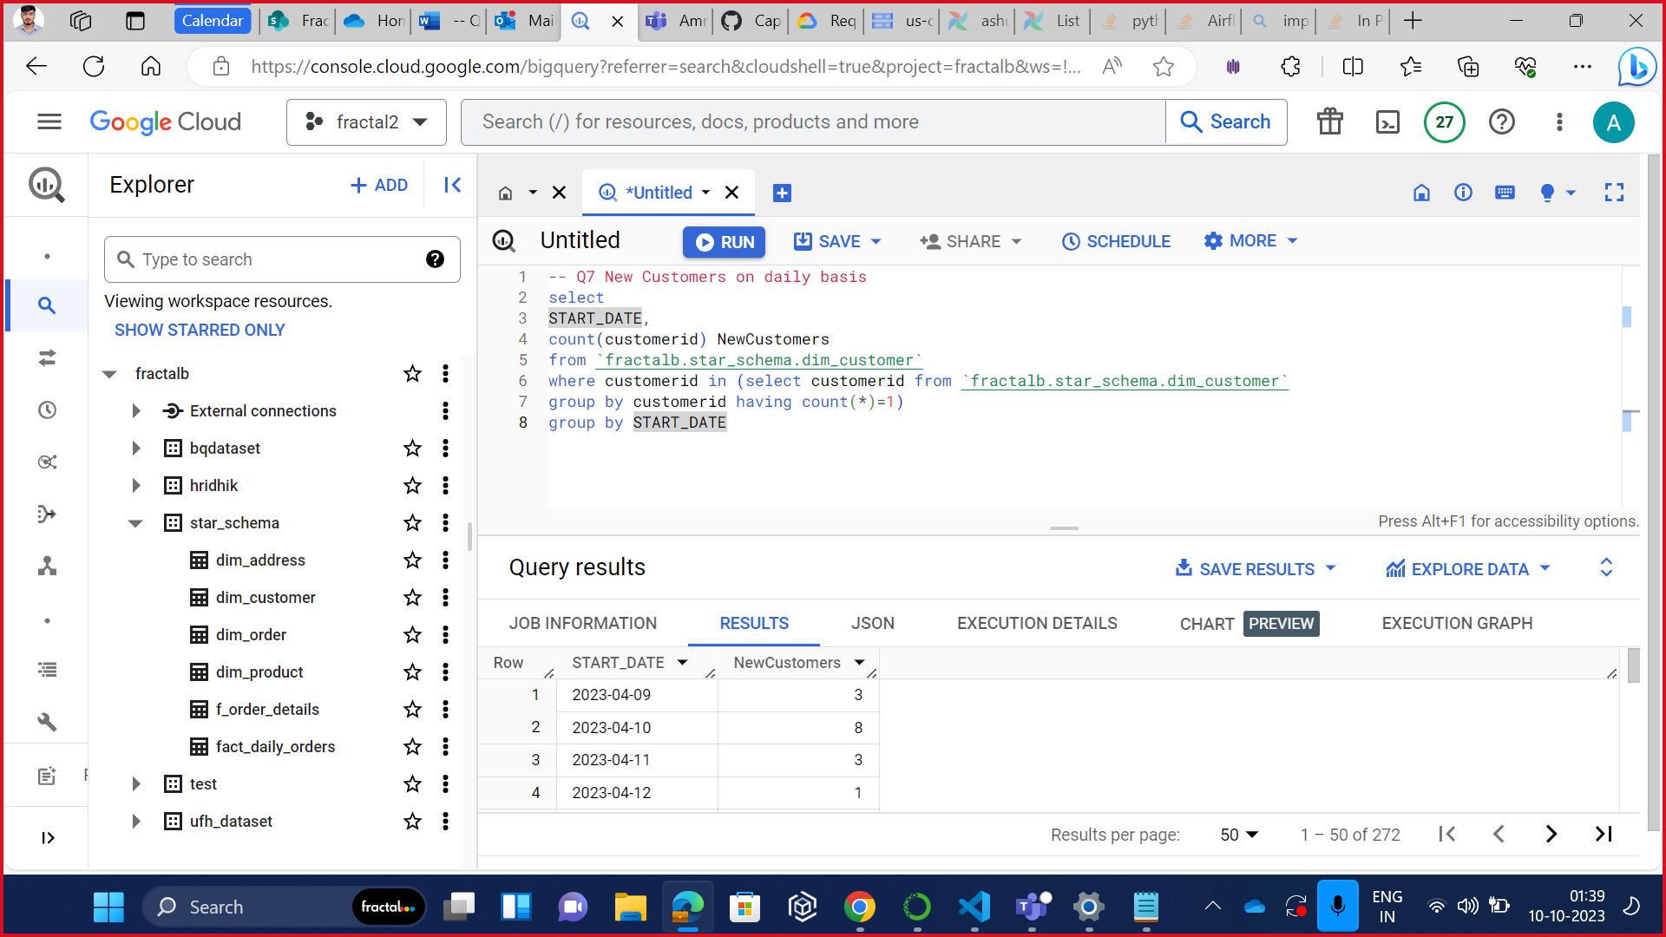

-- Q8 Total count of customers everyday

select distinct

EXTRACT(DATE from order_received_timestamp) Dates,

count(*) over (partition by EXTRACT(DATE from order_received_timestamp)) CustomerCounts

from `fractalb.star_schema.fact_daily_orders`

group by

order_received_timestamp

order by Dates

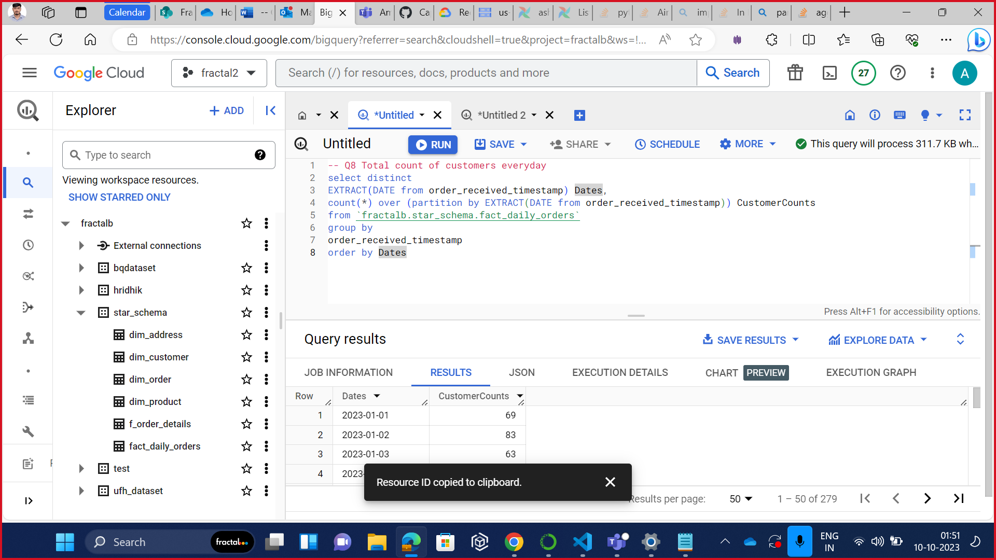

-- Q9 Average time to delivery order. Min and Max time. To be able to slice and dice on hour, weekday, weekend, daily, monthly, geography,

select distinct

EXTRACT(DATE from f.order_delivery_timestamp) DATES,

EXTRACT(WEEK from f.order_delivery_timestamp) WEEKS,

EXTRACT(DAYOFWEEK from f.order_delivery_timestamp) WEEKDAYS,

EXTRACT(MONTH from f.order_delivery_timestamp) MONTHS,

a.City,

Min(f.order_delivery_time_seconds) MinDeliveryTime,

max(f.order_delivery_time_seconds) MaxDeliveryTime,

avg(f.order_delivery_time_seconds) AvgDeliveryTime,

from `fractalb.star_schema.fact_daily_orders` f

join `fractalb.star_schema.dim_customer` c on f.customerid = c.customerid

join `fractalb.star_schema.dim_address` a on c.address_id = a.address_id

group by

DATES,

WEEKS,

WEEKDAYS,

MONTHS,

City

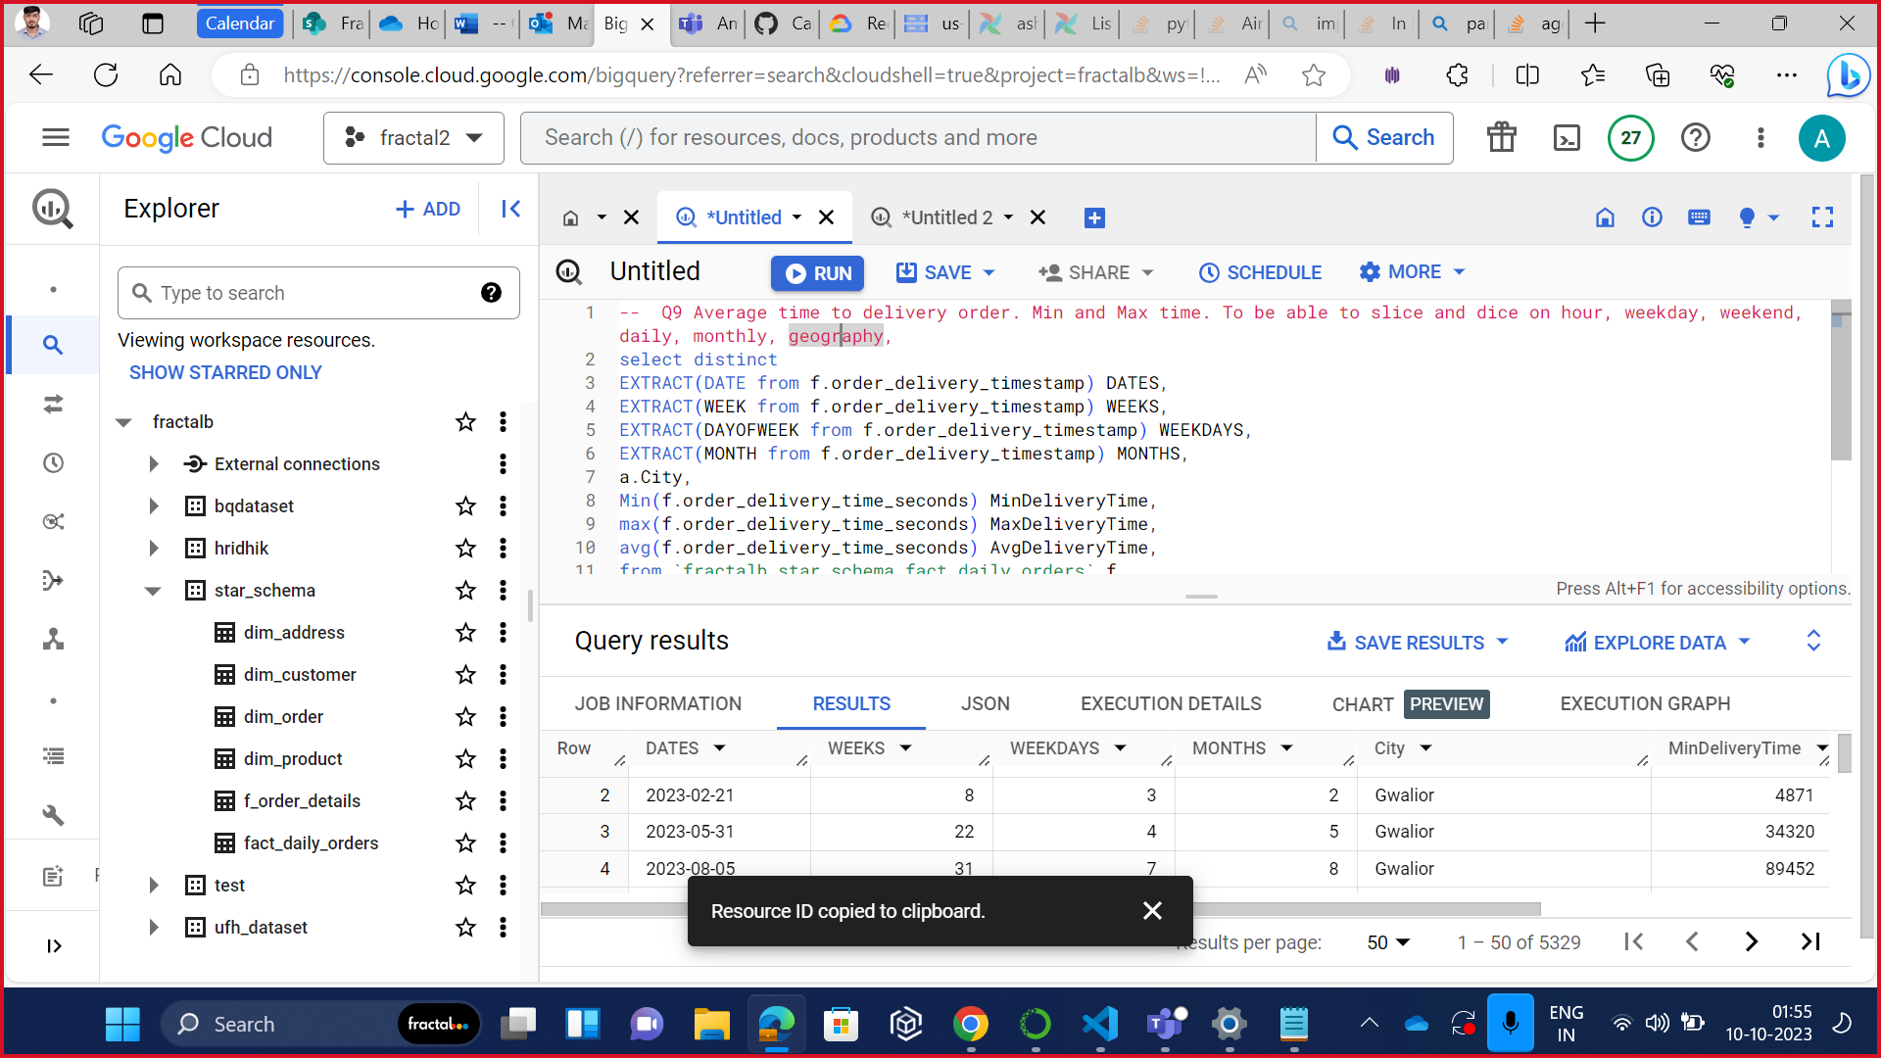

-- Q10 Total orders : to be able to slice and dice on hour, weekday, weekend, daily, monthly, geography

select distinct

EXTRACT(DATE from f.order_delivery_timestamp) DATES,

EXTRACT(WEEK from f.order_delivery_timestamp) WEEKS,

EXTRACT(DAYOFWEEK from f.order_delivery_timestamp) WEEKDAYS,

EXTRACT(MONTH from f.order_delivery_timestamp) MONTHS,

a.City,

count(orderid) NumberOfOrders

from `fractalb.star_schema.fact_daily_orders` f

join `fractalb.star_schema.dim_customer` c on f.customerid = c.customerid

join `fractalb.star_schema.dim_address` a on c.address_id = a.address_id

group by

DATES,

WEEKS,

WEEKDAYS,

MONTHS,

City

