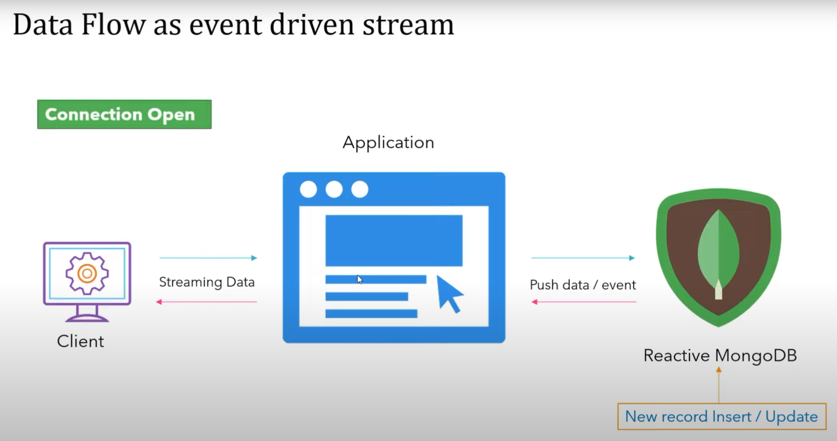

OpenConnection🡪Connection open all the time (if Publisher shares a data subscriber can get it all the time (stream of data is always open to connection)).. Data is transferred as an event for the client  
  
async and non-blocking