

**Abstract:**

I have lots of images and I want to share with the people who are there in the images. What should I do? Just simply upload it on cloud and share with all of them the link to the images. But you are only interested in viewing/getting the images you are present in. Presenting to you “**Pic Procure** share with concealment” the ultimate solution to all this problems. It does all the work of processing and identifying the image content and gives the output by clustering the images into separate folders based on each face identified using best **Machine Learning** and **Azure Cloud** Technologies.

**Introduction:**

PicProcure lessens the load on user to manually separate out the images w.r.t. person in it by using the best Clustering Algorithm in terms of speed and Azure Storage Service it does all the work within few minutes. All you need to do is sign in to our system providing all the credentials (including profile pic), then create an event, wait for a specified amount of time(2 hours) until all your near ones with whom you want to share have registered for the event. Then upload all the images and wait for few minutes (depending on the number and size of images the time could vary) and see the magic!!!.

All the registered users would then be able to see their images on this site for atleast 2 days from where they can download individual images or download a zip file of all the images.

**Tools and Technologies used:**

* Azure Storage Service (for storing images)
* Azure SQL Database (backend storage)
* Django Framework (for web)
* Visual Studio Build Tool for 2019 (for C++ compiler)
* DLib Library (for clustering images)
* Azure VM (for deployment)
* HTML, CSS, Bootstrap (frontend)

**WorkFlow/Implementation:**

User Functionalities:

Normally functionalities like user sign up and login have been developed. And in case when a user forgets his/her password access code is send to their registered email then they can reset their password.

Event Functionalities:

A user needs to create an event for sharing the images then remaining users can register for the event by viewing it from the view-events page. Right know we have a threshold of 2 hours for a event creator to wait for everyone to register. Then he/she can upload the images.

Clustering Functionality:

The event creator uploads the images which are directly stored on to azure blob container on a click using **django-storage[azure]** library. After this process completes the main functionality of clustering is started by first taking the profile pics of registered users of the event and all the uploaded images of the event.

Firstly, we took the pre-trained neural network models namely

* **shape_predictor_5_face_landmarks**
* **dlib_face_recognition_resnet_model_v1**

which takes the image data then find the face usingdlib.get_frontal_face_detector()and identifies the shape using dlib.shape_predictor() and does recognition using dlib.face_recognition_model_v1()

Then we compute **128D** vector that describes the face in the image then clusters the images using **Chinese Whisper Algorithm**.

Why used Chinese Theorem?

Chinese Whispers is a **hard partitioning**, randomized, **time linear flat clustering** method. The random property means that running the process on the same network several times can lead to different results, while because of hard partitioning one node can only belong to one cluster at a given moment. Chinese whispers works best for large collections with large no. of individuals and is the overall winner of all the image clustering algorithms.

By the end of above process system produces separate container on cloud. Now since we took the profile pic of registered users while clustering, that images will be present in one of the container generated. So we compare the image in the container with the registered pics and matched container will be renamed to the specific user. Thus container will be joined with users.

Now that process is complete registered user could go on our site and view all their images and can download the zip file of that event or can download individual image as per their choice. In this way privacy is maintained and easy and efficient sharing is possible.

**Screenshots for the demo:**

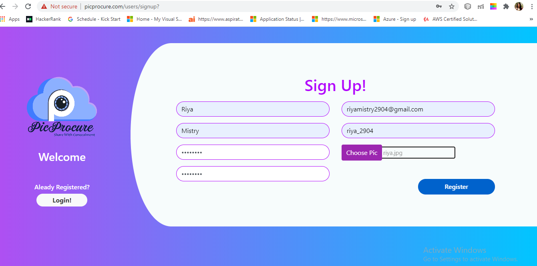

signUp Page

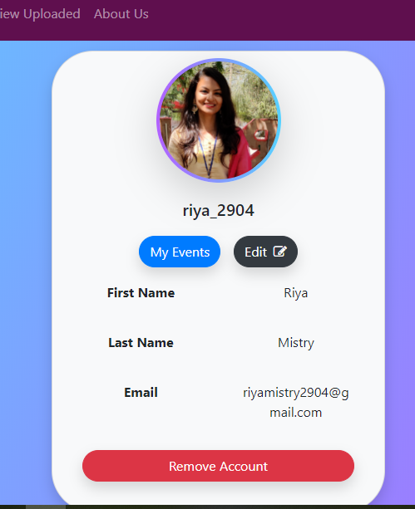

myProfile

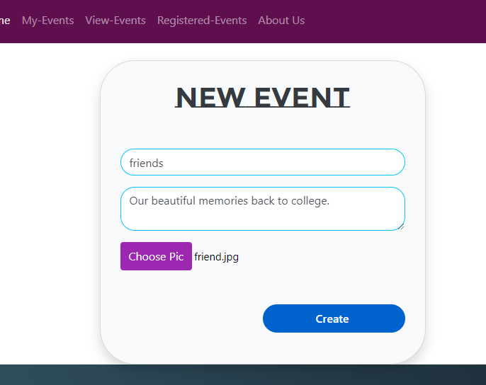

Creating New Event

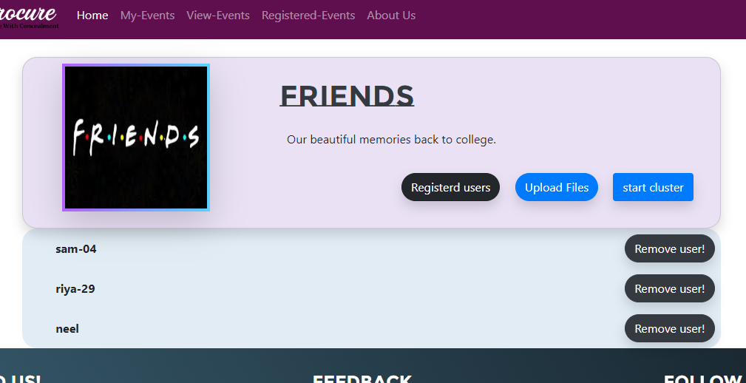

Viewing event and users those are registered into it

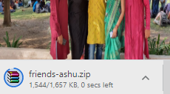

Downloading your pics in a folder!