**DAILY ONLINE ACTIVITIES SUMMARY**

|  |  |  |  |  |  |  |  |  |
| --- | --- | --- | --- | --- | --- | --- | --- | --- |
| **Date:** | **16/06/2020** | | | | | **Name:** | **Soundarya R** | |
| **Sem & Sec** | **6th & B** | | | | | **USN:** | **4al17cs096** | |
| **Online Test Summary** | | | | | | | | |
| **Subject** | |  | | | | | | |
| **Max. Marks** | |  | | **Score** | | |  | |
| **Certification Course Summary** | | | | | | | | |
| **Course** | **Loss function** | | | | | | | |
| **Certificate Provider** | | | **Great Learning Academy** | | **Duration** | | | **4hours** |
| **Coding Challenges** | | | | | | | | |
| **Problem Statement:** 1 Programs | | | | | | | | |
| **Status: Solved** | | | | | | | | |
| **Uploaded the report in Github** | | | | | **yes** | | | |
| **If yes Repository name** | | | | | <https://github.com/ashu102/Daily-_Status> | | | |
| **Uploaded the report in slack** | | | | | **yes** | | | |

Certification

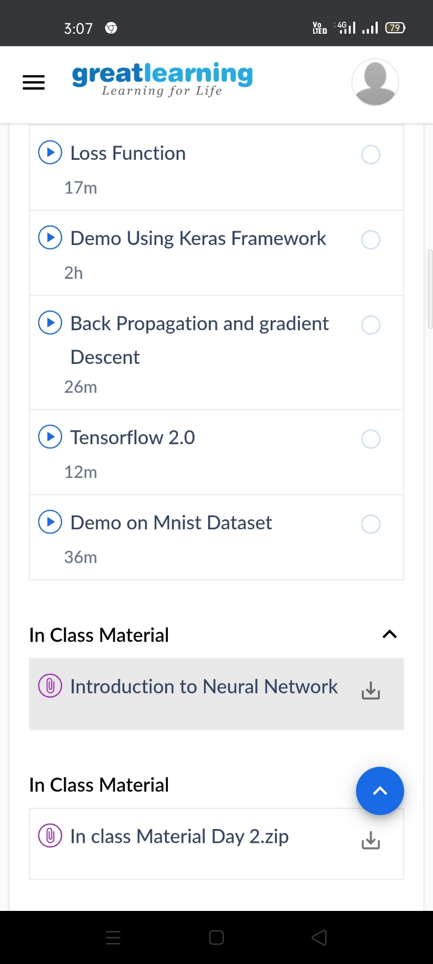

ONLINE CODING

**1. Python Program to Calculate the Number of Words and the Number of Characters Present in a String**

string=input("Enter string:")

char=0

word=1

for i in string:

char=char+1

if(i==' '):

word=word+1

print("Number of words in the string:")

print(word)

print("Number of characters in the string:")

print(char)

