**DAILY ONLINE ACTIVITIES SUMMARY**

|  |  |  |  |  |  |  |  |  |
| --- | --- | --- | --- | --- | --- | --- | --- | --- |
| **Date:** | **17/06/2020** | | | | | **Name:** | **Soundarya R** | |
| **Sem & Sec** | **6th & B** | | | | | **USN:** | **4al17cs096** | |
| **Online Test Summary** | | | | | | | | |
| **Subject** | |  | | | | | | |
| **Max. Marks** | |  | | **Score** | | |  | |
| **Certification Course Summary** | | | | | | | | |
| **Course** | **Measures of depression** | | | | | | | |
| **Certificate Provider** | | | **Great Learning Academy** | | **Duration** | | | **4hours** |
| **Coding Challenges** | | | | | | | | |
| **Problem Statement:** 1 Programs | | | | | | | | |
| **Status: Solved** | | | | | | | | |
| **Uploaded the report in Github** | | | | | **yes** | | | |
| **If yes Repository name** | | | | | <https://github.com/ashu102/Daily_Status> | | | |
| **Uploaded the report in slack** | | | | | **yes** | | | |

**Certification**

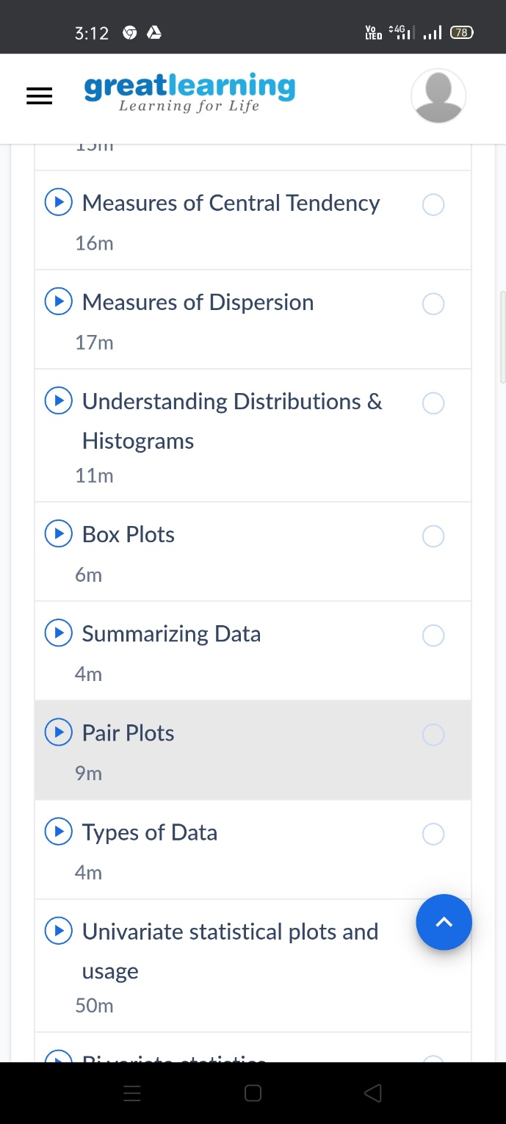

ONLINE CODING

**1. Find the smallest positive integer value that cannot be represented as sum of any subset of a given array sorted in ascending order.**

#include <stdio.h>

int findSmallest(int arr[], int n)

{

int res = 1;

for (int i = 0; i < n && arr[i] <= res; i++)

res = res + arr[i];

return res;

}

int main()

{

int arr1[] = {1, 3, 4, 5};

int n1 = sizeof(arr1)/sizeof(arr1[0]);

printf("output1: %d\n", findSmallest(arr1, n1));

int arr2[] = {1, 2, 6, 10, 11, 15};

int n2 = sizeof(arr2)/sizeof(arr2[0]);

printf("output2: %d\n", findSmallest(arr2, n1));

int arr3[] = {1, 1, 1, 1};

int n3 = sizeof(arr3)/sizeof(arr3[0]);

printf("output3: %d\n", findSmallest(arr3, n1));

int arr4[] = {1, 1, 3, 4};

int n4 = sizeof(arr4)/sizeof(arr4[0]);

printf("output4: %d\n", findSmallest(arr4, n1));

return 0;

}

