**DAILY ONLINE ACTIVITIES SUMMARY**

|  |  |  |  |  |  |  |  |  |
| --- | --- | --- | --- | --- | --- | --- | --- | --- |
| **Date:** | **18/06/2020** | | | | | **Name:** | **Soundarya R** | |
| **Sem & Sec** | **6th & B** | | | | | **USN:** | **4al17cs096** | |
| **Online Test Summary** | | | | | | | | |
| **Subject** | |  | | | | | | |
| **Max. Marks** | |  | | **Score** | | |  | |
| **Certification Course Summary** | | | | | | | | |
| **Course** | **Data pre processing Demo** | | | | | | | |
| **Certificate Provider** | | | **Great Learning Academy** | | **Duration** | | | **5 hours** |
| **Coding Challenges** | | | | | | | | |
| **Problem Statement:1programs** | | | | | | | | |
| **Status:solved** | | | | | | | | |
| **Uploaded the report in Github** | | | | | **yes** | | | |
| **If yes Repository name** | | | | | **http://github.com/ashu102/Daily-Activities** | | | |
| **Uploaded the report in slack** | | | | | **yes** | | | |

Certification Course Details:

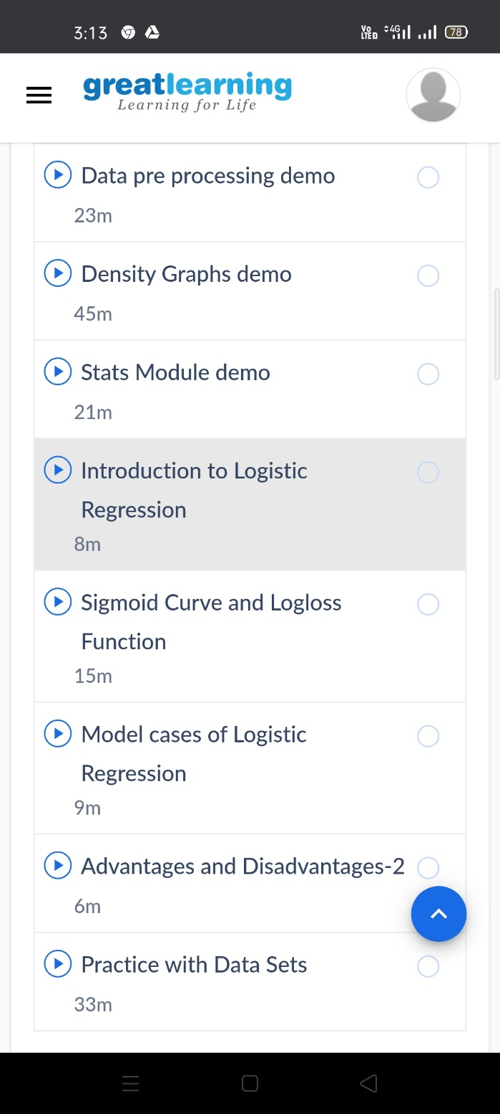

Coding Challenges Details:

**1. Write a C Program to generate first N Magic Numbers**.

#include<stdio.h>

int nthMagicNo(int n)

{

int pow = 1, answer = 0;

while (n)

{

pow = pow*5;

if (n & 1)

answer += pow;

printf("%d ",pow);

n >>= 1;

}

}

int main()

{

printf("Input: n = 1\n");

printf("output: ");

nthMagicNo(1);

printf("\nInput: n = 2\n");

printf("output: ");

nthMagicNo(2);

printf("\nInput: n = 3\n");

printf("output: ");

nthMagicNo(3);

printf("\nInput: n = 8\n");

printf("output: ");

nthMagicNo(8);

return 0;

}

