**DAILY ONLINE ACTIVITIES SUMMARY**

|  |  |  |  |  |  |  |  |  |
| --- | --- | --- | --- | --- | --- | --- | --- | --- |
| **Date:** | **19/06/2020** | | | | | **Name:** | **Soundarya R** | |
| **Sem & Sec** | **6th & B** | | | | | **USN:** | **4al17cs096** | |
| **Online Test Summary** | | | | | | | | |
| **Subject** | |  | | | | | | |
| **Max. Marks** | |  | | **Score** | | |  | |
| **Certification Course Summary** | | | | | | | | |
| **Course** | **Linear Regression** | | | | | | | |
| **Certificate Provider** | | | **Great Learning Academy** | | **Duration** | | | **6hours** |
| **Coding Challenges** | | | | | | | | |
| **Problem Statement:1programs** | | | | | | | | |
| **Status:solved** | | | | | | | | |
| **Uploaded the report in Github** | | | | | **yes** | | | |
| **If yes Repository name** | | | | | **http://github.com/ashu102/Daily-Activities** | | | |
| **Uploaded the report in slack** | | | | | **yes** | | | |

Certification Course Details:

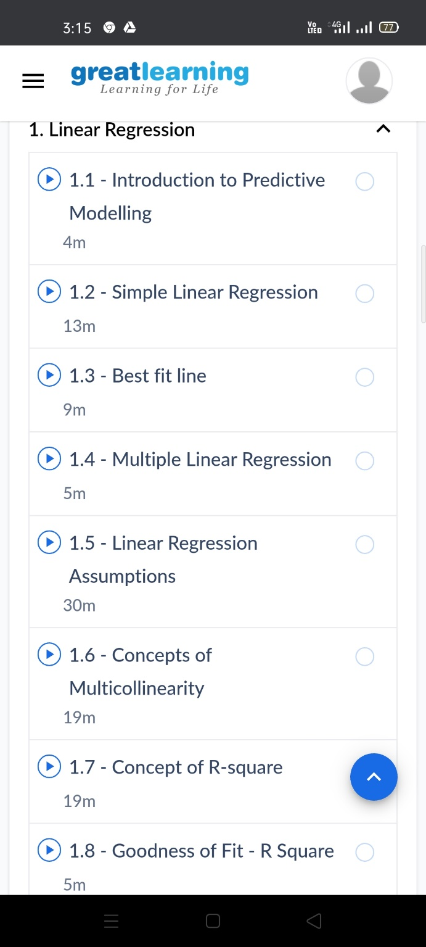

Coding Challenges Details:

**1. Swapping 2 numbers using pointers**

#include <stdio.h>

void swap(int *x,int *y)

{

int t;

t = *x;

*x = *y;

*y = t;

}

int main()

{

int num1,num2;

printf("Enter value of num1: ");

scanf("%d",&num1);

printf("Enter value of num2: ");

scanf("%d",&num2);

printf("Before Swapping: num1 is: %d, num2 is: %d\n",num1,num2);

swap(&num1,&num2);

printf("After Swapping: num1 is: %d, num2 is: %d\n",num1,num2);

return 0;

}

