**DAILY ONLINE ACTIVITIES SUMMARY**

|  |  |  |  |  |  |  |  |  |
| --- | --- | --- | --- | --- | --- | --- | --- | --- |
| **Date:** | | **24/06/2020** | | | | **Name:** | **Soundarya R** | |
| **Sem & Sec** | | **6th & B** | | | | **USN:** | **4al17cs096** | |
| **Online Test Summary** | | | | | | | | |
| **Subject** | | |  | | | | | |
| **Max. Marks** | | |  | **Score** | | |  | |
| **Pre-placement Training Summary** | | | | | | | | |
| **Topic** |  | | | | | | | |
| **Faculty** |  | | | | **Duration** | | |  |
| **Coding Challenges** | | | | | | | | |
| **Problem Statement:** 2 programs | | | | | | | | |
| **Status: Solved** | | | | | | | | |
| **Uploaded the report in Github** | | | | | **yes** | | | |
| **If yes Repository name** | | | | | <https://github.com/ashu102/Daily-Status> | | | |
| **Uploaded the report in slack** | | | | | **yes** | | | |

ONLINE CODING

**1. Python Program to Create a Class and Compute the Area and the Perimeter of the Circle**

import math

class circle():

def __init__(self,radius):

self.radius=radius

def area(self):

return math.pi*(self.radius**2)

def perimeter(self):

return 2*math.pi*self.radius

r=int(input("Enter radius of circle: "))

obj=circle(r)

print("Area of circle:",round(obj.area(),2))

print("Perimeter of circle:",round(obj.perimeter(),2))

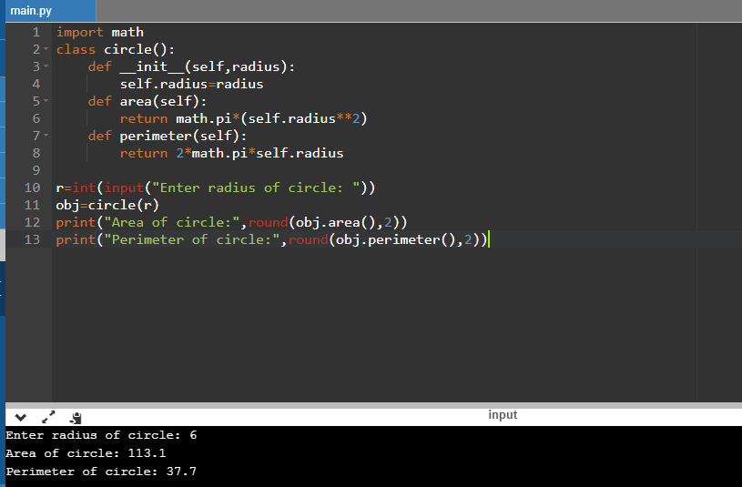

**2. Create a class named 'Shape' with a method to print "This is This is shape". Then create two other classes named 'Rectangle', 'Circle' inheriting the Shape class, both having a method to print "This is rectangular shape" and "This is circular shape" respectively. Create a subclass 'Square' of 'Rectangle' having a method to print "Square is a rectangle". Now call the method of 'Shape' and 'Rectangle' class by the object of 'Square' class.**

class Shape{

public void print_shape(){

System.out.println("This is shape");

}

}

class Rectangle extends Shape{

public void print_rect(){

System.out.println("This is rectangular shape");

}

}

class Circle extends Shape{

public void print_circle(){

System.out.println("This is circular shape");

}

}

class Square extends Rectangle{

public void print_square(){

System.out.println("Square is a rectangle");

}

}

public class Test{

public static void main(String[] args){

Square sq = new Square();

sq.print_shape();

sq.print_rect();

}

}

