Kubernetes
1. Deploy your your previous assignment flask frontend and express backend in kubernetes cluster locally with minikube.
Submission guidelines: share github repo link and screenshots of your running deployments and commands.

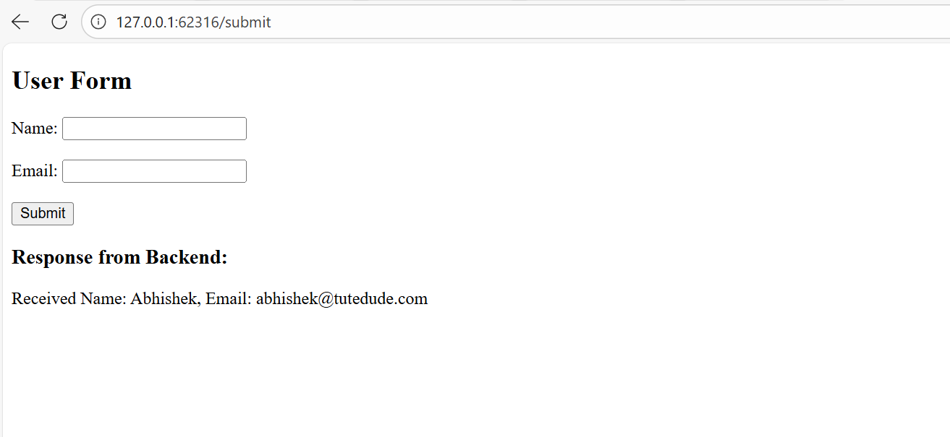
Install minikube
winget install -e --id Kubernetes.minikube
Commands
- Delete all Kubernetes resources
kubectl delete -f k8s/
- Stop Minikube
minikube stop
- Start Minikube
minikube start
- Apply Kubernetes configs
kubectl apply -f k8s/
(we can apply one by one file also)
- Check pods
kubectl get pods
- Check services
kubectl get svc
- Open frontend service
minikube service express-frontend-service
- Quick Restart (Without Deleting Everything)
kubectl rollout restart deployment/flask-backend
kubectl rollout restart deployment/express-frontend

