- Creating and Renaming Files/Directories

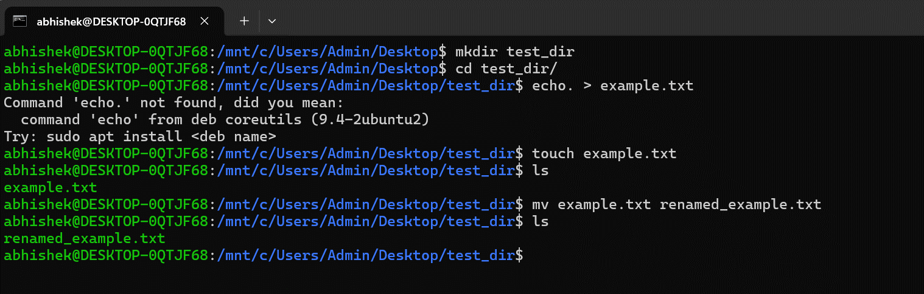

- Viewing File Contents
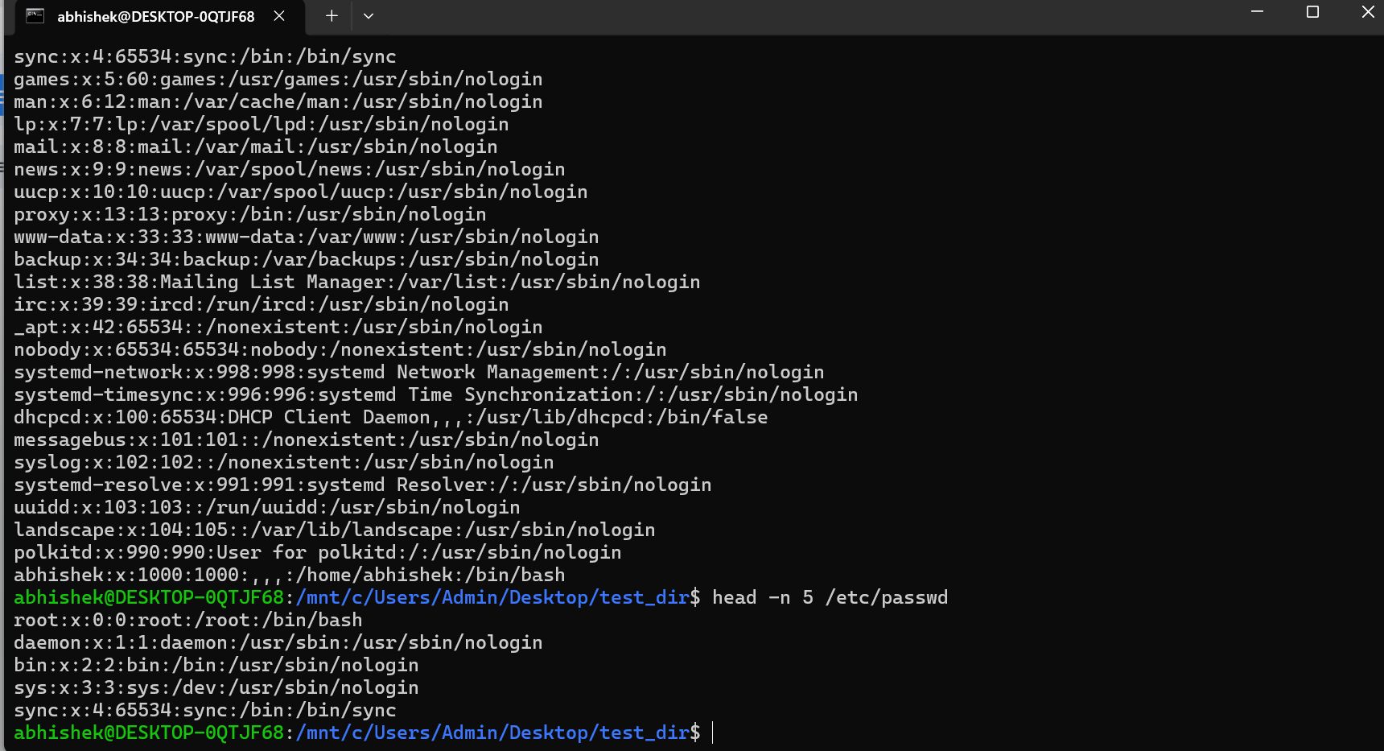

- Searching for Patterns
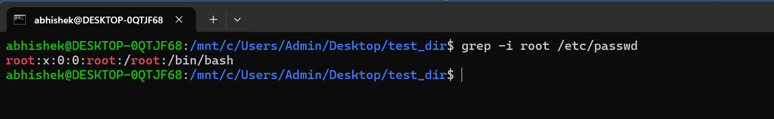
4. Zipping and Unzipping
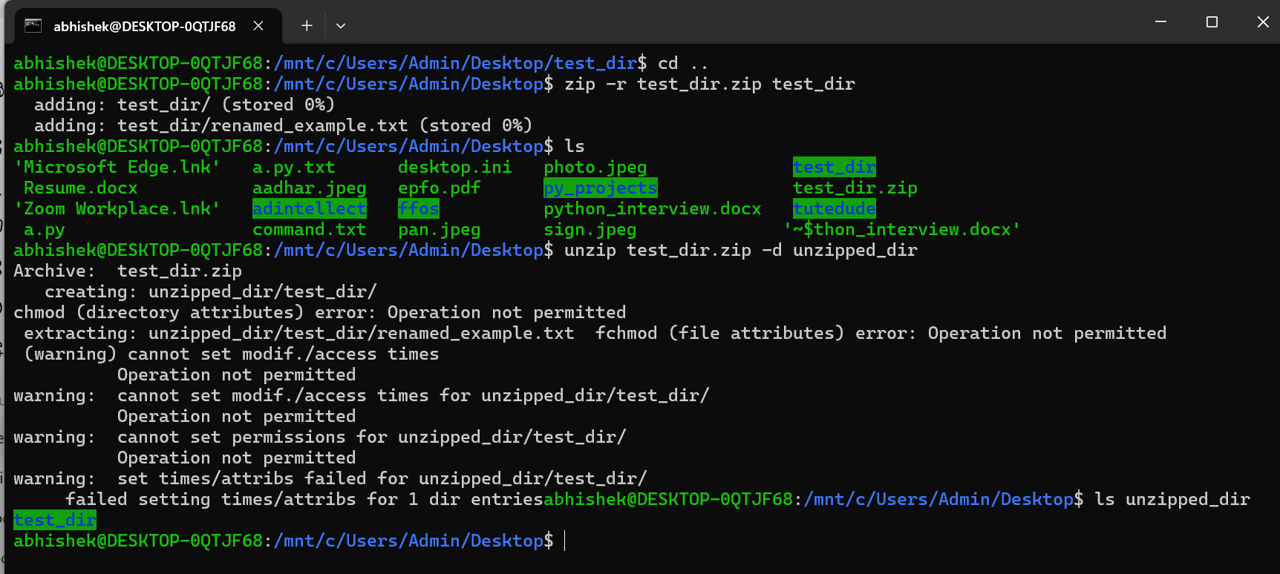

5. Downloading Files
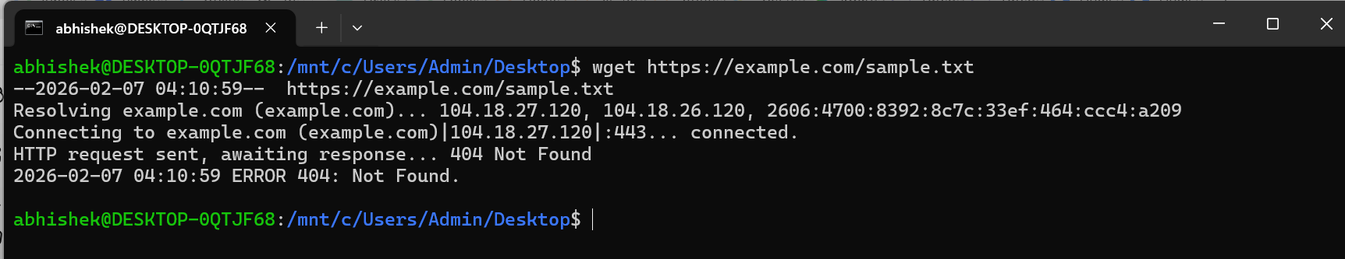
6. Changing Permissions

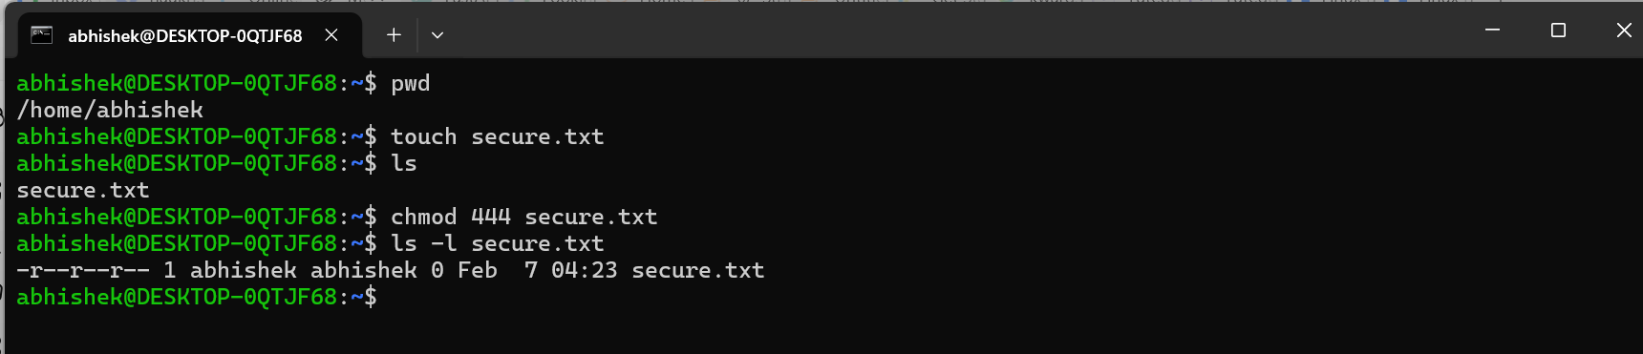
7. Working with Environment Variables
