Npm Packages Examples :
how to install all packages :
$npm i(u can use install) validator
const validator = require(‘validator’)
1)validator
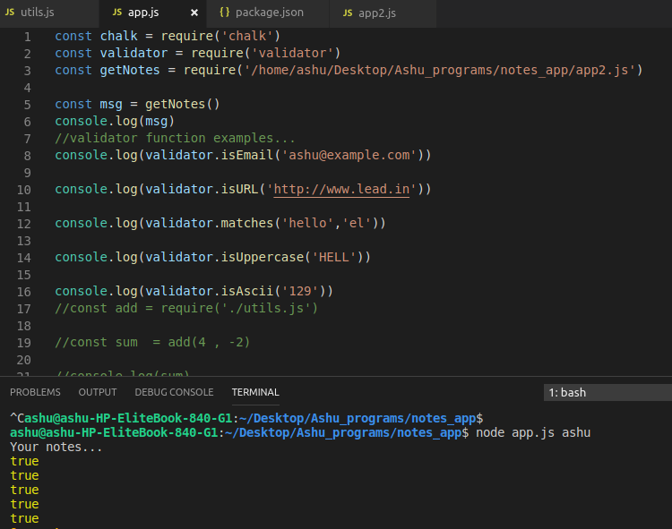
2)Chalk : same installion process has done before by me
first execute package: const chalk = require(‘chalk’)
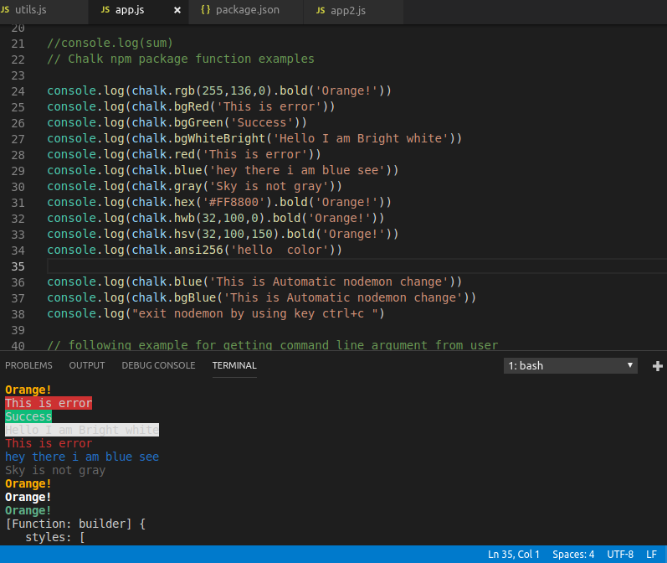
3) nodeman package :
npm i nodeman@1.19.1 -g (globally install)
this package is used for working command promt or terminal automatically such as when we update app.js file after that we save this file then on terminal it will automatically change and get output correct that’s it.
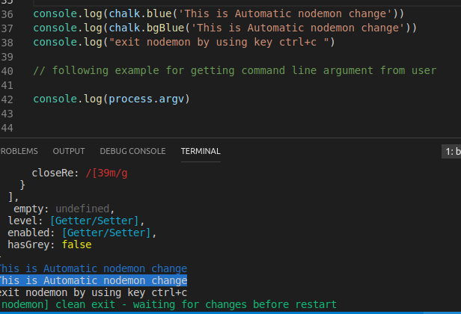
4) Getting Command line argument:
by using Process
process is big object which is having dozens of properties and methods.
In code
console.log(process.argv)

that’s it gives path and last passing argument.
If we want to print only passing argument then only change in argv[2] then remove path and get only passing argument easily.
See:-

5) Getting Command line argument: Yargs
This helps you to build interative command line tools,by
parsing arguments & generating an elegant user interface.

In code: console.log(yargs.argv)

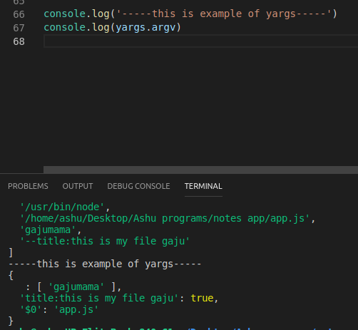

Yargs : By using yargs we are adding a command
yargs can also used for adding a commands through command line argument it’s sytax are following:
yargs.commands({
command: ‘add’,
describe : ‘Add a new node’,
handler:function (){
console.log(“**this is add command”)
},
builder :{
title: {
describe: “Node add title”,
demandOption: true,
type: ‘string’
}

},
body:{
describe: “Node add title”,
demandOption: true,
type: ‘string’
}
})

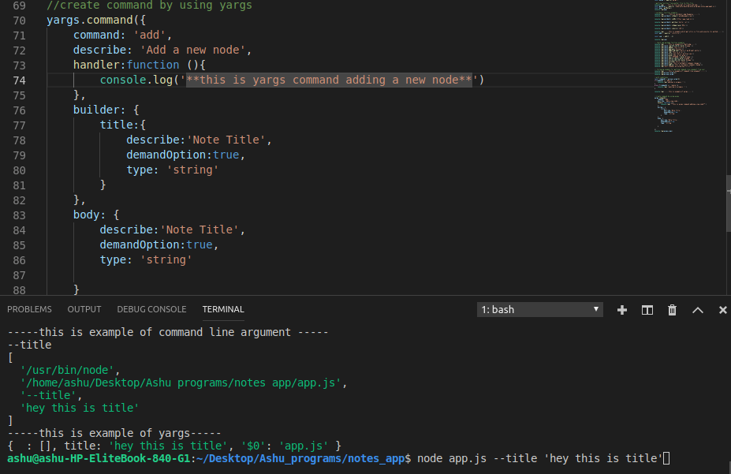
With Output:
Only for using add command
$node.js add
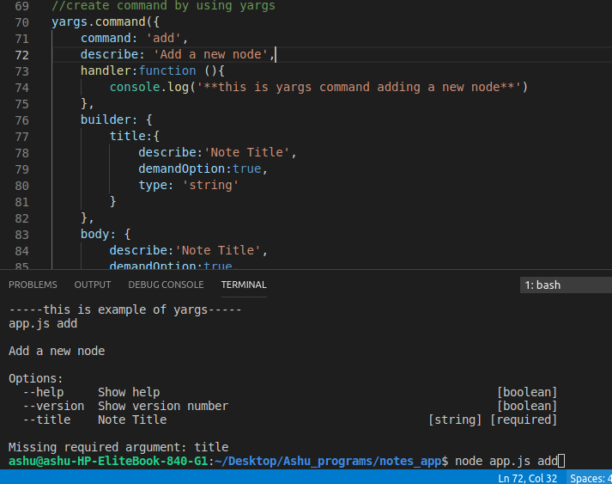
builder: builder is an object,It is used for to adding title,describe option and handler function .
Describe: describe option is used for giving detail about title and command
handler:handler is used for adding function to handle any situation in command it means printting existing output.
demandOption:it’s meaning we have to provide it what are command work correctly. If It is also using for if we are passing incorrect argument then it will have given error see in e.g
for Example in example see in red word:
ashu@ashu-HP-EliteBook-840-G1:~/Desktop/Ashu_programs/notes_app$ node app.js add title="shopping list"
(correct syntax is : --title)

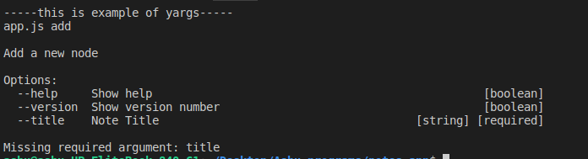
by using only yargs.parse() we can show our output on command promt/terminal.

Storing data with JSON:

First we will take little bit information about JSON:
what is JSON?
JSON-Java Standard Object Notation
JSON file is used for giving all details of our product and application
for e.g
(ex.json)
{
"name": "notes_app",
"version": "1.0.0",
"description": "",
"main": "app.js",
"scripts": {
"test": "echo \"Error: no test specified\" && exit 1"
},
"author": "",
"license": "ISC",
"dependencies": {
"chalk": "^2.4.2",
"validator": "^11.0.0",
"yargs": "^13.2.4"
}
}
NOTES:
1) If we want to convert json object file to String then that time we are using JSON.stringify() function.
2) If we want to convert String file to json object then that time we are using JSON.parse() function.
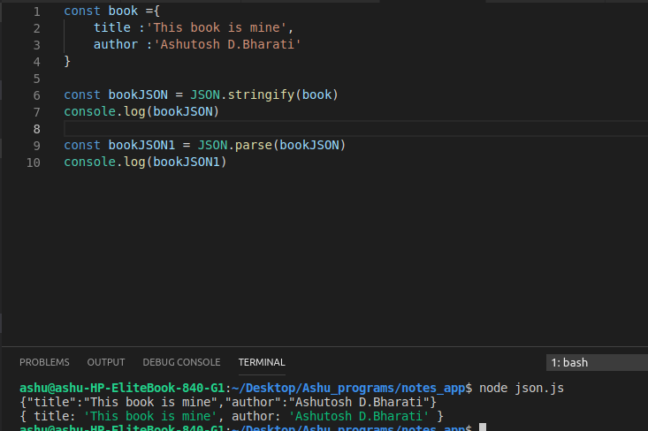
By using fs file for reading file data and writing data in file
by using :
const as = fs.readFilesync(‘filename.json/js/txt’)
live example is given below:
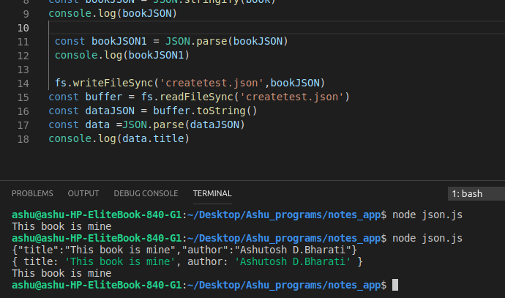
we can change file data of .json file example is following:
first check file data :
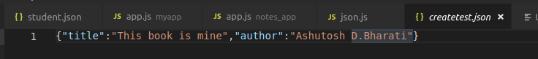
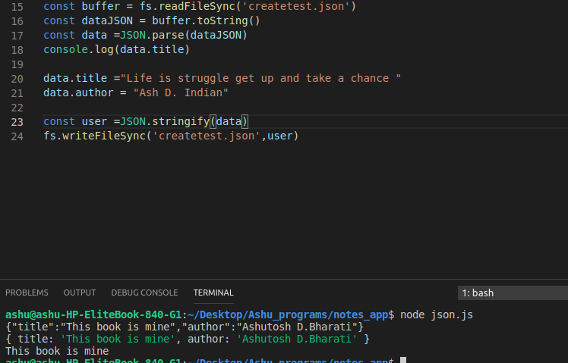
createtest.json file after it’s conversion see below:
changable json file given below:
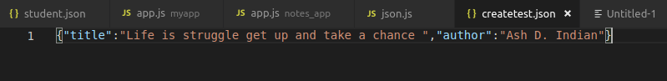
how to add json file? And change on terminal and get automatically change in json file.
e.g
first we have two files app.js and notes.js here we are passing functions from notes.js to app.js.It means app.js is our main file
and we are running main file.
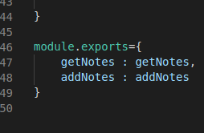

by using this command:-

Second thing we are loading a file note11.json if there is no file then i created file by using function savefile() let us know about it:
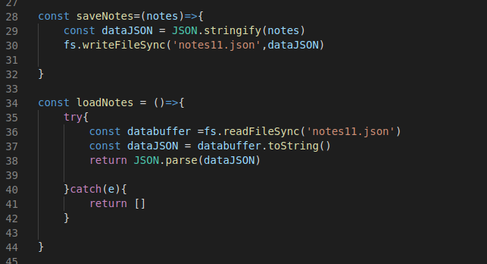
Third thing in programme is adding these two function in addnote cause we are calling or exporting only two funtions so internally execute in addnode function
e.g const notes = loadNotes()
notes.push({ //adding parameters
title:title,
body: body
})
fullcode
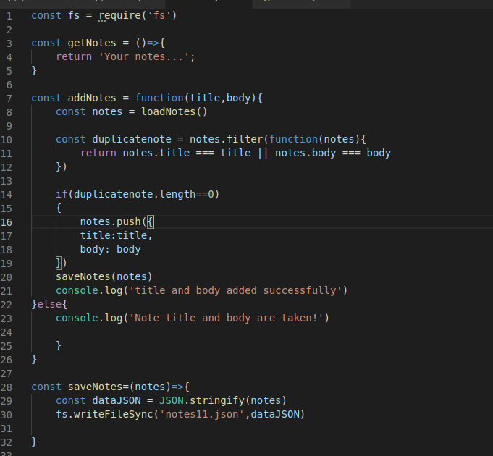

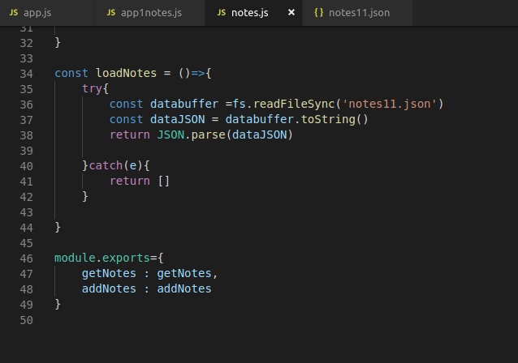
appnotes.js file are following
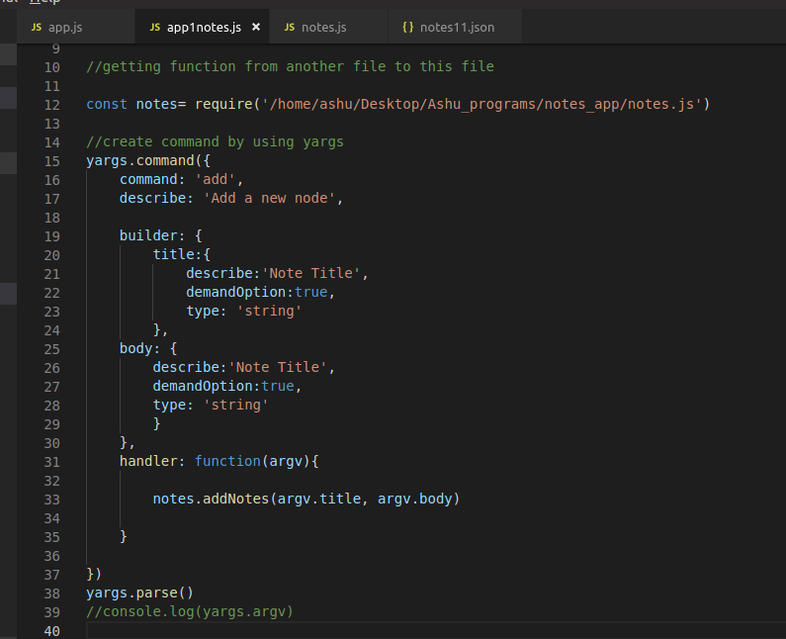
output
