*BRAIN TUMOR*

*CLASSIFICATION*

(CNN architecture Model)

* Submitted by: Ashu Singh

Abstract

Medical image classification has gained tremendous attention in recent years, and Convolutional Neural Network (CNN) is the most widespread neural network model for image classification problem. In this project, we proposed a convolutional neural network (CNN) based approach for the classification of MRI images to detect the presence of brain tumors. Magnetic Reasoning Imaging (MRIs) is an experimental medical imaging technique that helps the radiologists find tumor region. Nowadays, the advancement of machine learning and deep learning in specific allow the radiologists to more reliably identify the brain tumors. The Proposed CNN architecture consists of multiple convolutional and pooling layers followed by fully connected layers. The model is trained using a dataset of MRI images, with each image labelled as either depicting the presence of a brain tumor or showing no evidence of tumor. The model, utilizing batch normalization, Conv2D layers, and MaxPooling layers, achieved significant accuracy on the test set. The trained CNN model demonstrates promising results in classifying MRI images for brain tumor detection.

* Keywords- convolutional neural network (CNN), brain tumor, deep learning, Image Classification, Magnetic Resonance Imaging (MRI).

Introduction

Brain tumors are among the most challenging medical conditions, requiring prompt and accurate diagnosis for effective treatment. Magnetic Resonance Imaging (MRI) is a powerful tool for non-invasive imaging of the brain and is widely used for the detection and characterization of brain tumors. Deep learning, particularly Convolutional Neural Networks (CNNs), has shown remarkable success in various image classification tasks, including medical image analysis. The primary objective of this project is to develop a CNN-based classification model that can accurately distinguish between MRI images depicting the presence of a brain tumor and those showing no evidence of a tumor. The model aims to provide healthcare professionals with a reliable tool for assisting in the diagnosis of brain tumors, potentially reducing the time and effort required for manual inspection. The proposed CNN architecture is trained and evaluated using a dataset of MRI images, with the goal of achieving high accuracy and reliability in tumor detection.

Methodology

A. Dataset

The dataset provided for this project consists of MRI images of the brain, some containing tumors and others showing no evidence of tumors. The dataset consists of 129 MRI brain images in the two separate folders containing files saved in jpg format. The dataset is being pre- processed to resize the images given in the dataset for further use.

B. CNN Model

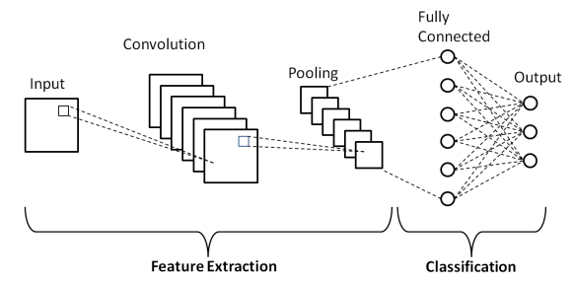

CNNs are the state-of-the-art method for detecting brain tumors in medical images. We have designed a Convolutional Neural Network (CNN) architecture for our project, which includes convolutional layers and pooling layers. The initial layer is typically a Convo layer, which uses filters to abstract features from the images, The pooling layer is the second layer which is generally added to decrease the size of the feature map while preserving essential features, thus reducing the number of parameters to avoid overfitting. To improve training stability and speed, we incorporated batch normalization technique for each convolutional and dense layer. When compiling the model, we used categorical crossentropy loss and the Adam optimizer.

* Categorical Crossentropy Loss: This loss function is commonly used for multi-class classification problems. It measures the difference between the predicted probability distribution and the actual distribution of the labels.
* Adam Optimizer: The Adam optimizer is an adaptive learning rate optimization algorithm that is well-suited for training deep neural networks. The Adam optimizer helps to efficiently update the model's weights during training, leading to faster convergence and improved performance.

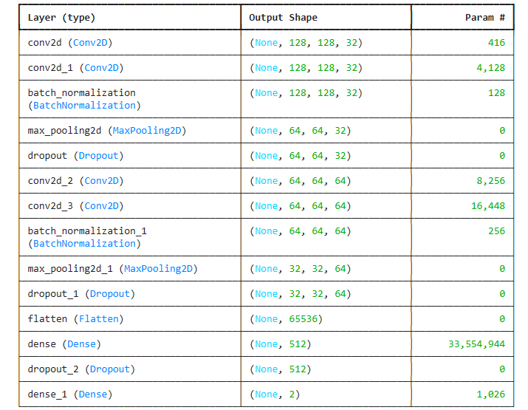

C. Result Analysis

For fitting the training data with the model, a batch size of 32 and 20 epochs are used. Fig illustrates the loss and accuracy of the training set validation set for 20 epochs.

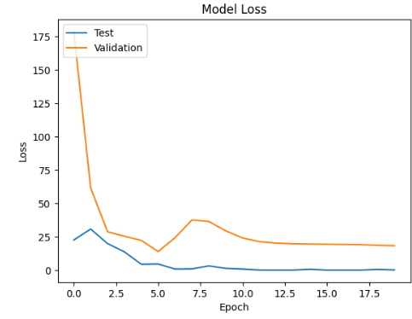

* Snippet of plot for model loss

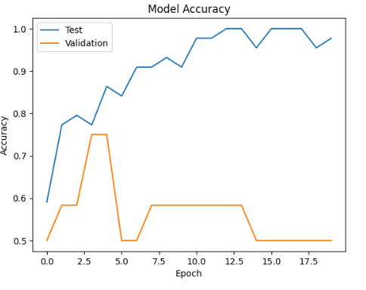

* Snippet of plot for model accuracy

Conclusion

In this project, we developed a Convolutional Neural Network (CNN) model for the classification of MRI images to detect brain tumors. The model utilized batch normalization, Conv2D layers, and MaxPooling layers to effectively learn and classify images with accuracy. After testing CNN, we noticed that it outperformed by a significant amount of accuracy and speed. The number of parameters of the model is too high, and the model is trained on a significantly small amount of data. Hence, there is a possibility of overfitting. To prevent the overfitting, a regularization technique, i.e. dropout regularization, is used on the model. It helps the model to concentrate on the most prominent patterns during the training phase. Therefore, there is a better chance of generalization which keeps the model stable. Overall, our CNN model shows great promise in improving the efficiency and accuracy of brain tumor detection.