**TODO**

**Highlevele task:-**

(1)One to solve Bug related to google Maps

(2) Change UI using Material Ui react components for Mobile browser friendly

**Constarints:-**

I want whole ccode to be in scala , sclajs or may be some native js libraies from node but no seperate component in other framework compiled and bundeled into my project

Code sshould produce the single bundle js and css .

**Tips and supporting websites:-**

(1)<https://github.com/chandu0101/scalajs-react-components>

above link shows how to use react component and call with scala using scalajs library. Above link also show Material UI demo using scala js

demo link <http://chandu0101.github.io/scalajs-react-components/>

(2) Template to Use in material Ui examples Dashboard(developed by google )

from below url

<https://getmdl.io/templates/index.html>

and how to integrate in scalajs project:-

https://github.com/dborisenko/scalajs-react-play-material-ui.g8

**Current State:-**

App is currently showing basic react components in header , footer and side bar and build using webpack. All coponents also exhibit responsive behaviour as the resize on browser resize.

**TASK 1:-**

Bug related to google Maps ,

description:- I have made one sscala react component involving googlemap in ordertracking.scala under AndroidApp/src/main/scala/scalajsreact/template/components/items

It is not show in current view . This ui code is taken from link(1) demo code . It will render the google map path for start and end location and render responsive component

**TASK 2:- Material Ui view**

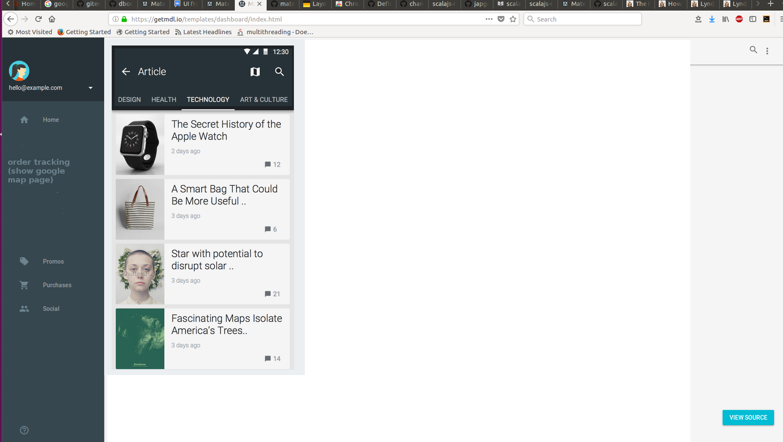

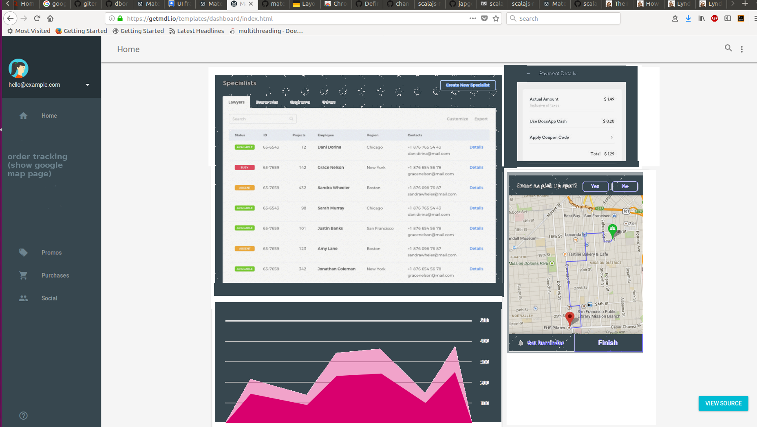

important links:-

1. <https://www.scala-js.org/doc/sjs-for-js/es6-to-scala-part1.html>
2. <https://japgolly.blogspot.com/>
3. <https://scalacenter.github.io/scalajs-bundler/cookbook.html>
4. <https://stackoverflow.com/questions/40818082/how-to-use-node-modules-in-scala-js>
5. <https://www.toptal.com/scala/using-scala-js-with-npm-and-browserify>
6. <https://facebook.github.io/react-native/docs/native-modules-setup>
7. <http://facebook.github.io/react-native/blog/2016/03/24/introducing-hot-reloading.html>
8. https://facebook.github.io/react-native/docs/getting-started.html