MINIPROJECT: THE FREELANCERS’ NEST

**ABSTARCT:**

The FreeLancers’ Nest is essentially a website developed as a solution to the problem of bringing about both the freelancers and the companies which require freelancing jobs, together in order to provide a wide range of recruitment opportunities and open communication within the clients and the freelancers. A freelancer is a person who is self employed and prefers to work from home without long-term commitments.

**PROBLEM STATEMENT:**

Since the IT boom, a large number of occupations became possible to be performed remotely at the comfort of the working personnel. Most of the jobs in companies can be done on a project-basis and without a long term employment. This in turn, reduces paperwork and payroll enlisting, which is the reason this industry is favored by both Small businesses and Multi National Corporations alike. But the Recruiting, Screening and Shortlisting of freelancers becomes a tough job due to lack of Human Resources. Our website aims to globally connect freelancers with companies and help them find jobs in their desired field of proficiency.

**FEATURES:**

The website is equipped with a frontend as well as a backend where the frontend is a Website developed using the “mobile-first” approach which is implemented using HTML5,CSS3, JavaScript and JQuery where as the backend is implemented with Server-side Scripting Language such as PHP and Database Connectivity with MySQL. Some of the main feature include:

1. Homepage with responsive design.
2. Login/Register Page
3. Dashboard

The homepage comes with a responsive design that is adjustable to the device width and hence prevents horizontal overflow of the website content in order to prevent the confusions and the unnecessary hassle faced by the user in repeated horizontal scrolling of the website which saves time as well as effort.

The Website is equipped with a backend and hence, also provides a Login and register facility where the new users and developers can register to the website, and then Log-in to their Ids, create profile, add portfolios and start applying for freelancing jobs based on their skills. The users can maintain a good profile and can keep adding the projects to their portfolios in order to develop more contact and gain more experience over the years.

The users also get a Dashboard where they can easily manage their inbox, and their communication with clients, the projects they have placed bids for, the work they have done and experience they have gained as well as new listings and job posts put on by the companies that might be favorable to them.

The companies can also search, shortlist and recruit developers according to their needs by using a company ID and posting jobs, to receive applications and bids which can be easily managed and negotiated in order to get a particular project completed.

**WORKING:**

User lands onto the Home page first:

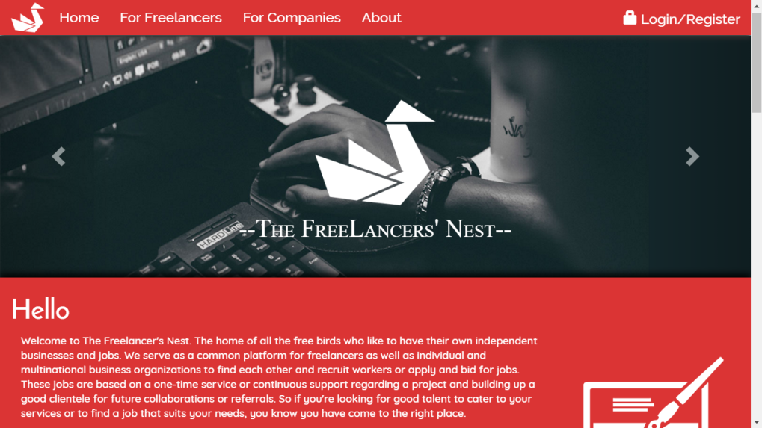 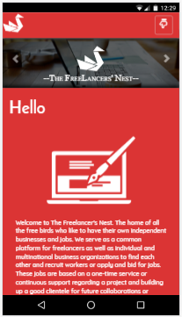

The website also provides Geo-location using Google MapsTM API.

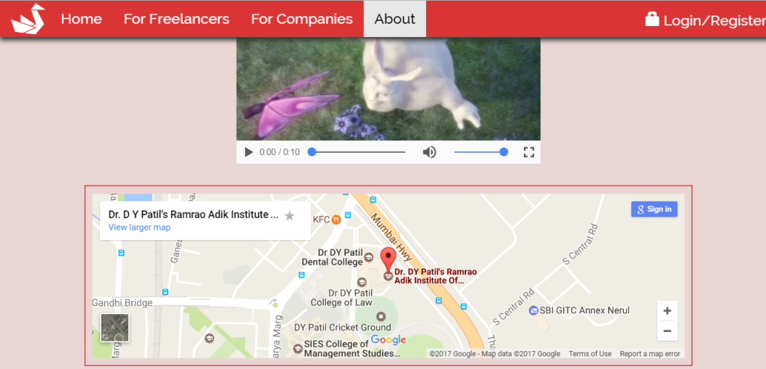 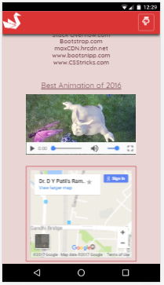

From here, They Can Login or Register:

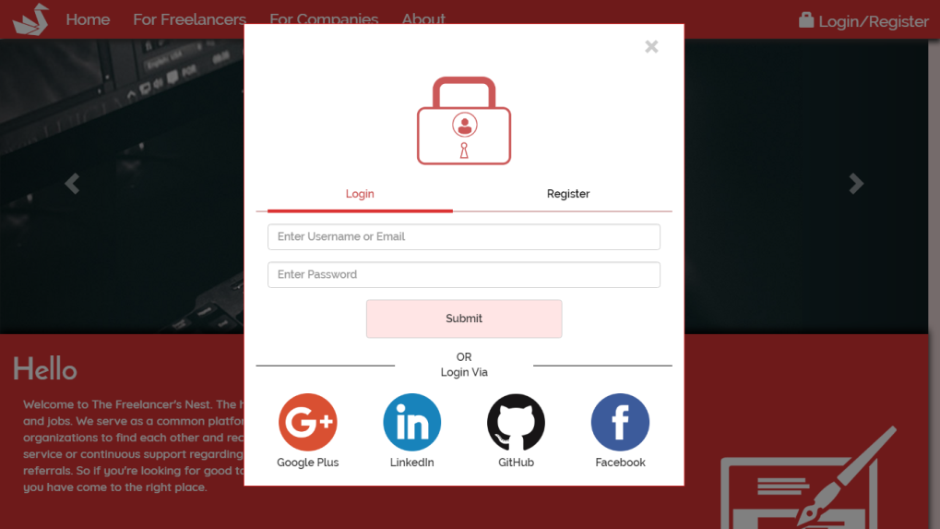 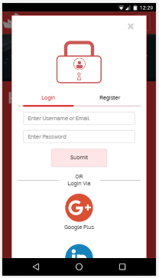

Finally, They can Start Building Their Profiles, and search and bid for jobs and projects.

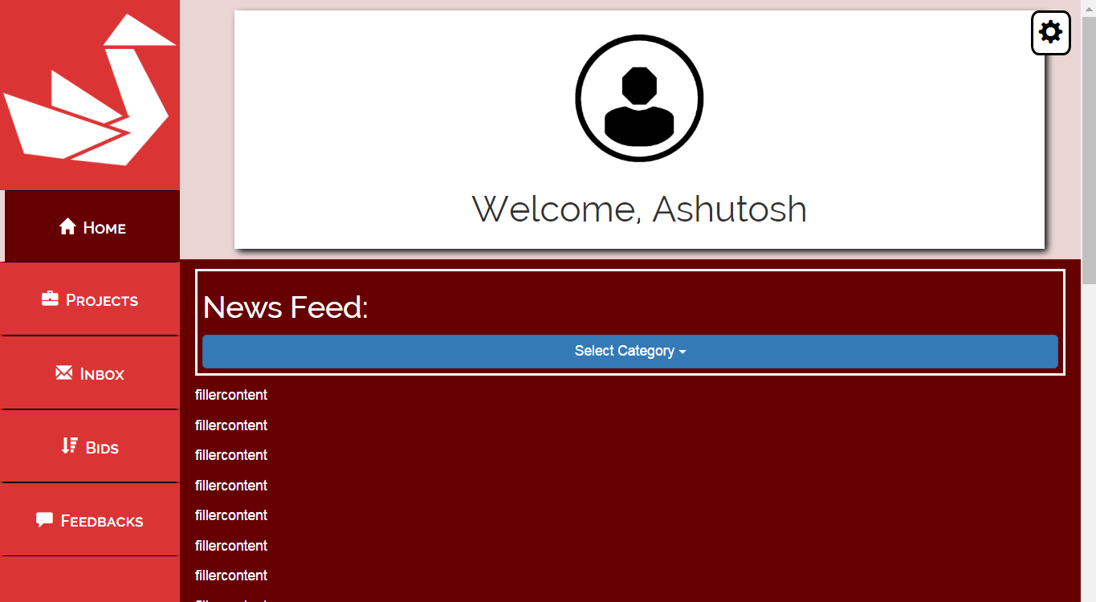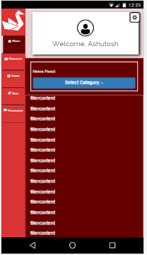

**REFERENCES:**

1. W3-schools.com
2. www.bootsnipp.com
3. Stack-overflow.com
4. Maxcdn.hrcdn.com
5. Csstricks.com