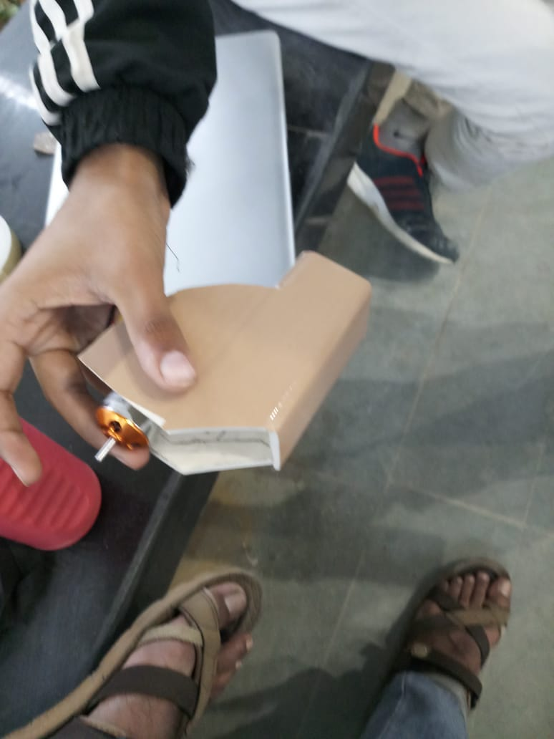
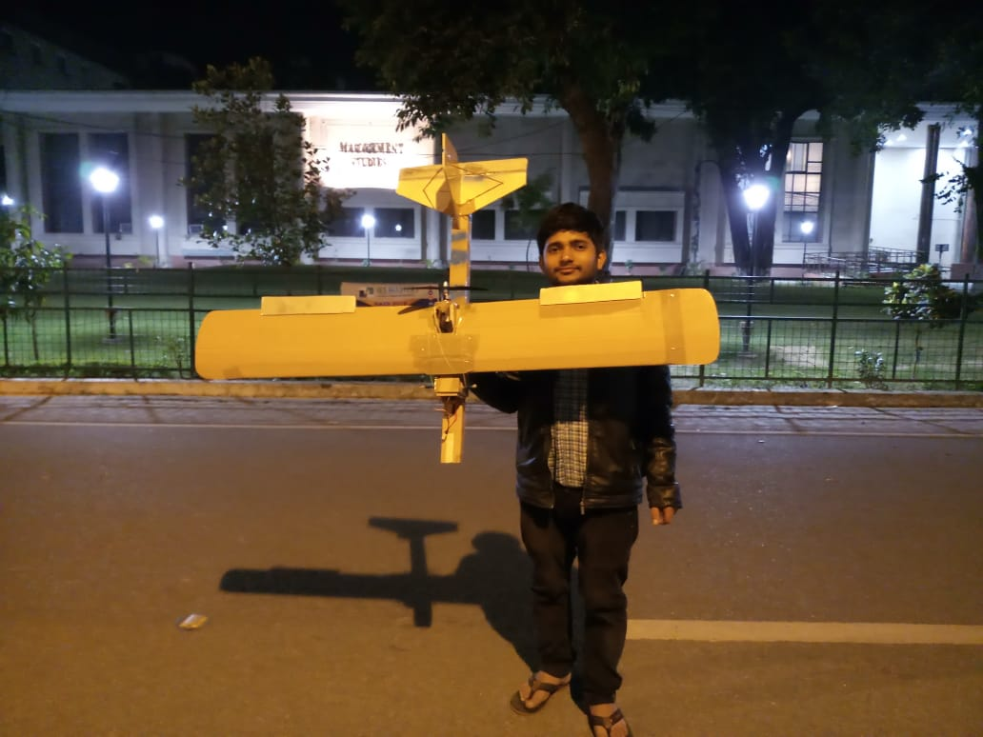
We use depron sheet for making our RC PLANE .
Depron® is an extruded polystyrene foam product, manufactured into sheets of a standard size. It is extremely lightweight and moisture resistant.
Developed as a high performance Wall and Floor Insulation, now Depron has a wide variety of uses such as food packaging, but more recently in Modeling due to it’s light weight and rigity

remote controller- fs-ct6b

A2212 10T/13T BLDC Motor
  - Model: A2212 10T/13T
  - Motor KV (RPM/V): 1000
  - Maximum Efficiency: 80%
  - Current Capacity: 12A/60S
  - No-Load Current(A): 0.5A @10V
  - Max. Efficiency Current: 4-10A
  - Maximum Watts(W): 150
  - Internal Resistance(mΩ): 90
  - Poles: 14
  - Shaft Diameter (mm): 3.17
  - LiPO Batteries: 2S-3S
  - Length (mm): 27.5
  - Width (mm): 27
  - Weight (gm): 64

SimonK 30A ESC
  - Constant Current: 30A
  - Maximum Current: 40A @10S
  - BEC: 3A
  - LiPO Batteries: 2S-3S

1045 (10×4.5) SF Props
  - Length : 10″.
  - Pitch: 4.5″.
  - Weight: 14 gm.
- Skip to content
- Skip to main navigation
- Skip to 1st column
- Skip to 2nd column

Your Shopping Cart

Show Cart
Your Cart is currently empty.

- Home
- Products
  - PRODUCT LIST
  - SHOPPER'S GUIDE
  - LATEST PRODUCTS
- Research
  - IATV
  - RESOURCES
- Contact Us
  - REQUEST QUOTE
  - HELPDESK
  - FORUM
- ABOUT
  - ABOUT US
  - GALLERY
  - NEWS

You are here: Home Products Remote Control FS-CT6B 6ch 2.4GHz transmitter & receiver

Ultrasonic Range Finder I2CXL -WRC-MB7040Ultrasonic Range Finder I2CXL-Trashsonar-WR MB7137-WRC
View Full-Size Image | FS-CT6B 6ch 2.4GHz transmitter & receiver
View Full-Size Image | Product ID: NR-REM-01  Weight: 605 gms  Price: Rs.4,130.00  Ask a question about this product
View Full-Size Image | Introduction:  This is FS-CT6B 6ch 2.4GHz transmitter & receiver It has 0.8W transmitter with range up to 1km line of sight.  For INDIAN customers as per the legal requirement from WPC (Wireless planning Comission of INDIA) before we ship this remote control we need scanned copy of the buyer's ID card . Without the ID we will not be able to ship the product.  Specifications:  - 6 Channels  - Frequency: 2.4GHz  - Type 2 remote control. (Throttle on the left side)  - Transmitter power: 0.8W  - Requires 8 AA size batteries  - Four model memory  - Computer programmable  - USB programming cable and program CD included  6 Channel 2.4GHz Remote Control and its Receiver  Package contains  One 6 Channel Remote control  One 6 channel receiver  One USB interface cable  One CD containing software  Visit forum for Online Discussion on this product
ROHS Compliant : YES

Customer Reviews:
There are yet no reviews for this product.
Please log in to write a review.

Customers who bought this product also bought this/these product(s)
1 to 1 Red Connector  Rs.6.74 | PI48 Heat Sink  Rs.11.33 | Mica Sheet  Rs.8.09

Contact Us
Please use HELPDESK to contact us.
Tel: +91-022-27782445
09.30 AM to 06.00 PM IST, Monday - Saturday
Address :
Nex Robotics Pvt Ltd.
Unit No. 13,
Building No. 2 (A3), Sector 1,
Millennium Business Park,
Mahape, Navi Mumbai 400 710,
Maharashtra, INDIA

NEX Robotics location on map

Login
Username
Password
Remember Me

- Forgot your password?
- Forgot your username?
- Create an account

RESEARCH
Find out more about latest research work being done at NEX Robotics. Here you will find links/papers demonstrating research done on our latest development platforms.

NEWS
Nex robotics has added support for Microsoft Robotics Developer Studio (MRDS) on FireBird V research platform. FireBird V is one of the most widely deployed research platforms designed by Department of CSE, IIT Bombay and Nex robotics.
Read more...

NEX Robotics has designed Intelligent autonomous transport vehicle for transporting personals autonomously inside the campus and for advance research in mobile robotics.
Read more..

Newsletter Subscribe
Name:
Email:

FOLLOW US

Product Categories
New Products Defense and Autonomous Robots 0x Series Robots Fire Bird XII Fire Bird XI Robots Fire Bird VI Robots Fire Bird V Robots Spark V Robot Multirotor Platforms Legged Robotics Robotic Arms and Grippers Humanoid Robot Micromouse Single Board Heater System Batteries and Chargers Coupons Electronic Components GPS Receiver Arduino Microcontroller Development Boards Microcontroller Programmer Motors and Accessories Motor Drivers PCBs and PCB Prototyping Plastic Enclosures Power Supply Remote Control Sensors Robot Chassis Servo Pods USB Interfacing Wheels and Accessories LCD Wireless Devices Robotis LIDAR
List All Products

We Accept

Currency Selector

Testimonals
Prakhar Goyal
I worked on Firebird II and Firebird III robotic vehicular platforms.
Read more...

- Home
- Products
- Testimonials
- Careers
- Contact Us
- About Us
- Sitemap
Copyright © 2005 - 2019 Nex Robotics.

FS-CT6B 6ch 2.4GHz transmitter & receiver

  - Shaft diameter: 6 mm.
  - Total length : 10 inch / 254 mm.
  - a set of reducers (2.75, 3, 3.17, 4, 4.70, 5, 6, 6.25 mm).
  - Epoxy resin cover.
  - Very strong and lightweight.
  - Color: Black.

remote controller- fs-ct6b
This is FS-CT6B 6ch 2.4GHz transmitter & receiver It has 0.8W transmitter with range up to 1km line of sight.
For INDIAN customers as per the legal requirement from WPC (Wireless planning Comission of INDIA) before we ship this remote control we need scanned copy of the buyer's ID card . Without the ID we will not be able to ship the product.
Specifications:
- 6 Channels
- Frequency: 2.4GHz
- Type 2 remote control. (Throttle on the left side)
- Transmitter power: 0.8W
- Requires 8 AA size batteries
- Four model memory
- Computer programmable
- USB programming cable and program CD included

The Basic Plane Parts
- Fuselage - The main body. Everything connects to this.
- The Vertical Stabilizer - Keeps the plane’s yaw movement stable.
- The Horizontal Stabilizer - Keeps the plane’s pitch movement stable.
- The Wing - Generates lift.

Airfoils
The shape of a wing or propeller blade as seen in cross-section.
- The difference between the top and bottom of the airfoil determines the amount of lift the wing will have. Symmetrical, Semi-Symmetrical and under-cambered are popular airfoils due to their unique characteristics.
  - Symmetrical - Very low drag which means it’s fast and more agile. It’s good for aerobatics. However, it’s not a high lift design.
  - Semi-Symmetrical - Has a high camber, producing a good lift-to-drag ratio.
  - Flat Bottom - Not very common.
  - Under-Cambered - Produces the most lift but it’s not the best choice for performance.

Lift
There are two principle on how a wing generates lift:
1. Bernoulli's Principle
As the velocity of a fluid (air) increases, its pressure decreases. The air on the top of the wing has further to travel in the same amount of time, therefor moving faster and lowering it’s pressure. This allows the high pressure under the wing to push it upwards.

2. Newton’s Law of Motion
Each action has an equal and opposite reaction. Air on the bottom of the wing is deflected down which pushes the wing up. Angle of attack important. This is why a flat plate foamie can fly.

Airflow and Stalls
The common denominator between these Bernoulli and Newton is… Airflow! Too little airflow means you will “stall!” You have to have air moving over your wing or you can’t generate lift.
Stalls are the biggest enemy of any new pilot. They result in loss of control. Most beginner planes recover from stalls more quickly than advanced planes such as jets or warbird.
There are two types of stalls to watch out for.
- Low Speed Stall - This occurs when your aircraft drops below it’s “stall speed.”
- Tip Stall - This occurs when you try to turn too tightly. The wing on the inside of the turn moves through the air slower than the outer wing. The inner wing loses lift and often pulls your aircraft into a death spiral.

How do I keep from stalling?!?!
- "When in doubt level out." A 20-30 degree incline or bank is a lot! Try to keep your plane fairly level. It’s not like a car… you can’t turn sharp or stop.
- More airspeed means more control. But be careful. Your reaction time needs to mature.
- Fly your plane high and learn the stall speed. When you get used to what it feels like to stall, it'll help you land without stalling. HERE is a good episode to learn about landing.

Control Surfaces
There are are 3 major sets of control surfaces. The control surfaces deflect the flow of air, in turn, pushes the control surface the opposite direction. This changes the angle of the plane on that axis.
- Elevator - Controls the pitch angle of the airplane. The elevator is situated horizontally on the tail of the airplane.
- Rudder - Controls the yaw (Left and Right). The rudder is situated vertically on the tail of the airplane.
- Ailerons - Controls the roll, or bank of the airplane. The ailerons are located on trailing edge of the wing.
- Elevons - Controls the pitch AND roll of an airplane. The elevons are a combination of the elevator and ailerons situated on the trailing edge

Transmitter
Transmitters are normally classified as MODE 1 or MODE 2. Most people, including the entire Flite Test crew, use MODE 2 transmitters.

