Objective:

To determine the transfer function of air brake system consisting of electro-pneumatic regulator (EPR).

Dominant frequency and magnitude:

|  |  |  |  |  |
| --- | --- | --- | --- | --- |
| Frequency | Input dominant frequency | Output dominant frequency | Maximum input | Maximum output |
| 0.1 |  |  |  |  |
| 0.2 |  |  |  |  |
| 0.3 |  |  |  |  |
| 0.4 |  |  |  |  |
| 0.5 |  |  |  |  |
| 0.6 |  |  |  |  |
| 0.7 |  |  |  |  |
| 0.8 |  |  |  |  |
| 0.9 |  |  |  |  |
| 1.0 |  |  |  |  |
| 1.1 |  |  |  |  |
| 1.2 |  |  |  |  |

Slope = -1.34

Slope = -19.3095

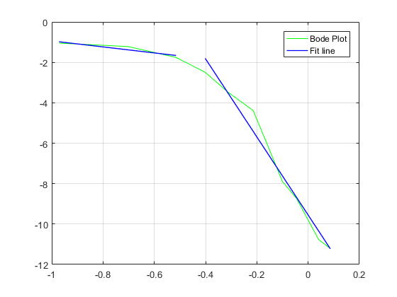

Figure 1: Bode plot and curve fitting a straight line for low frequency range and high frequency

As it can be observed above the slope is close to -20 which means it’s a second order system.

After analysing the step response of the system