**ED5330 Control of Automotive Systems**

**Problem Statement: Hydraulic Hitch Control In Tractors**

INTRODUCTION:

An agricultural tractor is used for various operations on the farm with the help of an implement attached at the rear. When the tractor is driven on-road or on uneven terrain, it experiences excessive vibrations in the pitch plane due to the oscillations of the overhanging implement, which results in front wheel lift-off as an extreme scenario.

SYSTEM DESCRIPTION:

The implement is attached to the tractor with the help of a three point hitch and the lifting and the lowering actions are controlled by an electrohydraulic system shown in Fig. 1. The system consists of two sensors:

1. Position sensor: The position sensor measures the angular displacement of the three pint linkage.

2. Force sensor: The force sensor measures the load from the implement on the top link of the three-point linkage.

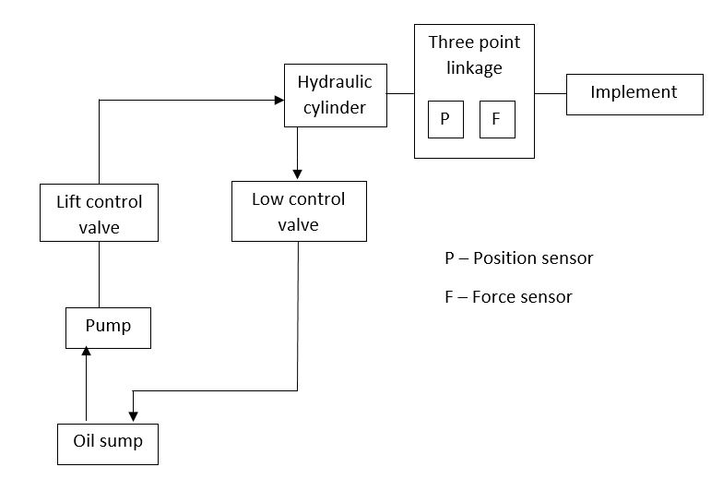

Figure 1: System Block Diagram

The objective of this project is to control the forces arising at the linkage (measured by the force sensor) such that any external disturbance force is attenuated. The controller should provide inputs to the system in accordance with the disturbance force, this causes the implement to be lifted or lowered and prevents the forces form being transmitted to the tractor body. Figure 2 shows the control system layout, where *Δ $F_{o}$*is the desired change in force, $F_{d}$ is the disturbance force, $∆F$ is the actual change in force and $I$ is the current input given to the valves. Before designing the controller, the electro hydraulic system needs to be modelled using experimental data.

$$I$$

$$e$$

Figure 2: Control System Layout

+

-

Compensator

Electro Hydraulic Hitch System

$$∆F$$

$$F_{d}$$

*Δ $F_{o}$*

As shown in Fig. 3, the system is modelled as a transfer function with current input and change in force output.

Change in Force (Output)

Current (Input)

Electro Hydraulic System Model

Figure 3: System Model

The transfer function can be hypothesized as shown in the equation below:

$P\left(s\right)=\frac{Ks}{τs+1}$,

where $K$ is the system gain and $τ$ is the time constant.

This project is divided into two parts, as given below:

PART 1: MODELLING

In this part, the following data sets are provided:

1. Frequency response data
2. Step response data

Obtain the system/plant transfer function model with the help of the data sets using a systematic procedure.

PART 2: CONTROLLER DESIGN

* Design a lag compensator to attenuate the force disturbance in the frequency range 1 Hz to 5 Hz.
* Tune the compensator gain such that the controller output does not exceed 2.3 A.
* Quantify the results (in terms of % attenuation of the disturbance forces).

SOME RELEVANT CONCEPTS:

1. Linear Time Invariant (LTI) system properties
2. Bode plot
3. Lag compensator

REPORT (SOFT COPY TO BE SUBMITTED):

Part 1: The report should consist of results and inferences of each step in the modelling process (with figures and illustrations) and finally the obtained system transfer function.

Part 2: The procedure followed for lag compensator design with relevant calculations, plots and calculations showing the performance of the compensator.

SUBMISSION:

**Format**: maximum 5 pages, Portable Document Format (.PDF)

**File name**: Rollnumber_Proj2.pdf (Ex: EDXXXXXX_Proj2.pdf)

**Date**: 10 October 2018

**Time**: before 4 p.m.

**Note:** You should individually demonstrate your code in the CAD lab from 4:50 PM on October 10, 2018.

**E-mail the soft copy report to** Gurudatta Anche – [gurudattaanche94@gmail.com](mailto:gurudattaanche94@gmail.com)