**Q1. Write a JavaScript function to capitalize the first letter of each word in a string.**

***Test Data* :  
(capitalize_Words('js string exercises'));  
"Js String Exercises"**

**CODE :**

<!DOCTYPE html>

<html lang="en">

<head>

<meta charset="UTF-8">

<meta http-equiv="X-UA-Compatible" content="IE=edge">

<meta name="viewport" content="width=device-width, initial-scale=1.0">

<title>Q1</title>

</head>

<body>

<script>

function capitalize_word(string){

var arr = string.split(" ");

var ans = ""

for(let i of arr){

ans+= i.charAt(0).toUpperCase() + i.slice(1)+" ";

}

return ans;

}

var string = window.prompt("Enter a string")

console.log(capitalize_word(string))

</script>

</body>

</html>

**Output:**

**Q2. Write a JavaScript function that takes a string which has lower- and upper-case letters as a parameter and converts upper case letters to lower case, and lower case letters to upper case.    
*Test Data* :  
(swapcase('AaBbc'));  
"aAbBC"**

**CODE:**

<!DOCTYPE html>

<html lang="en">

<head>

    <script>

        function swapCase(){

            var s = document.getElementById("first").value;

            var a = "";

            var l = s.length;

            for(var i = 0 ; i < l ; i++ ){

                if(s.charAt(i) == s.charAt(i).toLowerCase())

                    a += s.charAt(i).toUpperCase();

                else if(s.charAt(i) == s.charAt(i).toUpperCase())

                    a += s.charAt(i).toLowerCase();

            }

            document.getElementById("ans").value = a;

        }

    </script>

</head>

<body>

    Enter the string <input id="first">

    ans <input id="ans">

    <input type="button" onclick="swapCase()" value="SwapCase" />

</body>

</html>

**Output:**

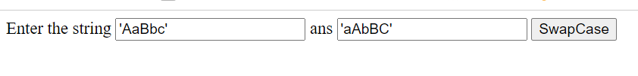

**Q3. Develop and demonstrate a HTML file that includes JavaScript script that uses functions for the following problems:**

**a) Parameter: A string**

**Output: The position in the string of the left-most vowel**

**b) Parameter: A number**

**Output: The number with its digits in the reverse order.**

**CODE:**

<!DOCTYPE html>

<html lang="en">

<head>

    <title>Document</title>

    <script>

        function leftMostVovel(){

            var s = document.getElementById("first").value;

            var a = 'aeiou';

            var n = s.length;

            for(var i = 0 ; i < n ; i++ ){

                var c = s.charAt(i);

                if(c == a.charAt(0) || c == a.charAt(1) || c == a.charAt(2) || c == a.charAt(3) || c == a.charAt(4)){

                    document.getElementById("ans").value = c;

                    break;

                }

            }

        }

        function rev(){

            var a = document.getElementById("sec").value;

            var b = a.split("");

            b.reverse();

            a = b.join("");

            document.getElementById("ans1").value = a;

        }

    </script>

</head>

<body>

    Enter the word here: <input id="first">

    ans <input id="ans">

    <input type="button" onclick="leftMostVovel()" value="Vovel" />

    <br>

    Enter the number: <input id="sec">

    rev <input id="ans1">

    <input type="button" onclick="rev()" value="Reverse" />

</body>

</html>

**Output:**

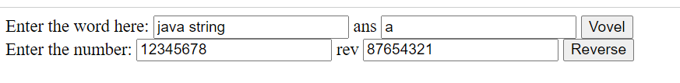

**Q4. Write a JavaScript function that takes a string as a parameter and  
count occurrence of each alphabet in a given string.**

**CODE :**

<!DOCTYPE html>

<html lang="en">

<head>

    <script>

        function occur() {

            var s = document.getElementById("first").value;

            var arr = new Array(26);

            var t = 'a';

            for(var i = 0 ; i < 26 ; i++ )  arr[i] = 0;

            for(var i = 0 ; i < s.length ; i++ ){

                arr[s.charCodeAt(i)-t.charCodeAt(0)]++;

            }

            document.getElementById("ans").value = arr;

        }

    </script>

</head>

<body>

    Enter the word here: <input id="first">

    ans <input id="ans">

    <input type="button" onclick="occur()" value="Occur" />

</body>

</html>

**Output:**

