**Q1. Write a JavaScript function to chop a string into chunks of a given length**

**Test Data :  
console.log(string_chop('welcome'));  
console.log(string_chop('welcome',2));  
console.log(string_chop('welcome',3));  
["welcome"]  
["we", "lc", "om", "e"]  
["wel", "com", "e"]**

**CODE:**

<!DOCTYPE html>

<html lang="en">

<head>

<meta charset="UTF-8">

<meta http-equiv="X-UA-Compatible" content="IE=edge">

<meta name="viewport" content="width=device-width, initial-scale=1.0">

<title>Assign5</title>

<head>

<script>

function chop(){

var s = document.getElementById("first").value;

var n = document.getElementById("sec").value;

var a = new Array();

if(n == 0){

a.push(s);

}else{

var l = 0;

while (l < s.length) {

var ch = "";

for (var i = 0; i < n; i++) {

ch += s.charAt(l);

l++;

}

a.push(ch);

}

}

document.getElementById("ans").value = a;

}

</script>

</head>

<body>

Enter the word here: <input id="first"><br>

Enter the number here: <input id="sec"><br>

ans <input id="ans">

<input type="button" onclick="chop()" value="Chop" />

</body>

</html>

**Output:**

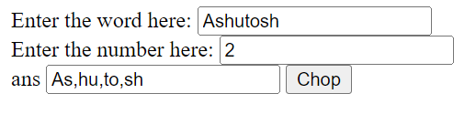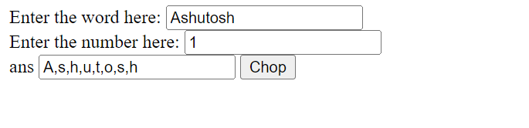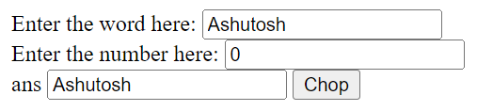

**Q2. Write a JavaScript function to convert a string to title case.  
Test Data :  
console.log(sentenceCase('hoW aRe YOU'));  
"How Are You"**

**CODE :**

<!DOCTYPE html>

<html lang="en">

<head>

<script>

function capitalize(){

var s = document.getElementById("first").value;

var a = "";

for(var i = 0 ; i < s.length ; i++ ){

var ch;

if(i == 0){

ch = s.charAt(i).toUpperCase();

}else if(s.charAt(i-1) == ' '){

ch = s.charAt(i).toUpperCase();

}else

ch = s.charAt(i).toLowerCase();

a += ch;

}

document.getElementById("answer: ").value = a;

}

</script>

</head>

<body>

Enter the word here: <input id="first">

Answer : <input id="answer: ">

<input type="button" onclick="capitalize()" value="Capitalize" />

</body>

</html>

**Output:**

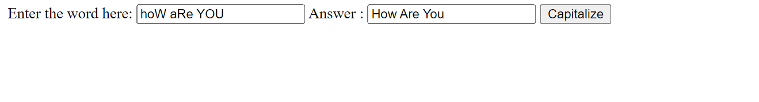

**Q3.**

**CODE :**

<!DOCTYPE html>

<html lang="en">

<head>

<script>

function evil() {

var a = 0;

var n = parseInt(document.getElementById("first").value);

while(n > 0){

var m = parseInt(n%2);

if(m == 1) a += 1;

n = parseInt(n/2);

}

if(a%2 == 0)

document.getElementById("ans").value = "Evil Number";

else

document.getElementById("ans").value = "Not Evil Number";

}

</script>

</head>

<body>

<b>Enter the number (N) here:</b><input id="first">

<b>OUTPUT</b> <input id="ans">

<input type="button" onclick="evil()" value="Check" />

</body>

</html>

**Output:**

