Step 1:

C:\Users\SONY VAIO\eclipse-workspace-New

Copy Duke folder

Copy PrudentialDataLakeEngine

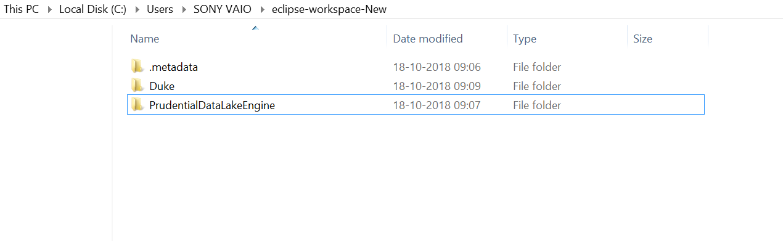

Step: Goto Eclipse – Import Maven Project – Existing Maven Project

Step : C:\Users\SONY VAIO\eclipse-workspace-New\Duke

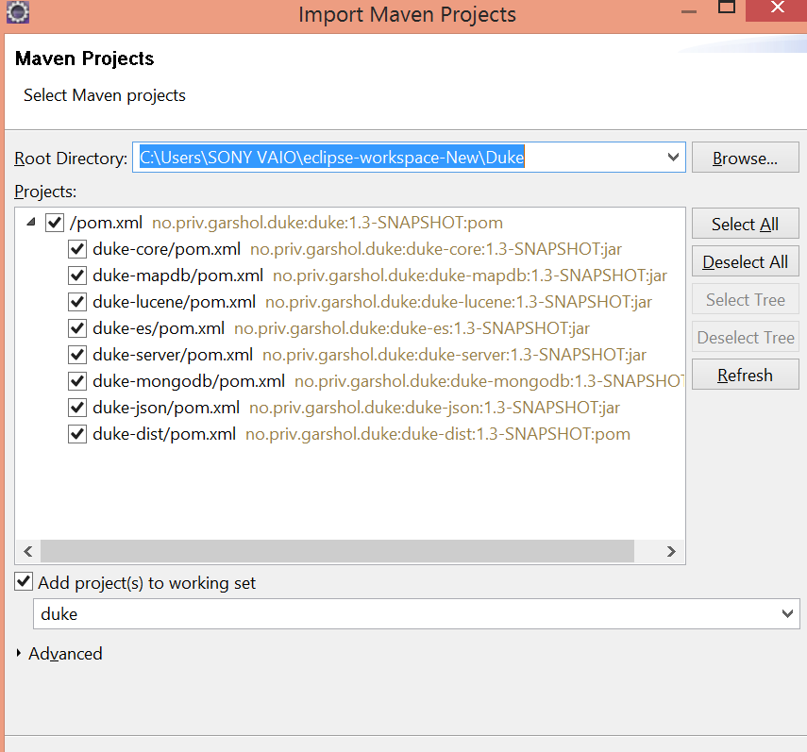

Right click POM – Clean , Build with package -X

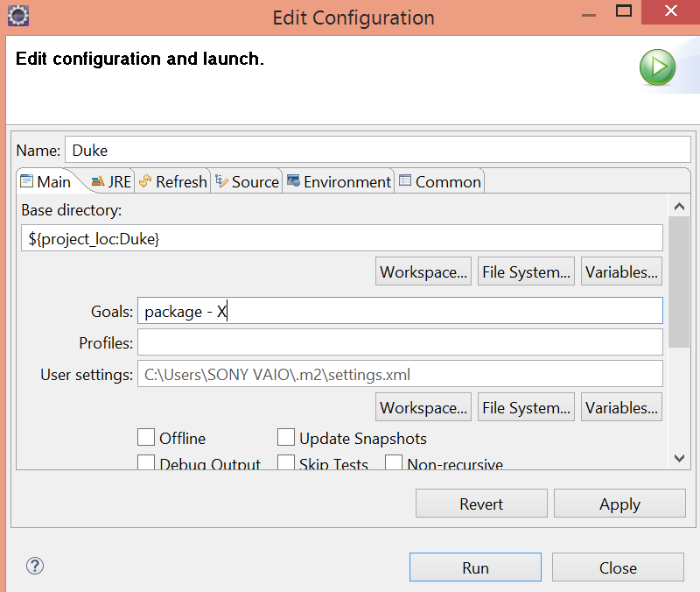

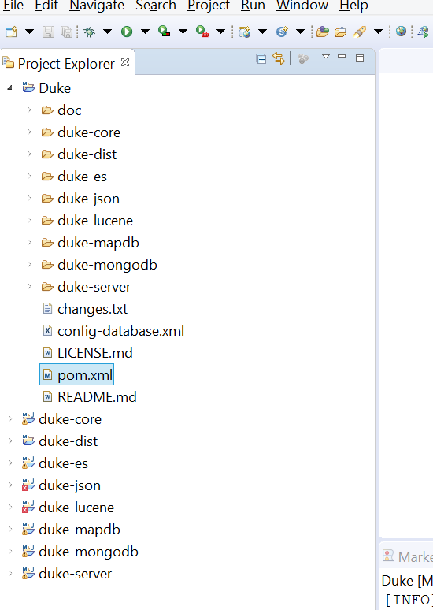

In Case Error is :

Unable to locate the Javac Compiler in:

C:\Program Files\Java\jre1.8.0_121\..\lib\tools.jar