

Centre for Advanced Studies
Dr. A.P.J. Abdul Kalam Technical University, Lucknow

OSS & SSD
(Operating System Security & Secure Software Design)

TOPIC NAME
(Operating System Security Project Using Python)

Submitted By: Submitted To:
Name : Nitesh Kumar Mr. Ashu Sharma
Roll No : 17mcs08 Assistant Professor Dept. Cyber security

TABLE

Sr. no. | Content
1. | Introduction to os security
2. | Project overview
3. | Tools and techniques
4. | Purpose of os security
5. | Conclusion
6. | Future scope & Summary
7. | Main program
8. | Program codes with pictures
9. | References

1. Introduction to os security :
The operating system is the physical environment where your application runs. Any vulnerability in the operating system could compromise the security of the application. By securing the operating system, you make the environment stable, control access to resources, and control external access to the environment.
The physical security of the system is essential. Threats can come through the Web, but they can also come from a physical terminal. Even if the Web access is very secure, if an attacker obtains physical access to a server, breaking into a system is much easier.
Review security policies and recommendations for your operating system. Consider implementing the following security best practices.

2. Project overview:
project is developed using python programming language and shell scripting language.
Authentification (Authentication refers to identifying each user of the system and associating the executing programs with those users. It is the responsibility of the Operating System to create a protection system which ensures that a user who is running a particular program is authentic. Operating Systems generally identifies/authenticates users )Scheme is used as used in linux for login to the system, for user login two entries are required:
i) username
ii) password
username means simply the name of the linux user which he/she used at the time of creating the user account.
Password used for to check the user is authentic or not.
Shadow file stored in etc folder of every linux operating system, is used for storing the password(in the form of hash value) and username.
Firewall setup,bruteforce attack.

2.1 How login works:
when we enter username and password and enter login button and first it check the /etc/shadow file for the specific username which we enter because /etc/shadow file contains all the user details like root user, mysql user, when we found username we entered then password matching process start.In password matching process we
first takeout the hash value of the password from the /etc/shadow file and store it into some variable, now we take 2nd and 3rd field of /etc/shadow file ($6$masjwl$ =2nd field is method used for hashing $6-SHA512 3rd field is salt used to create the hash value)
now use the crpt function to generate the hash value of the entered password if generated hash is same as the stored hash then it is True and login successful otherwise fails.

3. Tools and Techniques:
- Python programming
- Tkinter python GUI
- Shell Scripting
- Linux Authentication Scheme
- Crypt function
- UFW- ‘for firewall’
- nmap
- arp scan
- Dictionary – for brute-force attack

4. Purpose of os security:
Operating system security (OS security) is the process of ensuring OS integrity, confidentiality and availability.
OS security refers to specified steps or measures used to protect the OS from threats, viruses, worms, malware or remote hacker intrusions. OS security encompasses all preventive-control techniques, which safeguard any computer assets capable of being stolen, edited or deleted if OS security is compromised.
This project shows the small understanding of port and services used over the network, and easy to use over single click.brute force attack is used here because to know that never use small digit password and take care of strength of password used.

5. Conclusion:
OS security encompasses many different techniques and methods which ensure safety from threats and attacks. OS security allows different applications and programs to perform required tasks and stop unauthorized interference.
From this project you can easily understand which services are running in your operating system and you can manage these services add port rules to the firewall and delete specific port or service from firewall rules.

6. Summary & future works:
In the future more security features can be added and we will make it more userfriendly easy to use and more knowledge about operating system vulnerabilities and how to prevent from them.

7. Main Program:

import Tkinter
import tkMessageBox
import Image
import ImageTk
import tkFont
import os
import sys
import commands
import crypt
import subprocess
import tkMessageBox
from distutils.util import strtobool
from PIL import ImageTk,Image

top = Tkinter.Tk()
top.title('OS Security')
top.geometry('1350x600')
top.configure(background='Teal',highlightthickness=10,highlightbackground="white")
top.resizable(0,0)

def Username():
tkMessageBox.showinfo("Username","username="+commands.getoutput('whoami'))

def show():
ls=commands.getoutput('echo ' + textbox.get()+'| sudo -S ls')
systemhash=commands.getoutput('echo ' + textbox.get()+ '| sudo -S grep '+textbox1.get("1.0","end-1c")+ ''' /etc/shadow | awk -F'$' '{print $4}' | awk -F: '{print $1}' ''')
tkMessageBox.showinfo("systemhash",systemhash)
output=commands.getoutput('echo ' + textbox.get()+ '''| sudo -S awk -F[:$] '$1==''' '"'+ textbox1.get("1.0","end-1c")+ '"' '''{print "$" $3 "$" $4 "$"}' /etc/shadow''')
#print output
string=crypt.crypt(textbox.get(), output)
hash=string.replace(output,"")
tkMessageBox.showinfo("HASH",hash)
#print hash

if systemhash==hash:
tkMessageBox.showinfo("Match Password","Password Matches")
textbox.pack_forget()
B12.pack_forget()
B8.pack_forget()
l.pack_forget()
l1.pack_forget()
l2.pack_forget()
l3.pack_forget()
textbox1.pack_forget()
frame1 = Tkinter.Frame(top,bg='maroon',highlightthickness=8,highlightbackground="white")
frame1.pack(pady=70)
frame2 = Tkinter.Frame(frame1,bg='maroon')
frame2.pack(side = Tkinter.LEFT,pady=20)
frame3 = Tkinter.Frame(frame1,bg='maroon')
frame3.pack(side = Tkinter.RIGHT,pady=20)

def ipprotocol():
window = Tkinter.Toplevel(top)
window.title('IP-Protocol Scan Result')
p = subprocess.Popen("echo " + textbox.get()+"" "| sudo -S nmap -sO localhost" , stdout=subprocess.PIPE, shell=True)
(output, err) = p.communicate()
text = Tkinter.Text(window)
text.pack()
text.insert(Tkinter.END, output)

def udp():
window = Tkinter.Toplevel(top)
window.title('UDP-Protocol Scan Result')
p = subprocess.Popen("echo " + textbox.get()+"" "|sudo -S nmap -sU localhost", stdout=subprocess.PIPE, shell=True)
(output, err) = p.communicate()
text = Tkinter.Text(window)
text.pack()
text.insert(Tkinter.END, output)

def arpscan():
window = Tkinter.Toplevel(top)
window.title('ARP-Protocol Scan Result')
p = subprocess.Popen("echo " + textbox.get()+"" "|sudo -S arp-scan -l", stdout=subprocess.PIPE, shell=True)
(output, err) = p.communicate()
text = Tkinter.Text(window)
text.pack()
text.insert(Tkinter.END, output)

def rpc():
window = Tkinter.Toplevel(top)
window.title('RPC-Protocol Scan Result')
p = subprocess.Popen("echo " + textbox.get()+"" "|sudo -S nmap -sR localhost", stdout=subprocess.PIPE, shell=True)
(output, err) = p.communicate()
text = Tkinter.Text(window)
text.pack()
text.insert(Tkinter.END, output)

def tcp():
window = Tkinter.Toplevel(top)
window.title('TCP-Protocol Scan Result')
p = subprocess.Popen("echo " + textbox.get()+"" "|sudo -S nmap -sS localhost", stdout=subprocess.PIPE, shell=True)
(output, err) = p.communicate()
text = Tkinter.Text(window)
text.pack()
text.insert(Tkinter.END, output)

def osdetection():
window = Tkinter.Toplevel(top)
window.title('Operating-System detection Result')
p = subprocess.Popen("echo " + textbox.get()+"" "|sudo -S nmap -O localhost", stdout=subprocess.PIPE, shell=True)
(output, err) = p.communicate()
text = Tkinter.Text(window)
text.pack()
text.insert(Tkinter.END, output)
#tkMessageBox.showinfo( "Hello Python", "Hello World")
def firewall():
os.system('python firewall.py')

def Bruteforce():
os.system('python bruteforce.py')

def userstatus():
window = Tkinter.Toplevel(top)
window.title('current status of a user account')
p = subprocess.Popen("echo " + textbox.get()+"" "|sudo chage -l "+textbox1.get("1.0","end-1c"), stdout=subprocess.PIPE, shell=True)
(output, err) = p.communicate()
text = Tkinter.Text(window)
text.pack()
text.insert(Tkinter.END, output)
#tkMessageBox.showinfo("information",commands.getoutput('sudo chage -l '+textbox1.get("1.0","end-1c")))

def logout():
B12.pack(pady=10,padx=20)
l3.pack()
l.pack()
l1.pack()
textbox1.pack(pady=20,padx=20)
textbox.delete(0,'end')
textbox1.delete("1.0","end-1c")
l2.pack()
textbox.pack(pady=20,padx=20)
B8.pack(pady = 20, padx = 20)
#panel.pack_forget()
B.pack_forget()
B1.pack_forget()
B4.pack_forget()
B2.pack_forget()
B3.pack_forget()
B6.pack_forget()
B5.pack_forget()
B9.pack_forget()
B10.pack_forget()
frame1.pack_forget()
frame2.pack_forget()
frame3.pack_forget()
B11.pack_forget()

B9= Tkinter.Button(frame1, text ="logout",height=2,width=9,command = logout,font='Arial 10 bold')
B9.pack(pady = 20, padx = 20)
B4 = Tkinter.Button(frame2, text ="Scan alive hosts on a network",height=2,width=23,font='Arial 10 bold',command = arpscan,padx = 20,fg='red')
B = Tkinter.Button(frame2, text ="Operating System detection",height=2,width=23,font='Arial 10 bold',command = osdetection,padx = 20,fg='red')
B1 = Tkinter.Button(frame2, text ="Scan for UDP-Port",height=2,width=23,font='Arial 10 bold',command = udp,padx = 20,fg='green')
B10= Tkinter.Button(frame2, text ="Start Brute force Attack",height=2,width=23,font='Arial 10 bold',command = Bruteforce,padx = 20,fg='green')
B.pack(pady = 10, padx = 20)
B1.pack(pady = 10, padx = 20)
B4.pack(pady = 10, padx = 20)
B10.pack(pady= 10, padx=20)
B11= Tkinter.Button(frame2, text ="current status of user-account",height=2,width=23,font='Arial 10 bold',command = userstatus,padx = 20,fg='green')
B11.pack(pady= 10, padx=20)

B5 = Tkinter.Button(frame3, text ="Scan for RPC",height=2,width=19,font='Arial 10 bold', command = rpc,padx = 20,fg='red')
B2 = Tkinter.Button(frame3, text ="Scan for tcp-Port",height=2,width=19,font='Arial 10 bold', command = tcp,padx = 20,fg='red')
B3 = Tkinter.Button(frame3, text ="Scan for IP-Protocol",height=2,width=19,font='Arial 10 bold', command = ipprotocol,padx = 20,fg='green')
B2.pack(pady = 10, padx = 20)
B3.pack(pady = 10, padx = 20)
B5.pack(pady = 10, padx = 20)
B6 = Tkinter.Button(frame3, text ="Check status of firewall",height=2,width=19,command = firewall,padx = 20,fg='green',font='Arial 10 bold')
B6.pack(pady = 10, padx = 20)

top.mainloop()
else:
tkMessageBox.showinfo("Password Error", "Password is incorrect")

img1 = ImageTk.PhotoImage(Image.open("logo1.png"))
panel1 = Tkinter.Label(top, image = img1,height=300,width=600,bg='Teal')
panel1.pack(side = Tkinter.LEFT)

B12 = Tkinter.Button(top, text ="check your Username",command = Username,padx = 20,fg='green',font='Arial 10 bold')
B12.pack(pady = 10, padx = 20)
l3=Tkinter.Label(top,text="Password is same as your account Password",fg='white',bg='Teal',height=3,font='Arial 10 bold')
l3.pack()
l=Tkinter.Label(top,text="Enter your Device Password for sudo authentication",fg='white',bg='Teal',height=3,font='Arial 15 bold')
l.pack()
l1=Tkinter.Label(top,text="Username:",fg='white',bg='Teal',font='Arial 15 bold')
l1.pack()
textbox1=Tkinter.Text(top,height=1,width=25,font='Arial 15 bold')
textbox1.pack(pady=20,padx=20)
l2=Tkinter.Label(top,text="Password:",fg='white',bg='Teal',font='Arial 15 bold')
l2.pack()
textbox=Tkinter.Entry(top,font='Arial 15 bold')
textbox.config(show='*')
textbox.pack(pady=20,padx=20)
B8 = Tkinter.Button(top, text ="Login!",command = show,padx = 20,fg='green',font='Arial 15 bold')
B8.pack(pady = 20, padx = 20)
top.mainloop()

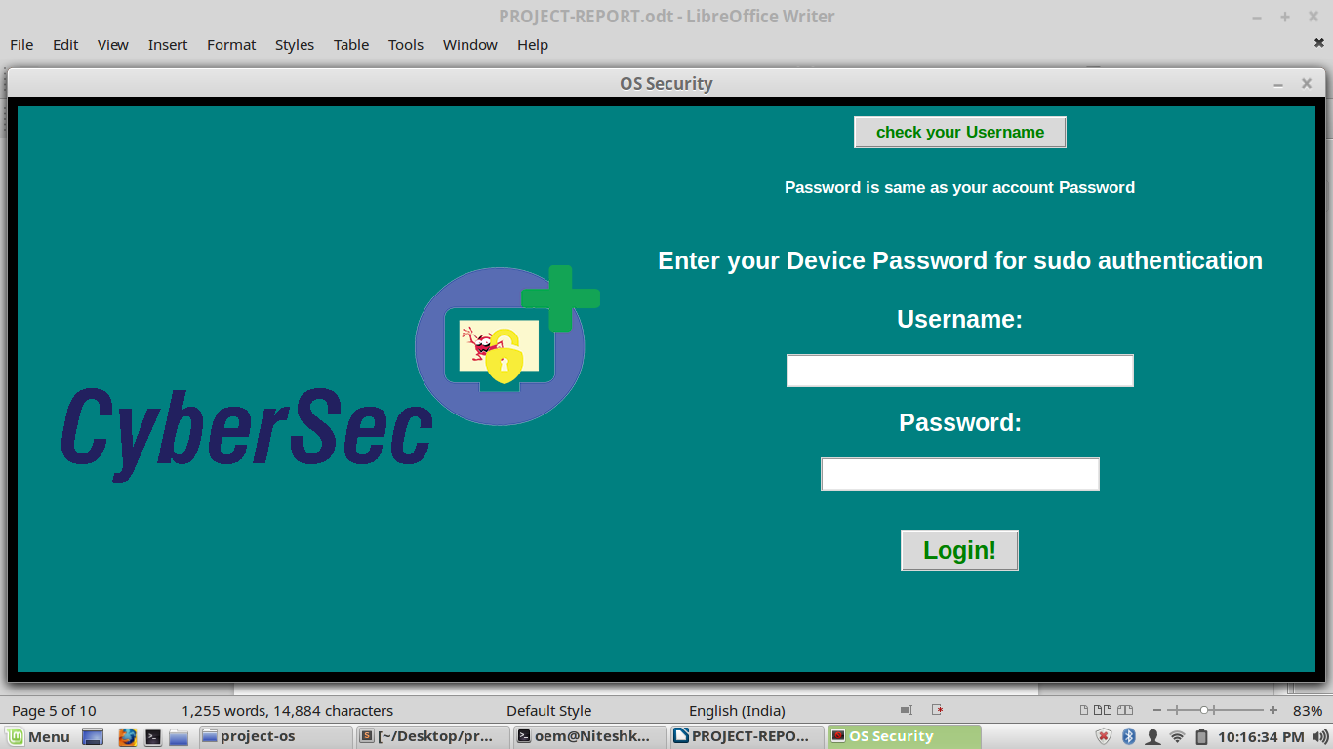

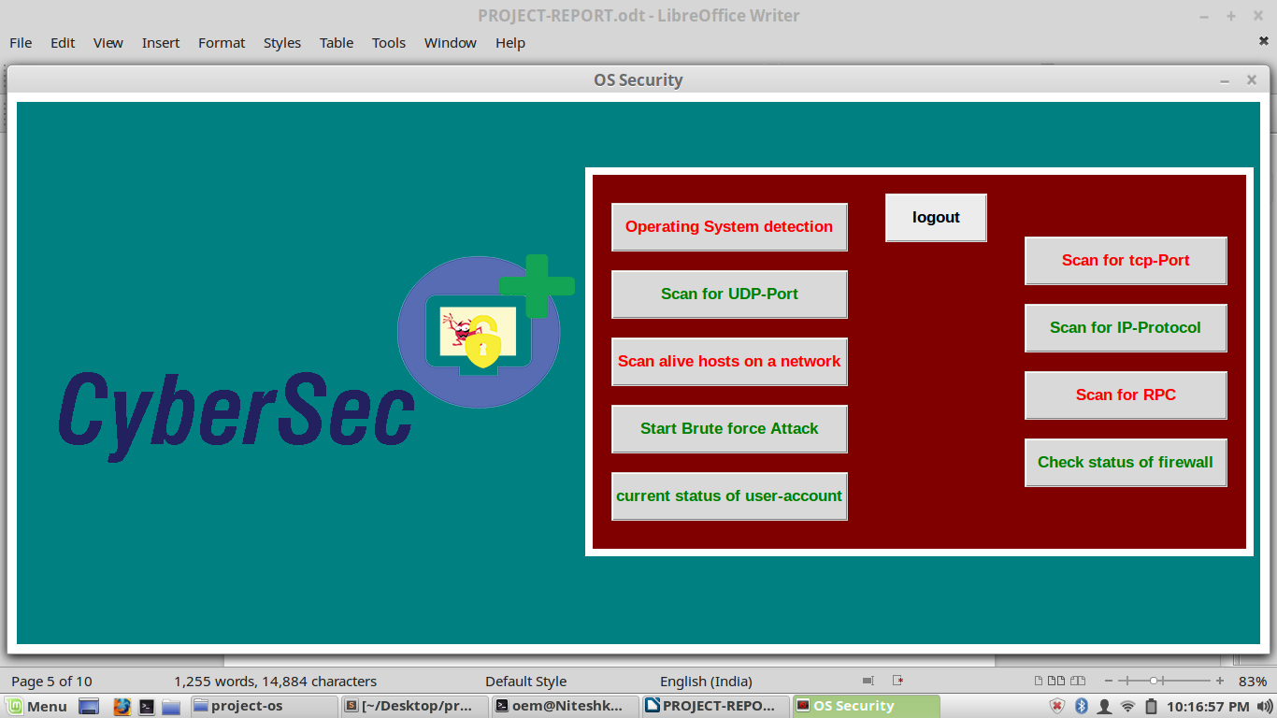

8. program codes:
Firewall
import Tkinter
import tkMessageBox
import Image
import ImageTk
import tkFont
import os
import sys
import commands
import crypt
import subprocess
import tkMessageBox
from distutils.util import strtobool
from PIL import ImageTk,Image

top = Tkinter.Tk()
top.title('firewall setup')
top.geometry('1320x550')
top.configure(background='Teal',highlightthickness=7,highlightbackground="white")
top.resizable(0,0)

frame3 = Tkinter.Frame(top,bg='maroon',highlightthickness=5)
frame3.pack(side = Tkinter.RIGHT,pady=20,padx=20)
frame4 = Tkinter.Frame(frame3,bg='maroon')
frame4.pack(side = Tkinter.LEFT,pady=20,padx=20)
frame5 = Tkinter.Frame(frame3,bg='maroon')
frame5.pack(side = Tkinter.RIGHT,pady=20,padx=20)
frame2 = Tkinter.Frame(top,bg='Teal',highlightthickness=3,highlightbackground="white")
frame2.pack(side = Tkinter.TOP,pady=10,padx=60)

def enable():
os.system('sudo service ufw start')
tkMessageBox.showinfo("information",commands.getoutput('sudo ufw enable'))

def disable():
tkMessageBox.showinfo("information",commands.getoutput('sudo ufw disable'))

def status():
tkMessageBox.showinfo("information",commands.getoutput('sudo ufw status'))

def Reload():
tkMessageBox.showinfo("information",commands.getoutput('sudo ufw reload'))

def Numbered():
tkMessageBox.showinfo("information",commands.getoutput('sudo ufw status numbered'))

def verbose():
tkMessageBox.showinfo("information",commands.getoutput('sudo ufw status verbose'))

def Policies():
tkMessageBox.showinfo("information",commands.getoutput('sudo ufw default deny incoming'))
tkMessageBox.showinfo("information",commands.getoutput('sudo ufw default allow outgoing'))

def Allow():
tkMessageBox.showinfo("information",commands.getoutput('sudo ufw allow '+textbox.get("1.0","end-1c")))

def deny():
tkMessageBox.showinfo("information",commands.getoutput('sudo ufw deny '+textbox1.get("1.0","end-1c")))

def Read():
tkMessageBox.showinfo("information",commands.getoutput('sudo cat PORT.txt'))

def delete():
tkMessageBox.showinfo("information",commands.getoutput('sudo ufw delete allow ' +textbox2.get("1.0","end-1c")))

l2=Tkinter.Label(frame2,text="Notice UFW is typically installed by default in Ubuntu\nBut if anything,you can install-it",bg='Teal',fg='black',font='Arial 10 bold')
l2.pack()
l3=Tkinter.Label(frame2,text="'sudo apt-get install ufw'",fg='black',bg='Teal',font='Arial 11 bold')
l3.pack()
B9 = Tkinter.Button(frame2, text ="Read about port and service of firewall",font='Arial 12 bold',command=Read, height=1,width=30,padx = 20,fg='black')
B9.pack(pady = 10, padx = 20)
B = Tkinter.Button(frame4, text ="Enable firewall",font='Arial 12 bold',command=enable, height=1,width=12,padx = 20,fg='black')
B.pack(pady = 10, padx = 20)
B1 = Tkinter.Button(frame4, text ="Disable firewall",font='Arial 12 bold',command=disable, height=1,width=12,padx = 20,fg='black')
B1.pack(pady = 10, padx = 20)
B2 = Tkinter.Button(frame4, text ="Reload firewall",font='Arial 12 bold',command=Reload, height=1,width=12,padx = 20,fg='black')
B2.pack(pady = 10, padx = 20)
B3 = Tkinter.Button(frame4, text ="Check status",font='Arial 12 bold',command=status, height=1,width=12,padx = 20,fg='black')
B3.pack(pady = 10, padx = 20)
B4 = Tkinter.Button(frame4, text ="Check-status Numbered",font='Arial 12 bold',command=Numbered, height=1,width=18,padx = 20,fg='black')
B4.pack(pady = 10, padx = 20)
B5 = Tkinter.Button(frame4, text ="Check status Verbose",font='Arial 12 bold',command=verbose, height=1,width=16,padx = 20,fg='black')
B5.pack(pady = 10, padx = 20)
B6 = Tkinter.Button(frame4, text ="Set Up Default Policies",font='Arial 12 bold',command=Policies, height=1,width=18,padx = 20,fg='black')
B6.pack(pady = 10, padx = 20)

l4=Tkinter.Label(frame5,text="Allow Connections(add rules):",bg='maroon',fg='white',font='Arial 10 bold')
l4.pack()
l6=Tkinter.Label(frame5,text="enter port or service:",bg='maroon',fg='white',font='Arial 10 bold')
l6.pack()
textbox=Tkinter.Text(frame5,height=1.2,width=16,font='Arial 12 bold')
textbox.pack()
B7 = Tkinter.Button(frame5, text ="Allow",font='Arial 12 bold',command=Allow, height=1,width=18,padx = 20,fg='black')
B7.pack(pady = 10, padx = 20)

l5=Tkinter.Label(frame5,text="Deny Connections:",bg='maroon',fg='white',font='Arial 10 bold')
l5.pack()
l7=Tkinter.Label(frame5,text="enter port or service:",bg='maroon',fg='white',font='Arial 10 bold')
l7.pack()
textbox1=Tkinter.Text(frame5,height=1.2,width=16,font='Arial 12 bold')
textbox1.pack()
B8 = Tkinter.Button(frame5, text ="Deny",font='Arial 12 bold',command=deny, height=1,width=18,padx = 20,fg='black')
B8.pack(pady = 10, padx = 20)

l9=Tkinter.Label(frame5,text="Delete rules:",bg='maroon',fg='white',font='Arial 10 bold')
l9.pack()
l8=Tkinter.Label(frame5,text="enter port or service:",bg='maroon',fg='white',font='Arial 10 bold')
l8.pack()
textbox2=Tkinter.Text(frame5,height=1.2,width=16,font='Arial 12 bold')
textbox2.pack()
B10 = Tkinter.Button(frame5, text ="Deny",font='Arial 12 bold',command=delete, height=1,width=18,padx = 20,fg='black')
B10.pack(pady = 10, padx = 20)
img1 = ImageTk.PhotoImage(Image.open("logo1.png"))
panel1 = Tkinter.Label(top, image = img1,bg='Teal')
panel1.pack(side = Tkinter.LEFT)
top.mainloop()

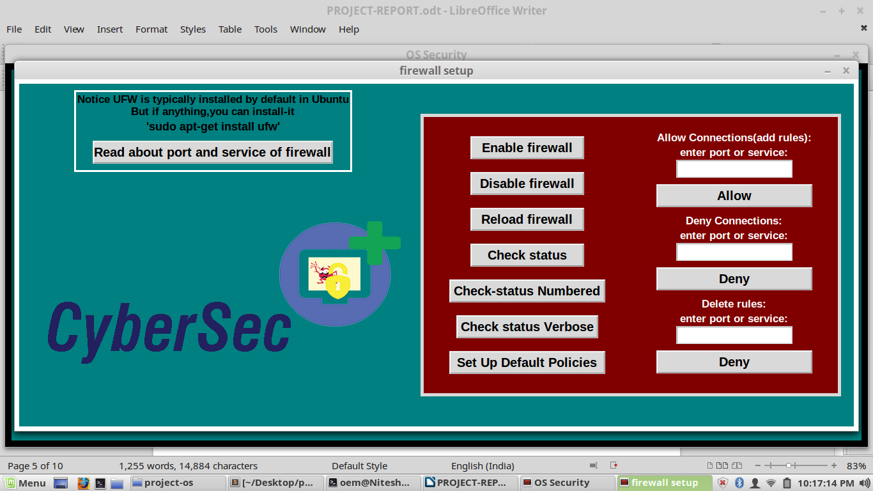
Brute-force
import Tkinter
import tkMessageBox
import Image
import ImageTk
import tkFont
import os
import sys
import commands
import crypt
import subprocess
import tkMessageBox
from distutils.util import strtobool
from PIL import ImageTk,Image

fp = open('bruteforce.txt') # open file on read mode
opcode = fp.read().split("\t") # create a list containing all lines
fp.close()

top = Tkinter.Tk()
top.title('Brute-:force-:Attack')
top.geometry('1000x500')
top.configure(background='Teal',highlightthickness=7,highlightbackground="silver")
top.resizable(0,0)

frame3 = Tkinter.Frame(top,highlightthickness=5,highlightbackground="silver",bg='maroon')
frame3.pack(side = Tkinter.RIGHT,pady=20,padx=20)

def Brute():
systemhash=commands.getoutput('sudo grep '+textbox.get("1.0","end-1c")+ ''' /etc/shadow | awk -F'$' '{print $4}' | awk -F: '{print $1}' ''')
#tkMessageBox.showinfo("systemhash",systemhash)
for word in opcode:
output=commands.getoutput('''sudo awk -F[:$] '$1==''' '"'+ textbox.get("1.0","end-1c")+ '"' '''{print "$" $3 "$" $4 "$"}' /etc/shadow''')
string=crypt.crypt(word, output)
hash=string.replace(output,"")
if hash==systemhash:
tkMessageBox.showinfo("Password",word)
break

l1=Tkinter.Label(frame3,text="Enter Username:",fg='white',bg='maroon',font='Arial 12 bold')
textbox=Tkinter.Text(frame3,height=1.4,width=20,font='Arial 15 bold')
l1.pack(pady=20)
textbox.pack(pady=20,padx=20)
B = Tkinter.Button(frame3, text ="start Brute-force Attack",font='Arial 12 bold',command=Brute, height=2,width=18,padx = 20,fg='green')
B.pack(pady = 20, padx = 20)

img1 = ImageTk.PhotoImage(Image.open("logo1.png"))
panel1 = Tkinter.Label(top, image = img1,height=300,width=600,bg='Teal')
panel1.pack(side = Tkinter.LEFT)
top.mainloop()

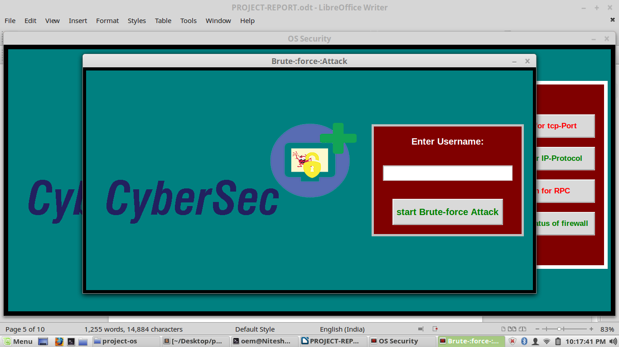

9: REFERENCES:
- http://code.activestate.com/recipes/580735-frame-with-border-color-for-tkinter/
- https://www.digitalocean.com/community/tutorials/how-to-set-up-a-firewall-with-ufw-on-ubuntu-14-04
- https://download.g0tmi1k.com/wordlists/large/
- https://help.ubuntu.com/lts/serverguide/user-management.html
- https://www.vultr.com/docs/how-to-configure-ufw-firewall-on-ubuntu-14-04
- https://docs.python.org/2/library/tkinter.html
- https://www.ibm.com/support/knowledgecenter/en/SSEP7J_10.2.1/com.ibm.swg.ba.cognos.crn_arch.10.2.1.doc/c_securing_the_operating_system.html
etc

