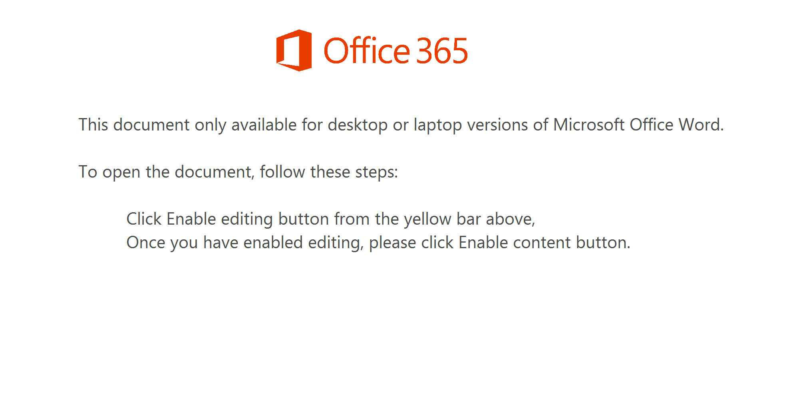
Click Enable button from the yellow bar above

