Quantum Key Distribution: Simulation of BB84 Protocol in C

Abstract—Quantum cryptography is an emerging technology in which two parties may simultaneously generate & shared secret cryptographic key material using the transmission of quantum states of light by applying the phenomena of quantum physics. The security of these transmissions is based on the inviolability of the laws of quantum mechanics-the Heisenberg Uncertainty principle and the principle of photon polarization. This paper concentrates on the theory of quantum key distribution and how this technology contributes to the network security. In this paper, we employ the standard BB84 protocol as the basic model of quantum key distribution (QKD) and it was shown that the simulation of QKD with "C Programming Language" is feasible. It provides a new method to demonstrate the BB84 protocol to realize the simulation of quantum key distribution.

Keywords— Quantum cryptograph, Quantum key distribution, BB84, QKD simulation, C Programming Language.

1. Introduction
Data transmission has always been vulnerable to eavesdropping. Conventional cryptography has provided security in data communication however it has some limitations when dealing with passive eavesdropping. Recently, the quantum mechanics has made a remarkable entry in the field of data communication. The purpose of quantum key distribution (QKD) and classical key distribution are same, the only difference lies in their realization methods. The QKD [1] is based on the fundamental principle of quantum mechanics wherein both the parties are initially unaware of keys before sharing and the secret key is decided by matching of basis used at both ends which is completely random in nature. On the other hand, the classical key distribution is based on the mathematical theory of computational complexity where parties need to share a secret sequence of random numbers, the key, that is exchanged by physical means and thus they are open to security loopholes. Several protocols have been devised to implement QKD systems.
In this paper, we use "C Programming Language" to simulate the procedure of BB84- first QKD protocol which was proposed by Bennett and Brassard in 1984[2]. The BB84 protocol has been proven to be unconditionally secure [3] [4], which are based on the laws of quantum mechanics and uses polarization-coding to realize the QKD. It enables two legitimate parties shared a random secret key which only known to them to encrypt and decrypt the message [5].

2. BB84 Protocol

BB84 protocol coding scheme uses four non- orthogonal polarization states (0º, 90º, 45º and 135º). In this protocol Alice (sender) and Bob (receiver) have to communicate in two types of channel, Quantum Channel (eg. fiber optic or free space) and Public Channel (eg. Internet)

The quantum key distribution using BB84 protocol happens in two stages [6]:

1) Via Quantum Channel (one way communication)

Step 1: Alice sends a sequence of photons to Bob. Each photon is in a state with polarization corresponding to 1 or 0, but with randomly chosen basis.
Step 2: Bob measures the state of the photons he receives, with each state measured with respect to randomly chosen basis either to use diagonal or rectilinear basis.

2) Via Public Channel (two way communication)

Step 1: Bob will use public channel to tell Alice the secret basis (randomly chosen) he choose for every qubits he received during measurement.

Step 2: Alice will compare the list of polarization states which she got from Bob with the one she generated while sending.

Step 3: Alice indicates to Bob what measurements will be correct. This becomes the key.

3. Implementation of BB84 Protocol

3.1 Introduction

For the implementation of BB84, the simulation environment has been developed using C Programming language. This simulation works well for Alice and Bob communicating to each other with or without Eve attacks.

Based on physical implementation of BB84, this simulation[7] is working on two channels, which are quantum channel and public channel. Alice (sender), Bob (receiver) and Eve (eavesdropper) will play their own roles in this implementation. The simulation consists of five objects: Alice, Bob, Eve, Quantum Channel and public Channel. Alice, Bob and Eve will run on separated machine. In Quantum Channel, if there is an eavesdropper taping the communication, the bit will be changed. While the public channel is used by Alice and Bob to communicate for error detection of bit and accordingly, the key is generated. During this phase, Eve can only observe but cannot make any modification on bits.

3.2 Proposed Algorithm

The complete algorithm for simulating BB84 protocol in given in the above three blocks: Transmitter Section, Receiver Section and Public Channel Discussion Section. Our model consists of transmitter (traditionally referred to as Alice) and the receiver (Bob) are connected by a quantum communication channel which allows quantum states to be transmitted.

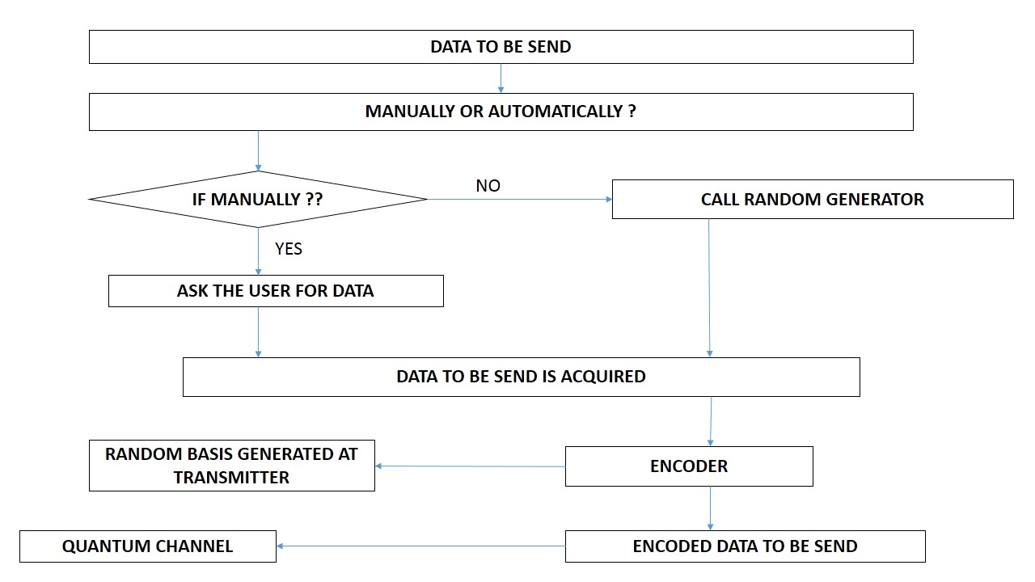
TRANSMITTER SECTION

RECEIVER SECTION
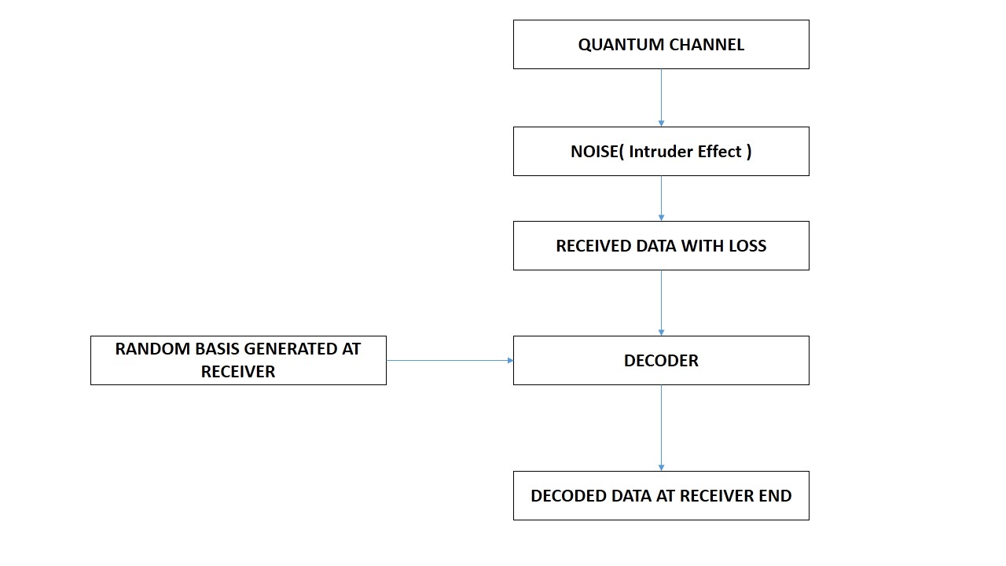

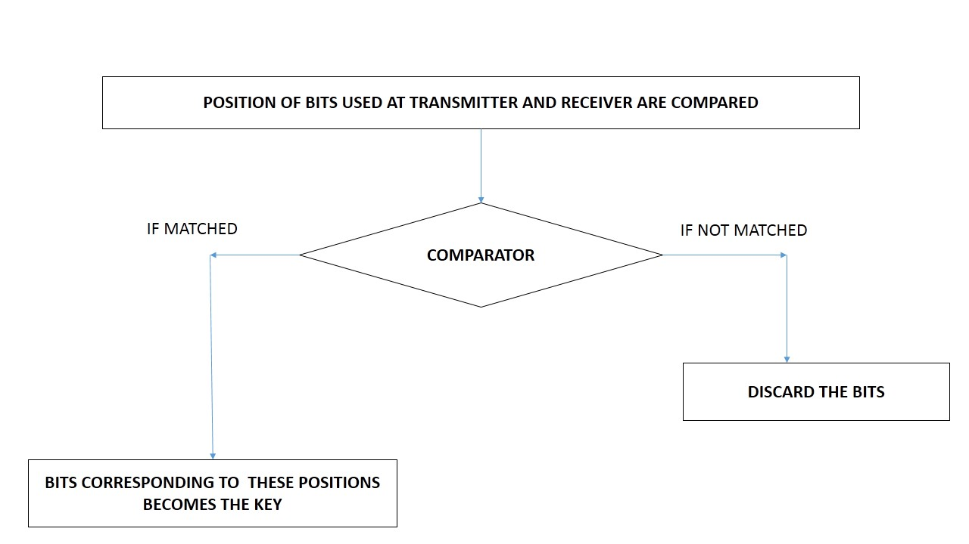
PUBLIC CHANNEL DISCUSSION

The steps of simulation are as follows:
1. First Alice decides the number of bits he wants to send to the Bob.
2. Then he encodes those bits in the form of photons S = {s1, s2, s3... sn} by randomly selecting the basis she wants to use for each bit independently. Those polarized photons are sent through the quantum channel.
3. For each photon, Bob randomly chooses either of the two bases {＋, ×} to decode the photons.
4. Alice and Bob discard all bits corresponding to that position where they use different bases while encoding/decoding.
5. Alice and Bob compute the error rate to decide whether there was an intruder effect present or not. If error rate is greater than some specified threshold then they will discard the sequence of bits.
The complete encoding and decoding is shown in the table:
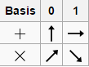

The unique symbols used for the bases used at both ends is shown above:

The Encoding and Decoding (Key Generation) is shown as given below:

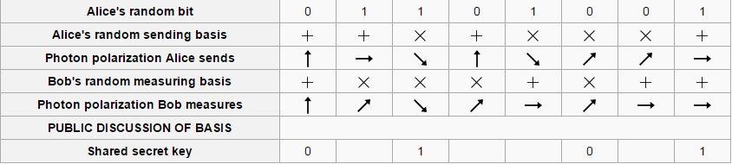

4. SIMULATION OUTPUTS:
Here we can explain the principle of simulation and give the results. In this paper, we perform the simulation based on the BB84 protocol.
During simulation, a particular threshold for data loss (for this simulation, the threshold level is set to 50 %) was chosen to decide the presence of intruder and in such a case, the whole sequence of bits are discarded and retransmission is requested.

- Here, the probability of data loss was found to be 80% which is more than 50% and hence, sender is asked to resend the data.
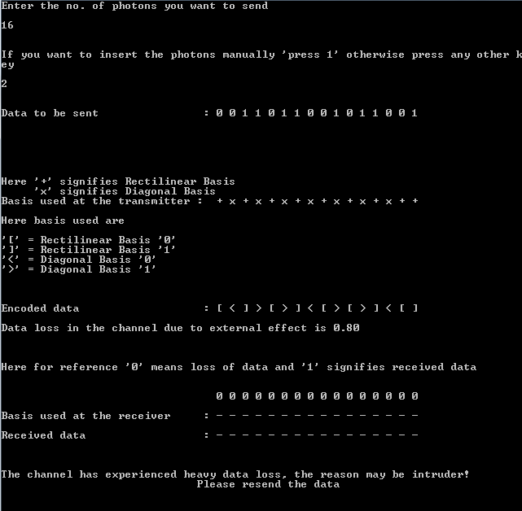

2. Here, the probability of data loss was found to be 10% which is acceptable and hence, the secret key is generated and shown.

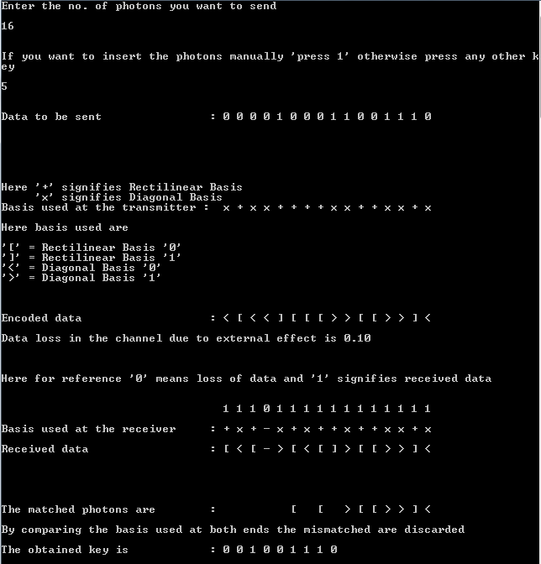

5. CONCLUSION:

6. REFERENCES:

[1] Ergűn GűműŞ, G.Zeynep Aydin and M.Ali Aydin, “Quantum Cryptography and Comparison of Quantum Key Distribution Protocol”, Journal of Electrical & electronics Engineering, vol.8, no.1, 2008.
[2] C. H. Bennett and G. Brassard, ”Quantum cryptography: Public key distribution and coin tossing,” Proceedings of IEEE International Conference on Computers, Systems and Signal Processing, Bangalore (New York, IEEE, 1984).
[3] D.Mayer, J.Assoc. Comput . Mach. 48,351 (2001). Its preliminary version appeared in “Advances in Aryptology-Proc. Crypto” 96, Vol.1109 of Lecture Notes in Computer Science, Ed. N. Koblitz, Springer-verlag, New York, 1996, p.343
[4] P.W.Shor and J.Preskill, [J] Phys Rev.Lett.85, 441(2000)
[5] Vladimir L. Kurochkin and Igor G. Neizvestny, “Quantum Cryptography”, 10th International Conference And Seminar Edm'2009, Section Iii, July 1-6, Erlagol.
[6] Hui Qiao, Xiao-yu Chen, “Simulation of BB84 Quantum Key Distribution in depolarizing channel”, Proceedings of 14th Youth Conference on Communication.
[7] Implementation of BB84 Protocol on 802.11i, Found in Network Applications, Protocols and Services, International Conference on By Nur Hanani Kamarul Aizan, Zuriati Ahmad Zukarnain, Hishamuddin Zainuddin,2010-09,”
[8] Quantum Cryptography,"Vladimir L. Kurochkin, Igor G. Neizvestny",Institute ofSemiconductor Physics, Siberian Division, RAS, Novosibirsk, Russia
[9] P. A. M. Dirac, The Principles of Quantum Mechanics, 4th ed.Oxford, U.K.: Oxford Univ. Press, 1958; reprinted 1978.
[10] Lo, H.-K. Quantum Cryptology. World Scientific, 1998.

